Mathematics Instructional Plan – Grade 7

Connecting Dilations to Similar Figures
Strand: Measurement and Geometry
Topic: Dilations
Primary SOL: 7.MG.4 The student will apply dilations of polygons in the coordinate plane.
- Given a preimage in the coordinate plane, identify the coordinates of the image of a polygon that has been dilated. Scale factors are limited to $\frac{1}{4},\frac{1}{2},$ 2, 3, or 4. The center of the dilation will be the origin.
- Sketch the image of a dilation of a polygon limited to a scale factor of $\frac{1}{4},\frac{1}{2},$ 2, 3, or 4. The center of the dilation will be the origin.
- Identify and describe dilations in context including, but not limited to, scale drawings and graphic design.

Materials
- What Do You Notice? What Do You Wonder? image (attached)
- Dilation Group sheets (attached)
- Dilations Practice (attached)
- chart paper
- Markers
- Dilation Practice (attached)

Vocabulary
dilation, scale factor, image, preimage

Student/Teacher Actions: What should students be doing? What should teachers be doing?
- Project or hand out the What Do You Notice? What Do You Wonder? image (attached). Give students a minute of independent think time. Have students share their thoughts with a partner, then have some partners share their ideas with the whole group. Record what students notice and wonder on the board. Accept all answers but listen for ideas that connect to ideas and concepts the students have already explored with similar figures. Let students know that this image is an example of a dilation and that they will be learning more about them today.
- Group students in small groups, giving each group one of the four Dilation Group sheets (attached). Each Dilation Group sheet has the same preimage but requires students to use a different scale factor. You may have multiple groups with the same sheet, but all sheets should be used to ensure a rich whole class discussion. As students explore, ask probing questions. Some questions could include:
  - Your rectangles seem to be getting bigger, what might make the rectangle smaller?
  - What do you think made this rectangle smaller when the one drawn was larger?
  - Is there a relationship between the side lengths of the rectangles?
  - What if you chose a different factor to create another rectangle? Would the same relationships you noticed hold true?
  - Where else have we seen quadrilaterals that had the same shape but a different size?
  - You said these are similar figures. How might you prove it?
- Have students complete a gallery walk to view each group’s work. As they visit each group, have them answer the following questions:
  - How are this group’s rectangles similar to or different from yours?
  - How does what this group noticed about the relationship between the rectangles compare to what your group noticed?
- Lead a whole group discussion to summarize the important ideas of dilations and make connections to what students have learned about similar figures based on what they noticed about the relationships between the rectangles. This is the time to attach formal vocabulary to their ideas, including the vocabulary of dilation, preimage, image, and scale factor. It is also the time to introduce the prime (ʹ) notation. You may choose to capture this information on an anchor chart with some visual examples of dilations and labels for vocabulary. Below are some points you will want to be sure students include as they discuss the relationships they noticed:
  - Dilations create figures that are the same shape but are different sizes. These figures have the same angles, and the sides are proportional, so they are similar.
  - A dilation is a transformation in which an image is formed by enlarging or reducing the preimage proportionally by a scale factor and is an application of similar figures.
  - To create a dilation of a polygon, you multiply the coordinates of each vertex by the given scale factor.
  - Scale factors greater than 1 enlarge the figure. Scale factors less than 1 but greater than 0 reduce the figure.
  - The original figure is called the preimage. The new figure after a dilation is called the image.
  - A preimage point A can be denoted as the image Aʹ (read as “A prime”).
- Have students work in partners or small groups to complete the Dilations Practice (attached). Encourage students to refer to the anchor chart and to use the new vocabulary as they work. As students work together, monitor student progress to prompt vocabulary use and to see which students may need additional support with this concept.
- To close the lesson, have students talk with a partner about where they might see dilations outside of the classroom. Have students share ideas and record some student responses on the anchor chart.

Assessment

Questions
  - What is the difference between a scale factor less than 1 and a scale factor greater than 1? How do you know, and what happens to the image?
  - How are a polygon and its image after a dilation related?
  - How are the coordinates of a preimage and its image after a dilation related?

Journal/writing prompts
  - Explain how dilations and similar figures are related.
  - Explain to a friend how to dilate a given polygon on a coordinate plane using a scale factor.
  - Explain how the value of the scale factor affects the dilated image.
  - Describe where you might see encounter examples of dilations outside of the classroom.

Other Assessments
  - Give students a polygon and its dilation and ask students to describe the relationship between the two polygons.

Extensions and Connections (for all students)
- Use online resources to model dilations.
- Have students explore careers that utilize dilations in their work.

Strategies for Differentiation
- Start with simpler polygons, such as rectangles and right triangles.
- Provide original polygons already drawn so that students only have to sketch the dilated image.
- Provide a numbered coordinate plane.
Note: The following pages are intended for classroom use for students as a visual aid to learning.

Virginia Department of Education © 2023
What do you notice? What do you wonder?
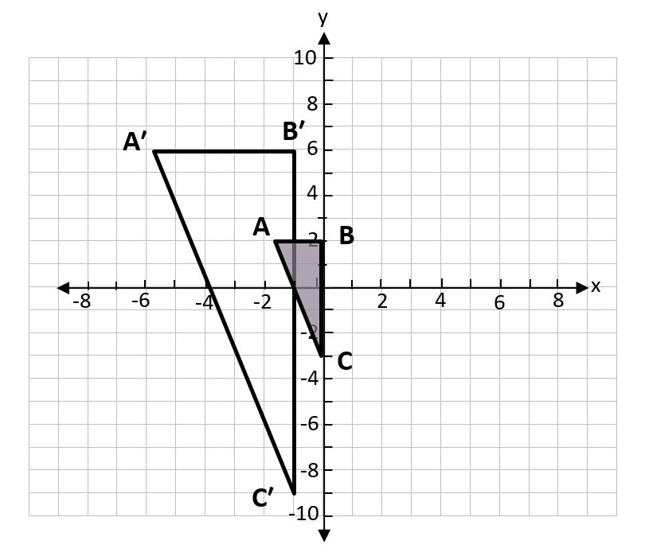

Dilation - Group 1
Name Date
- What do you notice about the coordinates of the shaded rectangle and the unshaded rectangle shown below?
- What relationships do you see between the shaded and unshaded rectangles? Explain.
- Draw a third rectangle whose coordinates are three times the values of the coordinates of the shaded rectangle. How is your new rectangle related to the other two? Explain.

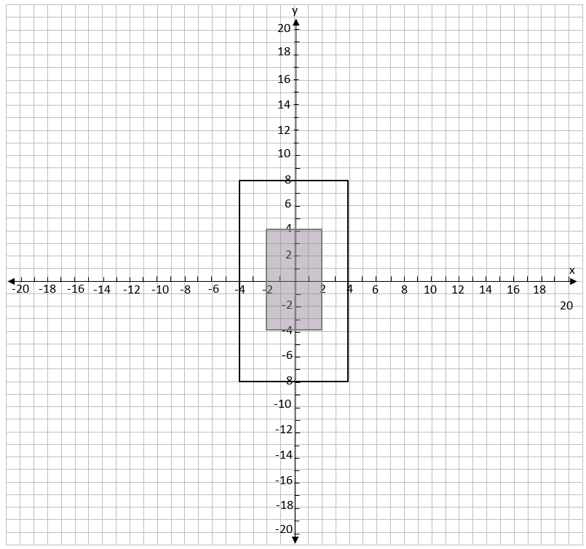

Dilation - Group 2
Name Date
- What do you notice about the coordinates of the shaded rectangle and the unshaded rectangle shown below?
- What relationships do you see between the shaded and unshaded rectangles? Explain.
- Draw a third rectangle whose coordinates are four times the values of the coordinates of the shaded rectangle. How is your new rectangle related to the other two? Explain.

Dilation - Group 3
Name Date
- What do you notice about the coordinates of the shaded rectangle and the unshaded rectangle shown below?
- What relationships do you see between the shaded and unshaded rectangles? Explain.
- Draw a third rectangle whose coordinates are half the values of the coordinates of the shaded rectangle. How is your new rectangle related to the other two? Explain.

Dilation - Group 4
Name Date
- What do you notice about the coordinates of the shaded rectangle and the unshaded rectangle shown below?
- What relationships do you see between the shaded and unshaded rectangles? Explain.
- Draw a third rectangle whose coordinates are one-fourth of the values of the coordinates of the shaded rectangle. How is your new rectangle related to the other two? Explain.

Dilations Practice
Name Date
- Graph, label, and connect these points: A (-1, 2), B (1, 0), C (0, -2). Sketch and label the image of triangle ABC after a dilation about the origin by a scale factor of 4.
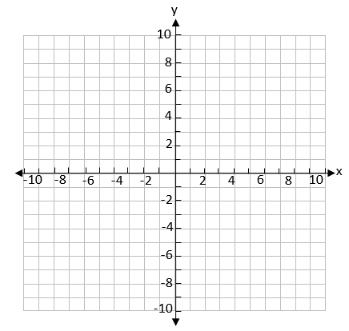

- Graph, label, and connect these points: A (-6, 10), B (2, 10), C (0, 6), D (-4, 4). Sketch and label the image of quadrilateral ABCD after a dilation about the origin by a scale factor of $\frac{1}{2}$.
Dilations Practice
- Given the preimage on the coordinate plane below, identify the coordinates of the image of polygon ABCD after it has been dilated by a scale factor of 2.
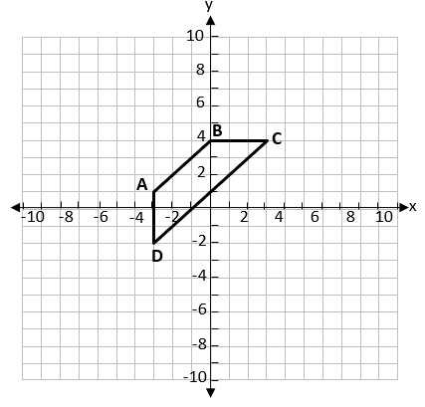

- Given the preimage on the coordinate plane below, identify the coordinates of the image of polygon DEFGH after it has been dilated by a scale factor of 2.
