Mathematics Instructional Plan – Grade 6

Data Cycle and Circle Graphs
Strand: Probability and Statistics
Topic: Using the data cycle to create a circle graph and analyze data from the graph
Primary SOL: 6.PS.1 The student will apply the data cycle (formulate questions; collect or acquire data; organize and represent data; and analyze data and communicate results) with a focus on circle graphs.
- Formulate questions that require the collection or acquisition of data with a focus on circle graphs.
- Determine the data needed to answer a formulated question and collect the data (or acquire existing data) using various methods (e.g., observations, measurement, surveys, experiments).
- Determine the factors that will ensure that the data collected is a sample that is representative of a larger population.
- Organize and represent data using circle graphs, with and without the use of technology tools. The number of data values should be limited to allow for comparisons that have denominators of 12 or less or those that are factors of 100 (e.g., in a class of 20 students, 7 choose apples as a favorite fruit, so the comparison is 7 out of 20, $\frac{7}{20}$ , or 35%).
- Analyze data represented in a circle graph by making observations and drawing conclusions.
- Compare data represented in a circle graph with the same data represented in other graphs, including but not limited to bar graphs, pictographs, and line plots (dot plots), and justify which graphical representation best represents the data.

Materials:
- Vocabulary cards for Circle Graph
- Notice and Wonder Circle Graph (attached)
- Beverages Circle Graph (attached)
- Marker Colors Circle Graph
- Real-life examples of circle graphs from current news
- Set of Comparing Graphs Cards (attached)
- Large poster paper

Vocabulary:

survey, population, data, circle graphs, percentage, part to whole, data cycle, conjecture, inferences, categorical data, discrete data

Student/Teacher Actions: What should students be doing? What should teachers be doing?
Teacher Actions:
- Explain the objective of the lesson: to use the data cycle to create a circle graph and analyze data from the graph. Discuss each step of the data cycle (formulate questions, collect/acquire data, organize/represent data, analyze data, communicate results) and provide examples for each step.
- Start the lesson by showing students the Notice and Wonder graph and have students develop a title for the graph and identify what each sector could represent.
- Show students a real-life example of a circle graph, such as circle graph in a newspaper or magazine. Ask them to discuss what they notice about the graph.
- Discuss the features of a circle graph and the types of data that circle graphs are best used to represent. Circle graphs are used for categorical and discrete numerical data. Circle graphs are used to show the relationship of the parts to a whole. Each section in the circle is proportional to the quantity it represents. The size of each sector in the circle graph represents the proportion or percentage of the data it represents.
- Give students a topic such as video games. Have them work with a partner to brainstorm a list of questions that they could include in a survey about video games. Once students have developed a list, have them consider which questions might lead to data that would make a circle graph. Give students time to share their questions and provide feedback about which questions would lead most reasonably to the creation of a circle graph. Be sure to highlight some examples of questions that would NOT lead to a circle graph and discuss why.
- Teacher leads discussion about factors that ensure a representation of a larger population. A few things to consider are the size of populations or groups you want to study, and how this will determine the size of the sample group to accurately reflect the views of the larger group. For example, if we surveyed students in our class, would this represent our entire school? Our city? Our state? Our country? What could we do to ensure that we included these other groups, and when is it appropriate to include and represent other groups?
- Have students create a survey question, gather the data and then put data into Excel, https://www.canva.com/graphs/pie-charts/ or another program such as https://nces.ed.gov/nceskids/createagraph/ to create a circle graph. Students should analyze their data and write conjectures about their data. (Note: This will likely take multiple class days.)

Assessment

Questions

Compare two different circle graphs and describe the similarities and differences between them.

Estimate the percentage of a category in a circle graph based on its visual representation.

What cannot be determined about the data from looking at a circle graph?
- Summarize the main findings or trends in a given circle graph.

Journal/writing prompts

How does a circle graph help you organize data?

Formulate a hypothesis about the relationship between two variables based on the information presented in a circle graph and design an experiment to test it.

Assess the effectiveness of using a circle graph to represent a specific set of data and justify your evaluation.

Draw conclusions about a given circle graph and explain how the data supports your conclusions.

Other Assessments

Investigate a real-world scenario where circle graphs were used to analyze data and discuss the insights gained from the graph.

Extensions and Connections (for all students)

Students can find real-life examples of circle graphs in newspapers, magazines, or online sources. They should analyze the data represented in the circle graphs and write a short paragraph explaining the insights they gained from the graphs.

Strategies for Differentiation

Have students conduct a survey among their classmates to gather data on their favorite sports and create circle graphs to represent the results. They can then analyze the data to draw conclusions about the most popular sport in the class.

Ask students to collect data on the favorite genres of books in the school library and create circle graphs to represent the data. They can compare the results with other graphical representations and discuss which one provides the clearest representation of the data.

Assign students a real-world scenario, such as analyzing the distribution of different types of plants in a garden, and have them collect data, create circle graphs, and draw conclusions based on their findings.
Note: The following pages are intended for classroom use for students as a visual aid to learning.
Virginia Department of Education ©2023
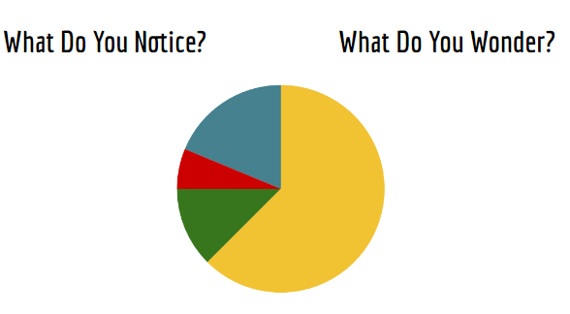
Create a list of possible titles for the graph and each sector.

Beverages Circle Graph
The results of a poll of favorite morning beverages for students in your school are shown in the circle graph below. Estimate the percent for each drink and label the circle graph accordingly.
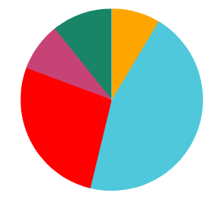
Coffee: ______%
Water: ______%
Juice: ______%

Milk: ______%

Energy Drink______%: ______%

Marker Colors Circle Graph
The teacher took inventory of all the markers in his collection box. The circle graph shows what he found. What is a possible number for each marker color in the collection box? Use the table below to show your work.
Marker Color | Amount
Red
Orange
Purple
Blue
Green
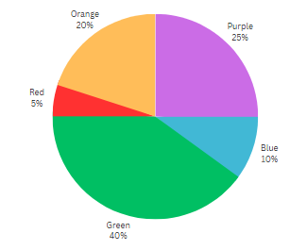

Explain and justify how you know your answer is correct.

Comparing Graphs – 1
Types of Animals on Mr. Segal’s Farm

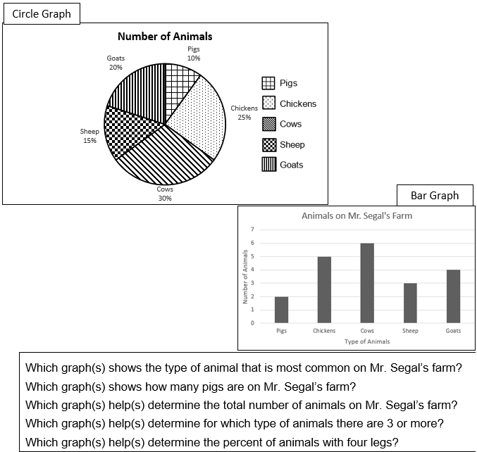

Comparing Graphs – 2
Types of Animals on Mr. Segal’s Farm

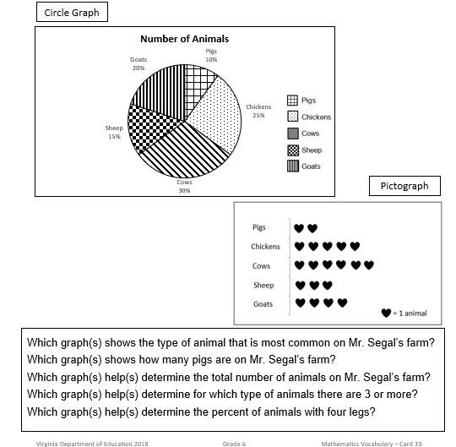
Comparing Graphs – 3
Types of Animals on Mr. Segal’s Farm

