Mathematics Instructional Plan – Grade 6

Contextual Problems Involving Area and Perimeter
Strand: Measurement and Geometry
Topic: Solving contextual problems involving the area and perimeter of rectangles and triangles
Primary 2023 SOL: 6.MG.2 The student will reason mathematically to solve problems, including those in context, that involve the area and perimeter of triangles and parallelograms.
Students will demonstrate the following Knowledge and Skills:
- Develop the formula for determining the area of parallelograms and triangles using pictorial representations and concrete manipulatives (e.g., two-dimensional diagrams, grid paper).
- Solve problems, including those in context, involving the perimeter and area of triangles and parallelograms.

Materials:
- Dot paper
- Parallelogram Formula activity sheet (attached)
- Bob the Builder activity sheet (attached)

Vocabulary:
From earlier grades: area, length, perimeter, square feet, square units, unit, width
From current grade: parallelogram, rectangle, triangle, right angle

Student/Teacher Actions: What should students be doing? What should teachers be doing?
- Distribute dot paper. As a review, facilitate a discussion regarding how the formulas for area and perimeter of rectangles are derived.
- Have the students draw both figures on their dot paper.
Figure 1 Figure 2
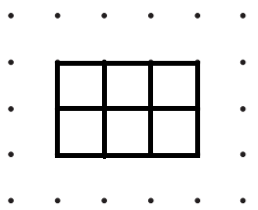
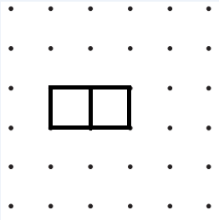

- Ask: “What do you notice about the units in each figure?” “What do you notice about the dimensions?” “What is the area of each figure?” “Can you justify the area by using the pictures?” “Can you justify your thinking using the formula?” Ensure that students are including square units in their discussion and that students can summarize the formula, $A=lw$.
- Ask students to determine the perimeter of each figure. Ask, “How does the perimeter relate to the dimensions of the rectangle?” Ensure that students can summarize
$P=2l + 2w$ or $P= 2(l + w).$
- Ask students to draw a diagonal across both figures. To elicit discussion, ask questions such as: “What is the resulting figure?” “How can a person find the area of the triangle?” “How is this different from the area of a rectangle?” “What is the relationship between the area of this triangle and the area of this rectangle?” Continue the discussion until students see that the area of a triangle is half of the product of base and the height, or $A=\frac{1}{2}bh$ . Have students draw an additional triangle (without a right angle), and have them calculate the area after identifying the base and height.
- Review how to find the perimeter of the triangle $(P=a + b +c).$
- Divide students into small groups. Give each group a copy of the Parallelogram Formula activity sheet. Read the instructions aloud to students and then provide students with time to think about how the parallelogram might relate to what they already know about the area of rectangles and triangles. As students are working, move around the room to ask guiding questions.
- When students are ready, prompt them to develop a formula for finding the area of parallelograms (they will document this on their Parallelogram Formula activity sheet). You might need to provide some hints about b and h or the connection to rectangles. You might encourage students to use scissors and cut their paper to test their ideas. You might also provide additional dot paper for students.
- After students have had time to solidify their thinking, designate some students to share their ideas. Use student sharing to identify the actual formula for area of parallelograms ($A=bh$) and demonstrate why that formula works. Before moving on, ask students whether the base (b) always has to be on the “bottom” of the shape to encourage flexible thinking about parallelograms. It would also be a good idea to remind students that the height is going to be different from the various side lengths as you wrap in a discussion of how to find the perimeter of a parallelogram.
- Read the following to the students:
Bob is a general contractor and needs help deciding on various measurements to complete his latest home improvement project for a client. With your partner, perform the necessary calculations to help him finish his job.
- Distribute the Bob the Builder activity sheet. Have students work through each problem with a partner and record their findings in their notebooks.

Assessment

Questions
  - What is the difference between the area of a figure and its perimeter?
  - What is the relationship between the area of a triangle and the area of a rectangle?
  - Is there a difference between $A=lw$ and $A=bh$?
  - What is the relationship between the area of a rectangle and a parallelogram?

Journal/writing prompts
  - Describe in your own words how you can find the area and perimeter of a rectangle and triangle.
  - Describe the similarities between area and perimeter.
  - How are the areas of a triangle and rectangle related?
  - How are the areas of rectangles and parallelograms related?
  - Describe the minimum amount of information needed to find the perimeter (or area) of a rectangle (or triangle or parallelogram).

Other Assessments
  - Write a problem with a practical application for finding area or perimeter and trade with another student to solve.
  - Give students rulers and have them find the perimeter and area of figures around the room.
  - Create an exit ticket that includes one perimeter and one area question for a rectangle and triangle.

Extensions and Connections (for all students)
- Have students create more Bob the Builder scenarios.
- Create a budget for Bob, and have students determine whether his project is within budget.

Strategies for Differentiation
- Use grid paper to allow students to see the units in the area and perimeter of the figures.
- Use geoboards instead of or in addition to dot paper.
- Add pictures to the Bob the Builder activity sheet to show the items in real life.
- Give the area of a rectangle and ask students to determine the possible perimeters.
- Give the perimeter of a rectangle and ask students to determine the possible areas.
- Give the perimeter of a rectangle and one dimension and ask students to determine the other dimension.
- Pre-teach important vocabulary for students before the lesson.
- Provide worked examples for students to use during the lesson.
- Give fewer problems as necessary for students to solve.
- Have students work with a partner before step 8 for all learning activities.

Note: The following pages are intended for classroom use for students as a visual aid to learning.

Virginia Department of Education ©2018 (Revised December 2023)
Parallelogram Formula Activity Sheet
Directions: With your group, explore the parallelograms below. What do you notice about the area of the parallelograms? What connections can you make between the area of a parallelogram and the area of a rectangle and/or triangle?
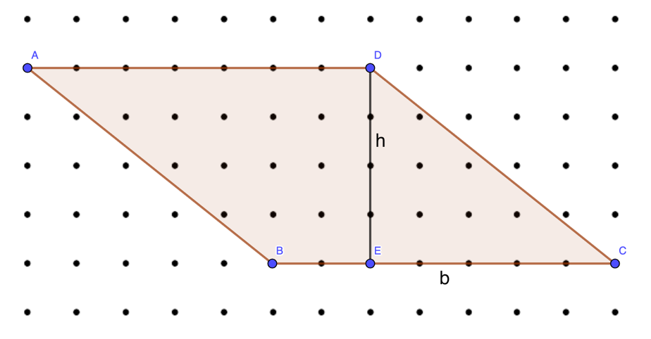
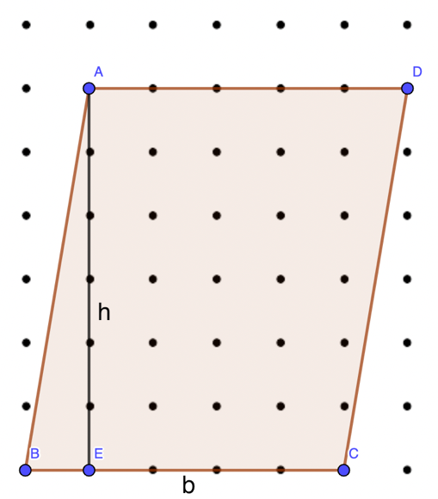
Document your ideas:

Develop a formula for finding the area of a parallelogram and write it on the line below. Test your formula using the parallelogram below.
Formula A = _________________
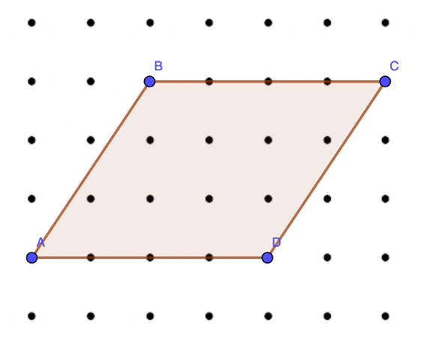

Bob the Builder Activity Sheet
- The kitchen is 20 feet long and 10 feet wide. How many square feet of flooring does Bob need to buy?

- The client wants the four kitchen windows to be framed with a special molding. If the windows are 22 inches by 24 inches, how many total inches of molding are needed for the kitchen windows?

- The homeowner is replacing the laminate countertops with granite. Bob purchased a slab of granite that is 18 square feet. If the slab is 6 feet long, how wide is it?

- Bob wants to place a triangular flower garden in the front of the house to increase curb appeal. What could be the dimensions of the garden if he has a space of 12 square feet to work with?

- The longest side of the triangular flower garden discussed in question 4 will be against the house. Bob wants to place decorative bricks around the other two sides of the garden. How many feet of brick does he need to purchase?

- Bob the Builder has a rectangular garden that he wants to transform into a parallelogram-shaped garden. The length of the garden is 12 meters and the height is 5 meters. By how much does he need to adjust the shape to create a parallelogram-shaped garden with the same area?

- Bob the Builder is constructing a ramp where the children can ride their bikes. The ramp is in the shape of a parallelogram, with a base of 10 feet and a height of 8 feet. What is the area of the ramp?

