Mathematics Instructional Plan – Grade 6

Circles
Strand: Measurement and Geometry
Topic: Identify the characteristics of circles
Primary SOL: 6.MG.1 The student will identify the characteristics of circles and solve problems, including those in context, involving circumference and area.
- Identify and describe chord, diameter, radius, circumference, and area of a circle.
- Investigate and describe the relationship between:
- Diameter and radius;

Materials
- Identify and Describe Parts of a Circle Sheet activity sheet (attached)

Vocabulary
chord, diameter, radius/radii, circumference, area, pi, center, circle, line segment

Student/Teacher Actions: What should students be doing? What should teachers be doing?
- Give students the activity sheet, Identify and Describe Parts of a Circle. Ask, “What makes a circle?” Allow students to share their thoughts.
- Have students look at the dot on the circle. Ask, “How can we use the dot to describe our circle?” Allow students to share their thoughts and revise their definition of a circle, if needed. Share with students the formal definition of a circle: a set of points on a flat surface (plane) with every point equidistant (an equal distance) from a given point called the center. Have students label the center point on their activity sheet as Point A.
- On the first circle, have students use a ruler and measure the distance from the center to a point on the outside edge of the circle. Record the distance. Explain that a line segment from the center of the circle to any point on the circle is called the radius of the circle. Have students record the definition under the first circle. Have students think of examples of real-world examples of circles, such as spokes of a bicycle tire.
- Have students use the ruler to draw a line segment from one point on the circle to another point on the circle. Tell students they formed a chord. A chord is a line segment connecting any two points on a circle. Have students record the definition on their paper under the second circle.
- Have students use the ruler and draw a line from one side of the circle through the center to the opposite side of the center. Label one point F and the other point G. Measure the distance from one point to the other and record it under the third circle. Ask, “What do you notice about the lengths of the radii and the distance point F to G?” Students should notice that the length of segment FG is twice or double the length of the radius. Explain that this is the diameter, a chord that goes through the center of a circle. Have students record the definition on their paper under the third circle. Have a discussion with the students. Ask, “Is a diameter also a chord? Is a chord also a diameter?” Have students justify their reasoning and use illustrations to prove their answers.
- Students can do the matching vocabulary/definition exercise on the paper.
- Have students draw and label a chord in each of the three circles. Have students share their reasoning or proof for their representations. If any student drew a diameter as a chord have the students discuss whether this is an accurate representation or not.
- Have students draw and label a diameter in each of the three circles. Have students share their reasoning or proof for their illustrations. Ask, “Is this a diameter a chord?” Students should recognize that a diameter is a chord.
- Have students draw and label a radius in each of the three circles. Have students share their reasoning or proof for their illustrations. Ask, “What is the difference between a radius and a diameter? What is the relationship between a radius and a diameter?”
- Have students complete the activity sheet. Students should continue to use mathematical reasoning to justify their answers. Teachers should have students share their answers since the class will have a variety of illustrations and justifications.

Assessment

Questions:
  - What is the relationship between the diameter and radius of a circle?
  - Are all diameters chords? Why or why not?
  - Are all chords diameters? Why or why not?

Journal/writing prompts:

Write a reflection on what you have learned about circles, including any challenges you faced and strategies you used to overcome them.

Extensions and Connections (for all students)
- Circle Diagram: Create a labeled diagram of a circle, including the radius, diameter, and circumference.
- Circle Measurements: Measure the radius, diameter, and circumference of various circular objects in your surroundings and record your findings. When students finish the table, ask them to look at the comparisons and discuss their discoveries and justifications.
Name of Object | Circumference | Diameter | Radius | Diameter  Radius | Circumference  Diameter | Circumference  Radius

- Circle Formula: Write a step-by-step explanation of how to calculate the circumference of a circle using the formula C = πd or formula C = π2r.
- Radius vs Diameter: Create a Venn diagram comparing and contrasting the concepts of radius and diameter in relation to circles.
- Find and describe at least three real-life examples where circles and their measurements are used.

Strategies for Differentiation

Provide students with a circle with the parts already labeled.

Provide various circle drawings for students to measure and label.
- Create a sort to match containing circles with a diameter or radius given and matched to each circle’s circumference.
- Give students one measurement and they find the measurement of other parts of the circle.
- Engage students in hands-on activities where they measure and compare the circumference of different circles to reinforce the concept of the relationship between the circumference and the diameter (or radius).
- Demonstrate the formula for finding the circumference using both the radius and diameter separately. Provide practice problems where students must calculate the circumference using the correct measurement. Encourage students to discuss their reasoning and correct any misconceptions during class discussions.
- Circle Exploration Stations: Set up different stations in the classroom where students can explore the relationship between radius, diameter, and circumference. Each station can have hands-on activities or manipulatives, such as circular objects of different sizes, string or yarn to measure circumference, and rulers to measure diameter and radius.
Students can rotate through the stations, engaging in activities that allow them to physically manipulate and measure circles, helping them develop a deeper understanding of the concepts.
- Circle Word Problem Gallery Walk: Create a gallery walk activity where different word problems related to circles and their properties are displayed around the classroom.
Students work in pairs or small groups and move around the room, reading and discussing the word problems. Encourage students to identify and discuss the relationships between radius, diameter, and circumference in each problem. As a class, discuss the different strategies used to solve the problems, emphasizing the conceptual understanding behind the calculations.

Note: The following pages are intended for classroom use for students as a visual aid to learning.
Virginia Department of Education © 2023
Identify and Describe Parts of a Circle
Name: _________________________________

Use the three circles to draw, label and define radius, chord, and diameter.

Match the definition with the word.
Diameter

Radius

Chord

- a line segment connecting any two points on a circle

- a chord that passes through the center of a circle

- a line segment joining the center of a circle to any point on the circle

In the first circle, draw and label a chord.
Repeat in the other circles with a different chord.
Draw and label a diameter in each of the circles below.
Draw and label a radius in each of the circles below.

Draw Circle A, with a radius of 18 cm.

Draw Circle B, with a radius of 7 cm.

Draw Circle C, with a radius equal to Circle A’s diameter.

Draw Circle D, with a diameter that is equal to Circle B’s radius.

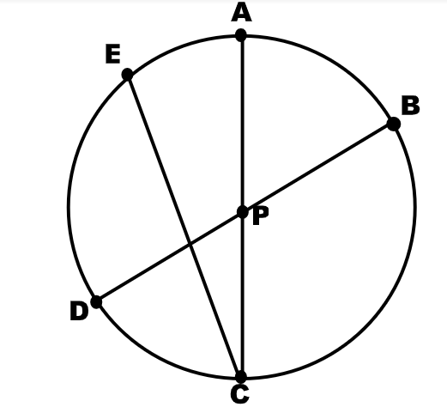
Here is a circle with center point P and some line segments. Identify examples and explain your reasoning. Measure the line segments to use as part of your justifications.
- Diameter

- Radius

- Chord

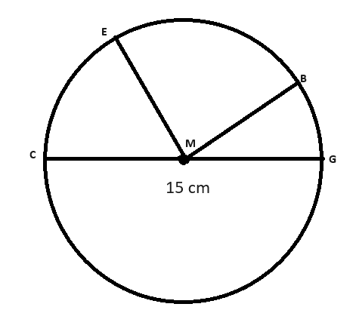
M is the center of the circle, and the length of CG is 15 cm.
- Name a segment that is a radius.

What is the length of the radius?

- Name a segment that is a diameter.

What is the length of the diameter?

- Write a comparative statement about the diameter and a radius?

- Write a comparative statement about a radius and a diameter?

