Mathematics Instructional Plan – Grade 3

Composing and Decomposing Fraction Centers
Strand: Number and Number Sense
Topic: Composing and decomposing fractions and mixed numbers
Primary SOL: 3.NS.3 The student will use mathematical reasoning and justification to represent and compare fractions (proper and improper) and mixed numbers with denominators of 2, 3, 4,E 5, 6, 8, and 10), including those in context.
- Compose and decompose fractions (proper and improper) with denominators of 2, 3, 4, 5, 6, 8, and 10 in multiple ways (e.g., $\frac{7}{4}$ = $\frac{4}{4}$ + $\frac{3}{4}$ or $\frac{4}{6}$ = $\frac{3}{6}$ + $\frac{1}{6}$ = $\frac{2}{6}$ + $\frac{2}{6}$) with models.

Materials
- Color tiles or other manipulatives in a variety of colors, fraction tiles or fraction strips
- Materials for each individual center

Vocabulary
Fraction, whole, proper, improper, compose, decompose, numerator, denominator

Student/Teacher Actions: What should students be doing? What should teachers be doing?
- Before the beginning of the lesson, assemble all the centers described in step three and place them around the room. Each center helps students develop an understanding of composing and decomposing fractions.
- Ask students to describe all the ways that they can think of to represent $\frac{5}{6}$. Record student responses so that they are visible to the class. Encourage students to think about both real-world contexts where they may see five-sixths as well as the various fraction representations that they have been working with in class.
- Explain to students that they are going to be able to work at different centers that involve composing and decomposing fractions. Explain that there will be manipulatives or tools at each center to help represent their work. Demonstrate expectations for working at each center.
  - Decomposing Fractions with Color Tiles
Materials: decomposing fractions with color tiles cards, color tiles or other counters in multiple colors, dry erase boards or math notebooks for recording

The student selects a decomposing fractions with color tiles card and builds the fraction on the card using two different colors of color tiles. The student records how the fraction can be decomposed into two parts, then repeats the activity using the same card to find a different way that the fraction can be decomposed.
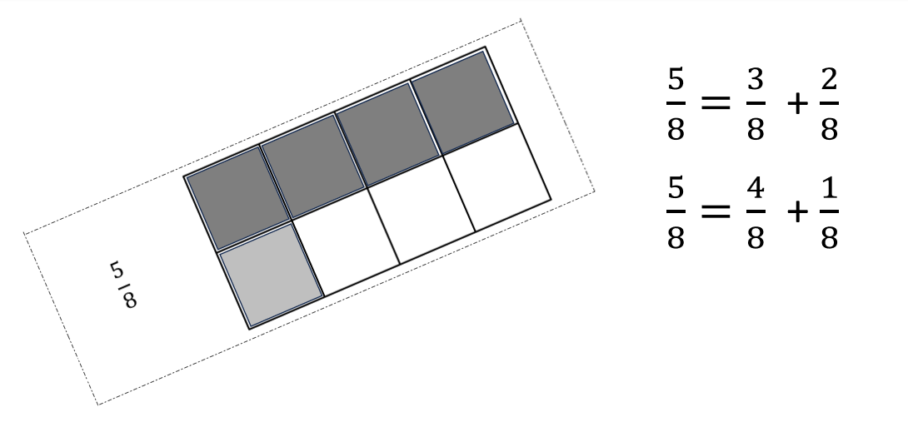
When the student feels they have found all the ways to decompose that fraction, they select another fraction card and begins the process again.

- Fractions Wall Break Apart
Materials: fraction break apart cards, fraction tiles or fraction strips, dry erase boards or math notebooks for recording

Students work with a partner. One student selects a fraction card and builds that fraction with fraction tiles or fraction strips. The second student breaks the wall into two parts. The first student names the two parts that the original fraction was decomposed or broken into. Students record how the fraction was decomposed. Repeat with additional fraction cards.
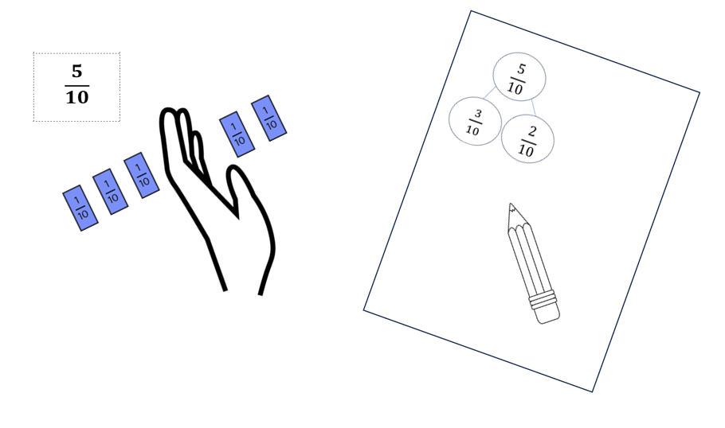
- Counting Unit Fractions
Materials: counting unit fractions spinner, fraction tiles or fraction strips

Students work with a partner. One student spins the spinner to determine the unit fraction that they will count by. Students take turns adding the appropriate fraction tile or fraction piece while counting out loud. Students continue taking turns adding the same unit fraction until they have built two wholes.
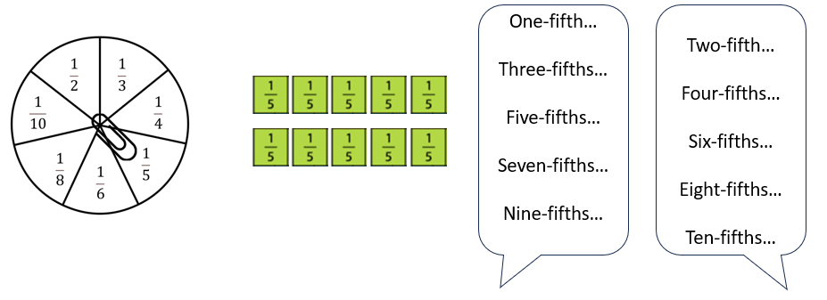
- Fraction Build It
Materials: fraction build it cards, color tiles or other counters in multiple colors, dry erase boards or math notebooks for recording

The student selects a fraction build it card and builds the fraction on the card using color tiles or counters. The student records how the fraction can be decomposed into two parts, then repeats the activity using the same card to find a different way that the fraction can be decomposed.
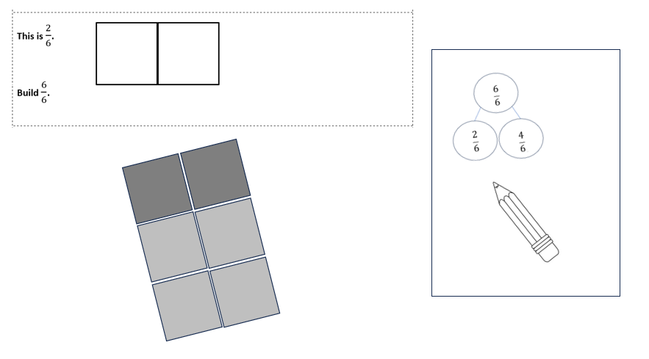
- As students are working at centers, observe and interact with them. As you observe each student, consider the following: Is the student able to use unit fractions to compose larger fractions? Does the student use the correct counting sequence when counting unit fractions? Is the student able to decompose a fraction into combinations that are not unit fractions? Is the student correctly recording the number combinations using equations, number bonds, or other part-part-whole representations?
- At the end of the class period, come back together whole group. Select various students to share their experiences from each center. What did you learn today? Were you surprised about anything? What was difficult? Did you notice any patterns in your work? Were there any similarities between the work that you did at different stations?
Select students to share the number bonds or number combinations that they recorded for various fractions. How do you know that you found all the ways to decompose this fraction? What strategies did you use? Were your results similar to or different from these results?

Assessment

Questions
  - Can you decompose $\frac{5}{6}$ in three ways? Use a model to help show your thinking.
  - Complete the number bond. Draw a model to represent the fractions in this number bond.
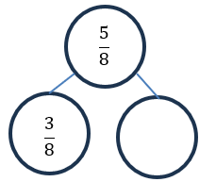
  - Show a number bond representing the shaded and unshaded parts of this figure.
Draw a different model that would be represented by the same number bond.

Journal/writing prompt
  - Why might it be helpful to be able to decompose or break apart a fraction into parts?

How can you check to see if you have found all the ways to decompose a fraction?

Other Assessments
- How can you decompose a fraction into unit fractions?
- How can you build a whole when you are given a fractional part?

Extensions and Connections (for all students)
- Connect composing and decomposing fractions to equivalent fractions, particularly those that are equivalent to $\frac{1}{2}$. When students begin comparing to benchmarks of 0, $\frac{1}{2},$ and 1, students will be able to tell if a fraction is greater than or less than $\frac{1}{2}$ by considering if the fraction can be decomposed into parts where one part is equal to one-half.
- Make connections between improper fractions and mixed numbers as students are composing and decomposing. Encourage students to name fractions both as improper fractions and mixed numbers.

Strategies for Differentiation
- Use number bond mats, with concrete manipulatives to model the fractions.
- Scaffold decomposing 1 whole into unit fractions, then progress to other parts.
- Use sentence strips to model fractions.
Note: The following pages are intended for classroom use for students as a visual aid to learning.
Virginia Department of Education©2023
Decomposing Fractions with Color Tiles Cards
$$\frac{9}{10}$$

$$\frac{6}{10}$$

$$\frac{4}{10}$$

$$\frac{8}{10}$$

$$\frac{7}{8}$$

$$\frac{5}{8}$$

$$\frac{3}{8}$$

$$\frac{8}{8}$$

$$\frac{4}{6}$$

$$\frac{5}{6}$$

$$\frac{3}{6}$$

$$\frac{5}{5}$$

$$\frac{4}{5}$$

$$\frac{3}{5}$$

$$\frac{4}{4}$$

$$\frac{3}{4}$$

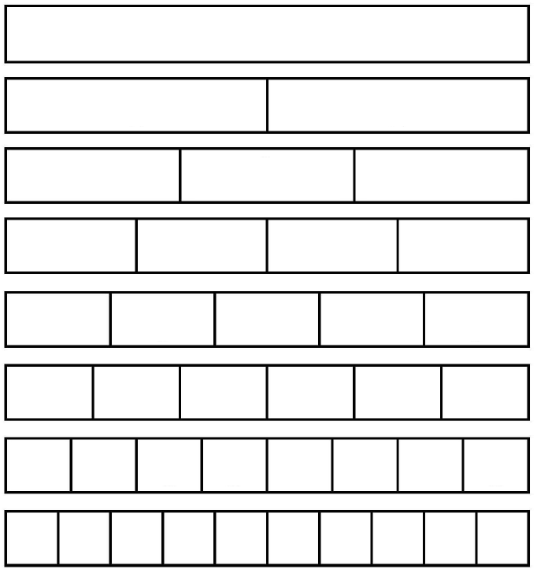
Fraction Strips

Fraction Wall Break Apart Cards
$$\frac{2}{4}$$ | $$\frac{6}{4}$$ | $$\frac{4}{4}$$ | $$\frac{2}{5}$$
$$\frac{7}{5}$$ | $$\frac{4}{5}$$ | $$\frac{2}{6}$$ | $$\frac{3}{6}$$
$$\frac{4}{6}$$ | $$\frac{5}{6}$$ | $$\frac{3}{8}$$ | $$\frac{4}{8}$$
$$\frac{10}{8}$$ | $$\frac{6}{8}$$ | $$\frac{7}{8}$$ | $$\frac{5}{10}$$
$$\frac{4}{10}$$ | $$\frac{12}{10}$$ | $$\frac{7}{10}$$ | $$\frac{9}{10}$$

Counting Unit Fractions Spinner

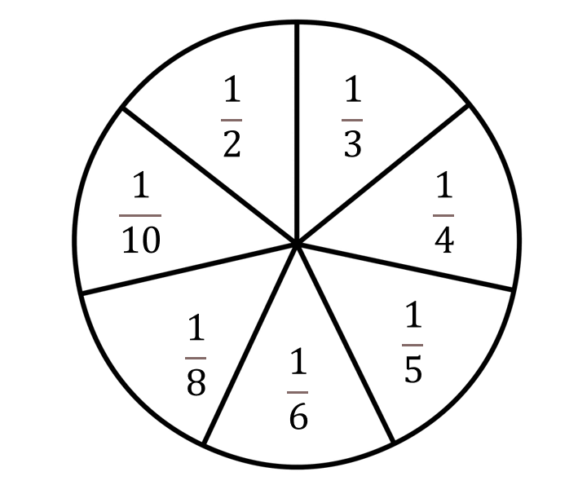

Fraction Build It
This is $\frac{1}{4}$.

Build $\frac{3}{4}$.

This is $\frac{2}{6}$.

Build $\frac{6}{6}$.

This is $\frac{3}{8}$.

Build $\frac{7}{8}$.

This is $\frac{2}{10}$.

Build $\frac{9}{10}$.

This is $\frac{3}{6}$.

Build $\frac{5}{6}$.

This is $\frac{3}{10}$.

Build $\frac{12}{10}$.

This is $\frac{1}{5}$.

Build $\frac{4}{5}$.

This is $\frac{4}{5}$.

Build $\frac{8}{5}$.

