Mathematics Instructional Plan – Grade 3

Place Value
Strand: Number and Number Sense
Topic: Reading, writing, and identifying the place value of six-digit numerals
Primary 2023 SOL: 3.NS.1 The student will use place value understanding to read, write, and determine the place and value of each digit in a whole number, up to six digits, with and without models.
- Read and write six-digit whole numbers in standard form, expanded form, and word form.
- Apply patterns within the base 10 system to determine and communicate, orally and in written form, the place and value of each digit in a six-digit whole number (e.g., in 165,724, the 5 represents 5 thousands and its value is 5,000).
- Compose, decompose, and represent numbers up to 9,999 in multiple ways, according to place value (e.g., 256 can be 1 hundred, 14 tens, 16 ones, but also 25 tens, 6 ones), with and without models.

Materials
- Classroom set of base-10 blocks
- Place value mats (attached)
- Digit Cards (attached)
- Place value expanders (attached)
- Plastic baggies
- Construction paper in six different colors
- Adding machine tape or sentence strips
- Scissors
- Stapler

Vocabulary
Value, digit, place value, number, numeral, standard form, expanded form, compare

Student/Teacher Actions: What should students be doing? What should teachers be doing?
Note: Before the lesson, prepare multiple sets of 24 Digit Cards, and place each set in a plastic baggie. Also, create headbands as follows: Cut strips of construction paper in six different colors, and staple them to make headbands. Designate a color for each of six place values (ones, tens, hundreds, thousands, ten thousands, hundred thousands), and write a place value on each headband. Create enough sets of six headbands so each student will have one.
- Using base-10 blocks as place value models, demonstrate how to represent place value through the thousands place by creating the number 2,743. Discuss the value of each number represented by the base-10 blocks (e.g., 7 represents 7 hundreds and 700).
- Use the attached place value expanders to model several different numbers through the thousands place. Use the expander to display a number in standard form and have students build it with base ten blocks. Then model how to use the number expander to assist with writing the number in expanded form.
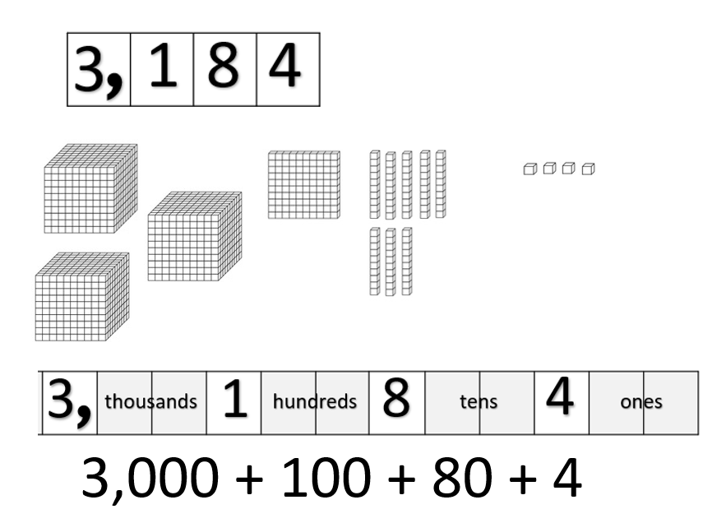
Once a number has been built in standard form, use the number expander to model how the same number can be built using various combinations of base ten blocks.
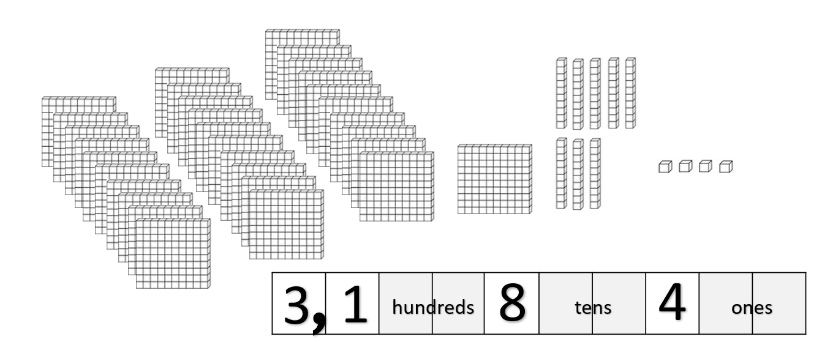
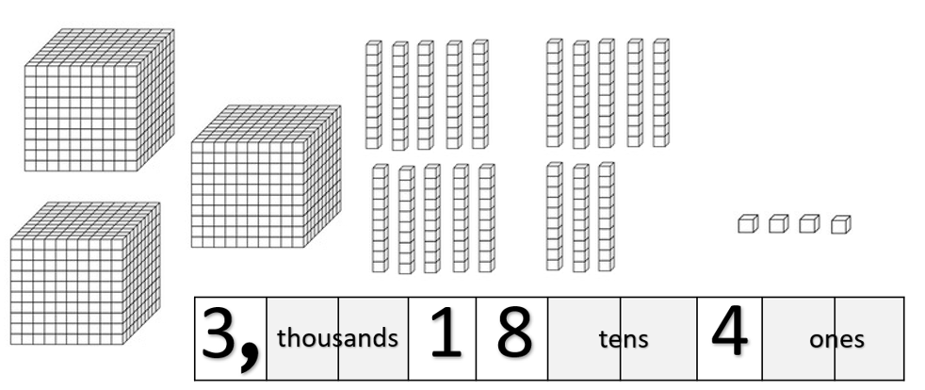
- Have students work in small groups to model four-digit numbers provided by the teacher. After a number has been modeled one way, encourage students to find another way to model the number. Groups may use the blank number expanders to assist if they are struggling to find more than one way to model the numbers.
- Next, explain to students that they will be exploring place value through the hundred-thousand place, using place value mats. Continue to discuss the value of each digit within a six-digit number. For example, in the number 165,724 the 6 represents 6 ten thousands with a value of 60,000. Model that 165,724 can be written in expanded form as 100,000 + 60,000 + 5,000 + 700 + 20 + 4.
- Assemble students into groups of six, and have each group member put on a place value headband. Give each group a set of 24 Digit Cards and a Place value mat, and have each group create six-digit numbers by randomly selecting a card and putting it in the correct places on the mat: the ones-place student draws a number and places it in the ones place; the tens-place student draws a number and places it in the tens place, and so forth. Have student teams create at least three to six numbers. After each six-digit number has been created, have each group member write it down in standard and expanded form and practice reading the number aloud to their group.
- When group work is finished, ask a representative from each group to share the group’s six-digit numbers with the class by reading them aloud. Have the class suggest ways to create greater or smaller numbers by moving the digits to different places.
Note: Use this activity throughout the unit to review place value through the hundred-thousand place.

Assessment

Questions
- Which digit holds the highest value in a six-digit number?
- What do you do when you do not have any tens in a number?
- What do you do when you do not have any hundred thousands in a number? How many digits would be in your number?
- Starting with the ones place, what are the place value spaces in order up to the hundred-thousand place?
- Where should the comma go when separating place-value digits?

Journal/writing prompts
- Explain how to determine the value of a digit in a number.
- Create the largest and smallest numbers that you can, using the numerals 1, 3, 5, 7, and 9. Explain why they are the largest and the smallest.
- Describe three different ways that you can model 1,462 with base ten blocks.

Other Assessments
  - Check for understanding by prompting students to find a mystery number. Announce randomly which numeral is in which place in the number, and have them write down the numerals in the correct order to create the mystery number
    - “The mystery number has a five in the hundreds place, a nine in the ten thousands place, a one in the tens place, a seven in the hundred thousand place, a three in the ones place, and a zero in the thousands place.”
    - “The mystery number has 2 thousands and 43 tens.”
- Tape a three- or four-digit number written on an index card on the back of each student. Have students attempt to discover their numbers by asking classmates “yes” and “no” questions about each digit (e.g., “Is the number in the tens place odd? Is the number in the ones place less than five? Greater than six?”) When students think they have figured out their numbers, have them write down the numbers and present them to the teacher for confirmation. Students who are incorrect must return to asking questions about their numbers.

Extensions and Connections (for all students)
- Have students practice reading larger numbers by reading numbers that indicate populations of various counties or cities or distances from one place to another.
- Have students demonstrate understanding of place value by changing numbers from standard form into expanded form, and from expanded form into standard form.
- Have students find a mystery number. Announce randomly which digit is in which place in the number, and have them write down the digit in the correct order to create the mystery number. For example, “The mystery number has a three in the ten thousands place, a one in the tens place, a two in the hundred-thousand place, a five in the ones place, and a seven in the thousands place. If all the digits have a sum of 22, what digit belongs in the hundreds place?”
- Split the students into two groups. Have each group create a number using the exact same digits for each place as the other team, except for one place. (One group could be given 123,456 and another group could be given 123,756.) As a class, discuss how much larger one number is than the other and why. “Team 2’s number is 300 more than Team 1’s number. How do we know?” This could be done many times using different numbers.
- Using adding machine tape or sentence strips, create a number line that starts at zero and skip counts by thousands (or any benchmark number) to a given number (e.g., 0–100,000).

Strategies for Differentiation
- Use place value mats to reinforce the concept of place values.
- Color code the place value mat to match the color of the headbands.
- If available, use multiple sets of base-10 blocks to create numbers larger than four digits so students can see the magnitude of the value of each place value.
- Use base-10 blocks to model place values for students who are not ready to move on to the numeral representations.

Note: The following pages are intended for classroom use for students as a visual aid to learning.

Virginia Department of Education ©2023

Place Value Mats

Hundred thousands | Ten thousands | Thousands | Hundreds | Tens | Ones

Hundred thousands | Ten thousands | Thousands | Hundreds | Tens | Ones

Hundred thousands | Ten thousands | Thousands | Hundreds | Tens | Ones

Digit Cards
Print on card stock, and cut apart on the dotted lines.
0 | 1 | 2 | 3 | 4 | 5 | 6 | 7
8 | 9 | 0 | 1 | 2 | 3 | 4 | 5
6 | 7 | 8 | 9 | 0 | 1 | 2 | 3
4 | 5 | 6 | 7 | 8 | 9 | 0 | 1
2 | 3 | 4 | 5 | 6 | 7 | 8 | 9
0 | 1 | 2 | 3 | 4 | 5 | 6 | 7
8 | 9 | 0 | 1 | 2 | 3 | 4 | 5
6 | 7 | 8 | 9 | 0 | 1 | 2 | 3
4 | 5 | 6 | 7 | 8 | 9 | 0 | 1
2 | 3 | 4 | 5 | 6 | 7 | 8 | 9

Place Value Expanders
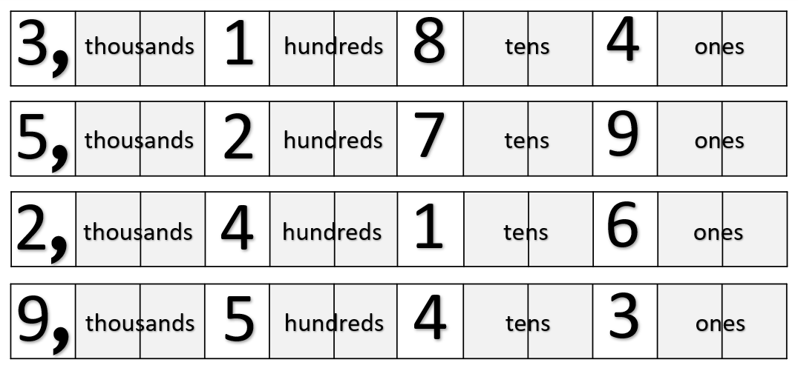
Blank Place Value Expanders