Mathematics Instructional Plan – Grade 3

Where Did the Time Go?
Strand: Measurement and Geometry
Topic: Determining elapsed time
Primary 2023 SOL: 3.MG.3 The student will demonstrate an understanding of the concept of time to the nearest minute and solve single-step contextual problems involving elapsed time in one-hour increments within a 12-hour period.
- Solve single-step contextual problems involving elapsed time in one-hour increments, within a 12-hour period (within a.m. or within p.m.) when given:
  - the starting time and the ending time, determine the amount of time that has elapsed;
  - the starting time and amount of elapsed time in one-hour increments, determine the ending time; or
  - the ending time and the amount of elapsed time in one-hour increments, determine the starting time.

Materials:
- Analog clock faces with moveable hands
- Where Did the Time Go? Recording Sheet (attached)
- Start and End Time Cards (attached)
- Interactive Bulletin Board (attached)
- Tic-Tac-Time Game Board (attached)
- Tic-Tac-Time Game Board Directions (attached)

Vocabulary:
a.m., p.m., analog clock, digital clock, elapsed time, half-hour, hour hand, hours, minute hand, minutes, quarter hour

Student/Teacher Actions: What should students be doing? What should teachers be doing?
- Using vocabulary cards, discuss equivalent times for minutes-hours and hours-days. Ask, “What happens to the time from the moment you get to school until you leave for home?” Describe elapsed time as an amount of time that passes between two given times. Using two demonstration clocks, set one clock to noon and the other clock to three o’clock. Ask students to name some things that often occur at school around noon and some things that occur around three o’clock. Ask, “What happens to the time?” between noon and three o’clock. Using the first demonstration clock, model how the time passes from noon until three o’clock. Ask students to count the hours that are passing as you turn the hands. Tell students that three hours is the elapsed time between noon and three.
- Distribute the Where Did the Time Go? Recording Sheet and analog clock faces with moveable hands. Group students into pairs, and give each pair a set of Start and End Time Cards. Have partners use the process modeled in step 1 to determine the elapsed time between the start and end times on each pair of cards. After students set the two times on their clock faces, make sure they are advancing the hands of the start time clock and counting the hours that pass until the clock reaches the time of the end time clock. Direct students to record their work on the recording sheet.
- Once students have completed the Where Did the Time Go? Recording Sheet, ask, “Why is it important to understand elapsed time?” “When do you use elapsed time in your daily life?” Discuss students’ answers.

Assessment

Questions
  - If you eat breakfast at 8 a.m. and you eat lunch at 11 a.m., what is the elapsed time between the two meals?
  - If a movie starts at 3:20 p.m. and it lasts for two hours, what time will it end?
  - If you arrive at an amusement park at 7 a.m., and stay for four hours, what time will you be leaving the park?
  - If it begins to rain at 5:45 p.m. and it continues to rain for six hours, what time did the rain stop?
  - I finished reading my chapter book at 6 p.m. and I read for three hours. What time did I begin reading my book?

Journal/writing prompts
  - Explain in detail how you count the hours to determine the elapsed time between a start time and an end time.
  - Look at several TV listings in a newspaper, and select a favorite show. Write the start time and end time of the show, and determine the elapsed time between the two.
  - If you watch a movie that is two hours long and the movie ends at 4 p.m., can you explain how you would figure out what time the movie began?

Other Assessments
  - Create an interactive bulletin board in the classroom, as shown on the attached Interactive Bulletin Board sheet. The clock faces will need to be laminated or placed in plastic sleeves so that students will be able to draw hands on them and then erase the hands. In the middle section, the teacher will change the elapsed time daily or even during the day. Students will be given a digital start time or end time written on the board. A student will go to the bulletin board and record the analog time on the start or end time clock face by drawing the hands. The student will then check the elapsed time and determine the start or end time to draw on the clock face. (Note: A geared clock needs to be available for students’ use at this bulletin board. Be careful when giving out start times and elapsed times; the end time should not cross over between a.m. and p.m.)

Extensions and Connections (for all students)
- Have students play the Tic-Tac-Time Game.

Strategies for Differentiation
- Allow students to use student clocks to count the elapsed hours when solving a problem.
- Students may use a number line labeled 1 to 12 as another representation of the hours, drawing “jumps” or “hops” as they count the hours. This would also be beneficial when given a starting or ending time and the elapsed number of hours, in order to find the subsequent time.

Note: The following pages are intended for classroom use for students as a visual aid to learning.

Virginia Department of Education ©2018 (Revised December 2023)

Where Did the Time Go? Recording Sheet
Name: ___________________________ Date: ____________________
Clock | Start Time | End Time | Elapsed Time
A | 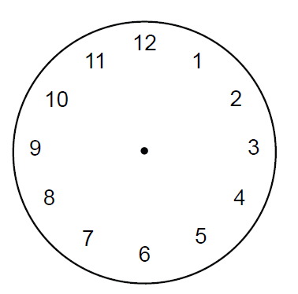
B
C
D
E

Start and End Time Cards
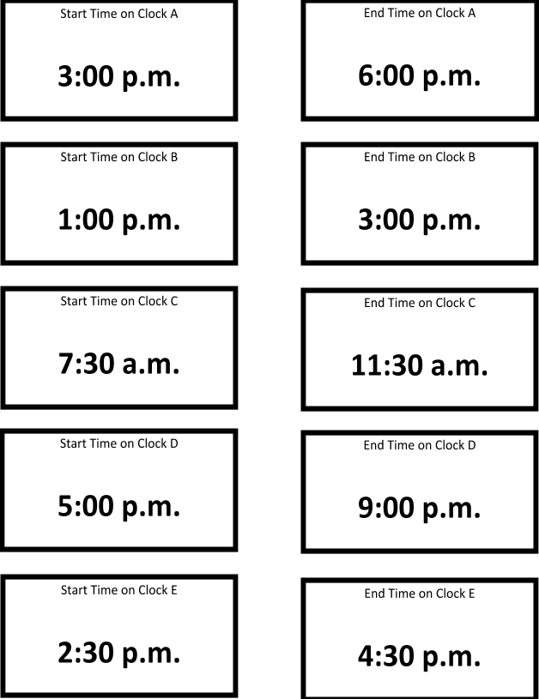

Interactive Bulletin Board
Name: Date:
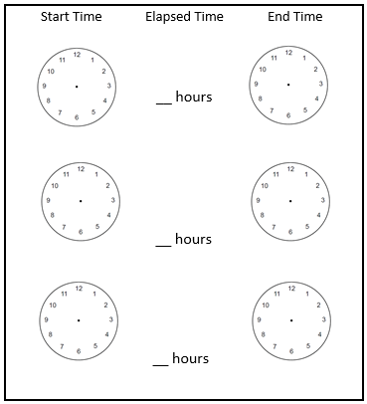
Tic-Tac-Time Game Board
Billy had a basketball game that started at 3:30 p.m. The game ended at 7:30 p.m. How long was the game? | Jackson gets to school at 8:05 a.m. The school day lasts for 3 hours. What time did his school day end? | Mrs. Stone arrives  to school at 7:45.  If she drives 1  hour to get to  school, what time  must she leave  her house?
Maggie began a bike race at 2:17 p.m. It took five hours to complete the race. At what time did Maggie finish the bike race? | Kevin finished his art project at 10:00 p.m. If he worked on his project for four hours, what time did he start the art project? | How long did John nap if he fell  asleep at 1:00 p.m. and woke up at  3:00 p.m.?
An airplane left the Newport News airport at 7:50 a.m. and traveled for four hours toward New York City. What time will the airplane land in New York City? | Cathy is making brownies. She started baking at 9:30 a.m. She finished baking at 11:30 a.m. How long did Cathy bake brownies? | A movie ended at 4:16 p.m. If the  movie lasts for 3  hours, what time  did the movie  start?

Tic-Tac-Time Game Board Directions
- Put students in pairs and distribute a Tic-Tac-Time Game Board to each pair.
- The students will then need to decide who will be “X” and who will be “O.” The first student will choose a box to answer. Once they have an answer, the partner will then check their work. If the student is correct, they may put their chosen symbol on that box. If the student is incorrect, their turn has ended, and they may not put a symbol in that box.
- The next student will take their turn by choosing any unmarked box to answer.
- The game continues until one student has answered three boxes in a row (vertically, horizontally, or diagonally) or if all squares have been answered. If all squares have been answered but neither player has answered three in a row, then the game would be considered a tie.

