Mathematics Instructional Plan – Grade 1

Comparing Numbers with Cubes and 10 Frames
Strand: Number and Number Sense
Topic: Comparing numbers between 0 and 120
Primary SOL: 1.NS.2 The student will represent, compare, and order quantities up to 120.
- Compare two numbers between 0 and 120 represented pictorially or with concrete objects using the terms greater than, less than, or equal to.

Related SOLs: 1.NS.2a, 1.NS.2c, 1.NS.2d, 1.NS.2f
Materials
- Linking cubes
- Two large paper plates or hula hoops
- 10 Frames (see attached)
- Partially Filled in 10 Frames (see attached)
- Math racks
- Counters

Vocabulary
ones, tens, compare, order, greater than, less than, equal to, least, greatest

Student/Teacher Actions: What should students be doing? What should teachers be doing?
- To model this activity, place two large circles (paper plates, hula hoops, etc.) on the floor. Gather students around the circles. Put seven linking cubes in one circle and two cubes in another circle. Compare the two sets by asking, “Which set has more? How do you know? How many more does this set have?” Prompt students to match what is the same in each set and count on the “extra” cubes to determine how many more are in that set if needed.
- Place six linking cubes in one circle and three linking cubes in another circle. Compare the two sets by asking, “Which set has less? How do you know? How many fewer does this set have? How many more would we need to add to this set to make it the same as the other one?”
- Place four linking cubes in one circle and four linking cubes in another circle. Ask questions such as, “Is the number of cubes in circle one greater than the number of cubes in circle two? Is the number of cubes in circle one less than the number of cubes in circle two? How can we compare the two circles?” Discuss the concept of equality by saying “we can use the phrase ‘equal to’ when the numbers are the same as each other.”
- Place nine linking cubes in circle one and five linking cubes in circle two. Ask students to think of ways to compare the linking cubes. If no student suggests putting the cubes together to form a tower, then ask, “Could we compare the linking cubes if we put the cubes together to make a tower?” Build the towers, then compare the two numbers using the terms greater than, less than, or equal to. Build several towers using different numbers.
- Ask, “What if I had two larger numbers, such as 12 and 18? Is there a better way to stack the cubes so that I do not have two tall towers?” Discuss place value and stacking the cubes into groups of tens and ones.
- Have the students build 12 and 18 by stacking cubes into groups of tens and ones. Using the place value representation, ask, “Which number is greater/less than? How do you know?” Repeat several times using different numbers and cubes.
- Model building 21 and 13. Ask the students to compare the two numbers. Show them how to represent these two numbers using mini ten frame models.
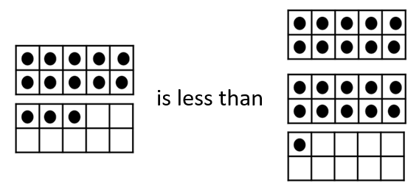
- Have students work in partners, with one partner naming and writing two two-digit numbers. The second partner will then build the two numbers with mini ten frames, and compare them using language such as, “___ is greater than ___, ___ is less than ___, or ___ is equal to ____.” Students should take turns switching roles for naming and writing the two-digit numbers and building and comparing the sets.
- Repeat several times using different numbers. Ask students to build representations of numbers with ten frames or cube stacks and circle or point to the amount that is greater or less than. As students are ready, model how to draw a picture of cube stacks, using sticks and dots to represent the tens and ones as in the model below comparing 13 and 21. (Note that first grade students need a lot of practice building and grouping by tens and ones and representing with sticks and dots is simply a way to draw a representation of cube stacks.)
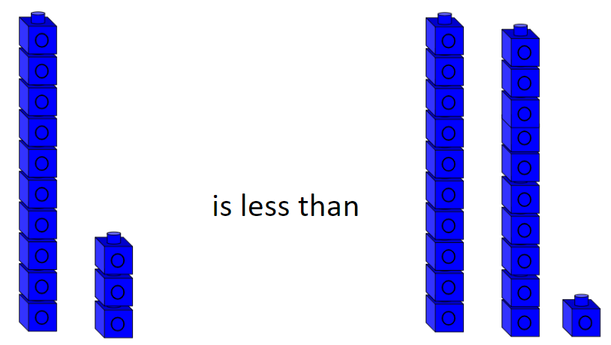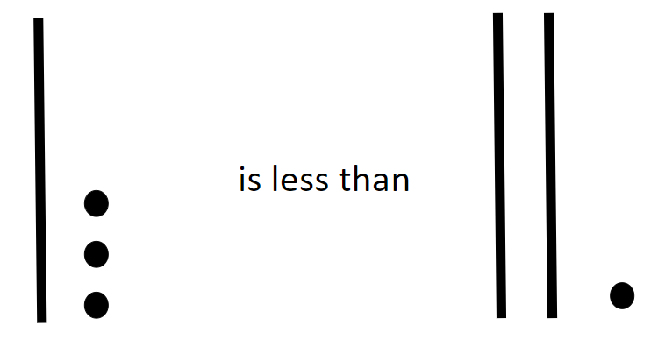

Assessment
- Questions
  - How does representing the numbers with a model or picture help you compare them?
  - How can you represent the number 30 with pictures?
  - Sam has 32 erasers. Dawn has 37. Who has more and how do you know?
- Journal/writing prompts
  - Write the numbers 34 and 43 in your journal. Represent each of these with cubes or pictorially. Compare and decide which is greater. Explain your thinking.
  - Write the following numbers in your journal: 27, 42, 36. Represent each and then write the numbers in order from greatest to least.
- Other Assessments
  - In small groups, have students practice building numbers using linking cubes, math racks, and/or mini ten frames. Have them practice representing their numbers concretely and then pictorially.
  - Observe as students move through the process of transitioning from the concrete to the representational drawings. Provide support, as needed.
Extensions and Connections (for all students)
- Add a third circle and a third number. Have students build each number using linking cubes or mini ten frames and compare the sets. Have students order the sets from the least to the greatest or greatest to least.
- Explore numbers that reach past the tens and into the hundreds. Build them in a variety of ways using linking cubes, math racks, or ten frames and counters. Show students how to represent these pictorially.
Strategies for Differentiation
- Set blocks up in ten frames for comparison.
- Have students use beans and cups to group tens and ones.
- Have students build the numbers in a variety of ways using linking cubes, math racks, or ten frames and counters.
Note: The following pages are intended for classroom use for students as a visual aid to learning.

Virginia Department of Education © 2018 (Revised December 2023)

10 Frame

Filled in 10 Frames
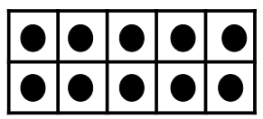

Partially Filled in 10 Frames
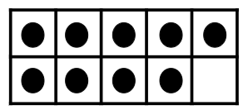
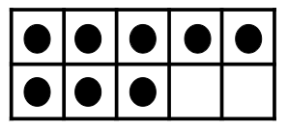
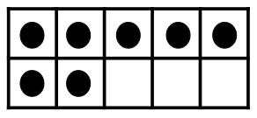
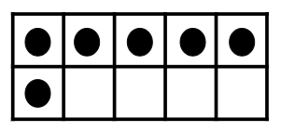
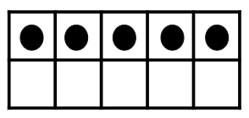
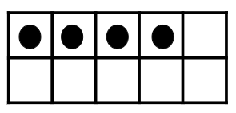

Partially Filled in 10 Frames
