Mathematics Instructional Plan – Kindergarten

Number Boards
Strand: Number and Number Sense
Topic: Recognize a numeral and/or a quantity up to 30
Primary SOL: K.NS.2 The student will identify, represent, and compare quantities up to 30.
Related SOL: K.NS.1

Materials
- One number board for each pair of students (several options for boards attached)
- Counters for covering the spaces (20 counters for each pair of students)

Vocabulary
count, number, numeral, set, zero (0), one (1), two (2), three (3), four (4), five (5), six (6), seven (7), eight (8), nine (9), ten (10), eleven (11), twelve (12), thirteen (13), fourteen (14), fifteen (15), sixteen (16), seventeen (17), eighteen (18), nineteen (19), twenty (20), twenty-one(21), twenty-two (22), twenty-three (23), twenty-four (24), twenty-five (25), twenty-six (26), twenty-seven (27), twenty-eight (28), twenty-nine (29), thirty (30), more, fewer, before, after, greater than, less than, equal to, same as

Student/Teacher Actions: What should students be doing? What should teachers be doing?
- Choose a number board for the day’s lesson. Each number board has two representations for the numbers from 1 to 10, 11 to 20, or 21 to 30. You will notice that some boards are all pictorial representations, some include dot arrangements, and some include numerals. Representations for the numbers on the number boards may vary to give students experience with thinking about the numbers in a variety of forms.
- Pass out a board and counters to each pair of students. Direct students to work with a partner to cover the spaces on a number board, based on clues given by the teacher. As you play, ask the following questions: How did you decide what to cover? Why is that space a good choice? Are there any other spaces you could cover? Begin by using simple clues. As number sense develops, the clues can become more complex. Examples of clues:
  - Cover a space that shows 4 (14, 24).
  - Cover the space that shows the same number as the ten frame card I am holding.
  - Cover the space that matches the number of fingers I am holding up.
  - Cover the number that comes right after 5. (Or cover the number that is one more than 5.)
  - Cover the number that comes right before 16.
  - Cover the number of legs that a puppy has.
  - Cover a space that shows a number greater than the card I am holding. (Teacher shows a picture of a ten frame or beaded rack).
- One number can be left uncovered for a quick check of accuracy at the end of the activity. “Which number is not covered on your board?”

Assessment

Questions
- How did you decide which number(s) to cover?
- How do you know what number comes after 25?
  - How do you know what number comes before 13?
  - What was the largest (greatest) number on the number board? Smallest (least) number?
  - Can you find two spaces on the number board that match? How do you know they match?

Journal/writing prompts
- Draw a set that shows 12.
  - Show what 5 looks like on a dot cube.

Other Assessments
- Observe students as they work. Who has difficulty finding the appropriate spaces to cover? Are they having difficulty with counting the pictured objects or recognizing numerals? What kinds of representations are easiest or most difficult? Are students subitizing or counting the various representations?

Extensions and Connections (for all students)
- Place the number boards at an independent workstation. Provide numeral cards, dot cards, or ten frame cards for students to use to generate the numbers to be covered.
- Make additional number boards for students to use.
- Instead of playing until all numbers are covered, play as a three-in-a-row or four-in-a-row game. Because there are two options for each number on the board, not all students will cover the same space during each turn.

Strategies for Differentiation
- For students who need to focus on a smaller range of numbers, create number boards focusing on one through three, one through five, etc.
- Use this activity as a small group teacher directed activity to be able to differentiate clues according to student needs.

Note: The following pages are intended for classroom use for students as a visual aid to learning.

Virginia Department of Education ©2018 (Revised December 2023)
Number Board 1
 | 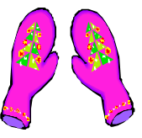 | 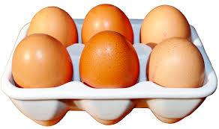
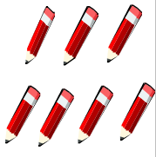 | 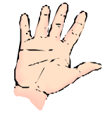
 |  | 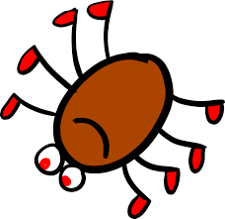
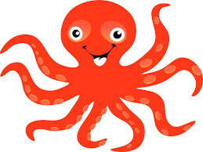 | 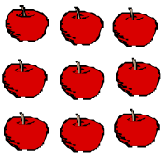 | 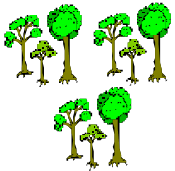

Number Board 2







☺☺
☺☺☺
☺☺☺

















8
7
6
5
3
2

Number Board 3
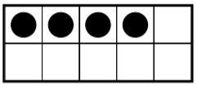 | 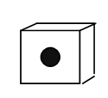 | 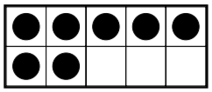 | 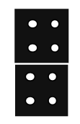
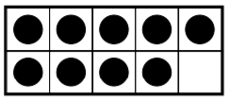 |  | 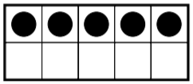 | 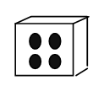
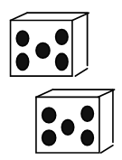 |  |  | 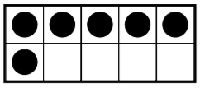
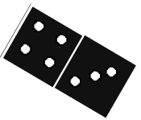 | 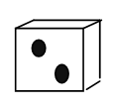 | 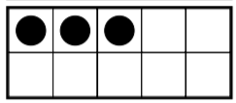
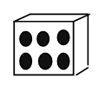 | 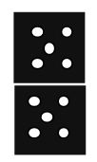 | 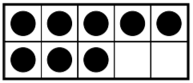 | 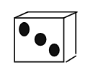

Number Board 4
12 | 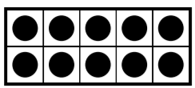  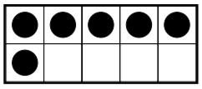 | 17 | 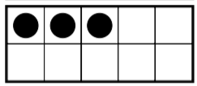
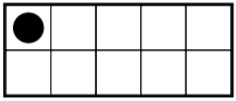 | 20 | 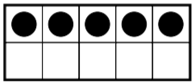 | 11
18 | 16 | 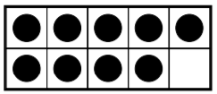 | 15
 | 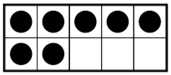 | 13 | 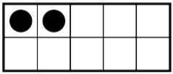
14 | 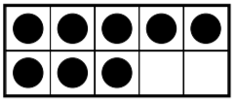 | 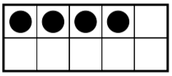 | 19

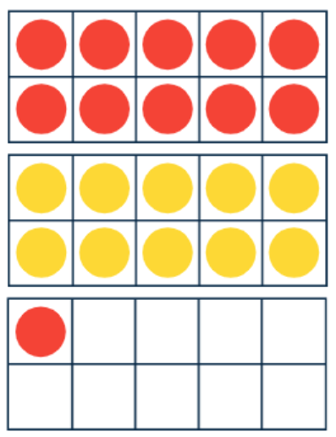
Number Board 5
22 |  | 27 | 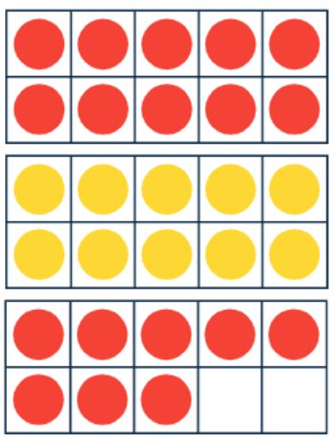
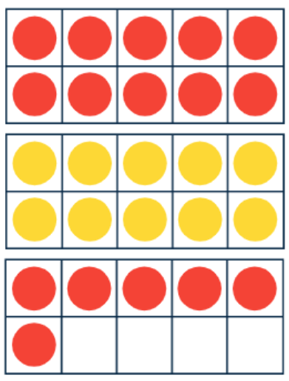 | 30 | 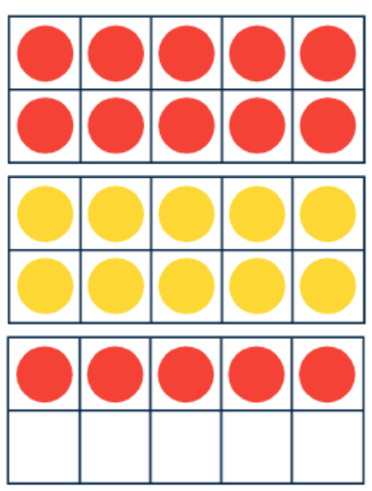 | 21
28 | 26 | 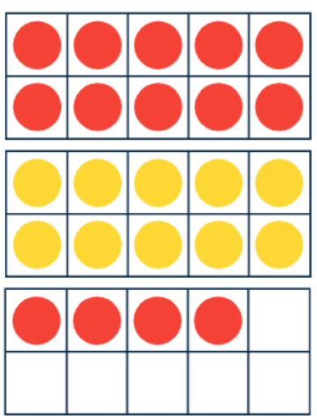 | 25
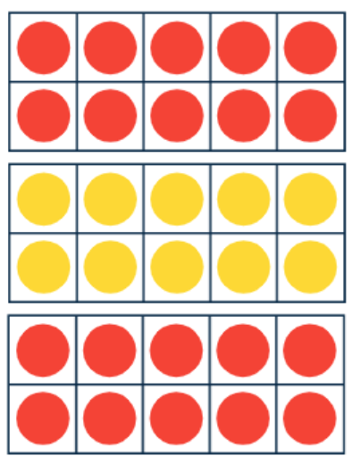 | 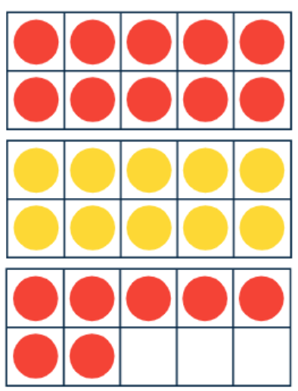 | 23 | 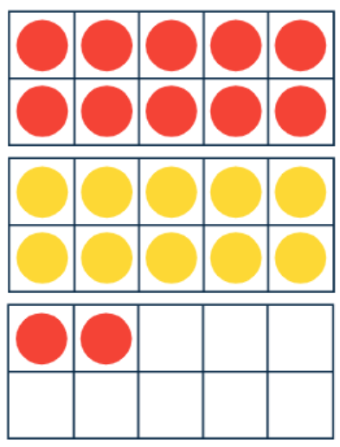
24 | 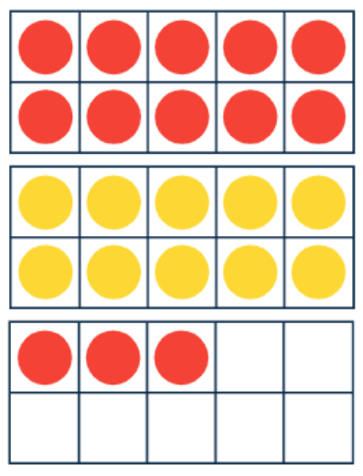 | 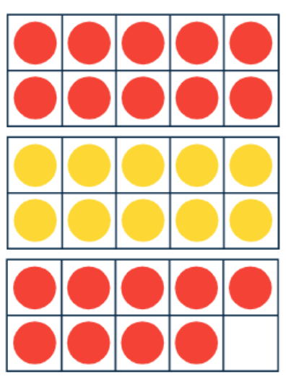 | 29

Number Board 6
21 | 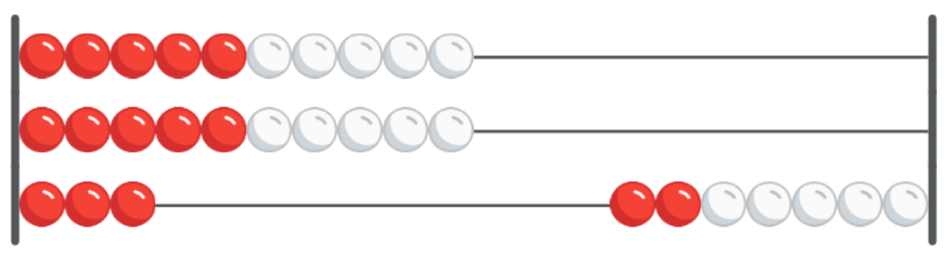 | 26 | 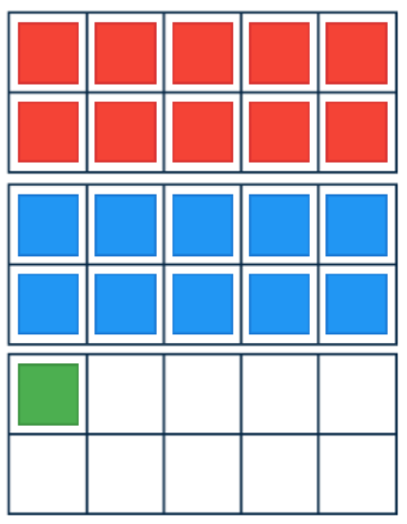
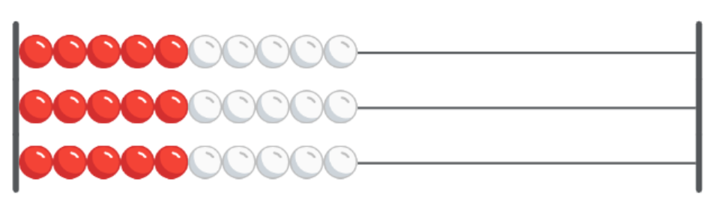 | 29 | 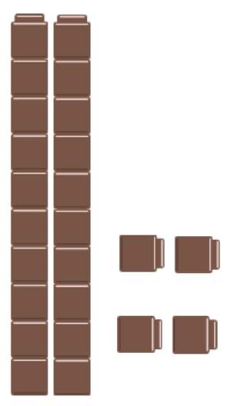 | 30
27 | 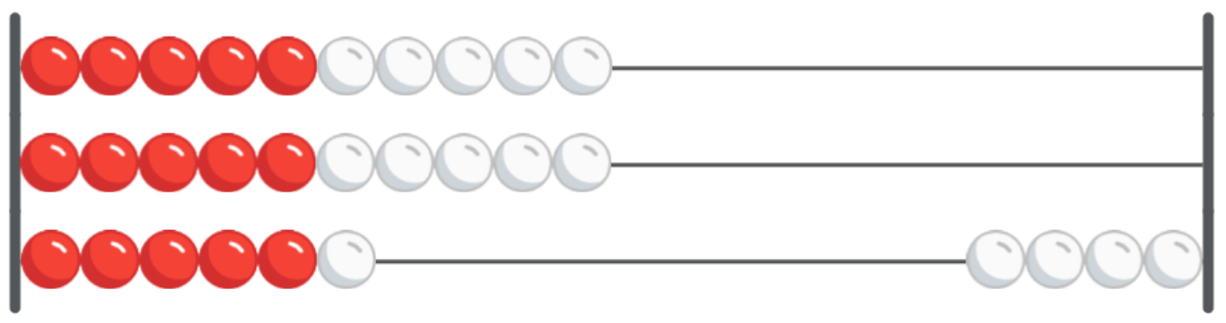 | 25 | 24
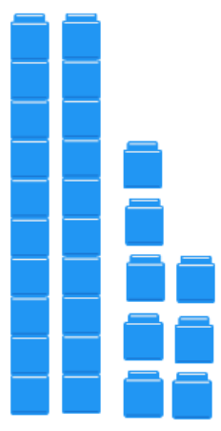 | 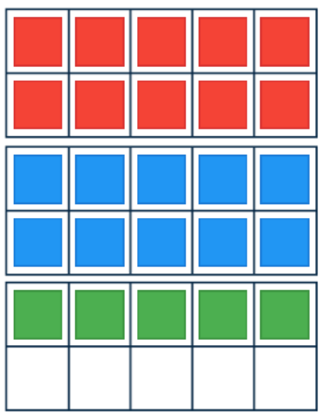 | 22 | 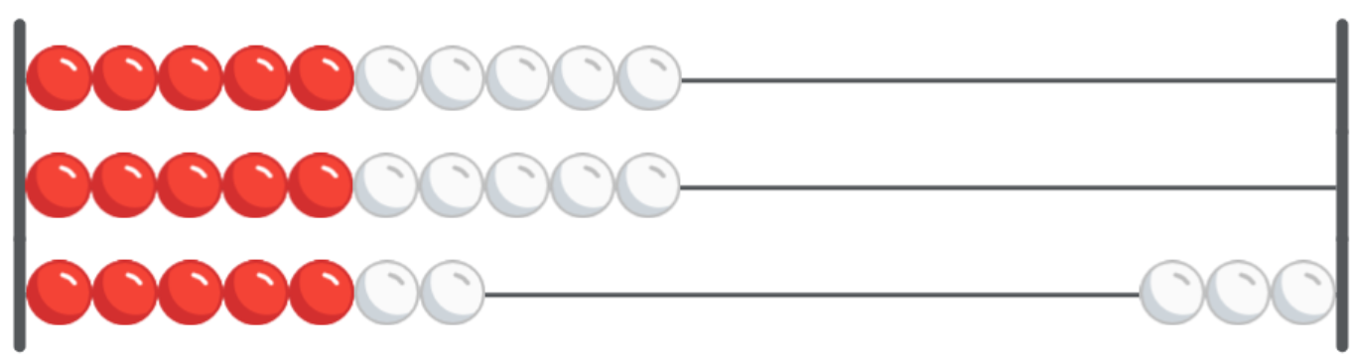
23 | 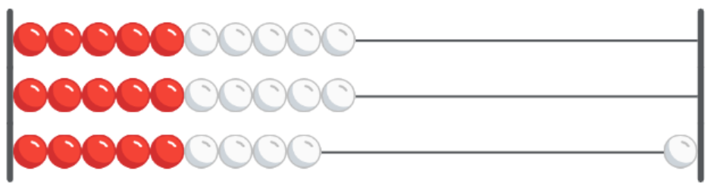 | 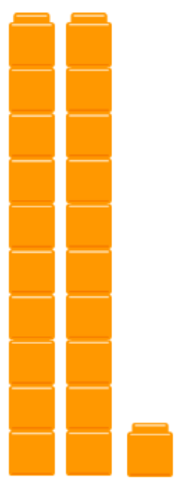 | 28

