The Virginia School Survey of
Climate and Working Conditions
Survey Administration Instructions

The Virginia School Survey of
Climate and Working Conditions
Survey Administration Instructions

Table of Contents
Overview of the Survey 3
Who: 4
How: 4
Participation: 5
Reports: 5
School Instructions for the Student Administration 6
Template for parent/guardian notification letter: 7
Student Survey Administration Manual: 8
School Instructions for the Classroom Instructors and Staff Administration 10
Template for the Classroom Instructors and Staff Information Letter 12
Frequently Asked Questions 13

Overview of the Survey
The Virginia School Survey of Climate and Working Conditions (Virginia School Survey) is being conducted through a partnership between the Virginia Center for School and Campus Safety at the Virginia Department of Criminal Justice Services (DCJS) and the Virginia Department of Education (VDOE). Participating in this survey fulfills one component of the annual school safety audit as well as the requirement that your school participate in a survey of the working conditions. This survey assesses school safety conditions and safety concerns, engagement and relationships, school supports, and the teaching and learning environment.
Figure 1. Survey administration process for the Virginia School Survey.

Who
Students: The VSS is administered biannually, rotating between middle and high school students. This will typically look like all students in grades 6, 7, and 8 taking the survey in odd years, and all students in grades 9, 10, 11, and 12 taking the survey in even years. All students should be provided an opportunity to complete the survey so that your school will have information about the school’s climate from as many students as possible. When reasonable accommodations are needed for students to take the survey, they should be provided. A read-aloud administration manual can be found on the DCJS and VDOE websites. Students have the option to take the survey in English or Spanish, so students identified as having Limited English Proficiency but who speak Spanish should not be excluded from taking the survey. Please work with personnel in your school or division if you wish to administer the survey in a language other than English or Spanish.
Adults: All licensed classroom instructors and any other individual holding a state professional license (such as those with a Collegiate Professional License, Postgraduate License, Provisional License, or Pupil Personnel Services License) in participating schools, regardless of grade levels served by the individual, must be invited to take the survey. Staff in schools serving students in grades 9, 10, 11, and 12 will participate during even years with the students in those grade levels. In odd years, all other staff in Virginia will participate. All licensed personnel should be provided an opportunity to complete the survey so that your school will have information about the school’s working conditions from as many personnel as possible. You also may invite other non-licensed staff members to complete the survey. Providing the survey to all staff members helps ensure that all the results represent the full scope of climate and working conditions in your school.
The adult survey will be separated into two groups: classroom instructors and staff. “Classroom Instructors” refers to all teachers, teacher aides and paraprofessionals that are directly responsible for instruction on a daily basis. “Staff” refers to all other licensed and non-licensed individuals.

How
All surveys will be completed online through a secure website and can be completed while on any internet-connected device (e.g., computer, cell phone, tablet, etc.). You will provide each student, classroom instructor, and staff member with a school-specific access code to begin the survey. The access codes will be emailed to the school point-of-contact the week before the survey window opens. Please note that there are separate access codes for students and the adults in your school. The access codes do not identify individuals but will identify the school as a whole. We expect the student survey will require 25–30 minutes to complete; and the classroom instructors and staff surveys will require 20–25 minutes to complete.
A minimum of 30-days prior to survey administration, provide parents of students in participating grades the information found in the letter template. Students should take the survey in a quiet space. It is important for a staff member to monitor students while they are taking the survey to ensure students do not confer with one another and to answer any questions that may arise. The adult administering the survey to students should review the Student Survey Administration Manual. which describes the survey process, prior to providing students the link and access code for the survey.
Prior to survey administration, provide staff the information found in the letter template which invites them to participate in the survey. The survey can be taken in a small group setting or individually, but participants should be advised not to confer with one another. Send reminders to your classroom instructors and staff members about the survey throughout the survey window to encourage participation.

Participation
Parents or guardians may withdraw permission for their student to complete the survey. Provide all parents and guardians of students in participating grades with the information contained in the letter template informing them that their child will be asked to participate in the survey. A Spanish version of the template can be found on the DCJS and VDOE websites. Due to the inclusion of student mental health-related questions, schools are required, at a minimum, to notify parents or guardians of this survey at least 30 days in advance of the administration and provide a process for opting their students out of the survey. This notification is required by the Code of Virginia § 22.1-79.3. Please also include your school or division’s standard opt-out procedure in the informational letter, so that parents can exempt their child from participating in the survey.
The higher your school’s response rate, the more likely the results of the survey will reflect the opinions of all students, classroom instructors, and staff in your school. An 80% response rate is the goal for each group participating. Reports will not be generated for survey groups with response rates less than 50% and/or fewer than 10 respondents.

Reports
Each school will receive Item Level and Measure Level Reports, if their response rates meet the indicated threshold previously mentioned. Your division point-of-contact will need to download these reports and share them with you near the end of the school year. The Item Level Report provides item-level responses aggregated across all individuals (e.g., the percent selecting “Strongly Disagree”, the percent selecting “Disagree”, etc.). Measure Level Reports present the school’s scores on the surveys’ measures of climate and working conditions. The Measure Level Report will facilitate comparisons to other schools in the division, region, and state.

School Instructions for the Student Administration
- Provide information to the parents and guardians of each student in participating grades informing them that students in their child’s grade are participating in the survey. We recommend you use the Template for the Parent/Guardian Information Letter (Spanish version can be found on the DCJS and VDOE websites). Please ensure that parents or guardians have been notified at least 30 days in advance of your planned administration time frame. They also must be provided instructions for opting their students out of the survey following your division opt-out protocol.

- The survey asks questions about mental health topics to include suicide. It is recommended that you provide additional suicide awareness programming to students and staff during the survey window. Resources can be found on the DCJS and VDOE websites.

- All students should be given equal opportunity to participate in the survey. Provide reasonable accommodations as needed for students to take the survey. Students should not be excluded on any systematic basis, such as excluding those students with low grades or disciplinary issues.

- Provide the Student Survey Administration Manual of this document, to all individuals administering the survey to students. A read-aloud administration manual can be found on the DCJS and VDOE websites.

- Provide the link and your school’s access code to all students in participating grades when ready to administer the survey.

- Questions or concerns regarding the Virginia School Survey of Climate and Working Conditions should be directed to vaschoolsurvey@dcjs.virginia.gov.

Template for Parent/Guardian Notification Letter
PRINCIPALS/POINTS-OF-CONTACT: Below is an example of the informational letter to provide to the parents and guardians of all students in participating grades, at least 30 days prior to the survey administration. When you prepare these communications:
- Be sure to specify the date and process by which parents and guardians may decline to have their child participate if they choose to opt their child out of the survey.
- Share with parents and guardians any accompanying training their students will receive around bullying, suicide prevention, and other related topics. Feel free to reference any of the resources available here: https://tinyurl.com/MentalHealthdcjs or https://tinyurl.com/VDOEstudentservices.

Dear Parent or Guardian,

Our school, in cooperation with the Virginia Department of Criminal Justice Services and the Virginia Department of Education, is conducting the Virginia School Survey of Climate and Working Conditions. We will survey students in grades {9, 10, 11 and 12}, as well as classroom instructors and staff, beginning in January 2024. The purpose of the student survey is to measure student support, student engagement, school discipline, and safety conditions in each school. This information will be used to guide educational practices that produce a safe and supportive school environment.

The student survey will be completed between {DATE and DATE}. The survey does not ask for your child’s name and all answers are anonymous. No one, including teachers and administrators, will know how your child answered the survey questions. You will not have access to your child’s survey answers. You may preview the questions asked in the student survey at this website: https://tinyurl.com/VaSchoolSurvey.

The survey will ask questions such as how students feel about their school, how students get along with one another and their teachers, how students feel about school rules, and their perceptions of their teachers’ willingness to help them. Please note that there are questions about topics that may be sensitive to some, including questions about bullying, mental health, and suicide. This is a great time to talk to your child about these important issues. For guidance and more resources on these topics, please see https://tinyurl.com/MentalHealthdcjs or https://tinyurl.com/VDOEstudentservices.

All students in your child’s grade level are eligible to participate in the survey. The survey is voluntary and you and/or your child can decide they prefer not to participate. No action will be taken against you, your child, or the school if your child does not participate. If you do not wish for your child to participate, {please notify the school office by telephone, email or letter by DATE}.

The Virginia School Survey results are provided to the school around the end of the school year. You can find survey results for your school and division here: https://tinyurl.com/VaSchoolSurvey. The results are used by the school, the division, and the state to identify strengths and to address relevant needs to improve learning environments for your child as well as students across the state.

Thank you for your cooperation in this important study of Virginia’s schools.

{Signed by principal}

Student Survey Administration Manual
Thank you for assisting in the administration of the Virginia School Survey of Climate and Working Conditions. It is intended to give schools information that can help maintain a safe, inviting, and supportive learning environment.
Please communicate to students that this survey is an effort to include their views and opinions to improve their school. Students should also trust that this survey is truly anonymous. No one from the school, survey team, or even their parents can find their individual answers.
What is the procedure for students to complete the survey? The survey should be administered in a quiet space where students can be monitored. Each student should use a separate internet-accessed device to complete their own survey.
The staff member administering the survey should encourage students to complete the survey honestly and to the best of their ability and should also inform students not to discuss or talk with one another while taking the survey. The survey should take 25–30 minutes to complete.
How do I administer the survey with a read-aloud accommodation? A read-aloud administration manual can be DCJS and VDOE websites. There is no audio recording of the survey, however the survey can be read to any and all students regardless of educational plan status.
How do I prepare for and administer the survey? We recommend that you place the information that students need ahead of time, including the survey link, the school’s access code for students, and the school and division information where students can easily access it, such as on the board.
Your school’s survey link and access code will be emailed to the school point-of-contact the week before the survey opens. Please note that the student access code must end in an “S”. If your code does not have this marker, please contact your DCJS point of contact. Students must enter this access code to complete the survey. All students in your school will use the same access code. Students will be asked to confirm the name of their school and division to ensure their responses are collected correctly.
Be sure to review the following instructions with all students. These instructions also appear on the welcome page of the survey. Text in bold and italics is the narrative you should read aloud as students begin the survey.

SAY: “You may take the survey in English or Spanish. Select English or Spanish from the menu displayed on your screen. The chosen language will be displayed for the entirety of the survey and cannot be changed.”
Students should see the following screen.

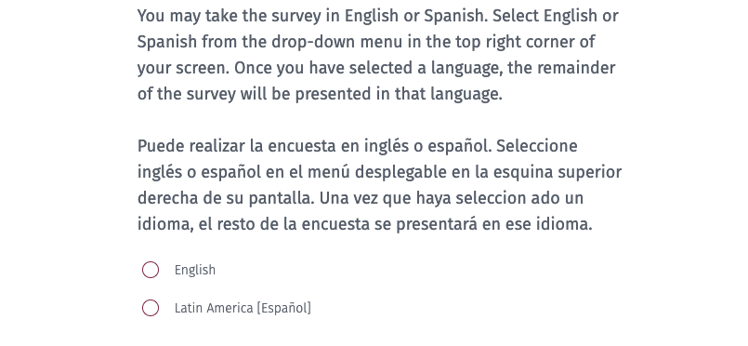
SAY: “Take a moment to read the information on the screen. Once you finished reading, please select the maroon box in the bottom left corner (or continue scrolling) to move forward.”
Students should see the following screen.
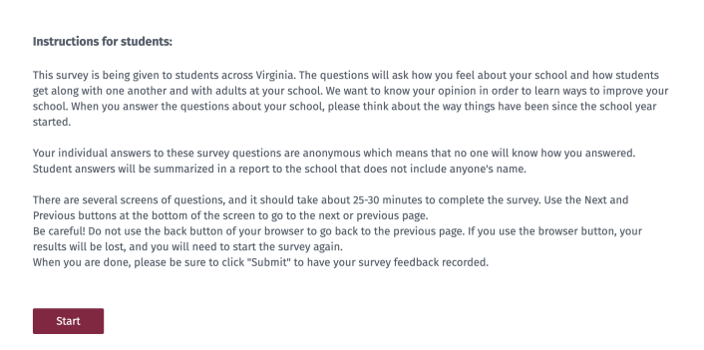

SAY: “The access code is _ _ _ _ _S then select the maroon box that says Next.”
Please write the access code given to you somewhere the students can easily see it. Students should see the following screen.
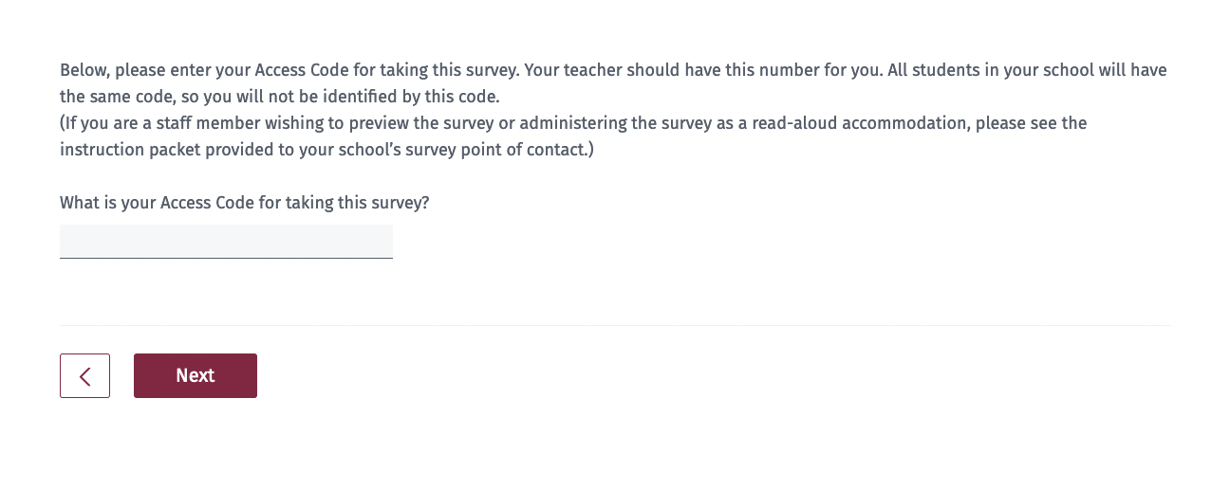
SAY: “You should see our division and school name. If the division and school name are not correct, please raise your hand.” (pause) “If this information is correct, please select ‘Yes’ from the menu displayed and then select ‘Next’ to begin the survey. Remember to answer each question honestly and to the best of your ability.”
If the division and/or school name are not correct, have the student select ‘No,’ and assist them with selecting the correct information.

What kind of help can I give to students in taking the survey? You are free to help students who do not understand survey instructions or who need clarification of a term or phrase used in the survey. Encourage students to express their own views and to answer all of the questions. If students attempt to skip a question, the survey will not permit them to continue to the next page. Students should be instructed to answer each question to their best ability.
Is the survey the same for all students? Almost all of the questions are the same for all students. In a few cases, a student who answers one question in a certain way will be asked a follow-up question that will not be asked if a student gives a different answer.
What if students ask about the race and ethnicity questions? Following standard practice, there is a question asking students whether they are of Hispanic or Latino ethnic background (Hispanic and Latino are intended to be interchangeable terms). Some students are unfamiliar with this distinction and may be concerned that there is a separate question about being Hispanic. It is appropriate to explain to students that these questions are following federal guidelines to recognize that people of different races can be Hispanic. Subsequently, they will be asked a question that allows them to report their race.
What if students ask about the gender question? The question that asks students to report their gender provides students with more flexibility in their response to this question. Encourage the students to select the option that best describes their gender.
Questions or concerns regarding the Virginia School Survey of Climate and Working Conditions should be directed to VAschoolsurvey@dcjs.virginia.gov.

School Instructions for the Classroom Instructors and Staff Administration
- You must invite all licensed individuals to complete the survey this includes individuals holding a Collegiate Professional License, Postgraduate Professional License, Provisional License, or Pupil Personnel Services License. You may also invite other non-licensed staff members to complete the survey. Inviting all personnel will provide you with the most accurate picture of your school’s climate and working conditions. Use the Template for the Classroom Instructors and Staff Information Letter to inform staff of the upcoming survey. We recommend you do so at least two weeks prior to your administration window and share with your employees the reasons why completing the survey benefits your school.

- During the administration window, send regular reminders to your classroom instructors and staff members to complete the survey. Be sure to include in these reminders the survey link and the access code they need to complete the survey. The survey code for employees should end in an “A”. If it does not, please contact your DCJS point of contact. We recommend dedicating time for classroom instructors and staff members to take the survey, such as the beginning of a staff meeting, but please consider your building’s bandwidth capabilities.

- Questions or concerns regarding the Virginia School Survey of Climate and Working Conditions should be directed to VAschoolsurvey@dcjs.virginia.gov.

Template for the Classroom Instructors and Staff Information Letter
Principals/Points-of-contact: Please provide the following information to all licensed classroom instructors as well as any other individuals holding a state professional license. Be sure to send it to other non-licensed staff members, if you are inviting them to take the survey. Be sure to specify the survey window dates. Please remind your classroom instructors and staff members periodically about the survey to ensure you meet the required response rates.
Dear Staff Member,
Our school, in cooperation with the Virginia Department of Criminal Justice Services and Virginia Department of Education, is conducting the Virginia School Survey of Climate and Working Conditions. We will survey all staff beginning in early 2024. Additionally, we will survey all students in {grades 9, 10, 11, and 12}, Instructions for the student survey will be forthcoming. The purpose of the survey is to measure school-level working conditions and climate, which have shown to impact staff retention as well as student educational outcomes.
All staff are asked to participate in the Virginia School Survey, regardless of what grade levels they serve. The survey can be completed on any internet-connected device (e.g., computer, cell phone, tablet, etc.) between {DATE and DATE}.
Participants will not give their names on the survey and all answers are anonymous. While you will be asked to identify your role in the school, your answers will not be reported by role within our school or division results.
The survey asks questions about staff collegiality, work environment, teaching and instruction, student supports, professional development, relationships with students and their families, teacher agency, school leadership, well-being and burnout, and safety.
Participants will be able to view the reports for the school, division, and state toward the end of the school year. This survey will help us ensure all students and staff have access to a safe, healthy, and positive environment in which to learn, work, interact, and grow.
Thank you for your cooperation in this important study of Virginia’s schools.

{Signed by principal}

Frequently Asked Questions
1. Who should complete the Virginia School Survey? In 2024, all students in grades 9 through 12 as well as all licensed individuals in these schools (such as those with a Collegiate Professional License, Postgraduate License, Provisional License, or Pupil Personnel Services License), regardless of what grades they serve, must be invited to take the survey. You may also invite other non-licensed staff members to complete the survey. Non-licensed staff members contribute to and experience their school climate and working conditions and it may benefit your school to include and understand their perspectives.
2. How will the survey be administered? All surveys will be completed online through a secure website. You will provide each participant with a link and a school-specific access code to begin the survey. The access codes will be emailed to the school point-of-contact in early January. The access codes do not identify individuals but will identify the school, do not share access codes between schools.
3. How long will the survey take? We expect the student survey will require 25–30 minutes to complete and the classroom instructors and staff surveys will require 20–25 minutes to complete.
4. How did you come up with this survey and why is it that long? Survey questions are based largely on nationally recognized measures of school climate and working conditions. The topics were primarily selected to meet the requirements set forth in the Code of Virginia and in other legislation. The Virginia School Survey Team selected well-established survey items that are valid and reliable based on existing research – that is, if the questions accurately measure what we expect them to measure consistently over time. Additionally, we analyze the data after each administration to ensure the questions continue to be relevant and meet these best practices each year. We chose the best number of questions that represent a key measure, like relationships among students or teacher agency. According to survey best practices, there should be, at minimum, three questions to represent a measure. Ensuring the integrity of our survey practices is critical to providing the most accurate and informative data to schools, divisions, and leaders in the Commonwealth.
5. How do I contact students and parents/guardians about the survey? Provide all parents and guardians of students in participating grades with the information contained in the letter template informing them that their child will be asked to participate in the survey. Please ensure that parents or guardians have been notified of the survey at least 30 days in advance of your planned administration time frame. This notification should also include instructions for parents to opt their students out of the survey following your division’s opt-out procedures. A Spanish version of the template can be found on the DCJS and VDOE websites.
6. How do I contact classroom instructors and staff members to invite their participation? Give staff the information found in the letter template. This letter invites them to participate in the survey. Also, consider sharing the reasons why this survey is important to your school, and any accompanying safety and/or mental health training.
7. How do students, staff members, and classroom instructors access the survey? You will provide each participant with a link to the survey as well as a school-specific access code to begin the survey. The link and access codes for your school will be provided via email to the school point-of-contact. Do not use an access code for a different school. The access code for students should end with an “S” while the access code for adults should end with an “A”. If you do not have the proper access codes, please contact your DCJS point of contact. The adult administering the survey to students should utilize the Student Survey Administration Manual.
8. What if a student is absent on the day the survey is administered? Students who are absent can take the survey if they return to school before the survey window closes. Providing an additional opportunity for absent students to take the survey is encouraged so that your school’s survey results reflect the experiences of as many students as possible.
9. What can I do to encourage staff participation on the survey? The greater the response rate, the more complete your results will be. Communicate the value of survey results to all staff. Also, dedicate time to take the survey during the workday, such as at the beginning of a staff meeting. It is essential, throughout your school’s survey window, to regularly remind and encourage your staff to complete the survey so that you can achieve a high response rate.
10. What response rate should I achieve? An 80% response rate is the goal for each group participating (students, classroom instructors and staff). Item Level and Measure Level Reports will not be generated for survey groups with response rates less than 50% and fewer than 10 respondents. Your division and school point-of-contact will have access to near real-time response rates for your school.
11. What results will I receive? Each school will receive an Item Level and a Measure Level Report, if their response rates meet the previously indicated thresholds. The Item Level Report provides item-level responses aggregated across all individuals (e.g., the percent selecting “Strongly Disagree”, the percent selecting “Disagree”, etc.). Measure Level Report presents the school’s scores on the surveys’ measures of climate and working conditions.
12. When will I receive the results of the survey? Near the end of the school year, each school meeting a response rate of at least 50% per survey group and the number of responses is 10 or greater will receive an Item Level and a Measure Level Report.
13. How will I receive the results of the survey? Your division point-of-contact will need to download these reports and share them with you.
14. What if I have other questions? Questions or concerns regarding the Virginia School Survey of Climate and Working Conditions should be directed to VAschoolsurvey@dcjs.virginia.gov.

