The Virginia School Survey of Climate and Working Conditions
Read-aloud Administration Manual

Thank you for assisting in the administration of the Virginia School Survey of Climate and Working Conditions (Virginia School Survey or “VSS”) to your students. This survey provides schools with information that can help maintain a safe, inviting, and supportive learning environment.
The administration of the survey is important to engaging students and in obtaining valid results. Please communicate to students that this survey is an effort to include their views and opinions to improve their school.
The purpose of this document is to provide you with the tools you need to conduct a read-aloud administration of the Virginia School Survey. Below are a series of questions and answers that can help you to prepare to administer the survey to any students requiring this accommodation. Following this section is the read-aloud protocol that you should use to administer the survey.
Questions or concerns regarding the Virginia School Survey of Climate and Working Conditions should be directed to vaschoolsurvey@dcjs.virginia.gov or (804) 786-3923.

Administration FAQ:
What is the procedure for students to complete the survey?
The survey should be administered in a quiet space where students can be monitored. Each student should use a separate internet-accessed device to complete their own survey.
The staff member administering the survey should encourage students to complete the survey honestly and to the best of their ability and should also inform students not to discuss or talk with one another while taking the survey. The survey should take 25–30 minutes to complete.
How do I prepare for and administer the survey?
We recommend that you place the information that students need ahead of time, including the survey link, the school’s access code for students, and the school and division information where students can easily access it, such as on the board.
Your school’s survey link and access code will be emailed to the school point-of-contact the week before the survey opens. Please note that the student access code must end in an “S”. If your code does not have this marker, please contact your DCJS point of contact. Students must enter this access code to complete the survey. All students in your school will use the same access code. Students will be asked to confirm the name of their school and division to ensure their responses are collected correctly.
Be sure to review the following instructions with all students. These instructions also appear on the welcome page of the survey. Text in bold and italics is the narrative you should read aloud as students begin the survey.
What kind of help can I give to students in taking the survey?
You are free to help students who do not understand survey instructions or who need clarification of a term or phrase used in the survey. Encourage students to express their own views and to answer all of the questions. If students attempt to skip a question, the survey will not permit them to continue to the next page. Students should be instructed to answer each question to their best ability.

Is the survey the same for all students?
Almost all of the questions are the same for all students. In a few cases, a student who answers one question in a certain way will be asked a follow-up question that will not be asked if a student gives a different answer.
What if students ask about the race and ethnicity questions?
Following standard practice, there is a question asking students whether they are of Hispanic or Latino ethnic background (Hispanic and Latino are intended to be interchangeable terms). Some students are unfamiliar with this distinction and may be concerned that there is a separate question about being Hispanic. It is appropriate to explain to students that these questions are following federal guidelines to recognize that people of different races can be Hispanic. Subsequently, they will be asked a question that allows them to report their race.
What if students ask about the gender question?
The question that asks students to report their gender provides students with more flexibility in their response to this question. Encourage the students to select the option that best describes their gender.

Instructions for staff administering this survey as a read-aloud accommodation:
The text in bold italics is the narrative you should read aloud as students begin the survey. The text in italics provides instructions to the reader and those should not be read aloud to the students. The narrative corresponds to the survey text from the Virginia School Survey.
SAY: This survey is being given to students across Virginia. The questions will ask how you feel about your school and how students get along with one another and with adults at your school. We want to know your opinion to learn ways to improve your school. When you answer the questions about your school, please think about the way things have been since this school year started.
Your individual answers to these survey questions are anonymous. No one will know how you answered. Student answers will be summarized in a report to the school that does not include any names.
You will see several screens of questions, and it should take about 25–30 minutes to complete the survey. Use the “Next” and “<” buttons at the bottom of the screen Ito go to the next or previous page.
Be careful! Do not use the back button of your browser to go back to the previous page. If you use the browser button, your results will be lost, and you will need to start the survey again.

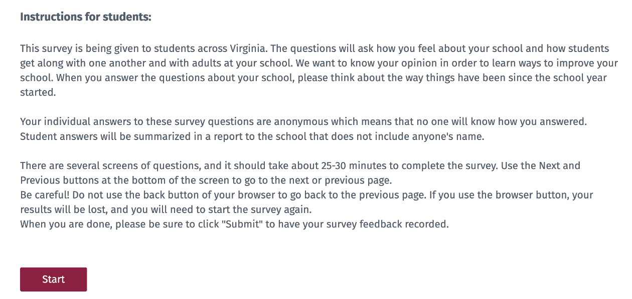
Students should see the following screen:
SAY: You may take the survey in English or Spanish. Select English or Spanish on the screen. The selected language will be displayed for the entirety of the survey. (Pause) Now select the “Next” on the bottom of the screen. Take a moment to read the information on the screen as I read it to you.
Below, please enter your Access Code for taking this survey. Your teacher should have this number for you. Many students will have the same number, so you will not be identified by this number.
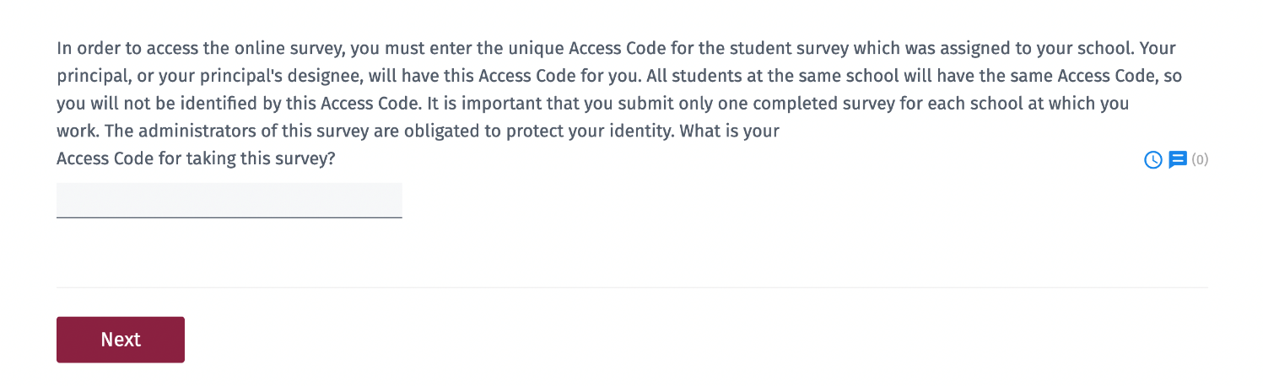
Students should see the following screen:
SAY: The access code is _ _ _ _ _S, then select “Next”.
Please write the access code given to you somewhere the students can easily see it.
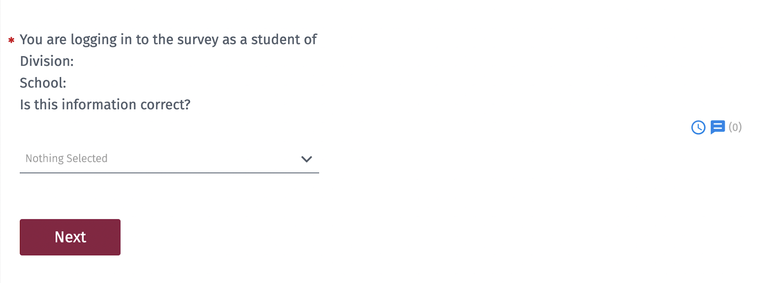
Students should see the following screen.
SAY: You should see our division and school name. If the division and school name are not correct please raise your hand. (pause) If this information is correct, please select ‘Yes’ and then "Next”.
If the division and/or school name are not correct have the student select ‘No,’ and assist them with selecting the correct information.
SAY: I will read each question aloud to you. Based on some of your answers you may or may not see every question. If you do not see the question I am reading, sit quietly until the rest of the class catches up. We will now begin the survey, remember to answer each question honestly and to the best of your ability.
SAY: First question. What grade are you in this year? Mark one.
(Pause)
SAY: Next question. How many years (including this year) have you been a student at this school? Mark one.
- This is my first year at this school.
- This is my second year at this school.
- This is my third year at this school.
- This is my fourth (or more) year at this school.
(Pause)
SAY: Next question. How have you attended classes this school year? Mark one.
- I have only attended classes remotely (e.g., at home).
- I have attended classes in-person and remotely (e.g., at home).
- I have only attended classes in-person.
(Pause)

SAY: Next question. Please indicate if and why you have a difficult time participating in academic or extracurricular activities. Mark all that apply.
- I do not have a difficult time participating.
- I chose not to participate because the activities are not of interest to me.
- I chose not to participate because of other obligations or outside activities
- I chose not to participate because I worry that I will be not fit in or will not be welcomed.
- I chose not to participate because I don’t feel safe in and around the school.
(Pause)
SAY: If you chose not to participate because you worry that you will not fit in: What makes you feel that you will not fit in or will not be welcomed? (Asked only if answered “I chose not to participate because I worry that I will not fit in or will not be welcomed”)
- My race or ethnicity
- My academic abilities
- My physical appearance
- My having too little or too much money
- My gender or gender identity
- My sexual orientation
- My disability
- Another reason
If you selected ‘Another reason,’ type your reason in the box
(Pause)
SAY: Next question. How strongly do you agree or disagree with the following statements? Mark one response per line.
 | Strongly Disagree | Disagree | Slightly Disagree | Slightly Agree | Agree | Strongly Agree
I get along well with other students at this school.
I care about other students at this school.
I feel that other students at this school care about me.
(Pause)

SAY: Next question. How strongly do you agree or disagree with the following statements? Mark one response per line.
 | Strongly Disagree | Disagree | Slightly Disagree | Slightly Agree | Agree | Strongly Agree
I stop and think before doing anything when I get angry.
I work out disagreements with other students by talking with them.
I can disagree with others without starting an argument or a fight.
I know how to decide right from wrong.
I can control myself when I am upset.
(Pause)
SAY: Next question. How strongly do you agree or disagree with the following statements about this school? Mark one response per line.
 | Strongly Disagree | Disagree | Slightly Disagree | Slightly Agree | Agree | Strongly Agree
Adults at this school care about me.
Adults at this school treat me with respect.
Adults at this school want me to do well.
Adults at this school listen to what I have to say.
Adults at this school have my respect.
Adults at this school notice if I am absent.
(Pause)
SAY: Next question. Do you have positive relationships with any adults in your school? Mark all that apply.
- The principal or assistant principal
- A teacher
- A counselor
- The School Resource Officer (SRO)
- The School Security Officer (SSO)
- An adult that shares my racial, ethnic, or cultural background
- An adult that does not shares my racial, ethnic, or cultural background
- I do not have a positive relationship with any adult at this school.
(Pause)

SAY: Next question. How strongly do you agree or disagree with the following statements about this school? Mark one response per line.
 | Strongly Disagree | Disagree | Slightly Disagree | Slightly Agree | Agree | Strongly Agree
The school rules are fair.
I know the consequences if I break a school rule.
When students are accused of doing something wrong, they get a chance to explain.
Adults at this school are good at acknowledging positive behavior.
Adults at this school are good at addressing bullying.
Adults at this school are good at addressing racially insensitive behaviors.
The consequences for breaking school rules are the same for all students.
(Pause)
SAY: If you disagree with the last questions: What do you believe causes differences in the consequences for breaking school rules? Mark all that apply. (Asked only if answered “Strongly Disagree”, “Disagree”, or “Slightly Disagree” to “The consequences for breaking school rules are the same for all students.”)
- The student’s race or ethnicity
- The student’s academic abilities
- The student’s physical appearance
- The student having too little or too much money
- The student’s gender or gender identity
- The student’s sexual orientation
- The student’s disability
- Another reason:
- I do not know
- None of the above
If you selected ‘Another reason,’ type your reason in the box.
(Pause)

SAY: Next question. How strongly do you agree or disagree with the following statements? Mark one response per line. (This question only asked if attended classes’ in-person this year.)
 | Strongly Disagree | Disagree | Slightly Disagree | Slightly Agree | Agree | Strongly Agree
I feel safe traveling between my home and the school.
I feel safe outside on the grounds of the school.
I feel safe in the hallways and bathrooms of the school.
I feel safe in my classes.
(Pause)
SAY: Next question. During the past 30 days, on how many days did you not go to school because you felt you would be unsafe at school or on your way to or from school? Mark one. (This question is asked only if they have attended classes in-person.)
- Never
- 1–2 Days
- 3–5 Days
- 6–10 Days
- More than 10 Days
(Pause)
SAY: Next question. How strongly do you agree or disagree with the following statements? Mark one response per line.
 | Strongly Disagree | Disagree | Slightly Disagree | Slightly Agree | Agree | Strongly Agree
I know what to do if there is an emergency, natural disaster (such as a tornado or a flood), or a dangerous situation (such as a violent person on campus) during the school day.
If I heard about a threat to school or students’ safety, I would report it to someone in a position of authority.
If other students hear about a threat to the school or students’ safety, they would report it to someone in authority.
(Pause)
SAY: Next question. Has anyone offered, sold, or given you alcohol or drugs while at school, at a school-sponsored event, on a school bus, or on your way to or from school this year? Mark one, Yes or No. (This question is asked only if they have attended classes in-person.)
(Pause)
SAY: Next question. Are you aware if your school uses a team to assess threats of violence from students or other individuals? Mark one, Yes or No.
(Pause)
SAY: Use this definition of bullying when answering the following questions.
- Bullying is when someone is repeatedly being hurt either by words or actions on purpose.
- Bullying is the repeated use of one’s strength or popularity to injure, threaten, or embarrass another person on purpose.
- Bullying makes the person being bullied feel intimidated or humiliated.
- Bullying happens repeatedly over time.
- Bullying can be physical, verbal, or social and includes cyber bullying.
- Bullying does not include teasing or horseplay. It is not bullying when two students who have the same strength or popularity have a fight or an argument.
(Pause)
SAY: How strongly do you agree or disagree with the following statements about this school? Mark one response per line.
 | Strongly Disagree | Disagree | Slightly Disagree | Slightly Agree | Agree | Strongly Agree
Bullying is a problem at this school.
Students at this school are bullied about their race or ethnicity.
Students at this school are bullied about their sexual orientation.
Students at this school are bullied about their physical appearance.
Students at this school are bullied for having too little or too much money.
Students at this school are bullied about their disability.
(Pause)

SAY: Next question. Have you been bullied this school year? Mark one, Yes or No.
(Pause)
SAY: If yes, what do you believe motivated the bullying? Mark all that apply. (This question is only asked if they answered “Yes” to question above.)
- My race or ethnicity
- My academic abilities
- My physical appearance
- My having too little or too much money
- My gender or gender identity
- My sexual orientation
- My disability
- Another reason:
- I do not know
- None of the above
If you selected ‘Another reason,’ type your reason in the box.
(Pause)
SAY: Next question. Have you participated in bullying another student this school year? Mark one, Yes or No.
(Pause)
SAY: For the next set of questions, select Yes or No, mark one response per line.
- Has another student spread rumors or lies about you online or on social media this school year?
- Have you spread rumors or lies about another student online or on social media this school year?
- Has another student at your school made unwelcome sexual comments, jokes, or gestures that made you feel uncomfortable this school year?
- Do adults at this school take action to solve the problem when students report bullying?
- Do any adults at this school bully students?
- Have you been bullied by an adult at this school this year?
(Pause)
SAY: Next question. How often do you worry about violence at your school? Never, Rarely, Sometimes, Often, or Always. (This question is only asked only if they have attended classes in-person.)
(Pause)
SAY: Next question. How often do students get into physical fights at your school? Never, Rarely, Sometimes, Often, or Always.
(Pause)
SAY: Next question. Have any of the following happened to you personally at school this year? Mark one response per line.
 | Never | One Time | More than Once | Many Times
A student threatened to harm me.
A student physically attacked, pushed, or hit me. (This question is asked only if they have attended classes in-person.)
I was in a physical fight on school property. (This question is asked only if they have attended classes in-person.)
A student stole or damaged my personal property. (This question is asked only if they have attended classes in-person.)
(Pause)
SAY: If any of the previous four questions have happened to you, what do you believe motivated these actions? Check all that apply. (This question is asked only if answered something other than “Never” to any of the four previous questions.)
- My race or ethnicity
- My academic abilities
- My physical appearance
- My having too little or too much money
- My gender or gender identity
- My sexual orientation
- My disability
- None of the above
- I do not know
(Pause)
SAY: Next question. Are there gangs at your school? Mark one, Yes, No, or Do not know. (This question is asked only if they have attended classes in-person.)
(Pause)
SAY: If yes, have gangs caused problems at your school this year (e.g., fights, sale of drugs)? Mark one, Yes, No, or Do not know. (This question is asked only if they answered “Yes” to the previous question.)
(Pause)
SAY: If you answered yes to having gangs in your school, have you considered joining a gang this year? Mark one, Yes or No. (This question is asked only if they answered “Yes” to question about gangs in school.)
(Pause)
SAY: Use these definitions of a School Resource Officer and School Security Officer when answering the questions below.
- A School Resource Officer (SRO) is employed by the Police Department or Sheriff’s Office and is assigned to the school to assist with matters related to safety, security, and the law.
- A School Security Officer (SSO) is employed by the school division for the purpose of enforcing the school’s Code of Conduct by maintaining order and discipline, preventing crimes, and investigating violations of school board policies and school rules.
(Pause)
SAY: Does your school have a School Resource Officer (SRO)? Mark one, Yes, No, Do not know. Remember a School Resource Officer (SRO) is employed by the Police Department or Sheriff’s Office and is assigned to the school to assist with matters related to safety, security, and the law.
(Pause)
SAY: If your school does not have an SRO or you don’t know, did your school have a School Resource Officer (SRO) in previous years? Mark one, Yes, No, or Do not know. (This question is asked only if they answered, “No” or “Do not know” to having an SRO.)
(Pause)
SAY: If your school does not have an SRO or you don’t know, would you feel safer if your school had an SRO? Mark one Yes, No, or Do not know. (This question is asked only if they answered, “No” or “Do not know” to having an SRO.)
(Pause)
SAY: If your school does have an SRO, how strongly do you agree or disagree with the following statements about this school? Mark one response per line. (This question is asked only if they answered “Yes” to having an SRO.)
 |  | Strongly Disagree | Disagree | Slightly Disagree | Slightly Agree | Agree | Strongly Agree
The School Resource Officer (SRO) makes me feel safe at this school.
The School Resource Officer (SRO) makes a positive contribution to our school.
(Pause)
SAY: Next question. Does your school have a School Security Officer (SSO)? Mark one, Yes, No or Do not know. Remember a School Security Officer (SSO) is employed by the school division for the purpose of enforcing the school’s Code of Conduct by maintaining order and discipline, preventing crimes, and investigating violations of school board policies and school rules.
(Pause)
SAY: If your school does not have an SSO or you do not know, did your school have a School Security Officer (SSO) in previous years? Mark one, Yes, No, or Do not know. (This question is asked only if they answered, “No” or “Do not know” to having an SSO.)
(Pause)
SAY: If your school does not have an SSO or you do not know, would you feel safer if your school had an SSO? Mark one, Yes, No, or Do not know. (This question is asked only if they answered, “No” or “Do not know” to having an SSO.)
(Pause)
SAY: If your school does have an SSO, how strongly do you agree or disagree with the following statements about this school? Mark one response per line. (This question is asked only if they answered “Yes” to having an SSO.)
 |  | Strongly Disagree | Disagree | Slightly Disagree | Slightly Agree | Agree | Strongly Agree
The School Security Officer (SSO) makes me feel safe at this school.
The School Security Officer (SSO) makes a positive contribution to our school.
(Pause)
SAY: Next question. During the past 12 months, did you ever feel so sad or hopeless almost every day for two weeks or more in a row that you stopped doing some usual activities? Yes or No.
(Pause)

SAY: Next question. How often over the last two weeks were you bothered by the following? Mark one response per line.
 | Not at all | Several days | More than half the days | Nearly every day
Feeling nervous, anxious, or on edge
Not being able to stop or control worrying
Feeling down, depressed, or hopeless
Having little interest or pleasure doing things
(Pause)
SAY: Next question. How strongly to you agree or disagree with the following statements about this school? Mark one response per line.
 | Strongly Disagree | Disagree | Slightly Disagree | Slightly Agree | Agree | Strongly Agree
The adults in my school care about students’ well-being and mental health
I am satisfied with the level of mental health supports, services, and programs available to students in my school.
The adults in my school are supportive of students’ use of mental health services in my school.
(Pause)
SAY: Next question. If you feel sad or hopeless, are there adults that you can turn to for help? Mark one; I never feel sad or hopeless, Yes, No, or Not sure.
(Pause)
SAY: Next question. During the past 12 months, did you ever seriously consider attempting suicide? Yes or No.
(Pause)
SAY: If Yes, Did you ask for help from someone such as a doctor or counselor, either in-person, via phone or online? Yes or No. (This question is asked only if they answered “Yes” to considering suicide.)
(Pause)
SAY: If you seriously considered attempting suicide, during the past 12 months, did you make a plan about how you would attempt suicide? Yes or No. (This question is asked only if they answered “Yes” to considering suicide.)
(Pause)
SAY: If you seriously considered attempting suicide, during the past 12 months, how many times did you actually attempt suicide? (This question is asked only if they answered “Yes” to the previous question.)
- 0 Times
- 1 Time
- 2 or 3 Times
- 4 or 5 Times
- 6 or More Times
(Pause)
SAY: Next question. If I am having thought of suicide or mental distress, I know where to turn for help. Yes or No.
(Pause)
SAY: Next question. If another student talked about causing harm to themselves, I would tell an adult at school. Yes or No.
(Pause)
SAY: Next question. Have you participated in any suicide prevention or mental health training? Yes or No.
(Pause)
SAY: Next question. How positive or negative is the atmosphere of the school? Mark one.
- Very negative
- Negative
- Slightly negative
- Slightly positive
- Positive
- Very positive
(Pause)
SAY: Next question. How does your school’s atmosphere impact your learning? Mark one.
- It has a very negative impact.
- It has a negative impact.
- It has a slightly negative impact.
- It has no impact.
- It has a slightly positive impact.
- It has a positive impact.
- It has a very positive impact.
(Pause)
SAY: If this is not your first year at this school, since you have been at this school, how has the overall school atmosphere changed? Mark one. (This question is asked only if they did not answer “This is my first year at this school.”)
- Become much worse
- Become worse
- Become slightly worse
- Stayed about the same
- Become slightly better
- Become better
- Become much better
(Pause)
SAY: Next question. How many days have you been absent from school this year? Mark one.
- 0 days
- 1–5 days
- 6–10 days
- More than 10 days
(Pause)
SAY: Next question. How many days have you been suspended out of school this year? Mark one.
- I have not been suspended from school this year.
- I have been suspended for one day.
- I have been suspended for two days.
- I have been suspended for three days.
- I have been suspended for four days.
- I have been suspended five or more days.
(Pause)
SAY: The following questions are asked of all respondents to better understand whether groups of individuals experience school climate differently. How do you describe your gender? Mark one.
- Male
- Female
- Non-binary
- Prefer not to disclose
(Pause)

SAY: Next question. Are you of Hispanic, Latino, or Spanish origin? Mark one.
- No, not of Hispanic, Latino, or Spanish Origin
- Yes, Mexican, Mexican American or Chicano
- Yes, Puerto Rican
- Yes, Cuban
- Yes, another Hispanic, Latino or Spanish Origin (ex: Salvadorian, Dominican, Colombian, Guatemalan, etc.)
(Pause)
SAY: Next question. What is the best description of your race or origin? If you are multi-racial, mark all that apply.
- American Indian or Alaska Native (ex: Navajo Nation, Mayan, Aztec, etc.)
- Asian (ex: Chinese, Vietnamese, Korean, Filipino, Japanese, etc.)
- Black or African American (ex: African American, Jamaican, Haitian, Nigerian, Ethiopian, etc.)
- Native Hawaiian or Pacific Islander (ex: Samoan, Chamorro, etc.)
- White (ex: German, Irish, English, Italian, Egyptian, etc.)
- Other Race
(Pause)
SAY: Next question. Do you have any of the following educational plans? Mark one response per line; Yes, No, Do not know.
- Individual Education Plan (IEP)
- Section 504 Plan
- Limited English Proficiency (LEP) Plan
(Pause)
SAY: Last question. How old are you? Select your age from the dropdown menu. Once you have answered this question; click the Submit button to submit your survey. [Dropdown menu of ages, e.g., 10 years old to 20 years old]
(Pause)
SAY: Thank you for participating in this year's survey. If completing the survey raised any concerns, please talk with a counselor at your school. A selection of health and wellness resources may be provided below. This is not an exhaustive list of local, state, and national resources that are available to you. If you need help, contact one of these organizations or talk to a trusted adult.
(Pause)
A list of mental health resources will be visible on the students’ screen. Please monitor your students for any signs of distress and assist them as needed.
SAY: You have now completed this year’s Virginia School Survey of Climate and Working Conditions. Your opinions are important; and will help our school maintain a safe, inviting, and supportive learning environment. Thank you.

