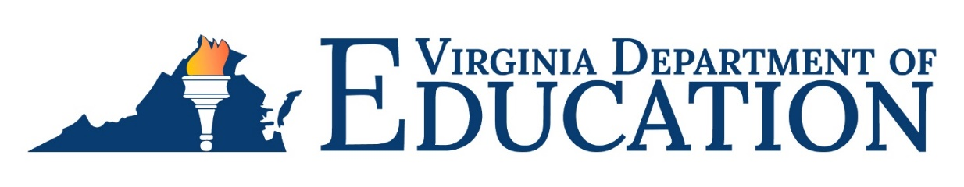

2024-2025 Special Education Annual Plan/Part B Flow-Through Application
Under provisions of the 2004 Individuals with Disabilities Education Act (IDEA 2004), its implementing regulations, and the Regulations Governing Special Education Programs for Children with Disabilities in Virginia (effective January 25, 2010), local educational agencies (LEAs) are required to submit an Annual Plan/Part B Flow-Through Application for providing special education and related services to children with disabilities. The 2024-2025 Special Education Annual Plan/Part B Flow-Through Application serves as the formal agreement between a local school board and the Virginia Department of Education (VDOE) for implementing federal and state laws and regulations governing these services. Accordingly, the disbursement of state and federal funds appropriated for the education of children with disabilities is contingent upon the approval of this plan and each of its components.
Each school division, state-operated program (SOP), and the Virginia School for the Deaf and the Blind (VSDB) shall maintain current policies and procedures and supporting documentation to demonstrate compliance with federal and state regulations governing the provision of special education and related services, licensure, and accreditation. Completion of the required certifications and assurances sections of the Annual Plan/Part B Flow-Through Application will verify adherence to the requirements of IDEA, its implementing regulations, and the Virginia special education regulations.
The application includes the following required components:
- The Superintendent's Certification
- Policy Statements
- Statement of Assurances (Including GEPA survey)
- Special Education in Local and Regional Jails
- The Report on the Implementation of the 2022-2023 Plan
- Maintenance of Effort Eligibility
- Coordinated Early Intervening Services and Proportionate Set-Aside
- The Application for Use of Federal Funds for Sections 611 and 619
Prior to submission to VDOE, each school division shall review its Annual Plan/Part B Flow-Through Application with its local special education advisory committee and submit it to its local school board for approval. The SOPs are required to submit their Annual Plans/Part B Flow-Through Applications to the State Special Education Advisory Committee (SSEAC) for review prior to submitting the plans to VDOE for approval. The VSDB is required to submit its Annual Plan/Part B Flow-Through Application to its board of visitors for approval and then to the SSEAC for review prior to submitting it to VDOE for approval. The SSEAC meeting is scheduled for March 7, 2024. The VSDB and SOPs should submit copies of their annual plans for review by the SSEAC by February 16, 2024, to sped-finance@doe.virginia.gov.

The Annual Plan/Part B Flow-Through Application must be completed and submitted electronically. School divisions, SOPs, and the VSDB are required to submit their Annual Plan/Part B Flow-Through Application using the Excel document via the Online Management of Education Grant Awards (OMEGA) System. The LEAs may already have approved access for all users in their approval queue. For those with new directors or others who would be new to the approval queue, an “OMEGA User Permission Form OP1” (OP1 form) must be on file with the VDOE’s Office of Finance to establish user access. Instructions for completing the OP1 form and online training opportunities are available at OMEGA Training and Instructions. Unless previously completed, please email a completed OP1 form for each individual in the LEA’s approval queue to OMEGA.Support@doe.virginia.gov no later than Monday, April 1, 2024.

School divisions, SOPs, and the VSDB must complete and successfully submit the Annual Plan/Part B Flow-Through Application electronically via OMEGA using the Excel workbook by Friday, May 10, 2024. The Excel workbook is located on the VDOE website. Official approval through OMEGA by school division superintendents, SOP directors, and the VSDB superintendent will serve as the confirmation that school divisions, SOPs, and VSDB have met all requirements, certifications, and assurances. Hard copies of these signed and dated documents must be maintained locally.
To clarify the provision of requirements for children with disabilities who are two years old and receive services under Part B Section 619, the Code of Virginia stipulates that the VDOE assures a free appropriate public education (FAPE) to eligible children with disabilities from age 2 (by September 30 of the school year) to 21, inclusive. Federal clarification has indicated that IDEA Part C (Early Intervention for Infants and Toddlers with Disabilities) regulations do not apply to any child with a disability who is receiving FAPE under Part B Section 619. This provision applies whether the services are fully or partially funded under Section 619.

For more information
The following individuals aid with specific sections of the IDEA Part B Flow-Through Application.
Topic | Staff Name | Email | Phone Number
Submission Statement, GEPA Statement, Section 611 Application and Report on the Implementation of the 2022-2023 Plan: Subgrants and Annual plans | Denise Lawus | Sped-finance@doe.virginia.gov | (804) 750-8601
Special education in local and regional jail programs | Laurie Cooper | Laurie.Cooper@doe.virginia.gov | (804) 418-4760
State-operated programs | Hank Millward | Hank.Millward@doe.virginia.gov | (804) 887-5000
Maintenance of Effort (MOE) Eligibility and Proportionate Set-Aside (PSA) | Shalonda Lewis | Shalonda.Lewis@doe.virginia.gov | (804) 774-4279
Section 619 (Early Childhood) Application | Samantha Tansey  Dawn Hendricks | Samantha.Tansey@doe.virginia.gov  Dawn.Hendricks@doe.virginia.gov | (804) 298-3149  (804) 225-2675
Comprehensive Coordinated Early Intervening Services Plans | Joseph Wharff | Joseph.Wharff@doe.virginia.gov | (804)750-8077
Coordinated Early Intervening Services Determination | J Jeffrey Phenicie | Jeff.Phenicie@doe.virginia.gov | (804)750-8145
OMEGA Support and OPI Form | Olinder Jones | Omega.support@doe.virginia.gov | (804) 371-0993

Please direct any other questions regarding the Annual Plan/Part B Flow-Through Application to the Office of Special Education Finance and Budget at SPED-Finance@doe.virginia.gov.

