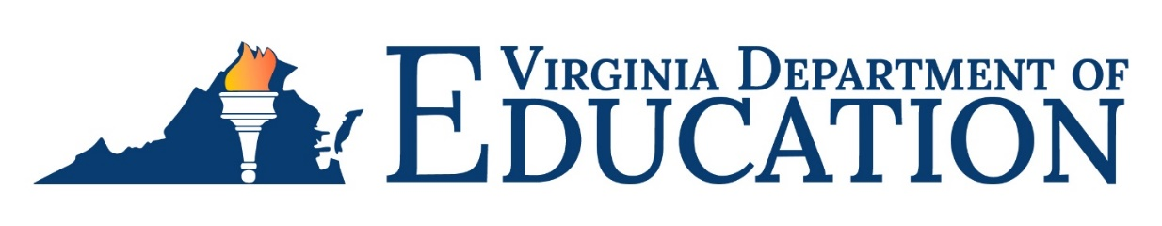

2022-2023 Individuals with Disabilities Education Act (IDEA)
Maintenance of Effort Requirements

The Virginia Department of Education (VDOE) is required by federal regulations to ensure all school divisions in Virginia comply with §300.203(b) of the Individuals with Disabilities Education Act (IDEA), which mandates that school divisions meet a maintenance of effort (MOE) obligation. The MOE regulation requires school divisions to spend at least the same amount of local or local plus state dollars for the current school year on the delivery of special education and related services, as were spent from that same source in the last year the school division met its MOE compliance obligation.
The school division must utilize the web-based application (IDEAMOE Application) to report costs associated with providing special education and related services to children and youth with disabilities that are above and beyond the cost of providing regular education programs to nondisabled students. Costs associated with capital outlay or regular education programs and services should be excluded from this expenditure calculation. The IDEA MOE Guidance Document and IDEA MOE Application User’s Manual will provide additional guidance and information.
The IDEA MOE Application can be accessed using the VDOE’s Single Sign-on for Web Systems (SSWS) portal. The person responsible for submitting the division’s IDEA MOE report of expenditures will need to contact their local SSWS administrator to gain access rights to the application. The data collection window will open on December 4, 2023, and close on January 31, 2024.
A pre-recorded training session to review the purpose of MOE, allowable and unallowable exceptions, methods of calculation, consequences of non-compliance and submitting the data will be made available to all school divisions. Special Education Directors will receive the link for accessing the pre-recorded training via email. Additionally, question and answer sessions will be conducted on January 10, 2024, at 11 a.m. and January 17, 2024, at 1 p.m. to provide assistance. Dr. Samantha Marsh Hollins, Assistant Superintendent of Special Populations, will send all Special Education Directors the Zoom link information in the very near future for these sessions. The Special Education Directors should share this link with those assisting with this data collection.

For more information
Any questions concerning Maintenance of Effort and the web-based application can be directed to Shalonda Lewis, Special Education Financial Data Specialist, at Shalonda.Lewis@doe.virginia.gov; telephone (804) 774-4279.

