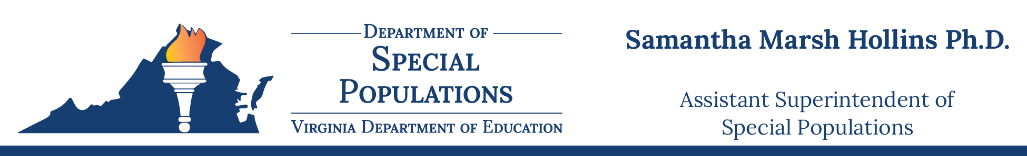

DATE: November 3, 2023

TO: Directors of Special Education

SUBJECT: December 1 Child Count 2023 Collection Event
The Department of Special Populations would like to provide local educational agencies (LEAs) with the following information regarding the 2023 December 1 Child Count Data Collection, submission dates, and procedures.

Student Record Collection (SRC) Pre-submission
The Student Record Collection (SRC) Pre-submission application will be available for divisions to submit their December 1 Child Count files after all divisions have completed their final Fall 2023 SRC submissions and prior to the opening of the December 1 Child Count window.

School divisions are encouraged to utilize this application during November to submit preliminary data files, identify potential errors, and make necessary corrections prior to the final data submission.

December 1 Child Count Submission Window
The December 1 Child Count submission window will open Friday, December 1, 2023, and close Thursday, December 14, 2023. Your superintendent’s verification by electronic signature is also due Thursday, December 14, 2023.

Please ensure every student with an active Individualized Education Program (IEP) or Services Plan (ISP) receiving special education services is reported on the December 1 Child Count. This includes students who are parentally placed in private schools and students in residential facilities, regional centers, private day schools, and hospitals. To avoid duplicate counts, please communicate with other agencies.

Following a successful Child Count submission, you must complete the Parentally Placed Private School Students Data survey before your report will proceed to the superintendent for verification. The LEA does not report students from the Virginia School for the Deaf and Blind, the Department of Juvenile Justice, the Department of Corrections, or state-operated programs; those entities report their own students.

December 1 Child Count Resubmission Window
A resubmission window will be available to all school divisions by request of their special education directors and for corrections only, beginning Monday, January 8, 2024, and ending Friday, January 12, 2024. Please refer to the December 1 Child Count webpage for additional guidance regarding resubmission once the window is closed and the verification is complete. Special education directors and superintendents will be able to review their Child Count data from December 14, 2023 - January 8, 2024. If needed, data will be able to be revised during this penalty-free resubmission window by request of the Special Education Director.

Special education directors must email their resubmission request to Special Education Data. You must copy your superintendent when making this request as it will require a new verification. In addition, division special education directors must communicate with any other divisions that might be impacted by your division’s resubmission.

Certification Report
Superintendents will electronically verify the December 1 Child Count certification report through the Superintendents Data Collection Approvals (SDCA) application within the Single Sign-on for Web Systems (SSWS) portal by Thursday, December 14, 2023. If the resubmission window (January 8-12, 2024) is used, a new verified certification report will be due on or before Friday, January 12, 2024.

Protocol for Resubmission of Child Count Data after January 12, 2024
The December 1 Child Count resubmission window will officially lock at midnight on Friday, January 12, 2024. If the school division needs to resubmit data after January 12, 2024, the division’s superintendent must send an email addressed to Dr. Samantha Marsh Hollins, Assistant Superintendent of Special Populations, and copy Spedprogramdata@doe.virginia.gov. Include the following information:

- Subject: Request for resubmission of child count data
- Reason(s) for the resubmission request
- Statement of the detailed changes to be made including specific data elements
- The school division’s plan to ensure accurate future submissions

Upon approval, our office will contact the division’s special education director to schedule the resubmission. Only the specific changes requested can be made.

Prior to resubmission, the requesting school division must notify any other impacted division(s) as this might require a resubmission on their part. If an impacted division also needs to resubmit, that division must follow the same resubmission procedures outlined in this email.

Students with Intensive Support Needs Application (SISNA) Reminders:
- If your school division has submitted a SISNA to VDOE for the 2023-2024 school year and has provided services to eligible students during your Summer Semester, your claims for reimbursement for the costs for those services must be reported with your December 1, 2023, Child Count.
- Summer semester claims are to be verified using the Summer Semester Students with Intensive Support Needs Reimbursement Verification Report.
- All students that are identified in your SISNA that are being reported on your Child Count must include the Intensive Support Services Code.
- Placement Codes reported for students identified in your SISNA should reflect where these students are receiving their services. Students receiving services through entities formerly known as Special Education Regional Programs are not automatically reported with Placement Code 2 – Separate Special Education Center.

Resources
Student Record Data Collection questions should be emailed to the Office of Data Services.

December 1 Child Count Data Collection questions should be emailed to the Office of Special Education Data.

Please refer to the Virginia Department of Education’s Special Education webpage for more information.

