VESOL Vocabulary Word Wall Cards
VESOL Mathematics vocabulary word wall cards provide a display of mathematics content words and associated visual cues to assist in vocabulary development. The cards should be used as an instructional tool for teachers of students with severe cognitive deficiency’s as well as a reference for the students.

Table Of Contents:
Number and Number Sense

Card Name | VESOL | Card Name | VESOL
Number Model of 2 | 3.1, 4.1 | Comparing Integers | 7.13, 8.1
Number Model of 9 | 3.1, 4.1 | Perfect Squares | HS.5
Number Model of 14 | 3.1, 4.1, 4.2 | Perfect Cubes | HS.5
Numeral | 4.6, 5.1 | Exponential Form | HS.5
Place Value | 4.2, 5.3 | Even and Odd Numbers | 5.5
(2) Digit | 3.1, 4.1, 4.2, 5.2, 5.3 | Even and Odd Numbers | 5.5
(3) Digit | Not directly related to any VESOL | Compare | 3.3, 3.10, 4.4, 4.6, 6.3, 6.16, 7.1, 7.14, 8.1
Counting by Ones | 3.1 | More Than | 3.2, 4.3
Counting by Tens | 4.2, 5.3 | Greater Than | 3.10, 3.16, 4.21, 6.16, 7.14
Fraction: Half and Fourth | 3.4, 4.5, 4.12, 4.13, 5.8, 5.10 | Greater Than | 4.4, 4.6, 6.3, 6.16, 7.1, 7.14, 8.1
Fraction: Half and Fourth | 4.4, 4.7, 4.12, 4.13, 5.8, 5.10, 6.1, 6.4, 7.2, 7.3 | Fewer Than | 4.4, 4.6, 6.3, 6.16, 7.1, 7.14, 8.1
Fraction: two-thirds | 5.10, 6.1, 6.4, 7.2, 7.3 | Less Than | 3.10, 4.4, 4.6, 6.3, 6.16, 7.1, 7.14, 5.16, 8.1
Fraction: three-eighths | 6.1, 6.4, 7.2, 7.3 | Less Than | 3.10, 4.4, 4.6, 6.3, 6.16, 7.1, 7.14, 5.16, 8.1
Numerator/Denominator | 5.10, 6.1, 6.4, 7.2, 7.3 | Less Than | 4.4, 4.6, 6.3, 6.16, 7.1, 7.14, 5.16, 8.1
Mixed Number | 5.8, 6.1, 6.4, 7.2, 7.3 | Equal To | 3.10, 4.4, 4.6, 6.3, 6.16, 7.1, 7.14, 5.16, 8.1
Equivalent | 6.1, 6.4, 7.2, 7.3 | Equal To | 4.4, 4.6, 6.3, 7.1, 8.1
Equivalent Relationships | 6.1, 7.2 | Closest To | 4.4, 4.6, 6.3, 7.1, 8.1
Integer | 7.13, 8.1

Computation and Estimation

Card Name | VESOL | Card Name | VESOL
Equal | 3.5, 4.9, 5.10, 5.11, 6.6, 7.3, 8.13, HS.6 | Division Number Line Model | 4.10, 5.7, 6.7, HS.3
Equal | 5.10, 5.11, 6.6, 7.3, 8.13, HS.6 | Fraction Addition | 5.8, 6.4. 7.3
Not Equal | 3.5, 4.9, 5.10, 5.11, 6.6, 7.3, 8.13, HS.6 | Fraction Subtraction | 6.4. 7.3
Not Equal | 5.10, 5.11, 6.6, 7.3, 8.13, HS.6 | Integer Addition/Subtraction Number Line | 6.6, 7.13, 8.1
Addition | 3.5, 3.6, 4.9, 4.11, 4.13, 5.8, 5.9, 5.13, 5.17, 6.4, 6.6, 6.15, 7.12, 8.8, 8.13, HS.3, HS.6 | Integer Addition/Subtraction Array | 6.6, 7.13, 8.1
Addition | 3.5, 3.6, 4.9, 4.11, 4.13, 5.8, 5.9, 5.13, 5.17, 6.4, 6.6, 6.15, 7.12, 8.8, 8.13, HS.3, HS.6 | Integer Multiplication | 6.6
Join | 3.5, 3.8, 4.13, 4.14 | Integer Multiplication and Division | 7.13, 8.1
Subtraction | 3.5, 3.6, 4.9, 4.11, 4.12, 4.13, 5.8, 5.9, 5.11, 6.4, 6.6, 6.15, 7.12, 8.8, 8.13, HS.3, HS.6 | Penny | 4.14, 5.6, 7.4, 7.12, 8.2, 8.8, HS.3
Subtraction | 3.5, 3.6, 4.9, 4.11, 4.12, 4.13, 5.8, 5.9, 5.11, 6.4, 6.6, 6.15, 7.12, 8.8, 8.13, HS.3, HS.6 | Nickel | 4.14, 5.6, 7.4, 7.12, 8.2, 8.8, HS.3, HS.4
Separate | 3.5, 3.8, 4.13, 4.14 | Nickel with Pennies | 4.14, 5.6, 7.4, 7.12, 8.2, 8.8, HS.3, HS.4
Multiplication | 3.7, 4.8, 6.6, 6.7, HS.3 | Dime | 4.14, 5.6, 6.5, 7.4, 7.12, 8.2, 8.8, HS.3, HS.4
Multiplication Array | 3.7, 4.8, 6.7, HS.3 | Dime with Pennies | 4.14, 5.6, 6.5, 7.4, 7.12, 8.2, 8.8, HS.3, HS.4
Number Line | 4.12, 5.1, 6.1, 6.2, 6.3, 7.1, 8.1, HS.3 | Quarter | 4.14, 5.6, 6.5, 7.4, 7.12, 8.2, 8.8, HS.3, HS.4
Number Line Model | 4.8, 6.6, 6.7 | Quarter with Pennies | 4.14, 5.6, 6.5, 7.4, 7.12, 8.2, 8.8, HS.3, HS.4
Division Array Model | 4.10, 5.7, 6.7, HS.3 | Dollar | 5.6, 6.5, 7.4, 7.12, 8.8, HS.3, HS.4

Measurement

Card Name | VESOL | Card Name | VESOL
Penny | 3.8 | Elapsed Time: Analog | 5.14, 6.8, 7.5, 8.3, HS.2
Nickle | 3.8 | Weight: Heavier/Lighter | 4.17, 5.16, 8.19, 8.22
Nickle with Pennies | 3.8 | Length: Longer/Shorter | 3.9, 3.11, 4.16, 6.9
Dime | 3.8 | Height: Taller/Shorter | 3.9, 4.16
Dime with Pennies | 3.8 | Temperature: Hotter/Colder | 3.10
Quarter | 3.8 | Volume: Less/More | 3.10
Quarters with Pennies | 3.8 | Ruler: Inch | 4.16
Clock: Digital | 3.13, 4.18 | Ruler: Centimeter & Inch | 4.16
Clock: Analog | 6.8, 7.5, 8.3, HS.2 | Ruler: Inch and Foot | 4.17
Clock: Digital/Analog | 5.14, 6.8, 7.5, 8.3, HS.2 | Balance Scale | 4.17
Clock: Minute, Half Hour, Hour | 7.5, 8.3, HS.2 | Scale | 4.17
Midnight | 3.13, 4.18, 5.14, 6.8, 7.5, 8.3, HS.2 | Pound | 4.17
Noon | 3.13, 4.18, 5.14, 6.8, 7.5, 8.3, HS.2 | Area | 3.12, 4.15, 5.12, 7.6, 8.5
AM | 3.13, 4.18, 5.14, 6.8, 7.5, 8.3, HS.2 | Area: Formula | 4.15, 5.12, 7.6, 8.5
PM | 3.13, 4.18, 5.14, 6.8, 7.5, 8.3, HS.2 | Perimeter | 3.11, 6.9
Clockwise | Not directly related to any VESOL | Volume: V=lwh | 5.12, 5.13, 7.6
Elapsed Time: Digital | 5.14, 6.8, 7.5, 8.3, HS.2 | Volume: V=Bh | 5.12, 5.13, 7.6

Geometry

Card Name | VESOL | Card Name | VESOL
Point | 3.14,.4.19, 5.15 | Pentagon | 5.15
Line Segment | 3.14,.4.19, 5.15 | Hexagon | 5.15
Line | 3.14,.4.19, 5.15 | Octagon | 5.15
Angle | 3.14,.4.19, 5.15 | Smaller/Larger | 3.3, 3.10, 4.4, 4.6, 6.3
Circle | 3.14,.4.20, 5.15, 7.8 | Same | 3.3, 3.9, 3.10, 3.15, 4.4, 4.6, 4.21, 6.3
Triangle | 3.14,.4.20, 5.15, 7.8 | Congruent | 6.11, 7.7
Square | 3.14,.4.20, 5.15, 7.8 | Similar Figures | 7.7
Square: Angle and Side | 7.8 | Coordinate Plane | 8.4, 8.7, 8.10
Rectangle | 3.14,.4.20, 5.15, 7.8 | Coordinate Plane: Quadrant I | 6.10
Rectangle: Angle and Side | 7.8 | Coordinate Plane: Quadrant I & II | 7.9

Probability And Statistics

Card Name | VESOL | Card Name | VESOL
Probability Number Line | 7.10, 8.6 | Bar Graph | 4.21, 6.12, 7.11
Certain | 7.10, 8.6 | Line Graph | 7.11, 8.7, HS 10
Likely | 7.10, 8.6 | Line Plot | 5.15, 6.12
Unlikely | 7.10, 8.6 | Scatter Plot | 8.7, HS.10
Equally Likely | 7.10, 8.6 | Positive Relationship | 8.7, 8.10, 8.11, HS.10
Impossible | 7.10, 8.6 | Negative Relationship | 8.7, 8.10, 8.11, HS.10
Table | 3.16, 4.21, 6.12, 7.11 | No Relationship | 8.7, 8.10, 8.11, HS.10
Picture Graph | 3.16, 4.21, 6.12, 7.11 | Mean: Model | 6.13
Pictograph | 3.16, 4.21, 6.12, 7.11 | Mean | 6.13

Patterns, Functions and Algebra

Card Name | VESOL | Card Name | VESOL
Counting by Twos | 3.17, 4.22 | Variable Expression | 6.15, 7.13, 8.13, HS.6
Counting by Fives | 3.17, 4.22 | Term | 6.15, 7.13, 8.13, HS.6
Patterns: Input/Output Table | 5.17, 6.14, 8.9, 8.12, HS.9 | Constant | 6.15, 7.13, 8.13, HS.6
Proportional Relationship | 6.14, 8.9, 8.12, HS.9 | Like Terms | 6.15, 7.13, 8.13, HS.6
Connecting Representations | 6.14, 8.9, 8.12, HS.9 | Variable to Algebraic | 5.15, 5.18, 7.12, 8.8, HS.1, HS.3
Function | 8.9, HS.9 | Variable to Algebraic | 8.8, HS.1, HS.3
Slope | 8.10, 8.11, 8.12, HS.10 | Order of Operations | 6.15, 8.8, HS.3, HS.5
Slope: Types | 8.10, 8.11, 8.12, HS.10 | Equation: One-step | 7.13, 8.13, HS.6
Equation | 6.15, 7.13, 8.13, HS.6 | Equation: Two-step | 8.13, HS.6
Expression | 6.15, 7.13, 8.13, HS.6 | Inequality | 6.16, 7.14, 8.14, HS.8
Variable | 6.15, 7.13, 8.13, HS.6 | Sales Tax | HS.7

Number
and
Number Sense

Number

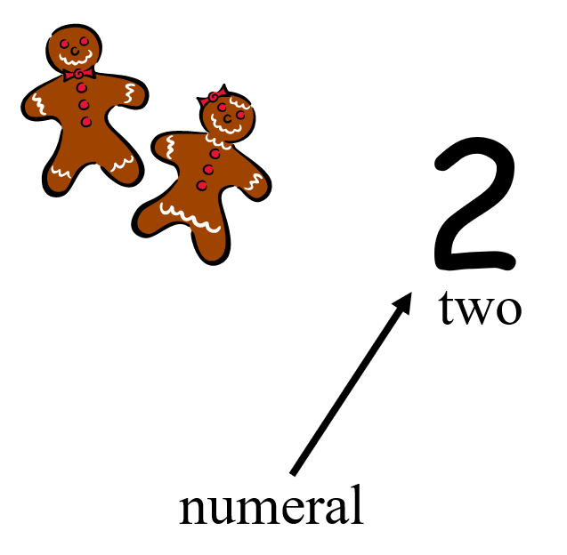

Number

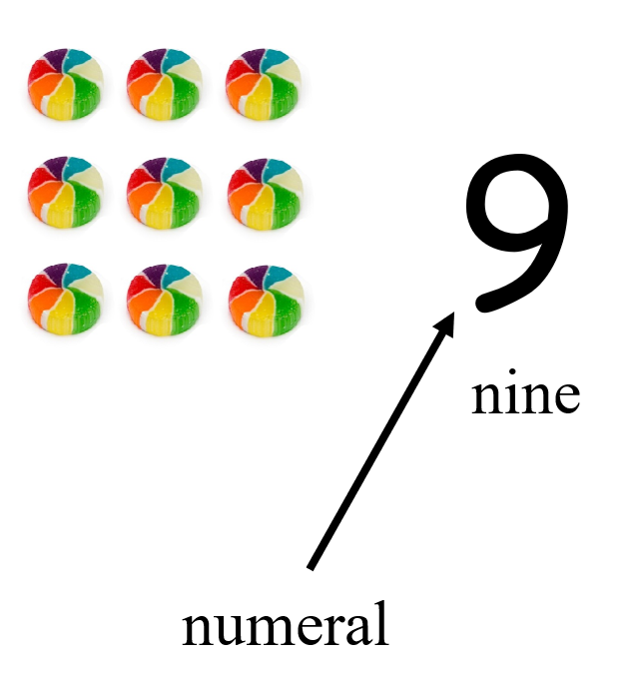

Number

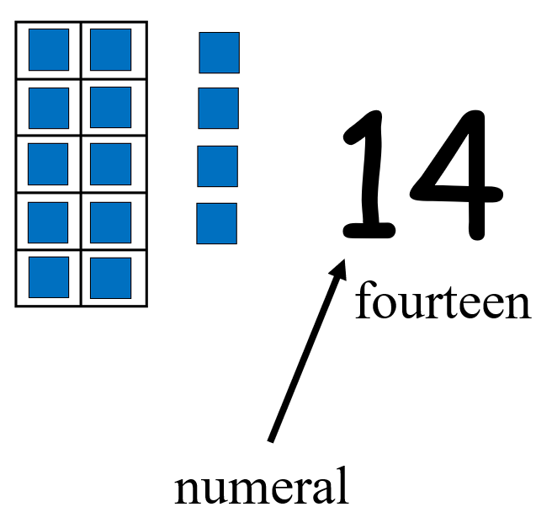

Numeral

two point five

two and five tenths

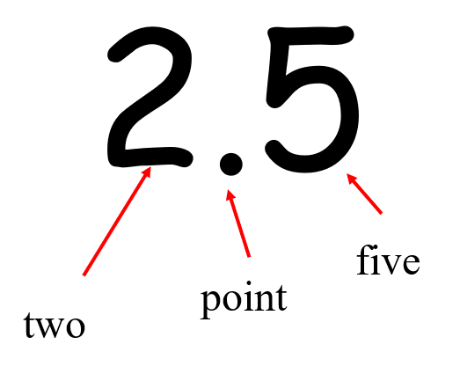

Place Value

Tens Ones

4 7
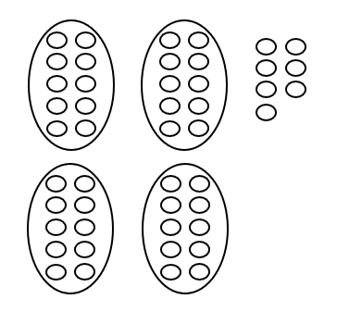
40 and 7

Digit

a numeral from 0 to 9

part of a number

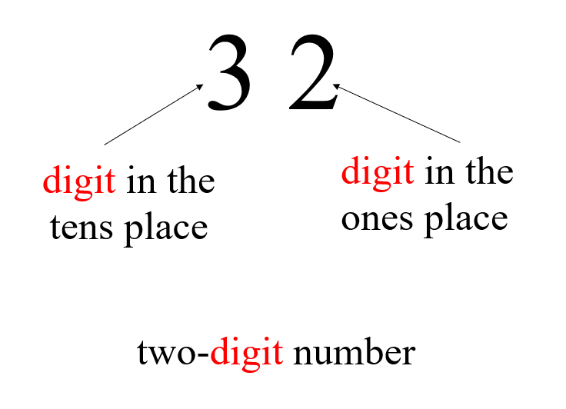

Digit

a numeral from 0 to 9,

part of a number

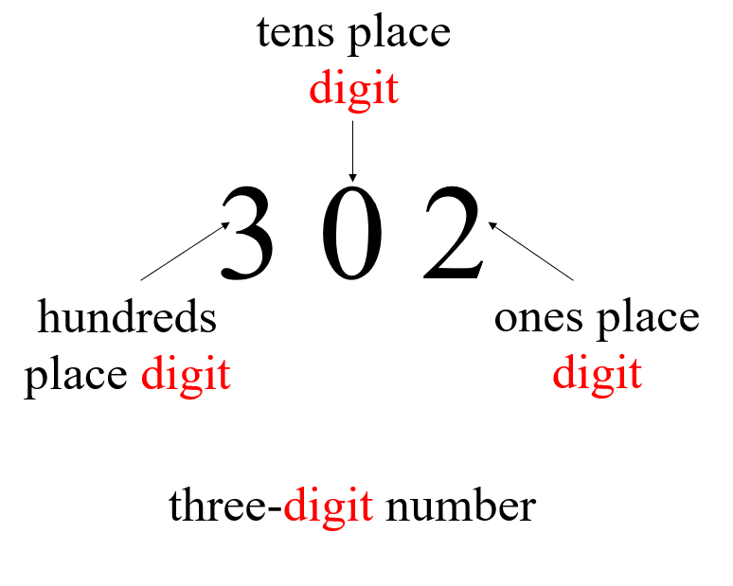

Counting by Ones

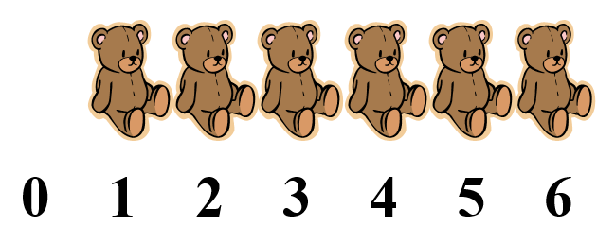

Counting by Tens

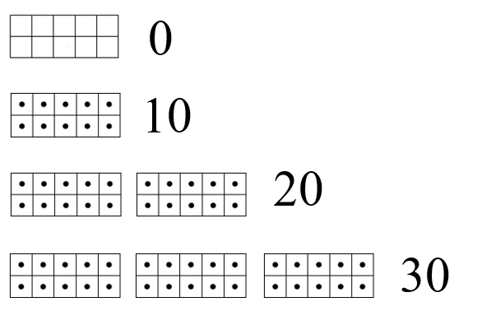

Fraction:
Half and Fourth
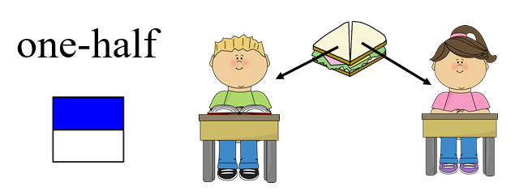

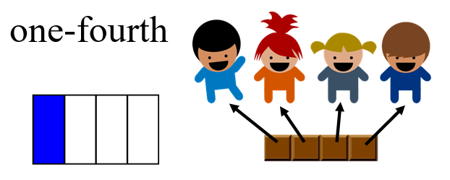

Fraction:
Half and Fourth

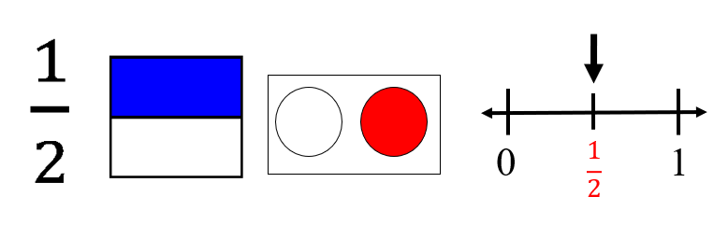

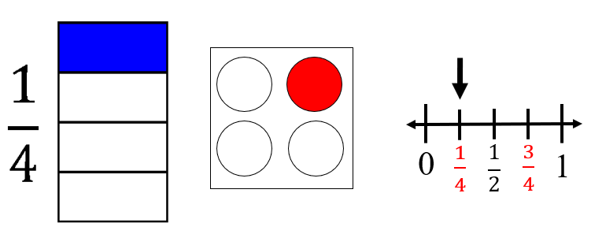

Fraction:
Models for two-thirds

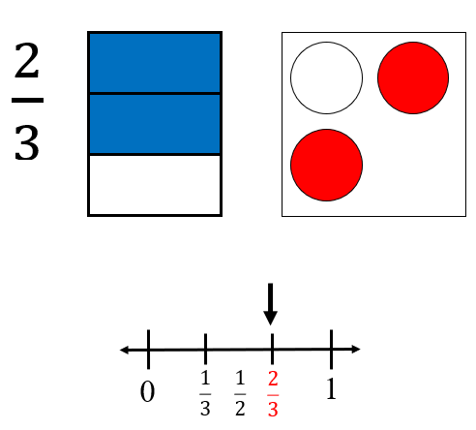

Fraction:
Models for three-eighth

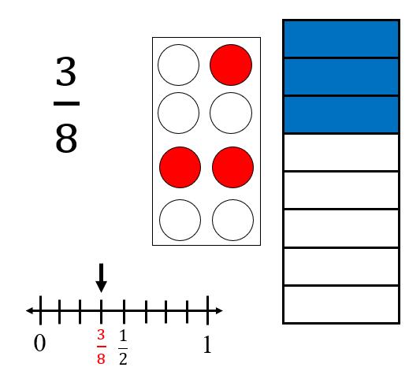
Numerator/ Denominator

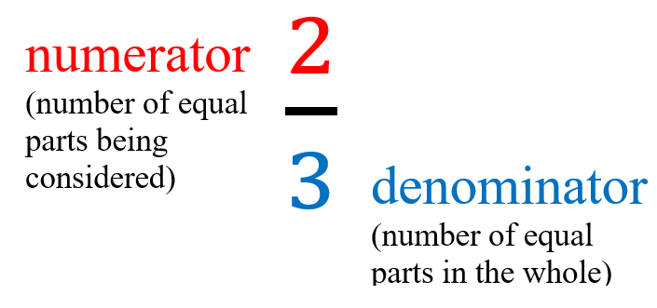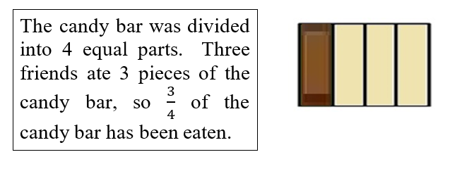

Mixed Number

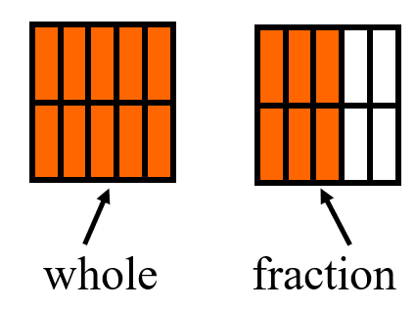

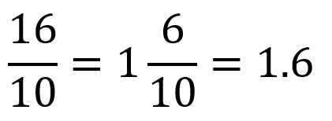

Equivalent
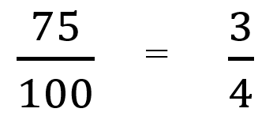

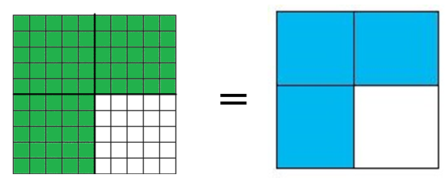

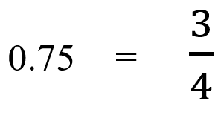

Equivalent Relationships

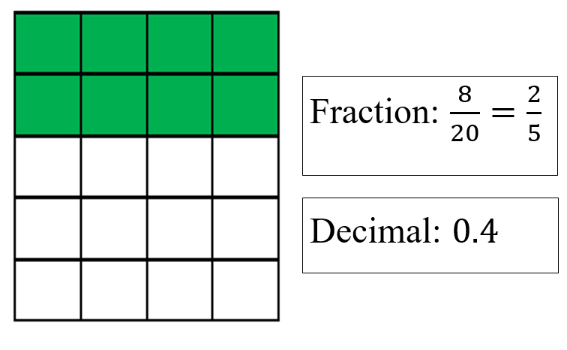

Integers

whole numbers and their opposites

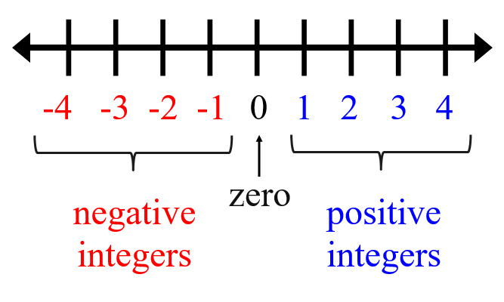

Comparing Integers

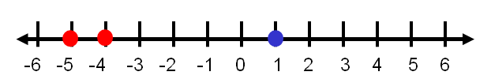

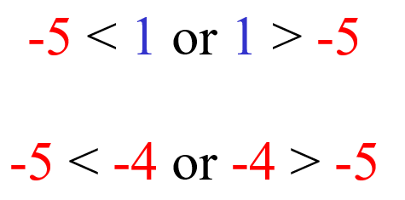

Perfect Squares

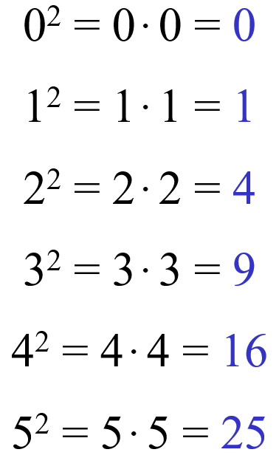

Perfect Cubes

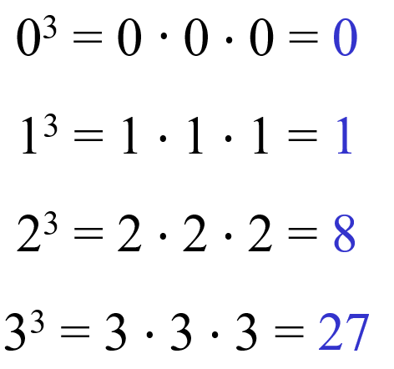

Exponential Form

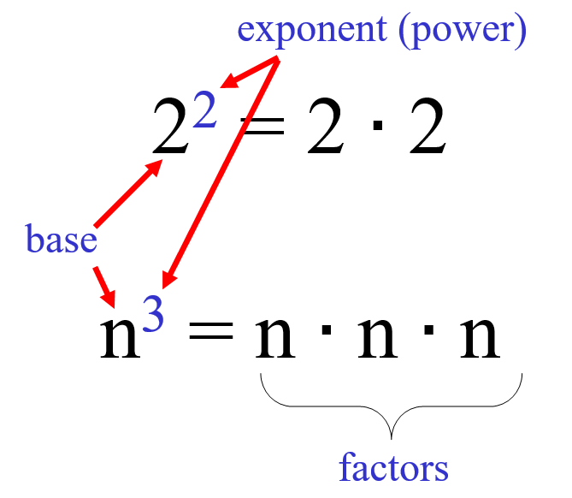

Even and Odd Numbers

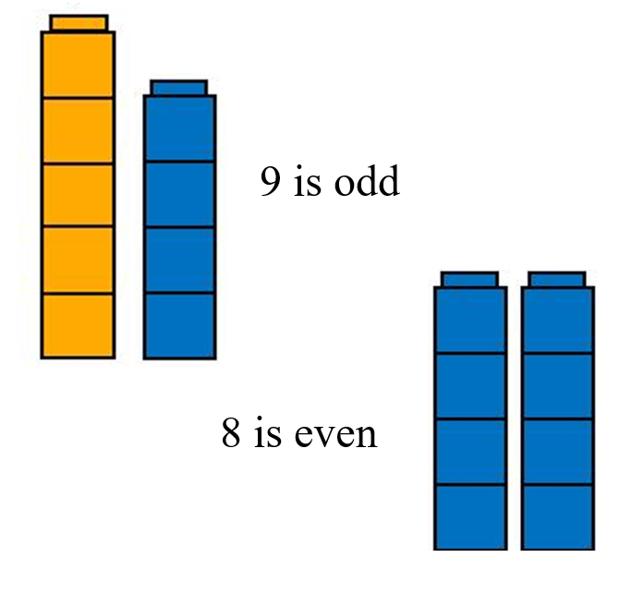
Even and Odd Numbers

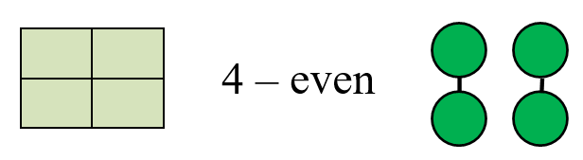

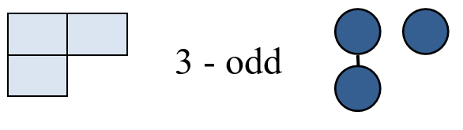

Compare

Ryan’s books Joe’s books

How many more books does Ryan have than Joe?

More Than

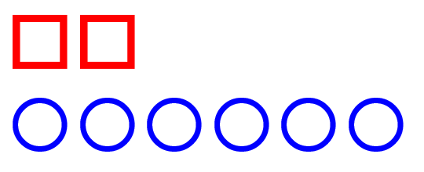

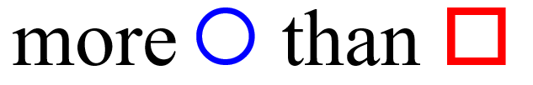

Greater Than

42

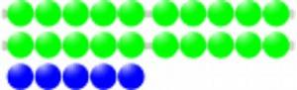

25

42 is greater than 25
Greater Than

> 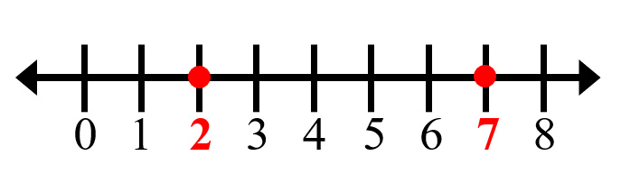

7 > 2

Fewer Than

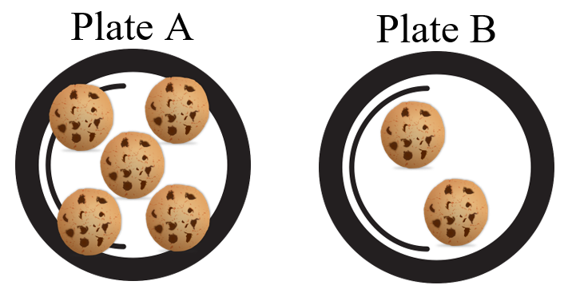

Plate B has fewer cookies than Plate A

Less Than

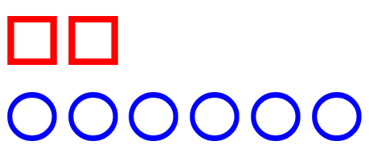

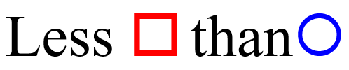

Less Than

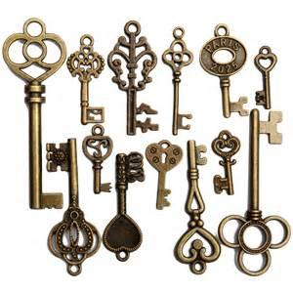
13 keys

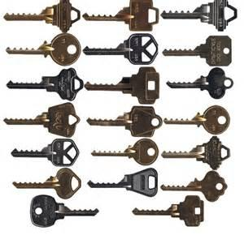
20 keys

13 is less than 20

Less than
<

2 < 7

Equal To

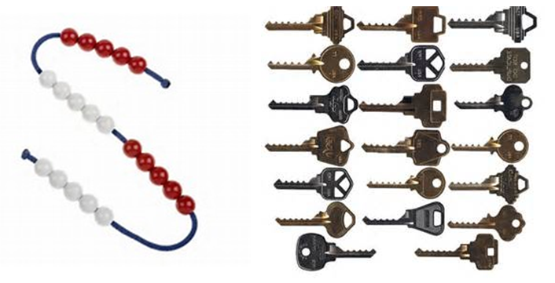

20 beads 20 keys

20 is equal to 20

Equal to
=

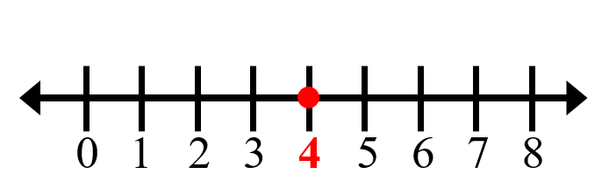

4 = 4

Closest to

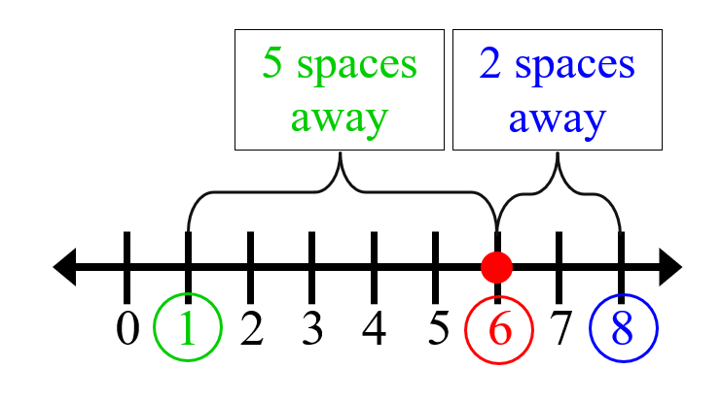

6 is closest to 8

Computation
And
Estimation

Equal
has the same value

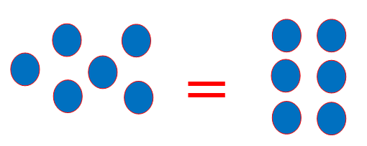

6 = 6
1 + 5 = 2 + 4
6 = 3 + 3
Equal
has the same value
=
9 + 24 = 10 + 23
45 – 9 = 46 – 10

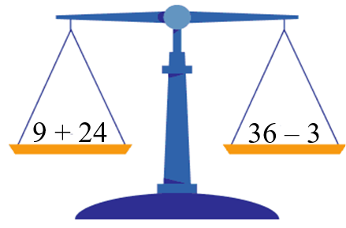
Not Equal

does not have the same value

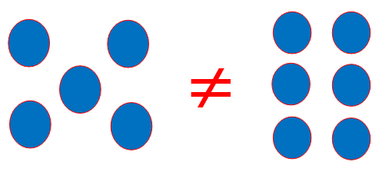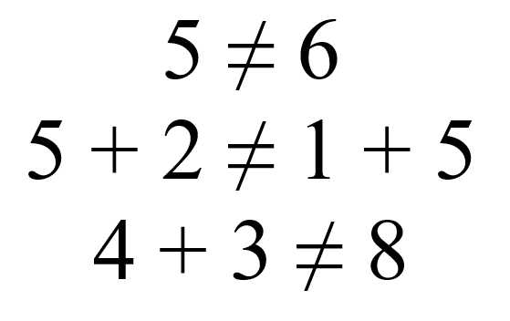

Not Equal

does not have the same value ≠

15 + 16 ≠ 31 + 15
14 + 3 ≠ 8

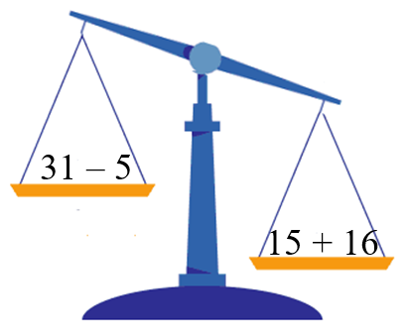

Addition
(add)

3 dogs and 1 dog is
4 dogs

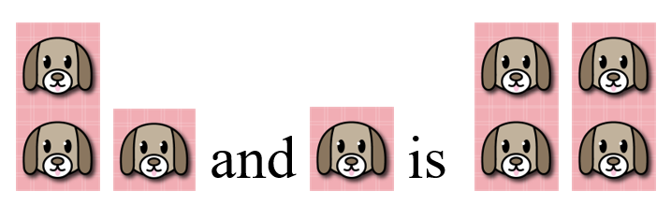

Addition

9 + 3 = 12
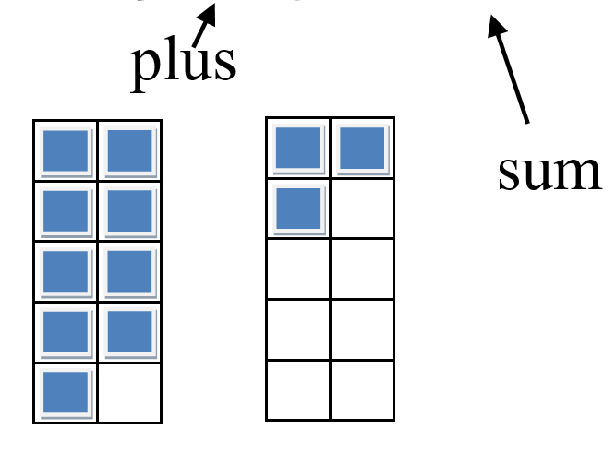

Join

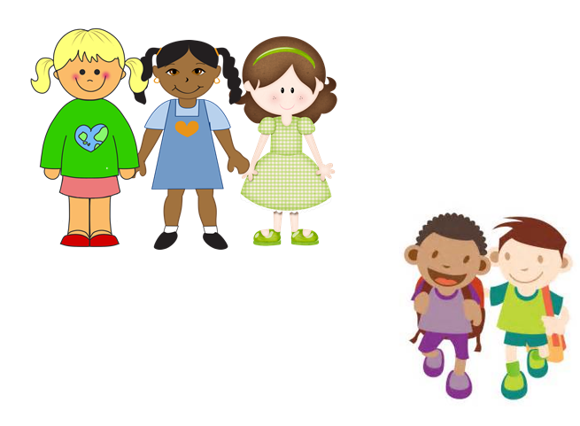

How many girls and boys are there?

Subtraction

(subtract)

6 cupcakes take away 2 cupcakes is 4 cupcakes

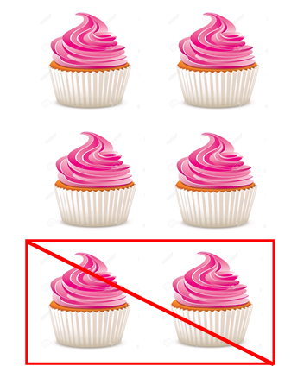

Subtraction

(subtract)
8 – 2 = 6
minus difference

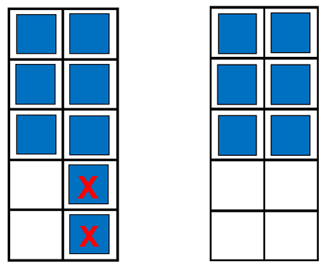

Separate

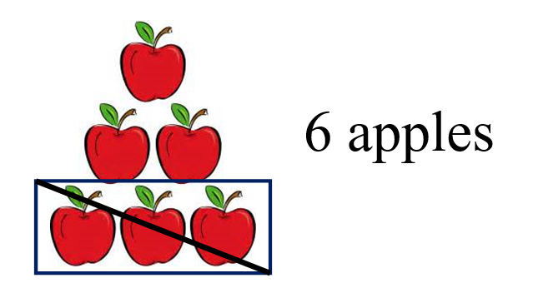

3 were eaten

How many are there now?

Multiplication

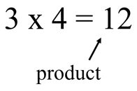

Multiplication

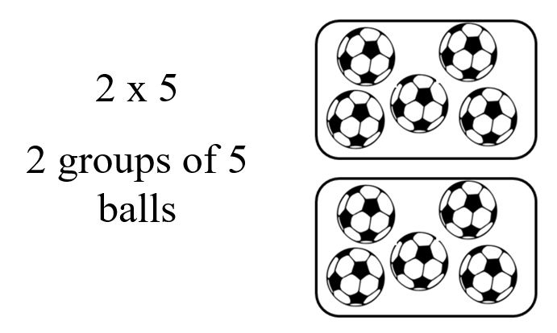

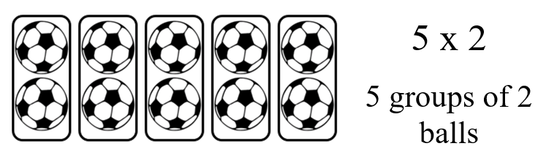

Number Line

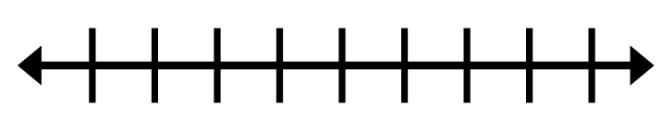

Number

Line Model

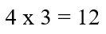

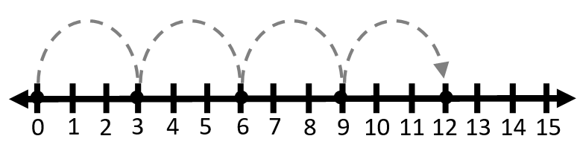

Division

15 pieces of candy shared with friends

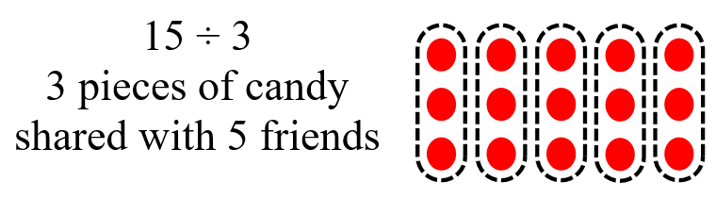
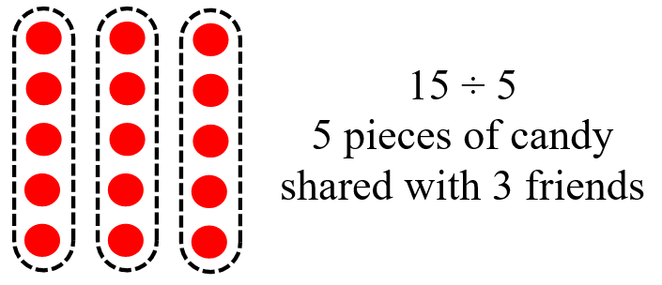

Division

Number Line

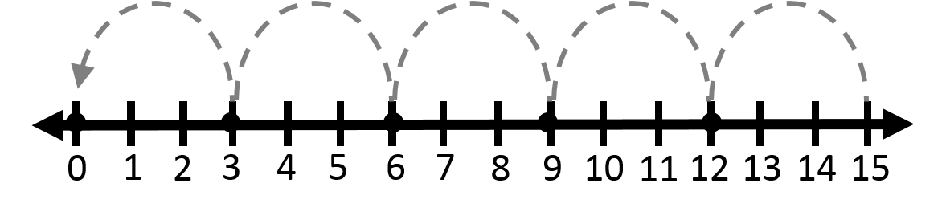

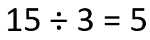

Fraction
Addition

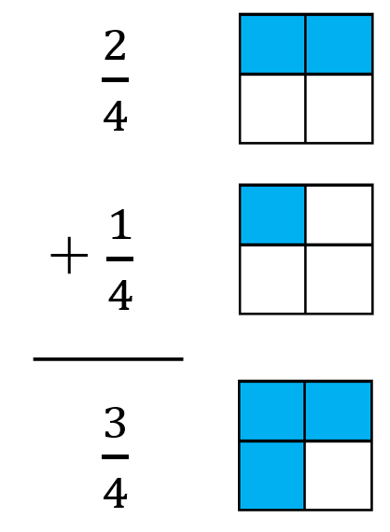
Fraction
Subtraction

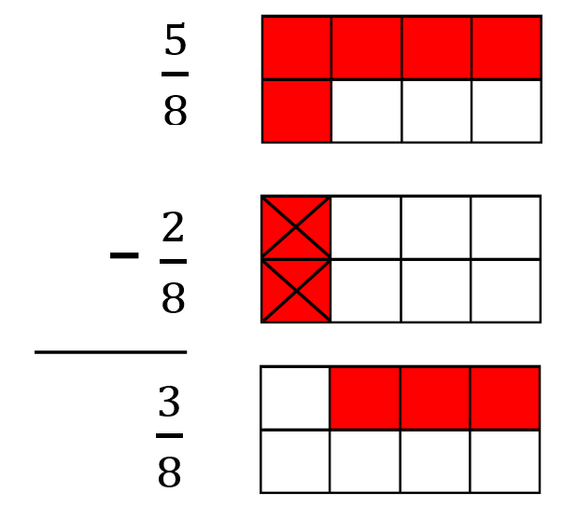

Integer Operations

Addition

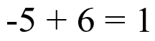
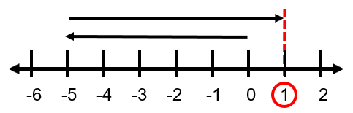

Subtraction

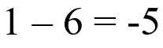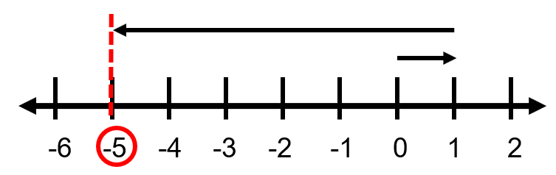

Integer Operations

Key:
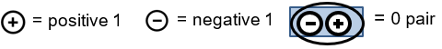

Addition
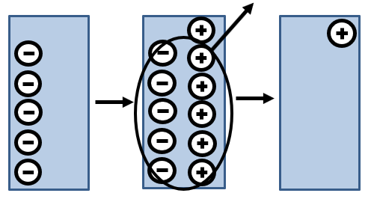
Subtraction
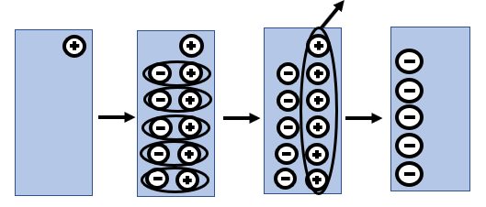
Integer Operations

Multiplication

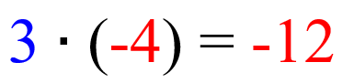

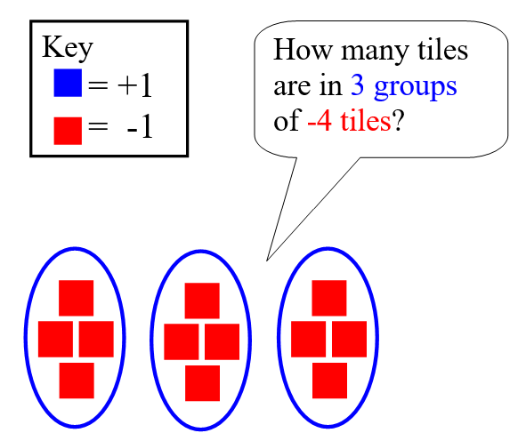

Integer Operations

Multiplication

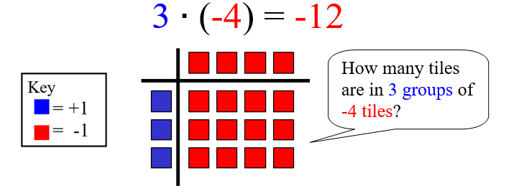

Division

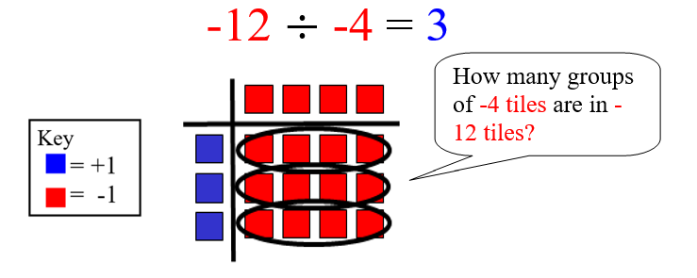

Measurement

Penny

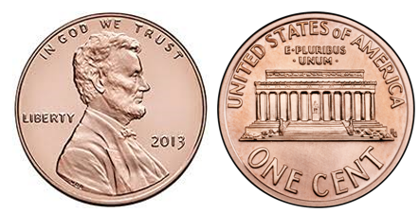

1¢

one cent

Nickel

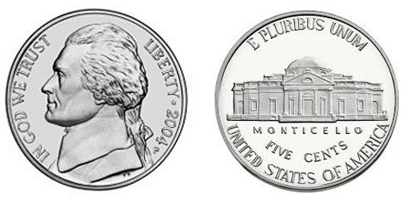

5¢

five cents
Nickel

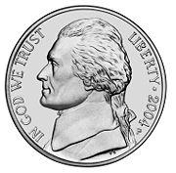

one nickel equals five pennies

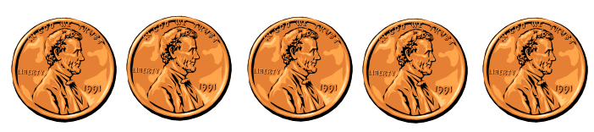
5¢
5 cents

Dime

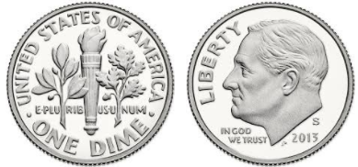

10¢
ten cents

Dime

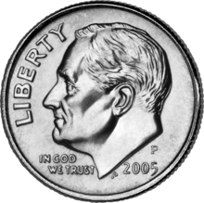

one dime equals ten pennies

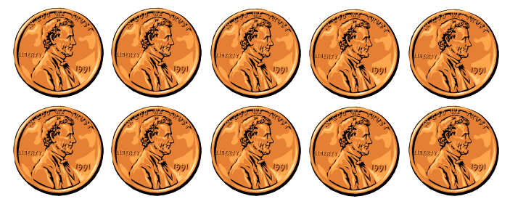

10¢
10 cents

Quarter

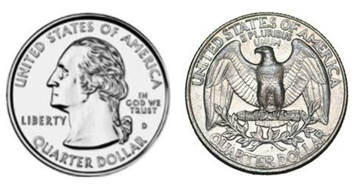

25¢
twenty-five
cents

Quarter

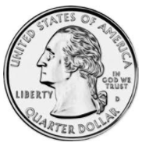

one quarter equals twenty-five pennies

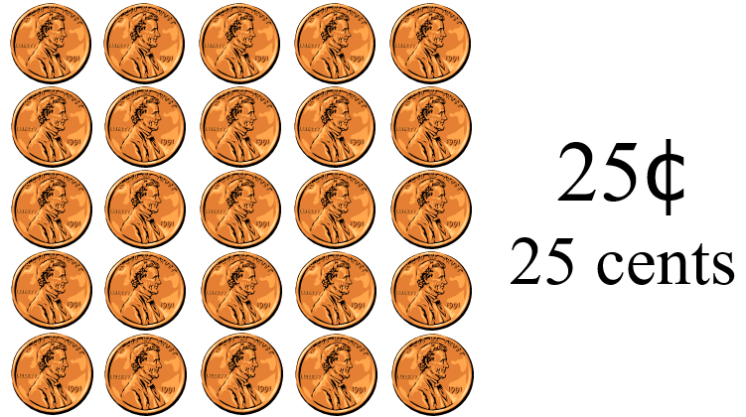

Dollar

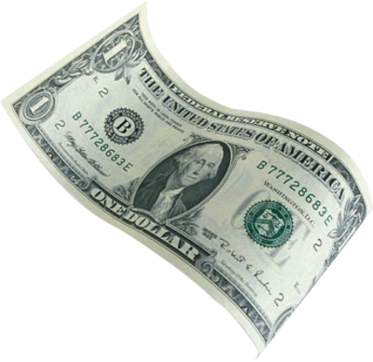

$1.00
one hundred cents

Clock
time

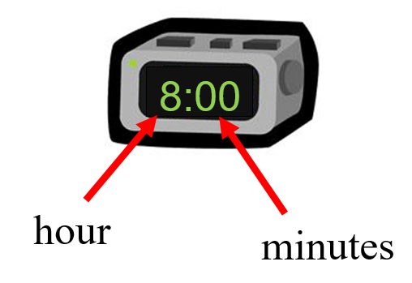

digital
Clock
time

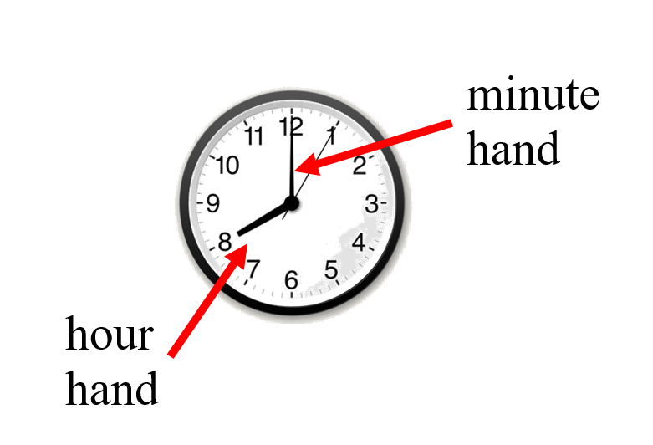

analog
Clock
time

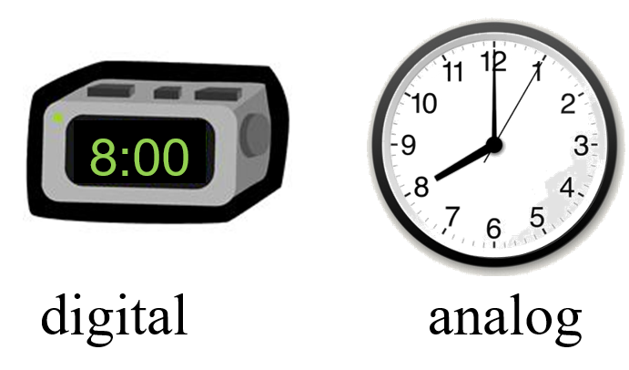

Clock
minutes, one-half Hour, one Hour

30 minutes = one-half hour
60 minutes = 1 hour
24 hours = 1 day
Midnight

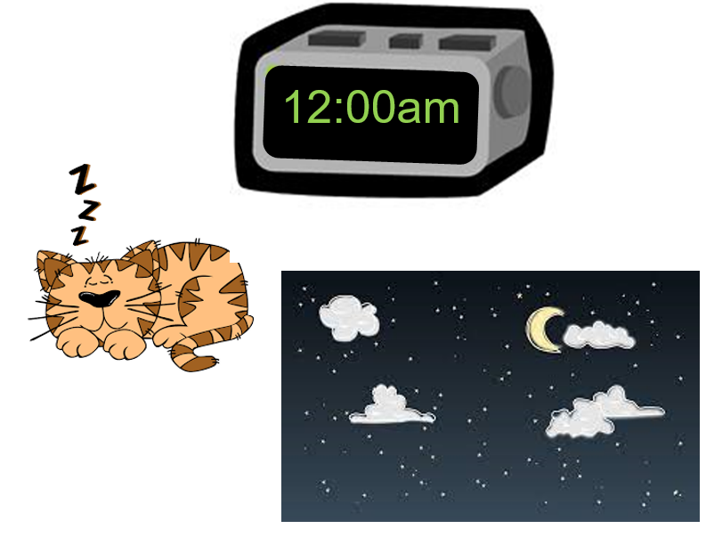
Noon

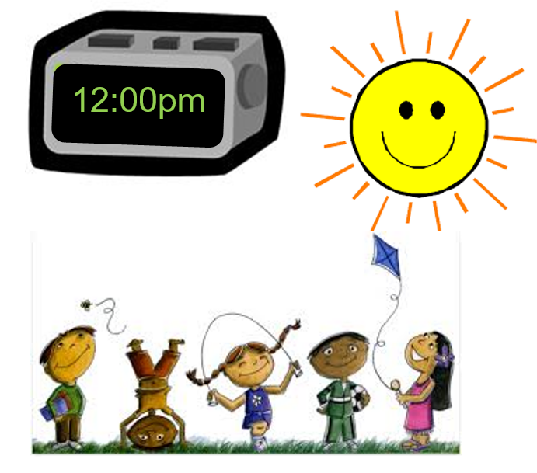
AM

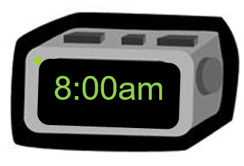

midnight to noon

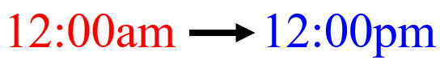
PM

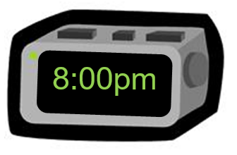

noon to midnight

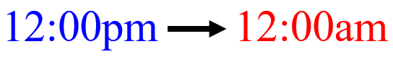
Clockwise

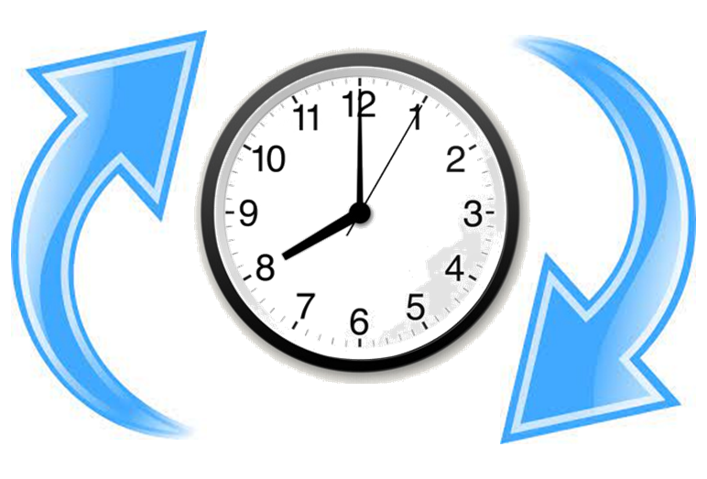

Elapsed Time
amount of time that has passed between two given times

The movie starts at 2:00 p.m. and ends at 5:00 p.m.

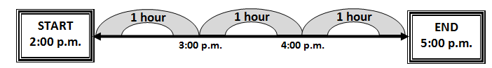

The movie is three hours long.

Elapsed Time
amount of time that has passed between two given times

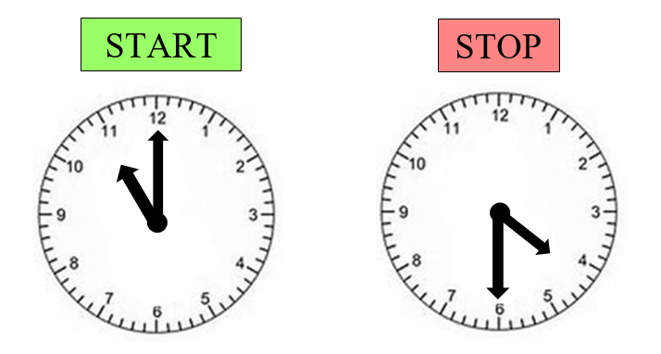
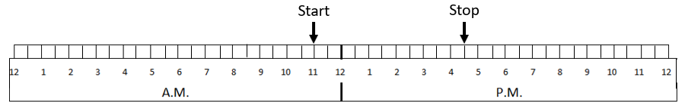

Weight heavier/lighter

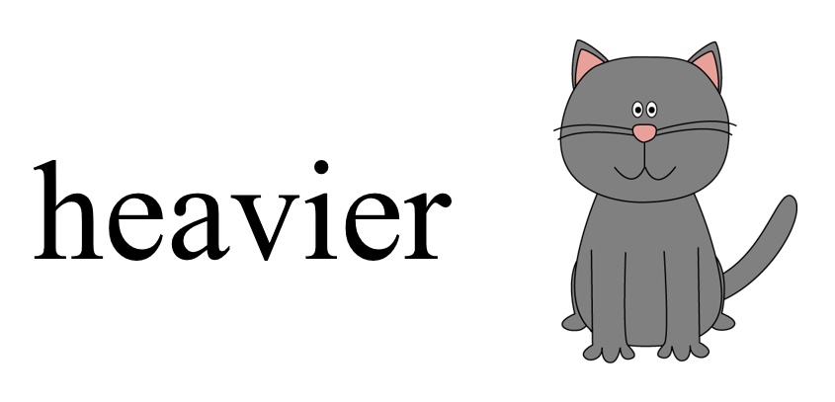

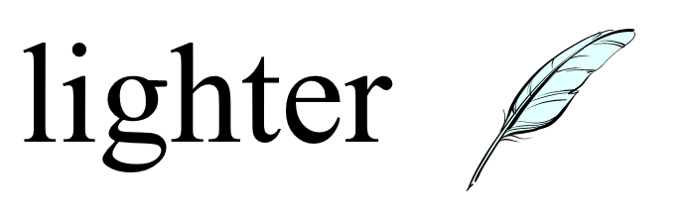

Length
longer/shorter

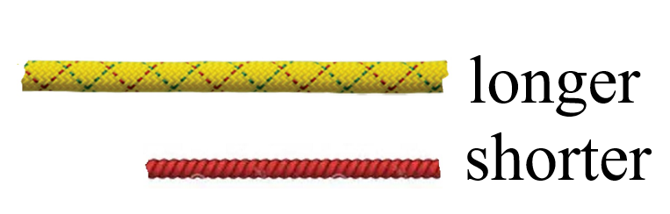

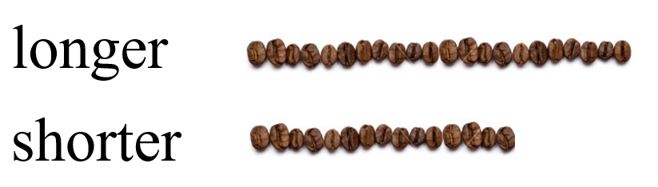

Height
taller/shorter

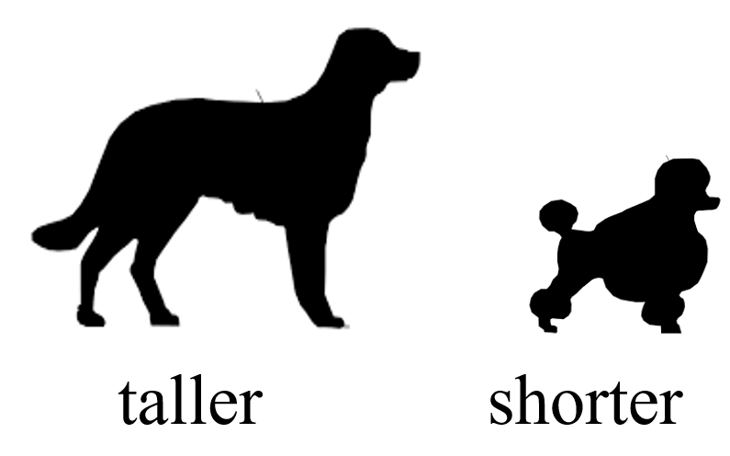

Temperature
hotter/colder

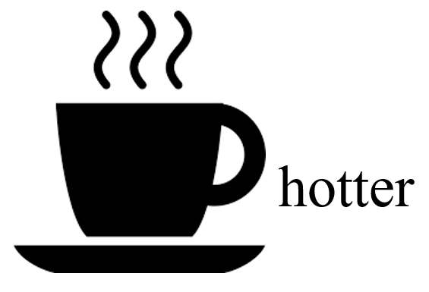
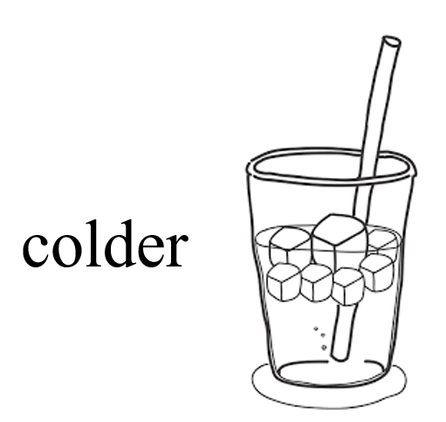

Volume
less /more

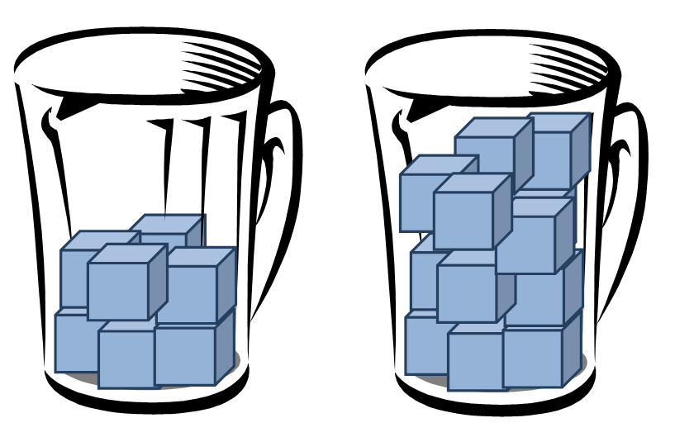

less more

Ruler

1 inch

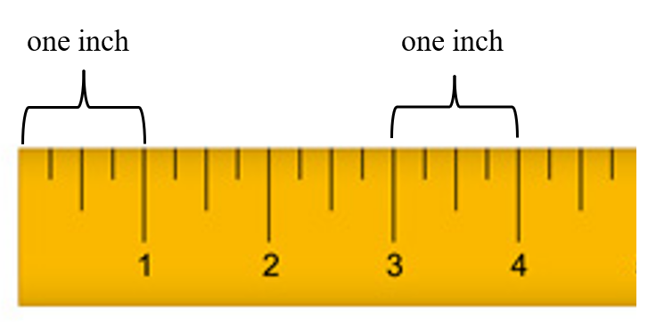

Ruler
centimeter/inch
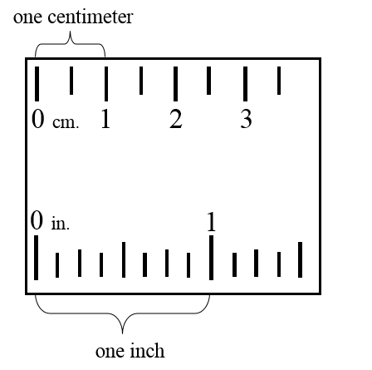

Ruler

inch/foot

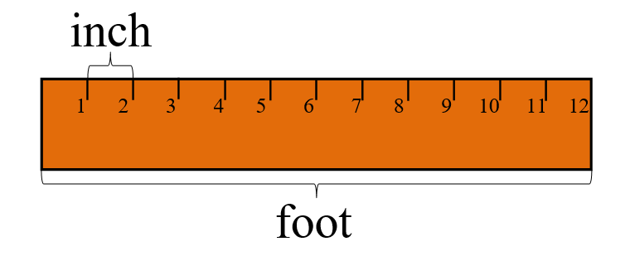

Balance
Scale
weight/mass

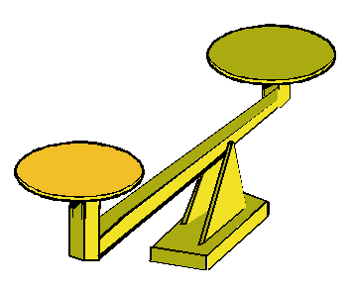

Scale
weight/mass

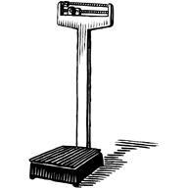

Pound (lb)

weight

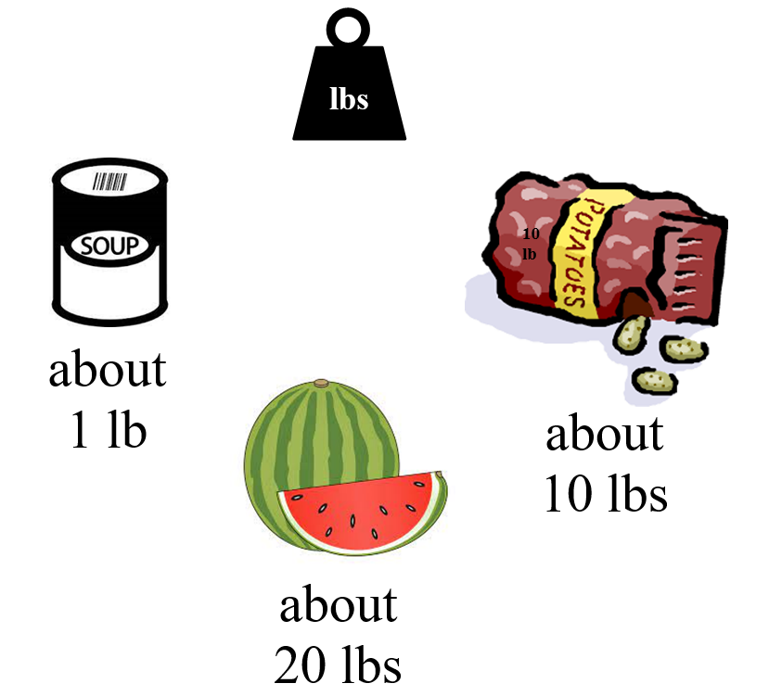

Area
square units
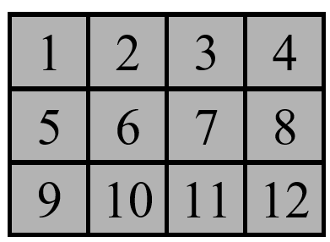

12 square units

Area
square units

length x width
3 x 4 = 12

12 square units

Perimeter
units

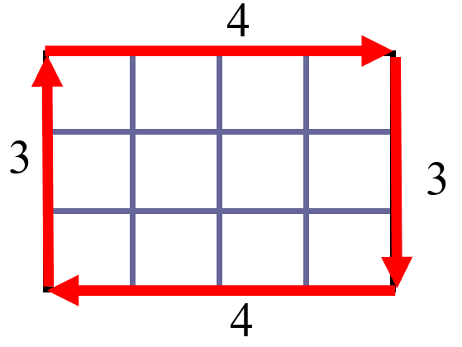

3 + 4 + 3 + 4
14 units

Volume
length, width, height
V=lwh

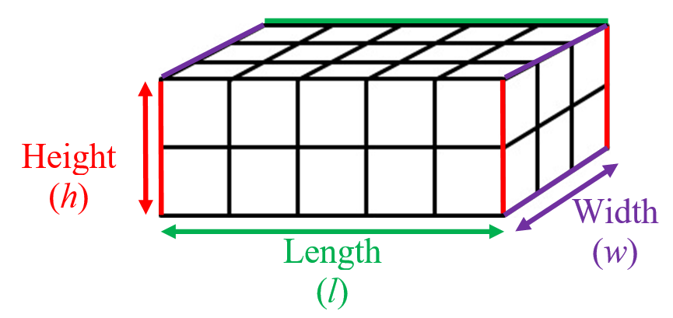

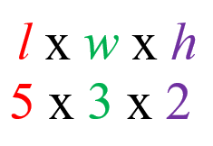

volume = 30 cubic units

Volume
area of the base times the height
V=Bh
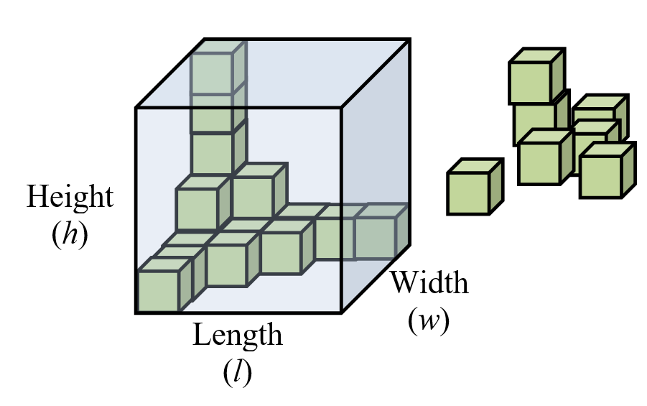
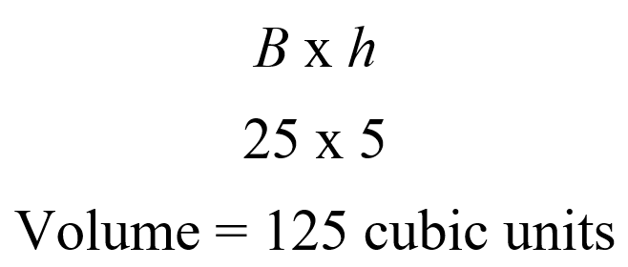

Geometry

Point

Line Segment

Line

Angle

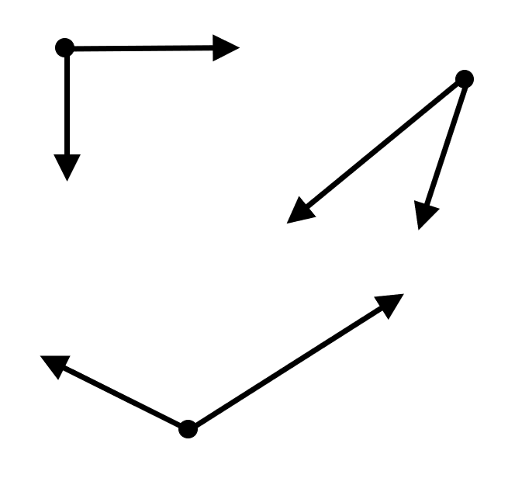

Circle

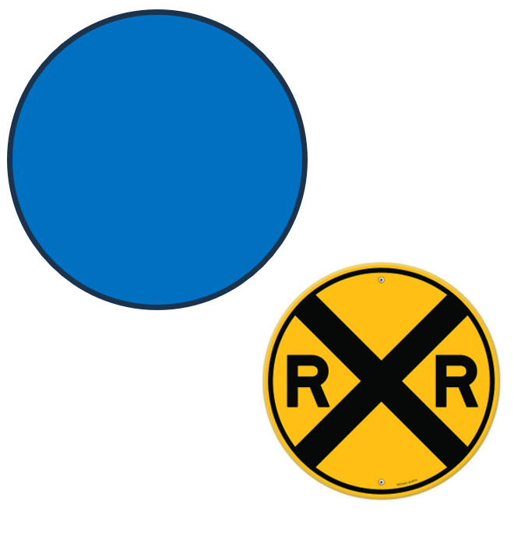

Triangle

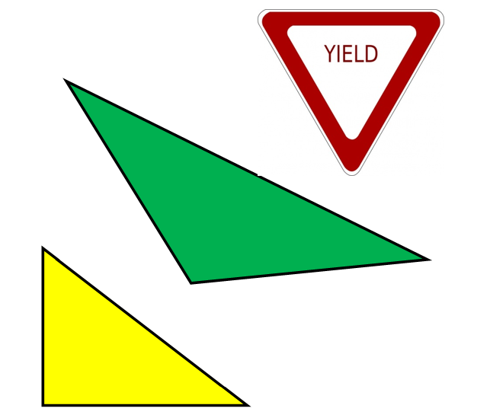

three-sided figure

Square

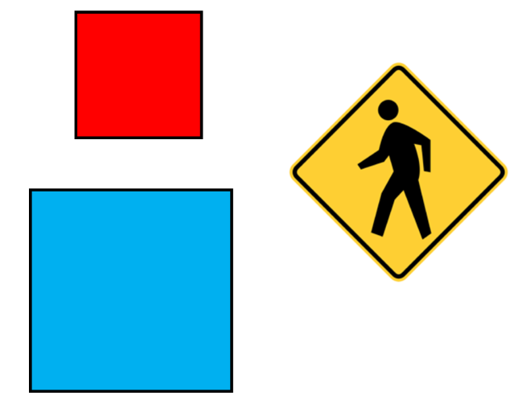

four-sided figure

Square
all angles are right angles
all sides are congruent

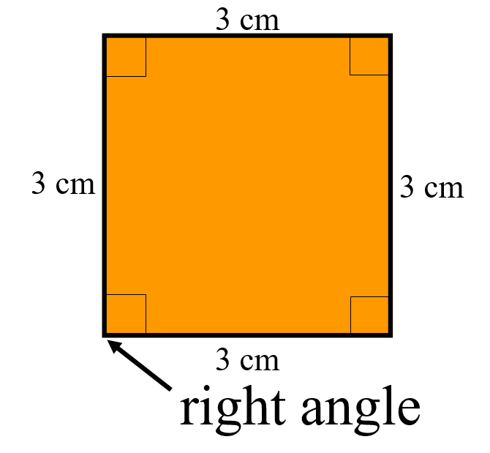

Rectangle

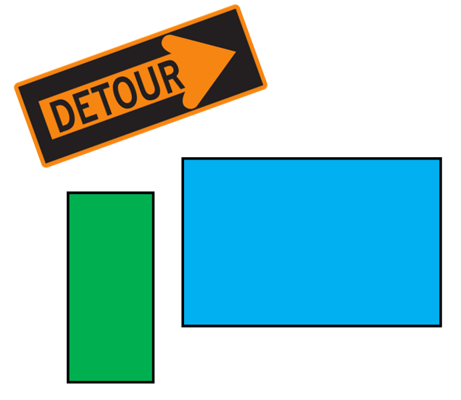

four-sided figure

Rectangle
all angles are right angles
opposite sides are congruent

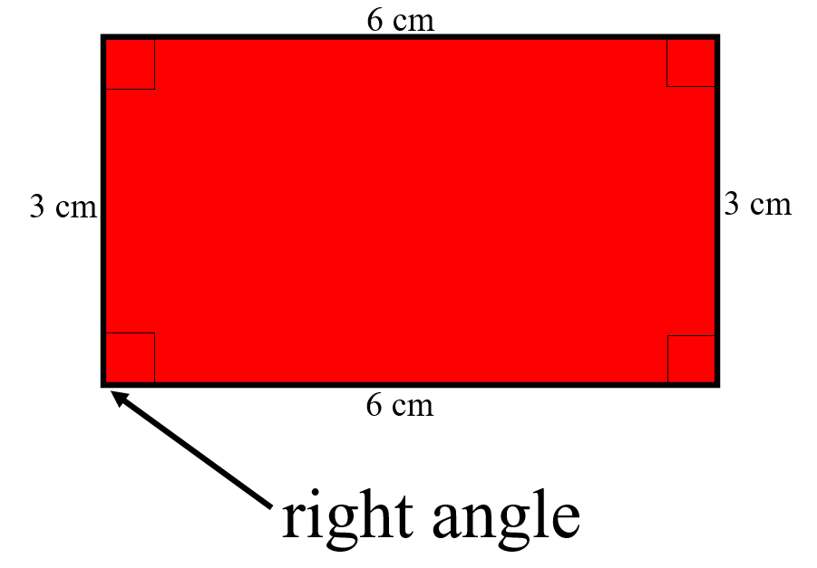
Pentagon

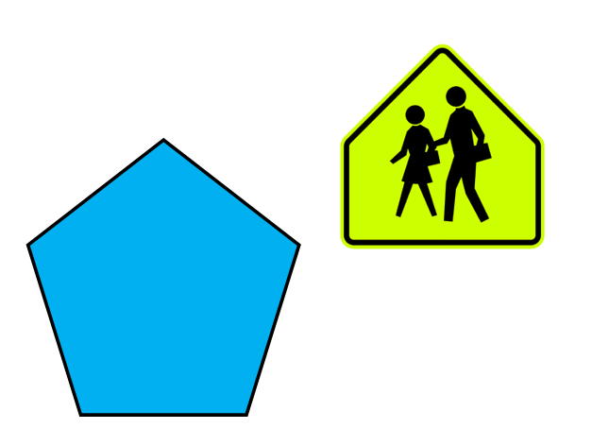

five-sided figure

Hexagon

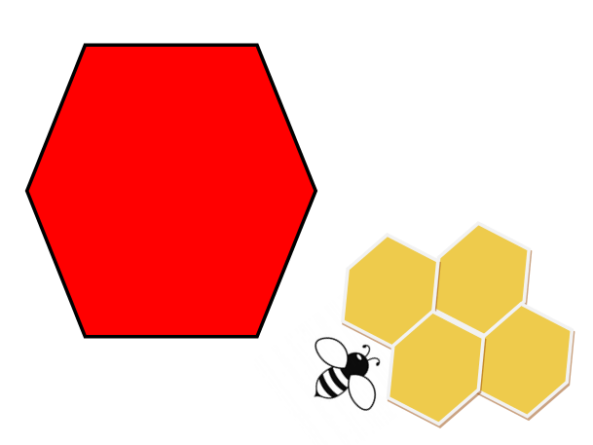

six-sided figure

Octagon

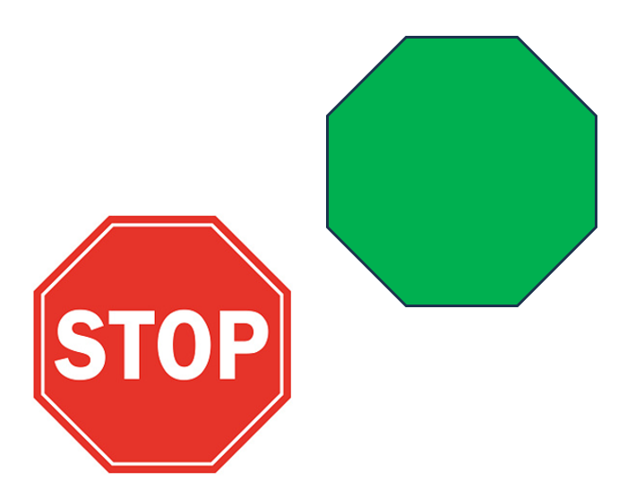

eight-sided figure
Smaller/Larger

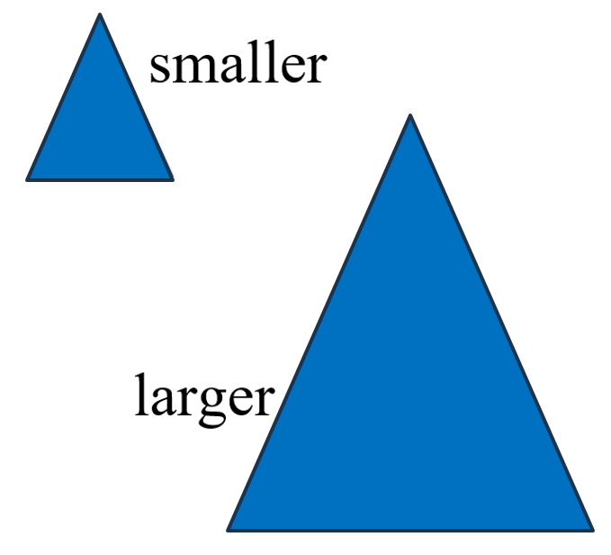

Same

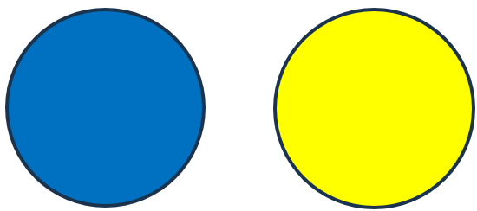
same shape
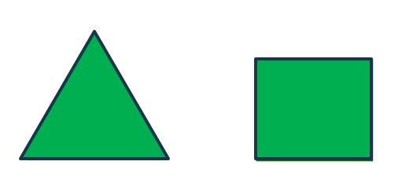
same color

Congruent

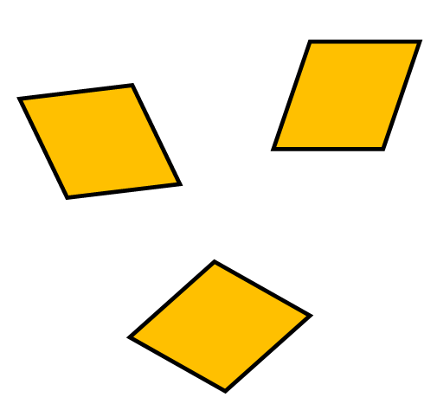

same shape and size

Similar Figures

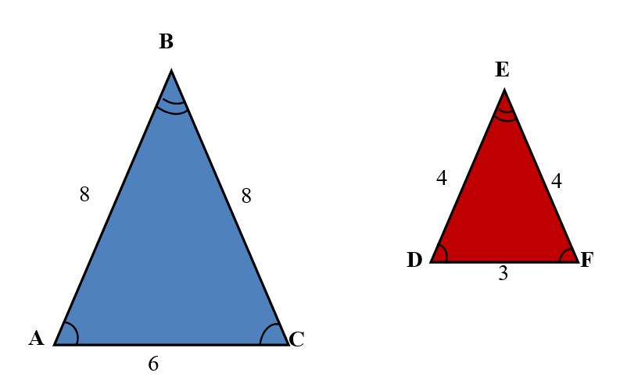

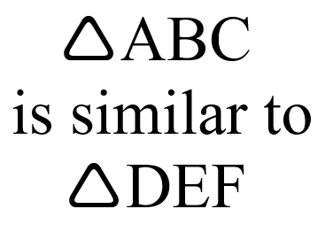

Coordinate Plane

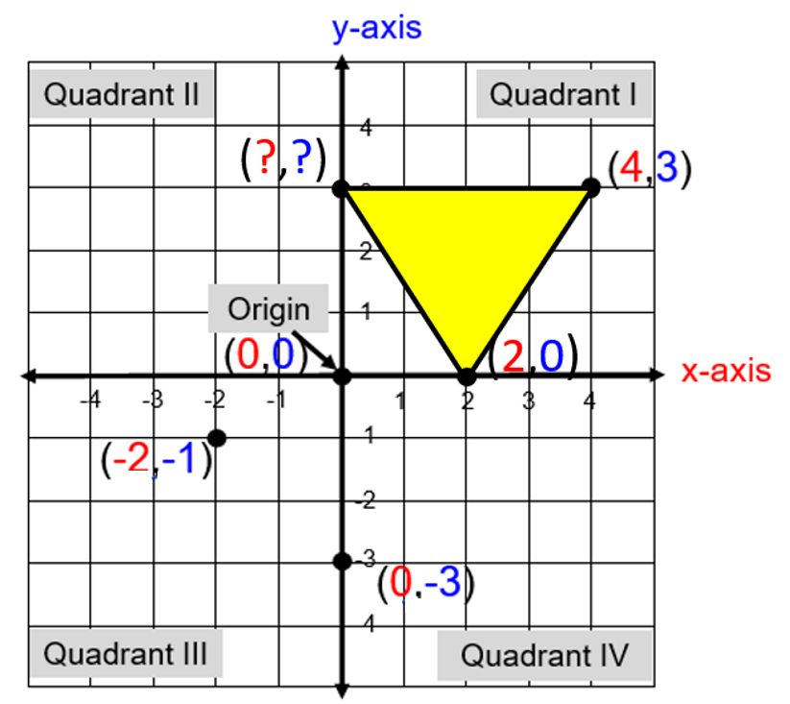

ordered pair (x,y)

Coordinate Plane

(Quadrant I Only)

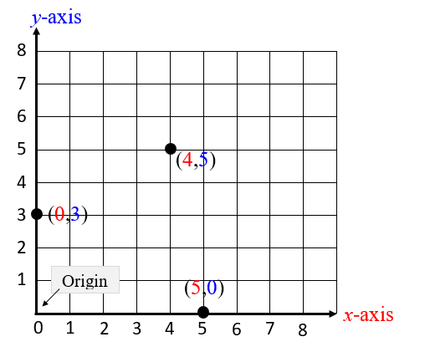

ordered pair (x,y)

Coordinate Plane
(Quadrant I & II Only)

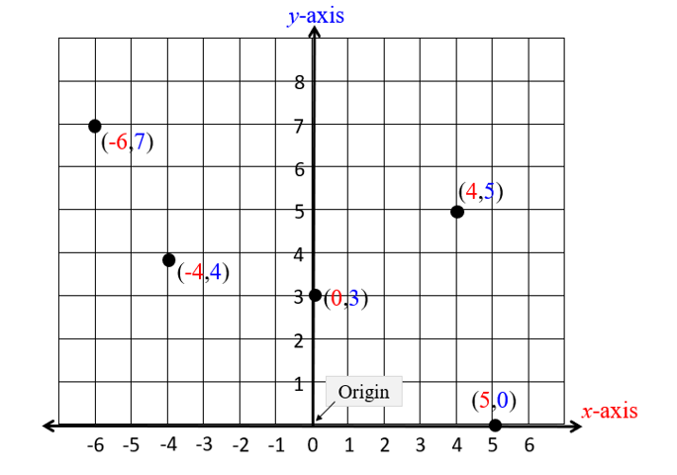

ordered pair (x,y)

Probability and Statistics

Probability Number Line

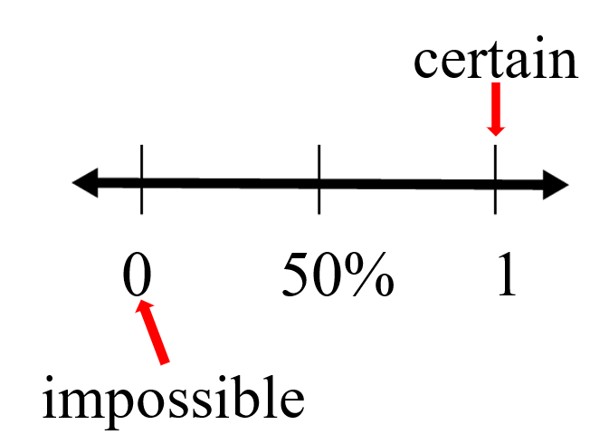

Certain

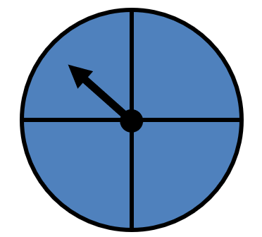

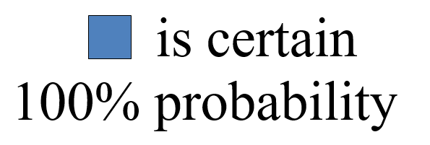
Likely

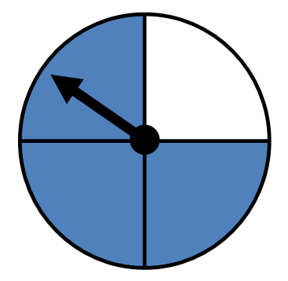

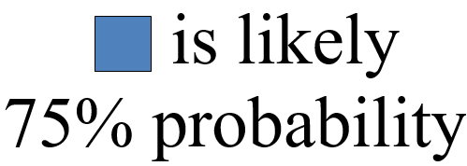

Unlikely

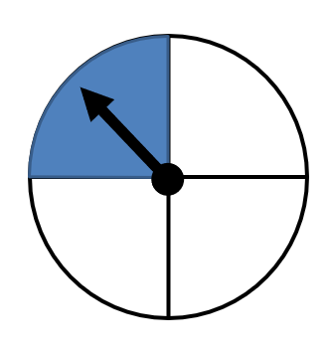

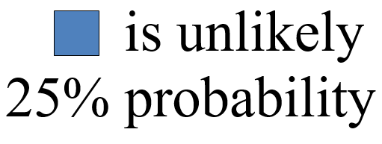

Equally likely

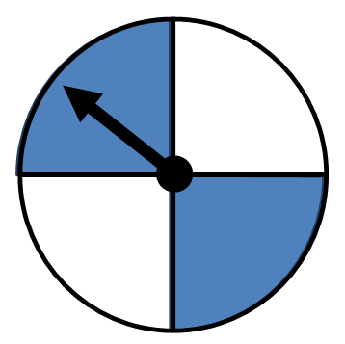

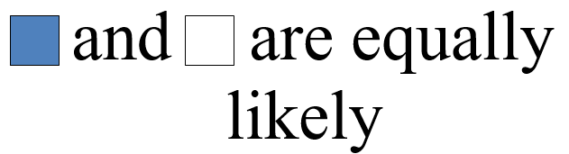

50% probability

Impossible

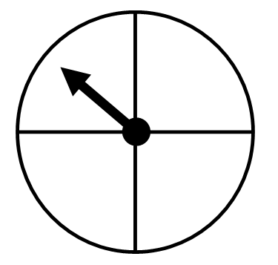

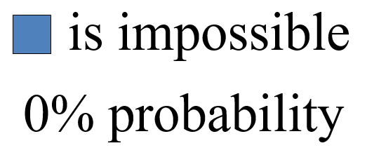
Table

Pets
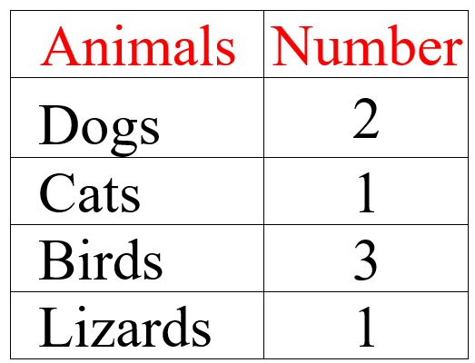

Picture Graph

Our Favorite Pets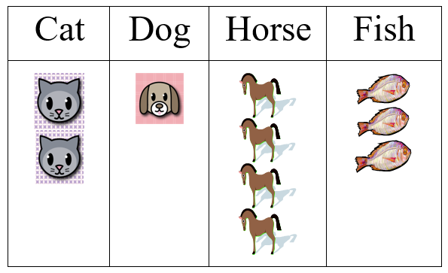

Pictograph

Our Favorite Pets
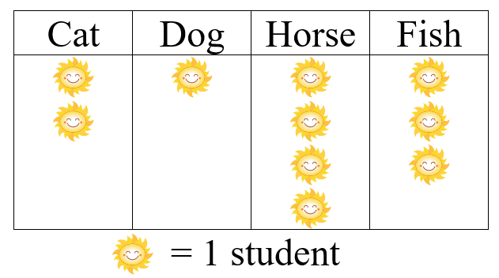

Bar Graph

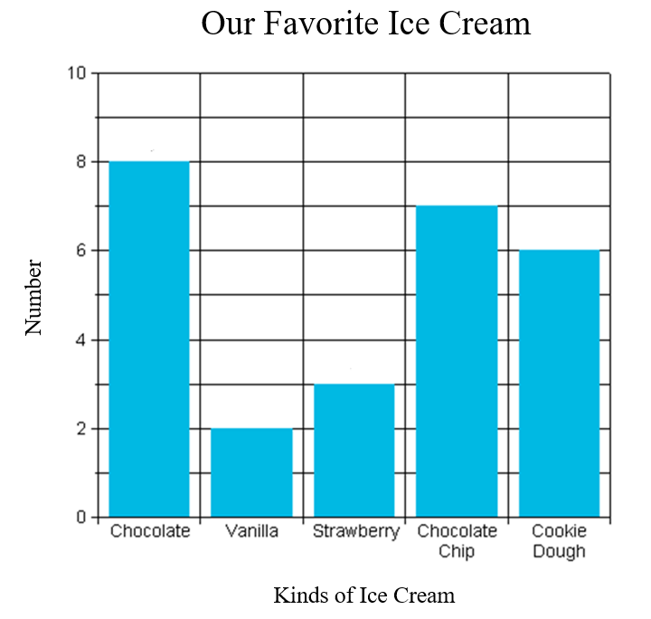

Line Graph

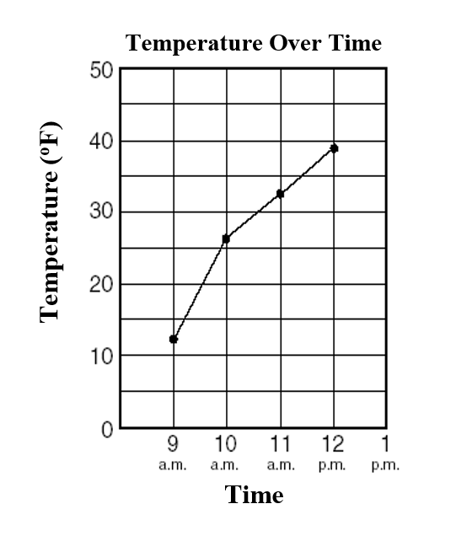

Line Plot

Number of Pets

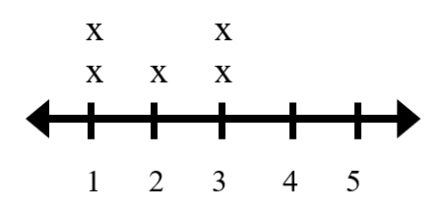
x represents 1 pet

Scatterplot

shows the relationship between two sets of data

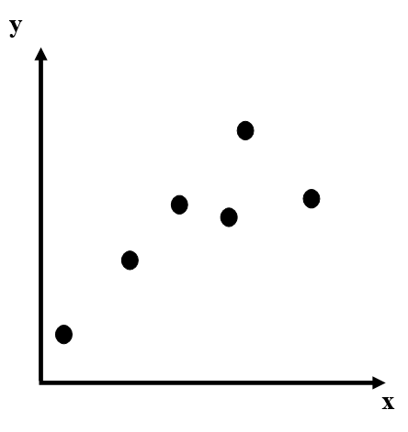

Positive Relationship

Points slope from lower left to upper right.

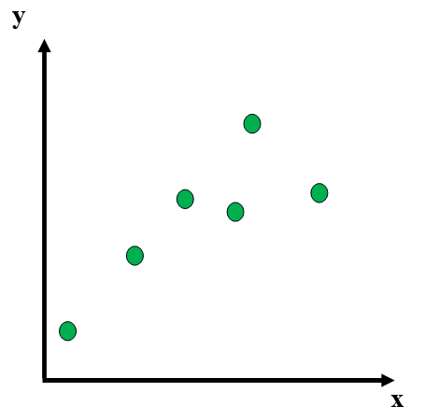
Negative Relationship

points slope from upper left to lower right

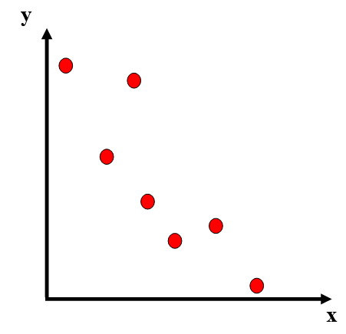

No Relationship

No relationship exists

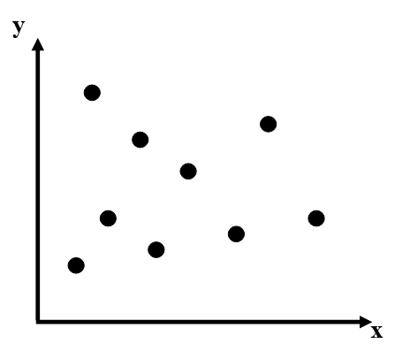

Mean
fair share

4, 7, 6, 6, 7

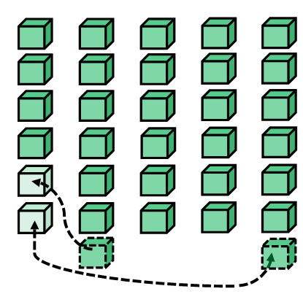

the mean is 6

Mean

fair share or
average

6, 9, 8, 8, 9

6 + 9 + 8 + 8 + 9 = 40
40 ÷ 5 = 8

mean = 8

Patterns, Functions and
Algebra

Counting by Twos
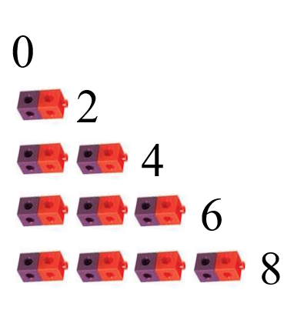

Counting by Fives
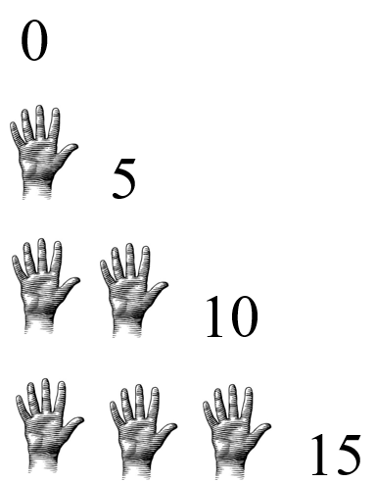

Pattern
growing patterns

Input output table
8, 10, 13, 17, __

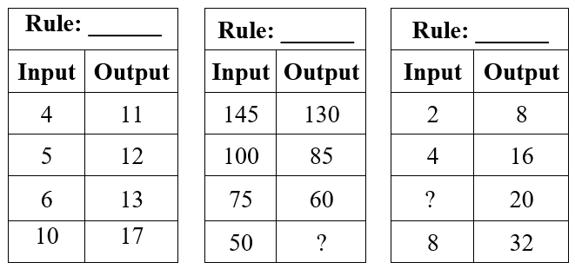

Proportional Relationship

Terry’s neighbor pays him $10 for every 2 hours he works.

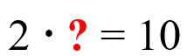

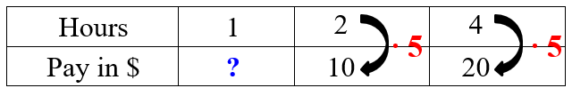

How much does Terry earn per hour?

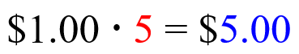

Terry earns $5.00 per hour

Connecting Representations
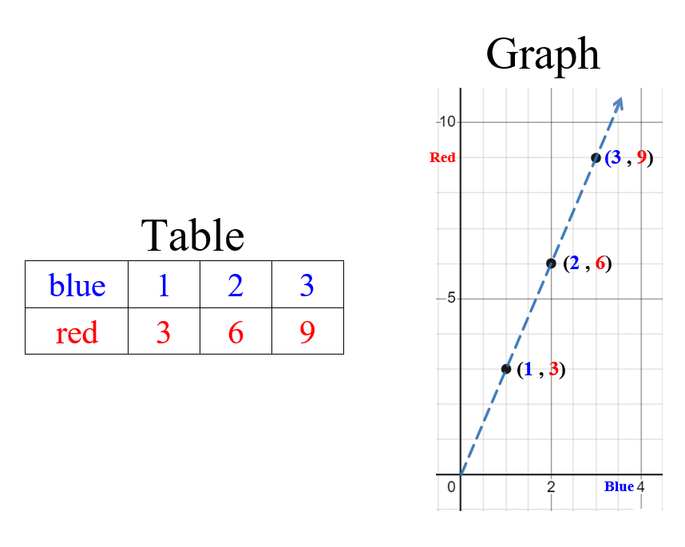

Function

{(-1,1), (0,1), (2,3), (4,1)}

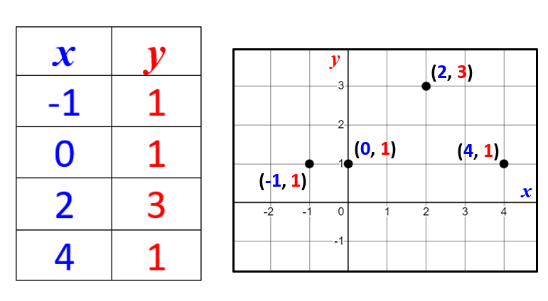

Slope

rate of change or

the “steepness” of the line

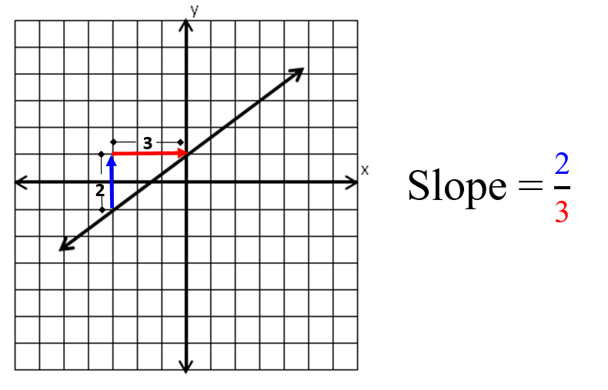

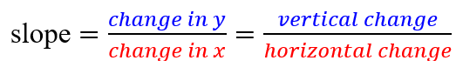

Slope

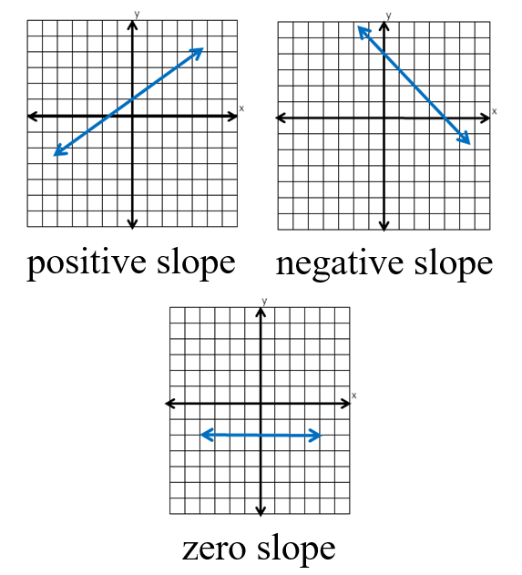

Equation
(Number Sentence)

8 = 3 + 5
6 – 2 = 4
75 = 50 + 25

Expression
a representation of a quantity

12.8

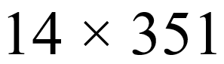

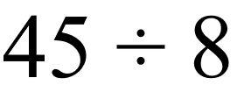

Variable
a symbol used to represent an unknown quantity

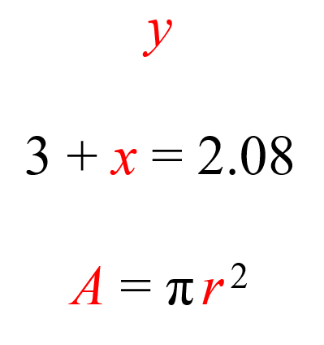

Variable Expression

an expression that contains numbers, operations, and variables

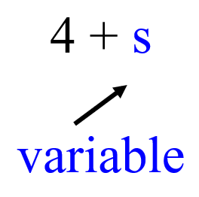

Term

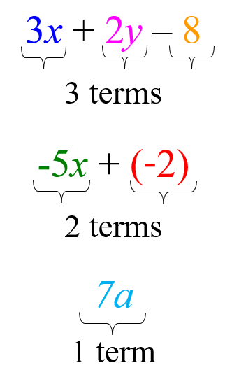

Constant

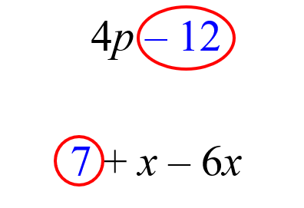

Like Terms

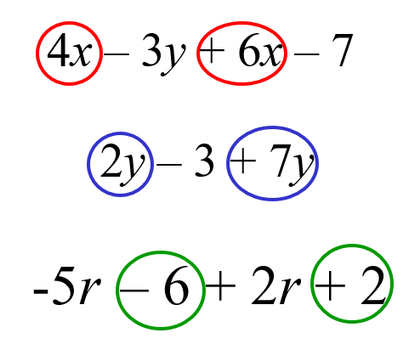
Verbal to Algebraic

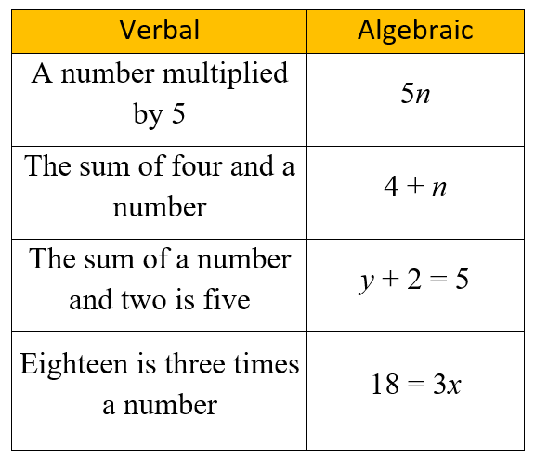
Verbal to Algebraic

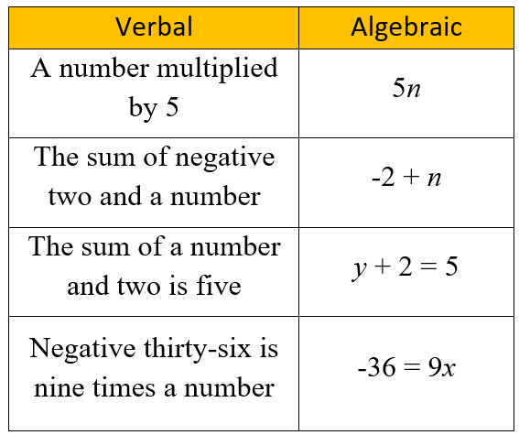

Order of

Operations

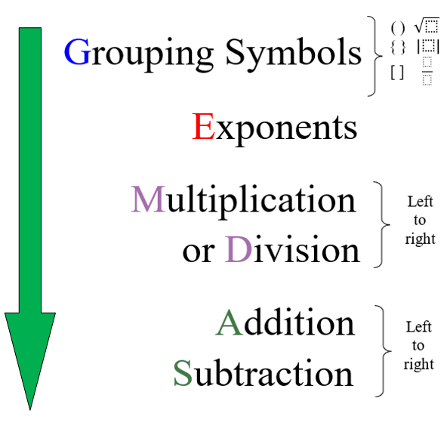

Equation
a mathematical sentence stating that two expressions are equal

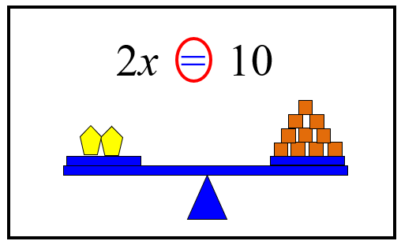

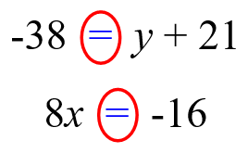
Equation
a mathematical sentence stating that two expressions are equal

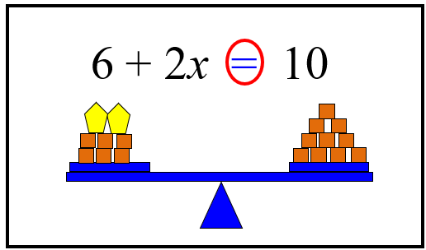

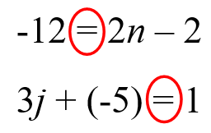
Inequality

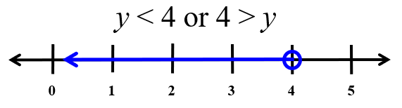

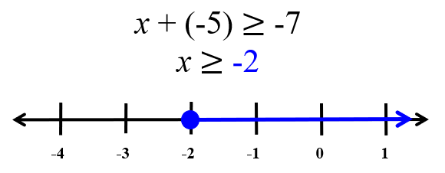

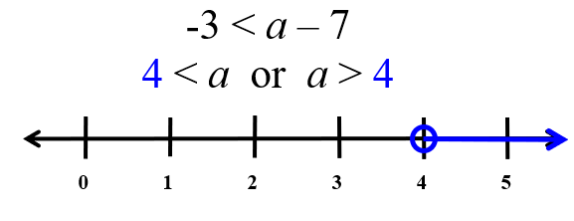
Sales Tax
