What’s Missing? A Lesson on Finding the Missing Number

Grade Level: 5th
Subject(s):
Primary: Math
Integrated Activity: Reading, Science
Reporting Category: Probability, Statistics, Patterns, Functions, and Algebra
Lesson Summary and Connections:
Students will learn strategies to skip count including number cards, number line, and/or a hundred chart, to determine the number of objects up to 60 items, and to find the missing number in a pattern.
Lesson Components Links
VESOL(s)  Complexity Continuum | Functional Skills | Assistive Technology | Materials
Vocabulary | Common Misconceptions | Student-Friendly Outcome(s) | Introductory Activity
Plan for Instruction | Differentiation | Reflection | Formative Assessment
Word Wall Cards | Supplemental Materials | Practice Items | Integrated Activity

VESOL(s):
M-5.17: The student will identify a missing number in a pattern when given an addition rule.
Complexity Continuum:
The patterns with a missing number could have a rule of +1, +2, +3, +4, +5, or +10 with numbers ranging from 1 through 60.

Integrated Activity VESOL:
S-5.8: The student will recognize oceans and identify the organisms that live in them.
R-5.2:The student will answer questions about a fiction passage that is read to the student or that the student reads.

Functional Skill(s):
- Skip counting, sequencing, counting, patterns
- Identifying patterns can improve student problem-solving skills.
- Applying counting skills to a real-world situation, such as counting animals at an aquarium
- Incorporating skip counting with telling time and counting money

Assistive Technology/AAC (Augmentative and Alternative Communication):
  - Number or picture cards
  - Items to sort/count
  - Enlarged materials for students with vision impairment
  - White boards and markers
  - Number line - enlarge or highlight to meet the needs of students
  - Individual student communication devices should be programmed with numbers for counting and responding.

Materials:
- Introductory Activity:
  - Spunky Monkeys on Parade by Stuart Murphy, illustrated by Lynne Cravath (check your school or local library)
    - Another text with skip counting may be substituted.
  - Pictures of monkeys (print and laminate) or counters to represent sets of monkeys
  - Materials (number line, counters, a hundred chart, calculator) per the accommodations in the student’s IEP
  - Pre/post assessment recording sheet
- Instruction:
  - Skip counting videos (links to Jack Hartmann are included in the plans)
  - Number lines – 1 per student (digital links are included in the plans)
  - Hundred charts – 1 per student
  - Dry erase sleeves or sheet protectors
  - Dry erase markers and erasers
  - Counters
- Integrated Activity:
  - Ocean animal figures or cards (up to 60)
  - Non-examples of ocean animals such as monkeys (from earlier activity) and non-ocean objects (see VESOL details)
  - Clear plastic containers or bowls (up to 10) for sorting
  - Dry erase board and marker/eraser, or paper and pencil
  - Materials (number line, counters, hundred chart, calculator) per the accommodations in the student’s IEP

Vocabulary:
Prior Knowledge What words will students need to know prior to starting the lesson?
- numbers | - counting | - counting by twos
- counting by fives | - counting by tens
Current Vocabulary What words will students learn during the lesson?
- Skip count | - Patterns

Common Misconceptions:
- Students may repeat the same number or the next number rather than follow the pattern.
- Students may think that to skip count, they will always have to start with 0. However, following an addition rule could begin with any number; therefore, as student ability allows, instruction may include patterns that begin with unexpected numbers. For instance, when adding 3, begin the pattern with 2 (2, 5, 8, ___, 14).

Student-Friendly Outcome(s):
- I can count.
- I can skip count.
- I can count by 2’s (or 3’s, 4’s, 5’s, or 10’s).
- I can find the missing number in a pattern.

Introductory Activity:
Use Spunky Monkeys on Parade by Stuart Murphy, illustrated by Lynne Cravath (request from the library or use a YouTube video) or a similar story that integrates counting by numbers.
- Read the text to (or watch a video with closed captioning on) the students.
- Assess student prior knowledge.
  - Print and laminate the monkey picture cards for student use.
  - Present a set of pictures (of 1, 2, 3, or 4 monkeys – other pictures or tangible items may be substituted).
    - Ask students to count by 1’s (or skip count by 2’s, 3’s, or 4’s).
    - Keep a record of results to determine growth by repeating the assessment at the end of the unit.
    - Allow students to use supports (counters, hundred chart, number line, calculator) per the accommodations in their IEP.
- If the student can skip count at least 4 numbers place a + in the appropriate column.
- If the student cannot skip count at least 4 numbers place a – in the appropriate column.
- Repeat the assessment at the end of the unit to determine growth.

Name | Pre/Post  1 | Pre/Post  2 | Pre/Post  3 | Pre/Post  4 | Notes
 | / | / | / | /
 | / | / | / | /
 | / | / | / | /
 | / | / | / | /
 | / | / | / | /
 | / | / | / | /
 | / | / | / | /
 | / | / | / | /
 | / | / | / | /
 | / | / | / | /
 | / | / | / | /
 | / | / | / | /
 | / | / | / | /
 | / | / | / | /
 | / | / | / | /

Plan for Instruction:
- After determining the student’s prior knowledge with the Introductory Activity, select the entry point for the lesson.

  - Students who need to start with number identification or counting by ones.
    - Assess which number are known and which are unknown.
    - Beginning with the lowest unknown number, present a card with that number.
    - State the name of the number, then ask the student to either state the number or touch the number. (Teacher says: 4. What number? Student responds: 4)
    - When the student can repeat the number ask them to state the number absent the prompt (teacher says: “What number?”, Student responds: 4)
    - When the student can state the number for 3 days in a row absent prompting, move on to the next number.
    - When two numbers are mastered, present both, one at a time, in random order.
    - Continue the process of introducing new numbers and reviewing known numbers until all numbers are known.

  - Students who are ready for skip counting.
    - These students can identify and rote count (by 1’s) numbers to 60.
    - Determine which skip pattern to instruct.
      - Skip counting by 5’s and 10’s can be tied to money and time. Teach these first.
      - Skip counting by 2’s can be tied to even and odd numbers.
      - Skip counting by 3’s and 4’s may provide more of a challenge and should be taught after other numbers have been mastered.
      - Once students have mastered counting by a certain number starting from zero, transition to a pattern that does not start at zero.
    - Determine the best method for your classroom (you may use any combination of the following activities):
      - Videos by Jack Hartmann (note: YouTube videos may have ads). Note that there is a time listed when the song reaches 60. Many songs repeat the skill starting over at 0 multiple times. You may choose to present the song in full. Please be aware that it does go beyond the bounds of the VESOL.
        - Count to 100 SILLY SONG! – Stop at 3:03 when it reaches 60.
        - Farm Count by 2 – Stop at 1:23 when it reaches 60.
        - Exercise and Count by 3 – This video stops at 30.
        - Beach theme count by 5 – Stop at 0:49 when it reaches 60.
        - Safari count by 10 – Stop at 0:43 when it reaches 60.
      - Number lines
        - Demonstrate how to find the number by which you are counting.
          - When teaching skip counting by 5, start at 0.
          - Count the lines until you reach 5, circling or marking 5.
          - Continue on to 10 and mark.
          - Repeat the process as needed to show students how to find the correct number to mark.
          - Gradually release responsibility for counting and marking to the students until you reach 60 (the limit of the VESOL).
          - Erase/remove the marks and begin again, increasing the amount of responsibility the students have to find the current number in the pattern.
        - Digital Number Line – Interactive number line for practicing skip counting
        - Bug Catcher Number Line Game

      - Hundred chart (stop at 60 per the VESOL)
        - Program the chart to show counting by the number you are choosing for instruction for the day.
        - Laminate or place in a sheet protector/dry erase sleeve so the chart can be reused.
        - Use pom poms or other markers to mark the skip count pattern.
        - Once the student understands the concept, replace the programmed chart with a clean (white) hundred chart and allow time for practice.
      - Sets of real objects and number cards
        - Make sets of objects and teach the students to say, match, or identify the number (using their preferred communication method) that goes with each set.
        - Money may be tied in to the lesson by using pennies, nickels, and dimes to count by 5’s or 10’s.
      - Repeated Addition on a Calculator
        - Demonstrate how to add the same number (+2, +3, +4, +5, or +10) to find the next number in the pattern.
        - Highlight a hundred chart, a number line, or record the results on a white board as each number in the pattern is found.
      - VESOL Assessment practice:
        - After teaching strategies to students ask them to choose the one that they prefer to use.
        - Write a series of numbers on a whiteboard, leaving one out.
          - Example: 5, 10, 15, _____, 25
        - Students will determine the missing number.

Differentiation:
- Kinesthetic learners can:
  - Use hands-on materials to make repeating groups (groups of 2 items) and assign number cards to help students see the pattern.
  - Program interlocking blocks (such as Lego’s or Unifix cubes) with numbers. Students will put them in order, or the teacher can put them in order with a blank block in the middle. Students will then replace the missing number.
- Visual learners can:
  - Color code a hundred chart to find the missing numbers.
  - Use color-coded index cards/construction paper cards (labeled with numbers) to create skip patterns.
- Auditory learners can:
  - Sing songs and watch videos about skip counting to learn to find the missing number.
- Multi-sensory learners can:
  - Use modeling dough to make balls. Use them to count/skip count. Students can crush the balls as they count.
  - Use sidewalk chalk to write numbers on the sidewalk. Student will say the number as they walk/jump/hop/roll over each number.
- Students who require repeated practice can:
  - Include creating file folders (from materials below) to be used as guided and/or independent practice.
- Extend beyond the parameters of the lesson:
  - Students who are not yet ready to skip count can work on counting by 1.
  - Students who are able to skip count by 2’s. 3’s. 4’s, 5’s, and 10’s past 60 can work on other numbers or can keep working to 100.

Reflection:
- During instruction, ask students to identify the next number in the pattern using their preferred method of communication.
- Encourage students to use the strategy that works best for them.
  - “Would you rather use a number line or a hundred chart?”
  - “Would you like to count using dimes or sets of 10?”
- Ask students to draw a picture and/or write a story about skip counting.

Formative Assessment:
- Pre/Post-test in the Introductory Activity – Spunky Monkeys on Parade by Stuart Murphy, illustrated by Lynne Cravath

Integrated Activity: Counting Animals at the Aquarium
- Materials
  - ocean animal figures or cards (up to 30)
  - an equal number of non-examples of ocean animals such as monkeys (from earlier activity) and non-ocean objects (see VESOL details) (there should be up to 60 items total)
  - clear plastic containers or bowls (up to 10) for sorting
  - dry erase board and marker/eraser, or paper and pencil

Animals from the zoo and aquarium are mixed up. They needed to be sorted.

Ocean animals belong in the aquarium. Animals that do not swim in the ocean belong in the zoo.

Count the animals. Were they all found?

  - Story: Students read (see version above) or the teacher reads the story (below). The student version (above) can be broken into segments per the reading VESOL.

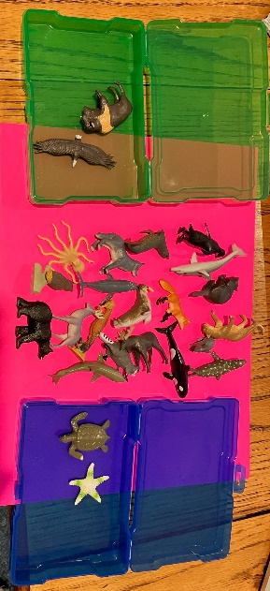
The animals from the zoo and the aquarium are mixed up. The aquarium owner and the zookeeper need to sort the animals. Animals that swim in the ocean belong in the aquarium. Animals that do not swim in the ocean belong in the zoo. After sorting, count the animals to make sure that all of the animals have been sorted.

- The students need to decide if the animal swims in the ocean (belongs in the aquarium) or does not swim in the ocean (belongs in the zoo).

- After students have sorted based on whether the animals live in the ocean, then have students sort the animals into groups of 2, 3, 4, 5, or 10 based on the skill they are practicing.

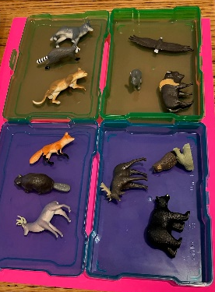

- Use cards to label groups to skip count, then assess the skills of the students:
  - Can the student put the numbers in order?
  - Remove a card – can the student recognize which number is missing?
  - Provide number line or hundred chart for differentiation.

VESOL references for the Integrated Activity:

S-5.8 (SOL 4.7a-c) The student will recognize oceans and identify the organisms that live in them.
- Complexity Continuum: Using simple pictures, diagrams, or representations, concepts could range from:
  - recognizing oceans as compared to common non-water objects or features (e.g., rocks, mountains, forests) to
  - recognizing oceans as compared to other common water features (e.g., lakes, rivers, streams) to
  - identifying common organisms that live in oceans.

R-5.2 (SOL 5.5D, 5.5F, 5.5G, 5.5I, 5.5J, 5.5K, 5.5L) The student will answer questions about a fiction passage that is read to the student or that the student reads.
- Complexity Continuum: The passage could range from a sentence with six or fewer words to two sentences with five to seven words or a short paragraph.

Word Wall Cards:

Counting by Twos
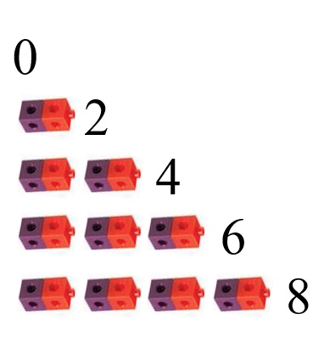

Counting by Fives
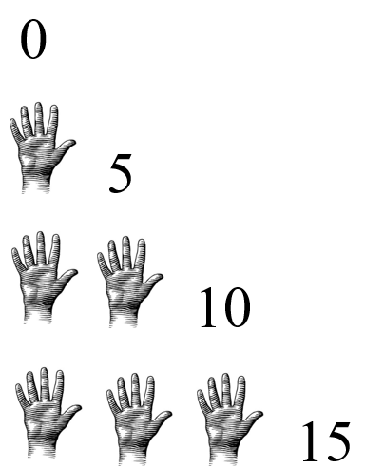

Counting by Tens

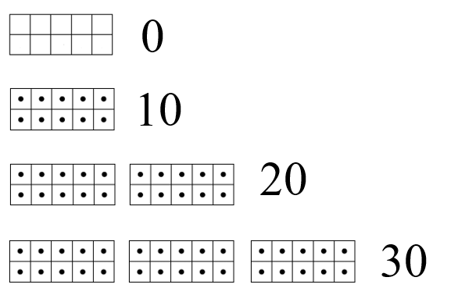

Supplemental Materials:

Monkey Pictures for Introductory Activity:

1 – 60 Chart

1 | 2 | 3 | 4 | 5 | 6 | 7 | 8 | 9 | 10
11 | 12 | 13 | 14 | 15 | 16 | 17 | 18 | 19 | 20
21 | 22 | 23 | 24 | 25 | 26 | 27 | 28 | 29 | 30
31 | 32 | 33 | 34 | 35 | 36 | 37 | 38 | 39 | 40
41 | 42 | 43 | 44 | 45 | 46 | 47 | 48 | 49 | 50
51 | 52 | 53 | 54 | 55 | 56 | 57 | 58 | 59 | 60

Number cards 1-60
1 | 2 | 3
4 | 5 | 6
7 | 8 | 9
10 | 11 | 12
13 | 14 | 15
16 | 17 | 18
19 | 20 | 21
22 | 23 | 24
25 | 26 | 27
28 | 29 | 30
31 | 32 | 33
34 | 35 | 36
37 | 38 | 39
40 | 41 | 42
43 | 44 | 45
46 | 47 | 48
49 | 50 | 51
52 | 53 | 54
55 | 56 | 57
58 | 59 | 60

Practice Items:
