Skipping Along the Number Line

Skip Counting to 40

Grade Level: 4th
Subject(s):
Primary: Math
Integrated Activity: Virginia Studies
Reporting Category: Probability, Statistics, Patterns, Functions, and Algebra
Lesson Summary and Connections:
Students will learn strategies to skip count, including using a number line as well as a hundred chart or a calculator. Skip counting will be related to money to provide a real-life application.
Lesson Components Links
VESOL(s)  Complexity Continuum | Functional Skills | Assistive Technology | Materials
Vocabulary | Common Misconceptions | Student-Friendly Outcome(s) | Introductory Activity
Plan for Instruction | Differentiation | Reflection | Formative Assessment
Word Wall Cards | Supplemental Materials | Practice Items | Integrated Activity

VESOL(s):
M-4.22: The student will recognize and perform skip counting by 2s, 3s, 5s, and 10s.
Complexity Continuum: Recognizing skip counting by 2s could include whole numbers 2 through 20.
Performing skip counting by 2s, 3s, 5s, and 10s could include whole numbers 2 through 40.

For the Introductory Activity and/or Integrated Activity:
M-4.14: The student will use a variety of coins to count the value through 50 cents.
Complexity Continuum: Coins could include pennies, nickels, dimes, and quarters.
Same or different coins could be counted with a total value of 50 cents or less.
Note: For this lesson, only nickels and dimes will be used.
HS-E 4 (SOL 1.9): The student will recognize that people save money for the future to purchase goods and services.
HS-E 6 (SOL 2.9) The student will explain that scarcity (limited resources) requires people to make choices about producing and consuming goods and services.

Functional Skill(s):
- Counting and sequencing/ordering are skills students use in their daily lives.
- Skip counting is a pattern that students can use in their daily lives.
- Applying the skill to a real-world situation involving exchanging money for a preferred item is an activity that is relevant to daily life.

Assistive Technology/AAC (Augmentative and Alternative Communication):
- Number or picture cards
- Items to sort/count
- Enlarge materials for students with vision impairments
- White boards and markers
- Number line – laminate, enlarge or highlight to meet the needs of the student
- Communication devices appropriate for the student programmed with numbers for counting and responding

Materials:
- Introductory activity: I Can Buy It!
  - Item for students to purchase (snack or toy)
  - Pennies, nickels, or dimes (depending on skill level of the students)
  - Card stating the value of the item (may include a picture of the item, the number, and/or coins representing the value of the coins) (“price tag”) – Samples found in the Supplemental Materials
  - Number line, a hundred chart, a calculator, and any other appropriate accommodation per the student IEP’s

- Instruction: Moving Along the Line
  - Painter’s tape, chalk, string and tape, or other way of denoting a straight line
  - Sticky notes, index cards, or number cards
  - Different colored sticky notes, bean bags, or other items to place as markers when skip counting
  - Portable dry erase board, marker, and eraser

- Integrated Activity: Saving up!
  - Token boards: print, laminate and apply Velcro prior to use
  - Coins for token boards: may be real or toy, apply Velcro to one side for use on the token board
  - Lesson (IEP Goal, Grade Level, or another VESOL lesson) for the student
  - Student’s preferred reinforcement

Vocabulary:
Prior Knowledge
- Numbers | - Counting
Current Vocabulary
- Skip Counting | - Counting by 2’s | - Counting by 5’s
- Counting by 10’s | - Dime | - Nickel

Common Misconceptions:
- Students may repeat the same number or the next number rather than follow the pattern.
- Students may think that to skip count they will always have to start with 0. However, following an addition rule could begin with any number, and therefore, as student ability allows, instruction may include patterns that begin with unexpected numbers. For instance, when adding 3, begin the pattern with 2. (2, 5, 8, ___, 14)

Student-Friendly Outcome(s):
- I can find the missing number.
- I can count.
- I can skip count.
- I can count by 2’s (or 3’s, 5’s, or 10’s).
- I can count nickels or dimes.
- I can save money to buy something special.

Introductory Activity: I Can Buy It!
- Present the each student or the class with an item to purchase. This could include a snack or toy.
  - Sample Cards are located at this link, in Supplemental Materials
  - The sample cards include one set that has only the price tag, one set that includes nickels to count, and one set with dimes to count. Choose the set that is most appropriate for your students.
- Provide any accommodations (such as number line, a hundred chart, or calculator) per student IEP’s.
  - Note: Students may be taught to use a calculator to add the same number repeatedly to get to the correct number pattern, per the student’s IEP.
- Ask students to read the “price tag”.
  - Students may respond verbally, by pointing, eye gaze, or using a communication device – encourage use of their preferred mode of communication.
- Provide the students with coins. Ask them to find the value of the item using the coins.
- Note whether the student can read the number, skip count using the coins, and the level of support needed to complete the transaction.
- Allow the students to consume or spend time with the item they have purchased.
- This activity may be repeated at the conclusion of the unit to determine mastery and growth.

Student Name | Amount of item for purchase/coins using | Able to read the number? | Able to skip count by value of the coin?
Ex: Steve | 50 cents/dime | yes | Yes to 30  No 40 or 50
1.
2.
3.
4.
5.
6.
7.
8.
9.
10.

Plan for Instruction: Moving Along the Line (Note: This lesson may take place over several days or be repeated for practice with skip counting by different numbers.)
- Create a number line (1 to 20) on the classroom or hallway floor using painter’s tape.
  - Lay a straight line in tape (floor or wall). Post numbers along the tape in equal intervals.
  - As an alternative, hang numbered index cards or post it notes on the wall.
  - If you can go outdoors, you could use sidewalk chalk.
  - Per the VESOL Complexity Continuum, students are expected to skip count to 40. As the floor size, learning, and student skill allows, expand the number line to 40.
- Program a cube with the following: 1, 2, 3, 5, 10, and choice.
- Tell the students that the class will be playing a game to learn how to skip count.
- Demonstrate how to play the game by rolling the dice. Example: 3
  - Start at 0.
  - Count the number that you rolled.
    - If you rolled a 3, then you will skip count by 3.
    - Students could use a pointer, touch the numbers, hop, or roll over the numbers. Choose the method that best matches your students interests and abilities.
  - Mark the number on which you landed.
    - You might use colored sticky notes, bean bags, or another marker that you have available in your classroom.
    - In the example, place a marker on 3.
  - Count the number that you rolled, and mark.
    - In the example you would count 3 spaces and land on 6.
  - Continue until you have marked several numbers in the pattern.
    - You may continue as long as student attention allows, until you get to the end of the number line.
  - Go back and review the rule as well as the numbers on which students landed when skip counting.
    - In the example, state that a 3 was rolled. We counted by 3. Write on the white board 3, 6, 9, 12, etc., until you have written all of the numbers that are in the pattern (up to 40).
    - Review the rule and the pattern, having the students touch or recite each number in the pattern.
  - As a class, guide the students (taking turns) to roll the dice and find the numbers in the pattern.
    - Repeat the process outlined above.
    - Gradually release responsibility for finding the numbers in the pattern to students.

- Closing: Provide students with a blank number line.
  - Ask them to roll the number cube then find the numbers in that pattern on the number line.
  - If they roll 2, then they should mark 2, 4, 6, 8, 10, etc., on their number line.
  - Assess student ability as they work. Are they able to find the correct number in the pattern?
  - Provide an incentive by stating that when they reach their goal they will receive the preferred item of their choice.

- Follow-up Activity (second day):
  - Provide a number line with a marked pattern.
    - From the Complexity Continuum: “Recognizing skip counting by 2s could include whole numbers 2 through 20.”
    - Demonstrate how to find the rule.
    - Release responsibility to students by letting the students find the rule and the missing number.

Differentiation and Ideas for Extension:
- Kinesthetic learners can:
  - Use hands-on materials to make repeating groups (groups of 2 items), and assign number cards to help them see the pattern.
  - Program interlocking blocks (such as Lego’s or Unifix cubes) with numbers. Students will put them in order, or the teacher can put them on order with a blank block in the middle. Students will then replace the missing number.
- Visual learners can:
  - Color code a hundred chart to find the missing numbers.
  - Use color-coded index cards/construction paper cards (labeled with numbers) to create skip patterns.
- Auditory learners can:
  - Sing songs and watch videos about skip counting to learn to find the missing number.
- Multi-sensory learners can:
  - Use modeling dough to make balls. Use them to count/skip count. Students can crush the balls as they count.
  - Use sidewalk chalk to write numbers on the sidewalk. Student will say the number as they walk/jump/hop/roll over each number.
- Students who require repeated practice can:
  - Include creating file folders (from materials below) to be used as guided and/or independent practice.
- Extend beyond the parameters of the lesson:
  - Students who are not yet ready to skip count can work on counting by 1.
  - Students who are able to skip count by 2’s, 3’s, 5’s, and 10’s past 40 can work on other numbers or can keep working up to 100. Alternate extension: Students can practice skip counting from various numbers other than zero (e.g., starting with 20, count by 2s to 40).

Reflection:
- During instruction, ask students to identify the next number in the pattern using their preferred method of communication.
- Encourage students to use the strategy that works best for them.
  - “Would you rather use a number line or a hundred chart?”
  - “Would you like to count dimes or sets of 10 pennies?”
  - “Would you like to use interlocking cubes to make sets of <2, 3, 5, 10> to count?”
- Ask students to draw a picture and/or write a story about skip counting.

Formative Assessment:
Throughout instruction, utilize observation and performance/participation assessment by asking the following:
- “What number comes next in the pattern?”
- “What number is missing in the pattern?”
- “Let’s start at 6. What number comes next?”

Notes:
- Laminated materials can be reused.

Integrated Activity: Saving Up!
Students will practice counting by 5 or 10, as well as reinforce learning about saving money over time and making economic choices.

- Prepare the token boards: Print and laminate the following token board. Place Velcro on nickels and dimes, as well as on the boxes.
- Present a lesson (IEP goal, VESOL, or Grade Level assignment).
- Tell the student that they will be earning nickels or dimes for each problem, question, or page that they complete. When they have reached a designated amount, they will exchange the money for their preferred reinforcing item.
- After giving each coin, count (by the value of the coins) to see if they have reached the agreed upon amount.
- Time the tokens so that the lesson ends when the last token is given.
- Students then count by 5 (nickels) or 10 (dimes) to see if they have enough money to “buy” their preferred reinforcement.

I am working for: I need: $0._______

I am working for: I need: $0._______

Word Wall Cards:
Counting by 2’s

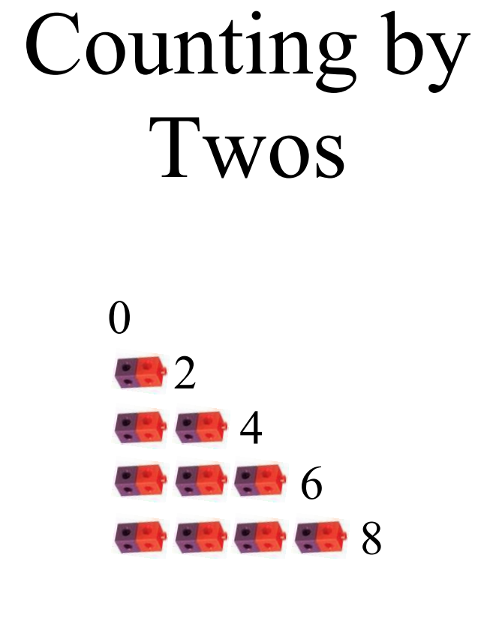

Count by 5’s
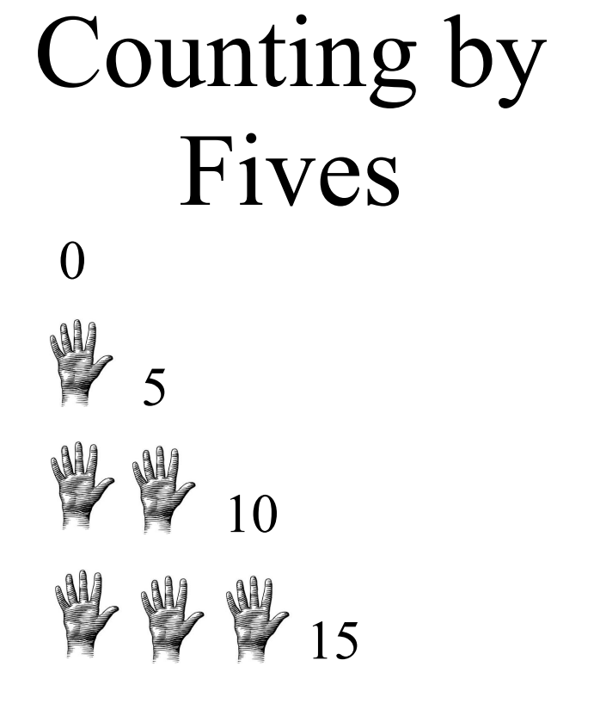

Count by 10’s
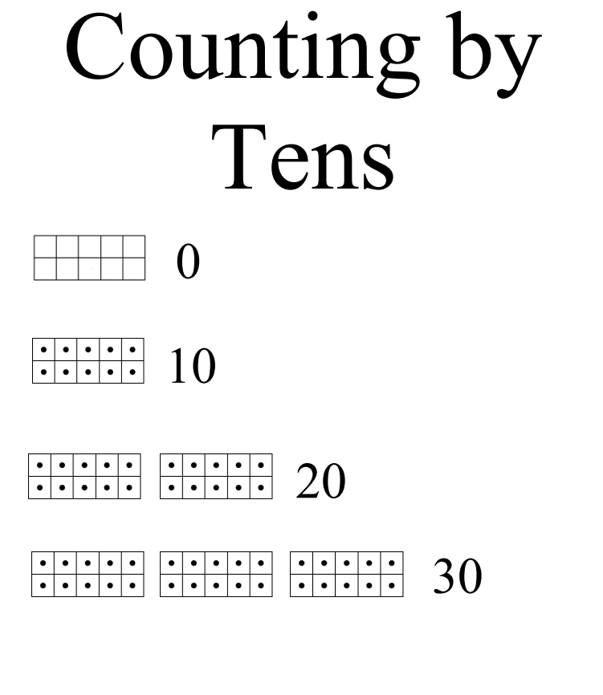

Nickel
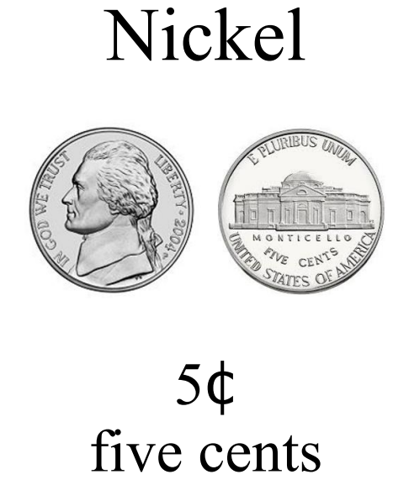

Nickel with Pennies

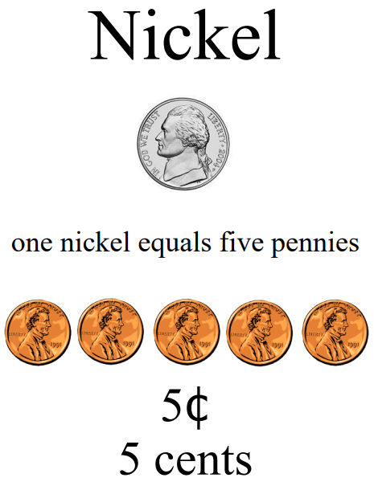

Dime

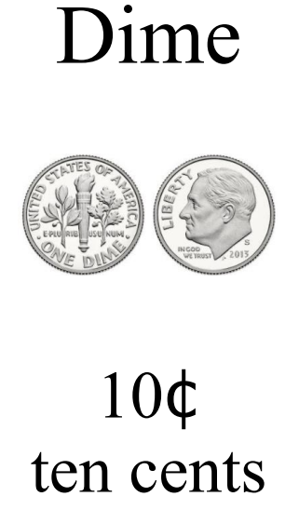

Dime with Pennies

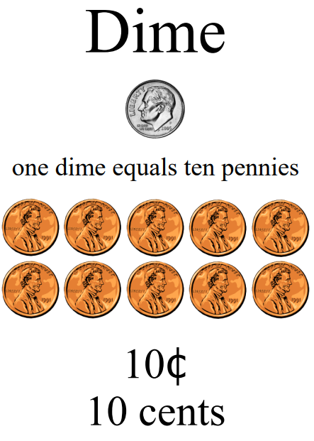

Supplemental Materials:

1 – 40 Chart

1 | 2 | 3 | 4 | 5 | 6 | 7 | 8 | 9 | 10
11 | 12 | 13 | 14 | 15 | 16 | 17 | 18 | 19 | 20
21 | 22 | 23 | 24 | 25 | 26 | 27 | 28 | 29 | 30
31 | 32 | 33 | 34 | 35 | 36 | 37 | 38 | 39 | 40

Number cards 1-40
1 | 2 | 3
4 | 5 | 6
7 | 8 | 9
10 | 11 | 12
13 | 14 | 15
16 | 17 | 18
19 | 20 | 21
22 | 23 | 24
25 | 26 | 27
28 | 29 | 30
31 | 32 | 33
34 | 35 | 36
37 | 38 | 39
40

Examples of cards for the Integrated Activity

Preferred items only number value
Blocks  $0.25 | Animals  $0.10
Snack  $0.50 | Puzzles  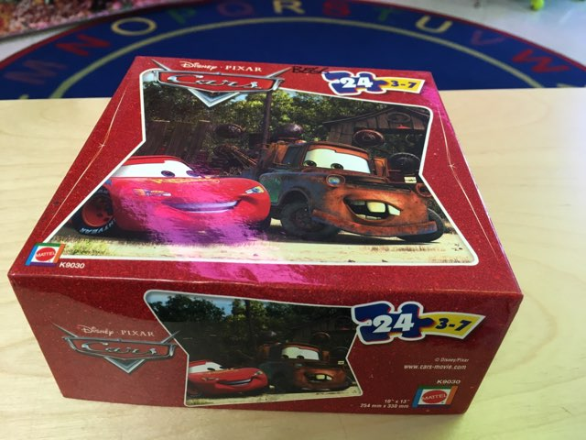  $0.20

Preferred items with nickels to count
Blocks  $0.25 | Animals  $0.10
Snack  $0.50 | Puzzles  $0.20

Preferred items with dimes to count
Blocks  $0.30 | Animals  $0.10
Snack  $0.50 | Puzzles  $0.20

Number cube for skip counting lesson

Practice Items:

