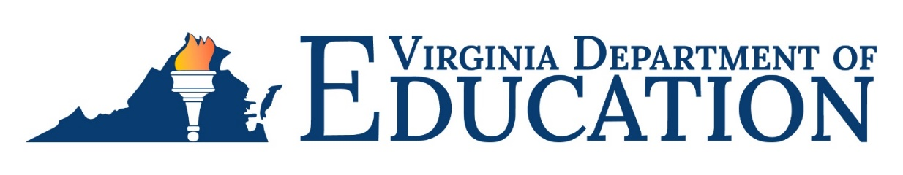

2023-2024 Individuals with Disabilities Education Act (IDEA)
Proportionate Set-Aside Requirements
The Virginia Department of Education (VDOE) is required by federal regulation to ensure all school divisions in Virginia comply with Part B of the Individuals with Disabilities Education Act (IDEA) §300.133 and Appendix B to Part 300 – Proportionate Share Calculation. This mandates that each school division spend a proportionate amount of its Sections 611 and 619 allocations on providing special education and related services (including direct services) to home-schooled or parentally-placed private school children with disabilities.
The VDOE will continue utilizing the web-based Special Education Proportionate Set-Aside (Speced-PSA) Application for divisions to report their proportionate set-aside calculations for fiscal year 2023-2024. This application is used to calculate the required set-aside amounts associated with providing special education and related services to children and youth with disabilities who are home-schooled or parentally-placed in private elementary and secondary schools located in the division.
The Speced-PSA Application can be accessed by using the VDOE’s Single Sign-on for Web Systems (SSWS) portal. The individuals who will be responsible for reviewing the worksheet and submitting the PSA information in SSWS will need to contact their local SSWS administrator to gain full access rights. All division superintendents or designees must access the Superintendent Data Collection Approvals (SDCA) Application to approve or disapprove submissions.
The application has been enhanced to calculate the IDEA Part B Section 611 and 619 set-aside amounts separately. The IDEA Proportionate Set-Aside Guidance Document provides additional guidance and information for submitting the worksheet and the Superintendent’s access to SDCA.
A pre-recorded training session for submitting the data will be made available to all school divisions. Special Education Directors will receive the link for accessing the pre-recorded training via email. Also, a Question and Answer Zoom session will be held and the link for accessing the session will be included in the email.
The collection window for submission and approval of the 2023-2024 proportionate set-aside calculation will open on October 30, 2023, and will close on November 30, 2023. All school divisions are required to complete the web-based application even if the division has no eligible students with disabilities that are home-schooled or parentally-placed in private schools.

For more information
Any questions concerning the Proportionate Set-Aside Calculation and the web-based application can be directed to Shalonda Lewis, Special Education Financial Data Specialist, at Shalonda.Lewis@doe.virginia.gov; telephone (804) 774-4279.

