Attachment A

SNP Memo No. 2023-2024-30

October 12, 2023

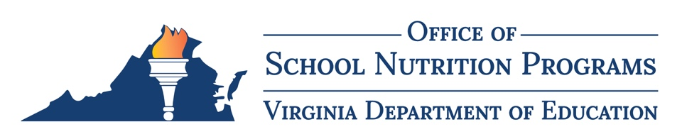

2023–2024 Virginia Standardized Recipe Development Team Application

Overview
The Virginia Department of Education, Office of School Nutrition Programs (VDOE-SNP), is recruiting members to the Virginia Standardized Recipe Development Team for the purpose of developing, standardizing, and implementing new standardized recipes featuring Virginia Harvest of the Month items. Specifically, the VDOE-SNP will recruit four school division teams (a team is comprised of one school nutrition director plus one additional school nutrition team member such as a chef, nutritionist, menu planner, field supervisor, manager, etc.) for a total of eight new team members. All interested school divisions must complete and submit this form, the Virginia Standardized Recipe Development Team Application, by COB Friday, October 27, 2023, to be considered for this opportunity.

School Division Team Information
School Division Name: Click or tap to enter text
Superintendent's Region (1–8): Click or tap to enter text
Team Member 1 (School Nutrition Director)
First and Last Name: Click or tap to enter text
Title: Click or tap to enter text
Email Address: Click or tap to enter text
Phone Number: Click or tap to enter text
Team Member 2 (School Nutrition Team Member)
First and Last Name: Click or tap to enter text
Title: Click or tap to enter text
Email Address: Click or tap to enter text
Phone Number: Click or tap to enter text

Signatures

Division Superintendent Name

Division Superintendent Signature

Date

Team Member 1 Name

Team Member 1 Signature

Date

Team Member 2 Name

Team Member 2 Signature

Date

