2024 Summer Residential Governor’s School (SRGS)
Engineering at Jefferson Lab Application
Information Page
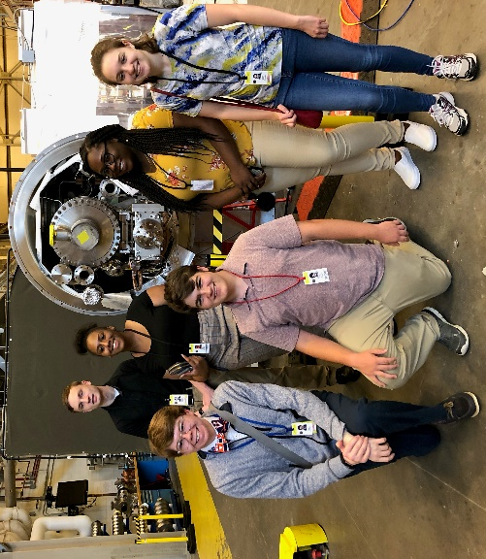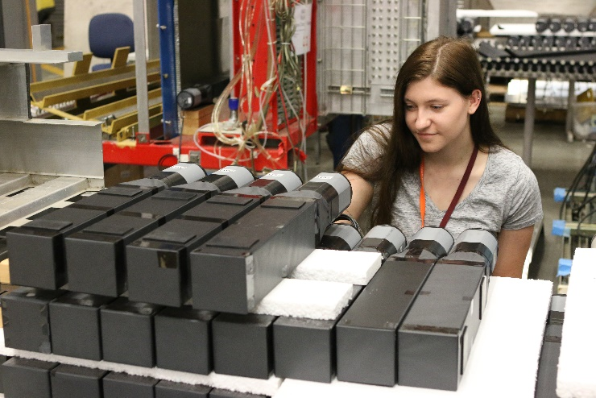

The Virginia Governor's School hosted at Jefferson Lab (JLAB) is a residential summer program designed to provide challenging, real-life, team-oriented work experiences for a total of 12 intellectually gifted high school students, who are at least 16 years old. Students will be working with JLAB mentors and staff in a team-oriented approach to their learning experiences. Mentorships change each year based on availability of relevant JLAB projects and mentors. Mentorships are assigned based on student interest and experience. Students are given the opportunity to apply classroom theory to “real world” engineering and research projects, thus enhancing the students’ academic and career goals. Students become familiar with career options through their individual mentorships, community time with other students, and tours and lecture opportunities. Occasionally, mentorships will be offered that are outside of a student's expectation and/or comfort zone. This program is best suited for students who are willing to be flexible and are excited about the opportunity to work with JLAB mentors.

The JLAB mentorship program will place students with mentors from various areas of expertise, such as electrical engineering, materials science, mechanical engineering, accelerator operations, physics and computer science.

Students should key in the data on the first page of this application for clarity and accuracy.

For division information, please contact the gifted education coordinator whose contact information is available on the Virginia Department of Education Website.

The Virginia Department of Education does not discriminate on the basis of race, sex, color, national origin, religion, sexual orientation, gender identity, age, political affiliation, veteran status, or against otherwise qualified persons with disabilities in its programs and activities and provides equal access to the Boy Scouts and other designated youth groups. The following position has been designated to handle inquiries regarding the Department’s nondiscrimination policies: Deputy Superintendent – Finance and Operations, Virginia Department of Education, P.O. Box 2120, Richmond, Virginia 23218-2120, (804) 225-2025.

For further information on Federal nondiscrimination regulations, contact the Office of Civil Rights at OCR.DC@ed.gov or call 1 (800) 421-3481.

You may also view Executive Order 1 (2014), which specifically prohibits discrimination on the basis of race, sex, color, national origin, religion, sexual orientation, gender identity, age, political affiliation, or against otherwise qualified persons with disabilities. The policy permits appropriate employment preferences for veterans and specifically prohibits discrimination against veterans. You may obtain additional information at the Commonwealth of Virginia’s official website concerning this equal opportunity policy.

2024 SUMMER RESIDENTIAL Governor's SCHOOL (SRGS)
JLAB MENTORSHIP Application

APPLICANTS MUST KEY THIS PAGE FOR CLARITY AND ACCURACY.

I attend Public School Private School Home School

Applicant Information: Complete all requested information
Item | Personal Information | No Data | No Data
First Name |  | Date of Birth
Middle Name |  | Nickname
Last Name |  | Graduation Year
Mailing Address |  | No Data | No Data
City |  | Virginia ZIP
Home Telephone |  | Student’s Email  (NOT school email)
Parent’s/Guardian’s Work Phone |  | Parent’s/Guardian’s Email
Parent’s/Guardian’s Work Phone |  | Parent’s/Guardian’s Email

High School Information: Complete all requested information.
Item | Personal Information
High School
School Address
City/State/ZIP
Telephone
Fax Number
HS Contact Name and Email
Public School Students Only | No Data
Division Name

Student Statement:
The decision to apply for Governor's School is my own. I want to participate fully in the program. If selected, I will abide by the rules and expectations explained in the program handbook and all other expectations provided by the program director. The responses contained in this application are my own work and are truthfully offered.

SIGNATURE OF APPLICANT DATE

For Official Use Only by Gifted Education Coordinator: Indicate student's score and rank.

Score (from page 8) ____________ Rank _______
(round to the nearest hundredth)

Applicant's Full Name

ALL APPLICANTS MUST COMPLETE INFORMATION ON THIS PAGE

Career Highlights: Activities, RESEARCH, and Honors
In the three sections that follow, list accomplishments that highlight your positions of leadership or intellectual activities. Higher scores will be awarded to activities/programs in which you hold a position of leadership and to research, study, presentations, and competitions associated with extracurricular clubs, community groups, national organizations, etc.

Activities/Programs
List the three most significant activities/programs in which you have participated during the past three years that relate to your area of interest. Include the complete name of the organization, sponsoring agency, or group. Also, describe the time involved and any leadership position you have held. Under “Year”, indicate the calendar year of the training or activity. If you need more space, attach a second sheet. Please explain any acronyms that you use.
Activity and Organization | Position Held | Time Involved | Year
Example: Mu Alpha Theta | Vice President | 6 hours/week | 2015
Research/Study Experiences
List the three most significant research/study experiences you have had in the past three years that relate to your area of interest. Make sure you include the name of any group, organization, or individual with whom you studied. If you need more space, attach a second sheet.
Study/Brief Description | Teacher | Organization | Time
Example: VJAS research project exploring series and parallel circuits. | Mr. Purman, Physics | Poquoson High School | 2 semesters,  2014-15
Honors/Recognitions
In this section, please list the three most significant honors/recognitions you have received during the last three years in your area of interest.
Honor/Recognition | Level of Competition – Regional, State, National, International | Year
Example: Selected participant/Virginia Rotary Youth Leadership Seminar/ Virginia Tech | State | 2015

Applicant's Full Name

ENGINEERING/JLAB APPLICANTS MUST COMPLETE INFORMATION ON THIS PAGE

JLAB Program: Students must be 16 years of age by June 17, 2024, and be a citizen of the United States in order to work at JLAB. No exception to these policies is permitted.

Have you worked with a mentor during your high school experience? Yes No
With whom do/did you work?
Where do/did you work?
For how long have you worked with this mentor?

Briefly describe any experience you have had with computers, programming, and/or software development (e.g., 3-D printing, C++, Pro E, etc.).

The future of engineering requires a team approach. Briefly describe any experiences you have had as a team member in an academic work-oriented situation. What was your role on the team?

The JLAB mentorship program will place students with mentors from various areas of expertise, such as electrical engineering, materials science, mechanical engineering, accelerator operations, physics and computer science.

JLAB Mentorship Essay
Students must respond to the prompt below as the essay component for the application. The essay should be 300-500 words (approximately two pages of double-spaced 12-point type, with a 1” margin on each side). Include your name in the upper right-hand corner of each page of the essay. Number the pages 3a and 3b and place them in the final academic application after this page. You should review the rubric below and consider each of the areas carefully as you proofread and edit your essay. You may seek advice from appropriate teachers as you draft and revise your essay. This is a graded element worth 24 points.

JLAB Mentorship Essay Topic
Thomas Jefferson National Accelerator Facility (Jefferson Lab) is a U.S. Department of Energy Office of Science national laboratory. Scientists worldwide utilize the lab’s unique particle accelerator, known as the Continuous Electron Beam Accelerator Facility (CEBAF), to probe the most basic building blocks of matter - helping us to better understand these particles and the forces that bind them - and ultimately our world. In addition, the lab capitalizes on its unique technologies and expertise to perform advanced computing and applied research with industry and university partners. The mentorship experience is designed for students to be able to participate in the lab’s innovative quest towards sharing with and educating the next generation in science and technology.
- What kind of invention do you envision being developed or engineered in any area of science in the next 25 years that would impact society as a whole? Discuss the benefits of implementing this project and the role engineering will play in its implementation. Describe relevant research and experience you have had that would assist you in creating your invention. This essay will be instrumental in identifying your interests, creativity, and experiences to assist with placing you with a mentor.

Scoring Rubric
Composition | 0 – 1 | 2 | 3 | 4
Central Idea/Position | Missing | Unclear | Weak | Strong
Evidence/Details | Unclear | Minimal | Adequate | Precise/Relevant
Organization/Unity | Lacking | Random/Many digressions | Lapses/ Some digressions | Logical/Unified
Counter Claims | Absent | Weak | Attempted | Effective
Word Choice | Lacking | Limited | Some Specificity | Highly Specific
MECHANICS | 0 | 1 | 2 | No Data
Sentence Structure | Weak | Some variety | Varied | No Data
Usage | Incorrect | Some incorrect | Consistently correct | No Data
Mechanics | Incorrect | Some incorrect | Consistently correct | No Data

Applicant's Full Name

ALL APPLICANTS AND PARENT/GUARDIAN MUST COMPLETE INFORMATION ON THIS PAGE

Applicant and Parent/Guardian Assurances
I, the parent/guardian of , permit my son/daughter, if selected, to participate in the 2024 Summer Residential Governor's School. I realize that transportation to and from the Governor's School and spending money for personal expenses must be provided by the participants. I understand that if selected for the program, he/she must abide by the rules and expectations set forth for the school. I further agree that I have been duly informed that LEAVES OF ABSENCE from these programs are allowed only for SEVERE CASES OF MEDICAL AND/OR FAMILY EMERGENCIES. Medical and family emergencies include major illness, hospitalization, or death of an immediate family member or guardian. I also understand that failure to participate in the programs, or unwillingness to abide by the rules and expectations, may be just cause for immediate dismissal.

SIGNATURE OF PARENT/GUARDIAN DATE

Both student and parent/guardian must initial after having read the following assurances. These constitute the expectations for students who apply or accept invitations to the summer residential governor's school program.
Student  Initials | Parent or  Guardian  Initials | Assurances
No Data | No Data | I understand that leaves of absence are granted ONLY in the case of medical or family emergencies as described above. Participants are expected to arrive at the site by the opening ceremony, indicated in the 2024 Student and Parent Guide for Governor's Schools, and remain at the site through the closing ceremony.
No Data | No Data | I understand that the programs require concerted academic focus, preparation, and motivation from all participants and that participants are expected to demonstrate the emotional maturity and self-discipline to participate in the activities and to demonstrate respect for self, others, program, and school.
No Data | No Data | I understand that participants will be expected to follow the rules and expectations outlined in the 2024 Student and Parent Guide for Governor's Schools, and any other instructions provided by the program director. These rules and expectations have been thoroughly read and are understood.
No Data | No Data | I understand that each nominee and division gifted education coordinator/private school regional coordinator will be mailed acceptance and alternate information by mid-April 2024, and that no information will be available before that date.
No Data | No Data | I understand that possession of tobacco or alcohol, weapons, or nonprescription drugs will result in the participant's immediate dismissal from the program and that participants are also subject to any disciplinary action that the sponsoring school division or private school chooses to invoke. Certain infractions may also result in legal consequences as outlined in the Code of Virginia.
No Data | No Data | I understand that previous participants of any Summer Residential Governor's School program (including Governor's Foreign Language Academies) shall not apply for or participate in the Summer Residential Governor's School program; and I am not applying for a 2024 Governor's Foreign Language Academy or for another Summer Residential Governor’s School.
No Data | No Data | I certify that I am a resident of the Commonwealth of Virginia and eligible for a free, public education in the Commonwealth.
No Data | No Data | I understand failure to provide complete and accurate medical, mental, and prescription information may result in immediate dismissal from the program.
No Data | No Data | I understand that I waive my rights to review and inspect my child’s application and score sheet for the Summer Residential Governor’s School program.
No Data | No Data | I certify that these are my truthful responses to these assurances.

Applicant's Full Name

INFORMATION ON THIS PAGE MUST BE COMPLETED BY THE APPROPRIATE CONTENT AREA TEACHER

Teacher Recommendation A
This recommendation must be completed by a teacher in the student's area of interest who can assess his/her current abilities, preferably a teacher who has taught the student in a course closely related to the selected program. There are two required parts to the recommendation: a rating scale and a narrative.

Rating Scale Teacher A
- What course or program of studies has the student taken under your supervision? In what year(s)?

- Please estimate the extent to which the student has demonstrated in your class(es) the qualities listed below. Use the scale from 0-2 as indicated. Be sure to respond to all qualities; items omitted are included as a zero when computing a score. Please use only whole number values.
0=Good (Above Average) 1=Excellent (Top 10 Percent) 2=Outstanding (Top 2-3 Percent)
No Data | Quality | Score
 | Motivation and initiative | No Data
 | Self-direction | No Data
 | Intellectual curiosity | No Data
 | Independence of thought | No Data
 | Originality of ideas | No Data
 | Use of higher-level thinking skills | No Data
 | Attitude toward learning | No Data
 | Ability to contribute to a group process | No Data
 | Willingness to accept ideas of others | No Data
 | Emotional stability, maturity, and self-discipline | No Data
 | Openness to new experiences | No Data
 | Cooperative behavior | No Data
 | Respect and tolerance for the views of others | No Data
No Data | Subtotal A (out of 26 points) | No Data

Narrative Teacher A
Teachers, please complete the narrative portion of the recommendation using specific examples from your work with this student to indicate how the student demonstrates these qualities: ability to work cooperatively and meaningfully in groups; openness to new and diverse situations; goals for academic growth; creativity; and intellectual and social maturity. Please print your narrative on school, personal, or professional letterhead. Sign and date both the printed rating scale and narrative and return them to the guidance office or as otherwise directed.
Signature of Teacher | Printed Name | Date
No Data | No Data | No Data
Email Address | Phone # | No Data

Applicant's Full Name

INFORMATION ON THIS PAGE MUST BE COMPLETED BY THE APPROPRIATE ADULT

Adult Recommendation B
This recommendation must be completed by any teacher/instructor/advisor/adult (outside of the student's family) who is familiar with the student’s work. There are two required parts to the recommendation: a rating scale and a narrative.

Rating Scale Adult B
- What course or program of studies has the student taken under your supervision? In what year(s)?

- Please estimate the extent to which the student has demonstrated in your class(es) the qualities listed below. Use the scale from 0-2 as indicated. Be sure to respond to all qualities; items omitted are included as a zero when computing a score. Please use only whole number values.
0=Good (Above Average) 1=Excellent (Top 10 Percent) 2=Outstanding (Top 2-3 Percent)
No Data | Quality | Score
 | Motivation and initiative | No Data
 | Self-direction | No Data
 | Intellectual curiosity | No Data
 | Independence of thought | No Data
 | Originality of ideas | No Data
 | Use of higher-level thinking skills | No Data
 | Attitude toward learning | No Data
 | Ability to contribute to a group process | No Data
 | Willingness to accept ideas of others | No Data
 | Emotional stability, maturity, and self-discipline | No Data
 | Openness to new experiences | No Data
 | Cooperative behavior | No Data
 | Respect and tolerance for the views of others | No Data
No Data | Subtotal A (out of 26 points) | No Data

Narrative Adult B
Recommender: Please complete the narrative portion of the recommendation using specific examples from your work with this student to indicate how the student demonstrates these qualities: ability to work cooperatively and meaningfully in groups; openness to new and diverse situations; goals for academic growth; creativity; and intellectual and social maturity. Please print your narrative on school, personal, or professional letterhead. Sign and date both the printed rating scale and narrative and return them to the guidance office or as otherwise directed.
Signature of Adult | Printed Name | Date
No Data | No Data | No Data
Email Address | Phone # | No Data

Applicant's Full Name

INFORMATION ON THIS PAGE MUST BE COMPLETED BY APPROPRIATE SCHOOL AND DIVISION PERSONNEL

Principal/Head of School Recommendation
I hereby certify that this student is qualified and genuinely interested in attending the Summer Residential Governor's School. I recommend this applicant.
No Data |  | No Data
Signature of Principal/Head of School | Printed Name | Date
 |  | No Data
School Name | Public School LEA Number | No Data

Gifted Education Coordinator/Private School Regional Coordinator Recommendation
I hereby certify that this student is qualified and genuinely interested in attending the Summer Residential Governor's School. I further certify that the nominee’s attendance and discipline records have been reviewed and that information has been taken into appropriate consideration. I thereby recommend this student for consideration.
No Data |  | No Data
Signature of Gifted Education or Private School Regional Coordinator | Printed Name | Date
 |  | No Data
Name of School Division | Private School Region | No Data
 |  | No Data
Email Address | Telephone | No Data

Division/Regional Selection Committee Date of Meeting:
No Data | Name | Position
 | No Data | No Data
 | No Data | No Data
 | No Data | No Data
 | No Data | No Data
 | No Data | No Data
 | No Data | No Data
 | No Data | No Data
 | No Data | No Data
 | No Data | No Data
 | No Data | No Data
 | No Data | No Data

Applicant's Full Name

INFORMATION ON THIS PAGE MUST BE COMPLETED BY THE GIFTED EDUCATION OR REGIONAL COORDINATOR

2024 Summer Residential Governor’s School Academic Scores Page
- Career Highlights: Activities, Research, & Honors
1 or 2 points possible per activity/program; no more than three may be counted. (6 max)
1 or 2 points possible per research/study experience; no more than three may be counted. (6 max)
1 or 2 points possible per honor/recognition; no more than three may be counted (6 max)

TOTAL I: ( Activities) + ( Research) + ( Honors) = (18 max)

- Essay Evaluation
Reader One: Rate as 6 5 4 3 2 1
Reader Two: Rate as 6 5 4 3 2 1

TOTAL II: [( Reader One) + ( Reader Two)] x 2 = (24 max)

- Teacher/Adult Recommendations
Rating Scale:
[Teacher A (26 max) + Adult B (26 max)] divided by 2 = (26 max)

Narrative Evaluation:
[Teacher A (06 max) + Adult B (6 max.)] multiplied by 2 = (24 max)

TOTAL III: [( Rating Scale) + ( Narrative)] multiplied by .52 = (26 max)

- Applicant Aptitude and Achievement
Mark the correct response in each category. Include test information below. Use scale (8, 7, 6, 5, 4 or 3) to assign points to each category. Private schools should consider the courses their students take that are comparable to AP/IB/Cambridge/AYGS courses when determining course difficulty.
Norm-referenced Test 1 | No Data | Norm-referenced  Test 2 | No Data | Grade Point Average | No Data | Course Difficulty | No Data | No Data
(99-98%) | 8 | (99-98%) | 8 | 4.0-3.8 | 8 | College scholar… | 8 | No Data
(97-95%) | 7 | (97-95%) | 7 | 3.7-3.5 | 7 | Challenging… | 7 | No Data
(94-90%) | 6 | (94-90%) | 6 | 3.4-3.0 | 6 | Moderate degree… | 6 | No Data
(89-85%) | 5 | (89-85%) | 5 | 2.9-2.5 | 5 | General program… | 5 | No Data
(84-80%) | 4 | (84-80%) | 4 | 2.5-2.0 | 4 | No Data | No Data | No Data
(<80%) | 3 | (<80%) | 3 | (<2.0) | 3 | No Data | No Data | No Data
TOTAL IV: |  | + |  | + |  | + |  | (32 max)

Test 1: | No Data | Date Taken: | No Data
Test 2: | No Data | Date Taken: | No Data

GRAND TOTAL: (Add Totals of Parts I + II + III + IV) =
Round to the nearest hundredth; e.g., 92.36 (100 max)

