Heavy and Light
Grade Level: 5
Subject(s):
Primary: Science
Integrated Activity: Language Arts, Math
Reporting Category:
Force, Motion, Energy, and Matter
Lesson Summary and Connections:
Students will be able to classify a novel object by its weight.
Lesson Components Links
VESOL(s)  Complexity Continuum | Functional Skills | Assistive Technology | Materials
Vocabulary | Common Misconceptions | Student-Friendly Outcome(s) | Introductory Activity
Plan for Instruction | Differentiation | Reflection | Formative Assessment
Word Wall Cards | Supplemental Materials | Practice Items | Integrated Activity

VESOL:
S-5.16: Recognize and compare the physical properties of matter in different phases.
Complexity Continuum:
Using simple pictures, diagrams, or representations, concepts could range from:
- recognizing physical properties of common objects including size and shape; to
- recognizing additional physical properties of common objects including hardness/softness and weight/mass of common objects (e.g., a rock is harder than an egg; a balloon weighs less than a basketball); to
- recognizing additional physical properties including volume and other representations of matter as a solid, liquid, and a gas/vapor.

Functional Skill(s):
- Students will recognize that the size of common objects is not always related to their weight.
- Students will learn that scales are used to determine the weight of objects.
- Students will learn that weight/mass determines objects they can pick up easily and objects they cannot.

Assistive Technology/AAC (Augmentative and Alternative Communication):
- The words “heavy” and “light” could be added to AAC devices for students who have significant communication difficulties.

Materials:
- Beach ball
- Ball that is smaller and heavier than a beach ball (e.g., baseball)
- Pictures of scales (included in supplemental materials)
- Clothes hanger (1 for each group)
- String (6 pieces per group, approximately 12-inch lengths)
- Cups (2 per group)
- Hole puncher
- Snack size resealable plastic bags
- Common small objects that are light (e.g., crumpled paper, cotton balls, feathers)
- Common small objects that are heavy (e.g., dried beans, marbles, beads)
- Student Data Recording Sheet (included in supplemental materials)

Vocabulary:
Prior Knowledge What words will students need to know prior to starting the lesson?
- size | - big | - small
Current Vocabulary What words will students learn during the lesson?
- weight | - heavy | - light

Common Misconceptions:
- Weight is always related to size. Big things are heavy and small things are light.
- A big object is always heavier than a smaller object. A small object is always lighter than a larger object.

Student-Friendly Outcome(s):
- I can tell whether objects are heavy or light by weighing them.

Introductory Activity:
- On the board write the following sentence frames:
  - A _____ is bigger than a _____.
  - A _____ is heavier than a _____.
- Show students a beach ball and a baseball.
- Ask students, “Which is bigger: a beach ball or a baseball?”
- Fill in the sentence frame.
  - A beach ball is bigger than a baseball.
- Ask students to predict (guess) which ball is heavier and which is lighter.
- Pass the balls around so the students can feel their weight.
- On the board fill in the sentence frame.
  - A baseball is heavier than a beachball.
- Tell students that we cannot always tell the weight of an item by its size. Tell students that they must use a scale to determine an object’s weight.
- Display a picture of the scale commonly used at doctor’s offices.
- Ask students to raise their hand if they have ever been weighed at the doctor’s office.
- Tell students that not all scales look alike but they all can tell the weight of an object. Show the pictures of the different types of scales. If you have access to scales (e.g., a balance scale, a kitchen scale, a bathroom scale) bring them in for students to see, touch, and use.
- Post the VESOL and student-friendly outcome on the board. Tell students that they will be using a scale called a balance to weigh common objects.

Plan for Instruction:
- Prior to the lesson:
  - Make a balance for each group (picture included in the supplementary materials).
    - Punch 3 holes in each cup.
    - Tie one end of a string to each hole.
    - Tie the other ends of the string together.
    - Hook a cup on either side of the clothes hanger.
  - Fill plastic bags with objects to be weighed. Make enough so that each group has a bag filled with each type of object. Write the name of the object on the outside of the bag with a permanent marker.
  - Print the recording sheets.
  - Create workstations by hanging the hangers on door handles or hooks in the room and placing a set of bags at each station.
- Gather students at one station. Demonstrate how to use the balance to compare the objects. Model recording the results on the recording sheet.
- Assign the students to the workstations. Circulate among the stations. Make sure they are using balance correctly to compare the objects and recording their results.

Differentiation:
- Students who have difficulty writing can have a peer or an adult scribe the answers on the recording sheet.
- The data sheet could be pre-populated with the items whose weights were being compared. Students could then highlight or circle the heavier item.

Reflection:
- During instruction, encourage students to predict which item will weigh more.
- Look for opportunities throughout the school year to incorporate scales in learning activities. Examples include weighing ingredients when cooking and creating task boxes that require students to sort heavy and light items using a scale.

Formative Assessment: Heavy/Light Show and Tell
- Ask students to bring in one thing that is heavy and one thing that is light from home for the Heavy/Light Show and Tell (sample parent letter in supplementary materials). Write the sentence frame used throughout the lesson on the board:
  - A _____ is bigger than a _____.
  - A _____ is heavier than a _____.
- Have students stand up one by one and present their items using the language in the sentence frame, supporting as needed.
- Have students complete the 3 questions on the Formative Assessment.

Notes:
- Many schools have purchased student sets of balances. They may be stored with math or science materials. These can be used instead of or in addition to making balances.
- Students could work in groups to make a balance. This activity is an opportunity to co-teach with the occupational therapist if your students receive these services.

Integrated Activity:
- Language Arts
- Incorporate the concepts of “heavy” and “light” when teaching antonyms.
- Increase students’ vocabulary by using a mind map to brainstorm items that are heavy and light.
Math
- Students can practice reading numbers on scales.
- The concepts of heavy and light can be related to the concepts of more and less. Students can use the balances to compare numbers. For example, give the student two numbers (e.g., 2 and 5). Using blocks that are the same size (e.g., unit cubes or linking cubes), the student can put 2 blocks on one side of the balance and 5 blocks on the other side. The student can visualize that 5 is greater than 2 by relating this comparison to their understanding that 5 blocks is heavier than 2 blocks. They can then record the number sentence 5 > 2 (or use these numbers to complete the sentence, “___ is greater than ___.”).

Formative Assessment:
Answer the following questions.
- Jami has a pencil and a book. Which item is heavier?
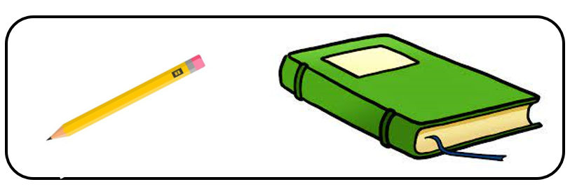
  - pencil b. book c. the same weight

- Here is a slice of bread and a can of soup. The slice of bread is ______ the can of soup:
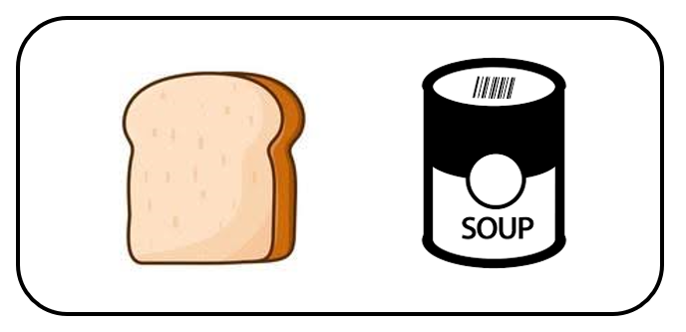
a. heavier b. lighter c the same weight

- Here are two weights. Which weight is lighter, A or B?

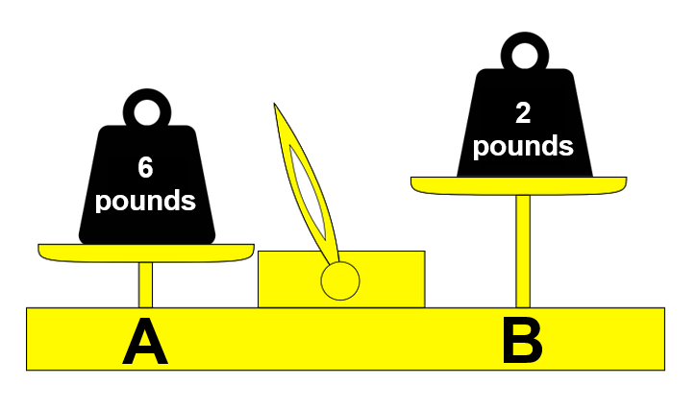

  - weight A b. weight B c. the same weight

Word Wall Cards:
Weight

Heavier/Lighter

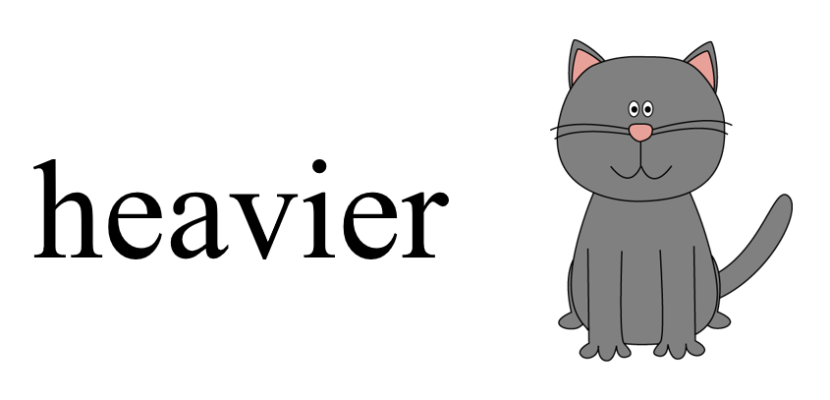

Heavy

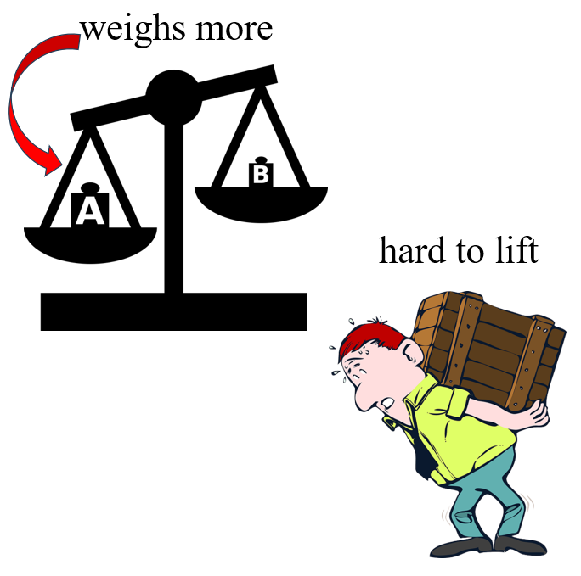

Light
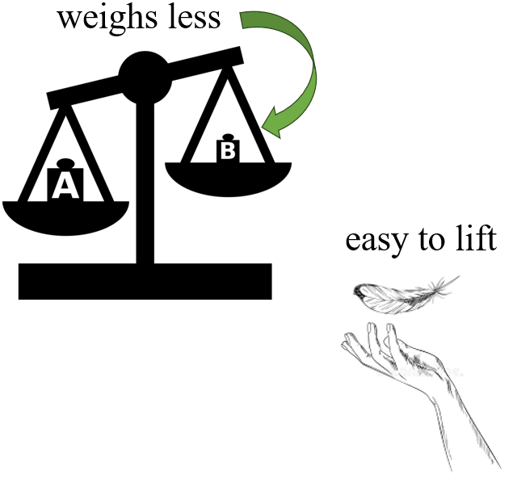

Picture of a physician’s scale

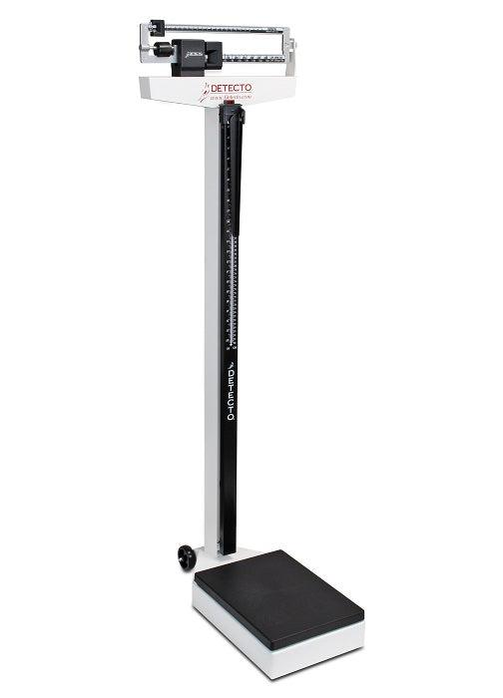

Picture of a bathroom scale

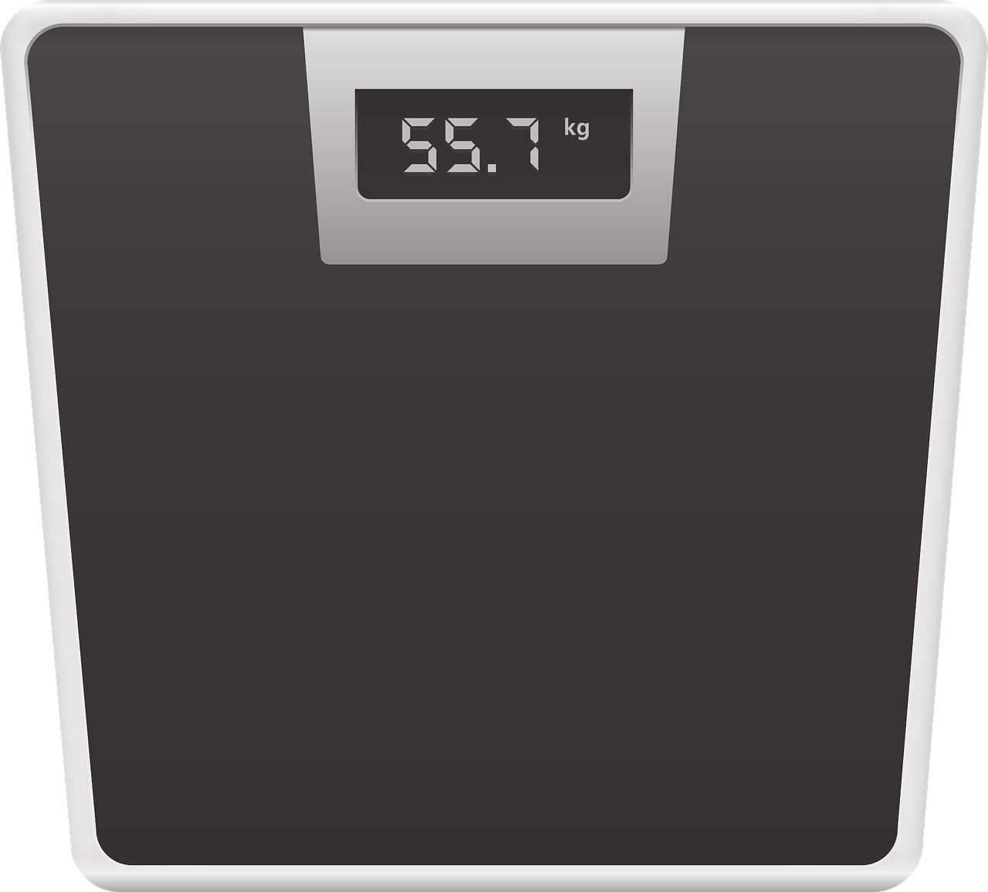

Picture of a kitchen scale

Picture of a balance scale

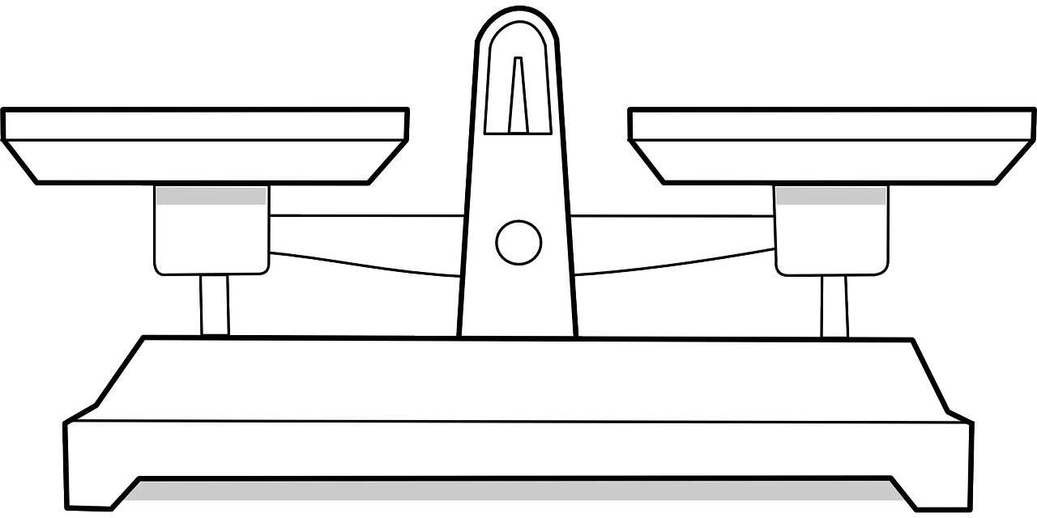

Example of the balance

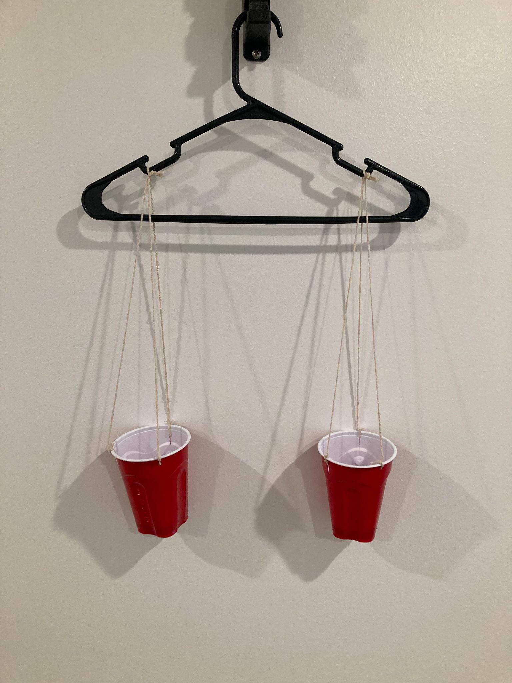

Student Data Recording Sheet

Name: Date:

1. ____________ is heavier than ____________

2. ____________ is heavier than ____________

3. ____________ is heavier than ____________

4. ____________ is heavier than ____________

5. ____________ is heavier than ____________

6. ____________ is heavier than ____________

Supplemental Material:

Parent Letter

Dear Parents,

In science, our class has been investigating the physical properties of objects. This week students explored the differences between heavy and light objects. We will celebrate our new learning by having a heavy/light show and tell. Each student should bring in one heavy object and one light object to present to their classmates by __________________.

Thank you for supporting our classroom,
Practice Items:
Grade 3 Math
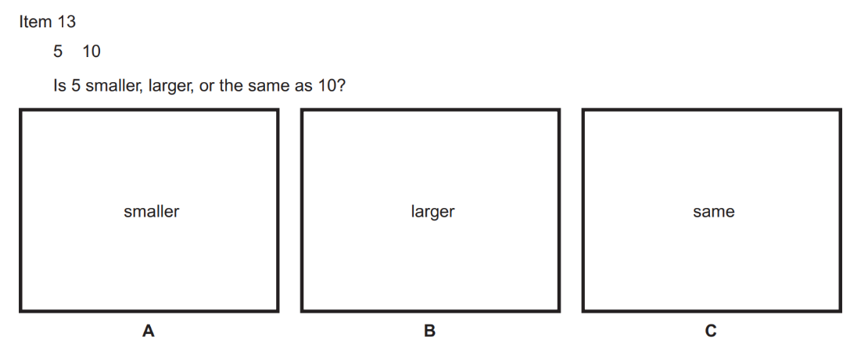

Grade 4 Math
