All About Apples and Pumpkins
Grade Level: 7
Subject(s):
Primary: Reading
Integrated Activity: Science, Writing
Reporting Category:
Demonstrate comprehension of nonfiction texts and use word analysis strategies.
Lesson Summary and Connections:
Students will listen to a story or read a passage (Reading, Science) about apples and pumpkins and will then answer questions and complete activities related to the reading.
Lesson Components Links
VESOL(s)  Complexity Continuum | Functional Skills | Assistive Technology | Materials
Vocabulary | Common Misconceptions | Student-Friendly Outcome(s) | Introductory Activity
Plan for Instruction | Differentiation | Reflection | Formative Assessment
Word Wall Cards | Supplemental Materials | Practice Items | Integrated Activity

VESOL(s):
R-7.1: The student will:
Understand the meaning of words in passages that are read to the student or that the student reads.

Complexity Continuum:
The words could be shown with or without a graphic representation or could appear in a sentence.

Functional Skill(s):
- Reading to understand their environment
- Reading to learn facts about plants
- Comparing (how items are similar) and contrasting (how items are different)

Assistive Technology/AAC (Augmentative and Alternative Communication):
- Audio books
- Video supplements

Materials:
- Pencils
- Highlighters
- Reading passage(s) (Passage A, Passage B, Passage C)
- Venn Diagram(s) (Diagram A, Diagram B, Diagram C)
- Formative Assessment(s) (Assessment A, Assessment B, Assessment C)
- Word Wall Cards
- Computer (teacher, to project Venn Diagram and show videos)
- Optional: Teacher may choose to check with the school’s library to see if any books related to the topic are available to use in the classroom.
- Optional: Other related free online books from TarHeelReader: Apple Orchard, Apples, The Pumpkin Patch, Pumpkins

Vocabulary:
Prior Knowledge
- Apples | - Pumpkins | - Stem | - Seeds
- Tree | - Pie | - Vine | - Different
- Same | - Similar
Current Vocabulary
- Orchard | - Pumpkin Patch

Common Misconceptions:
- Some students may not know that pumpkins are edible.
- Some students may think apples are only red.
- Some students may struggle using the Venn Diagram.

Student-Friendly Outcome(s):
- I will read a passage or have it read to me and will pay attention to the details.
- I will complete a Venn Diagram to show how apples and pumpkins are similar and different.
- I will be able to tell how apples and pumpkins are similar/same and how they are different.

Introductory Activity:
Ask students if they have ever eaten an apple, carved a pumpkin, or eaten apple or pumpkin pie. Those students who answer yes can then be asked what they know about apples and pumpkins (looks, touch, taste). These answers will then be the basis for students’ background knowledge going into the lesson.

Plan for Instruction:
- Introduce the lesson by explaining to the students they will read (or have read to them) a passage about the similarities and differences between apples and pumpkins. After reading, they will use the passage to help them fill out a Venn Diagram, and then they will answer questions about the passage for a formative assessment.
- Teacher will refer to the word wall and will introduce vocabulary that the students will be using during the lesson. The teacher will encourage students to tell what they know about vocabulary words. Teacher will define unknown/new words and will keep the visuals posted so that the students will be able to refer back to them.
- Teacher will show students videos so that the students without prior knowledge will receive an introduction to topic. Teacher can pause the videos to explain topics, check for understanding, and/or answer/ask questions related to the content of the videos.
  - All About Apples for Kids
  - All About Pumpkins for Kids
- Teacher will hand out a reading passage (choose appropriate level for each student: Passage A, Passage B, Passage C) and a highlighter to each student. Those students who are able to read by themselves will be given the appropriate level/passage and will begin reading independently. Those students who need adult assistance will follow along as the staff member reads to them.
- Throughout and after the reading, the teacher will model good reading strategies (highlighting important information, re-reading sections, chunking, writing notes in the margins, etc.) and circulate to prompt/ensure students are using these strategies.
- After passing out copies of the Venn Diagram (each student receives the diagram that matches the passage level: Diagram A, Diagram B, Diagram C) organizer to each student, the teacher will explain the activity to the class, so they understand what is expected of them.
  - Students who need additional assistance will receive a mini lesson on how to use a Venn Diagram. The teacher will project a Venn Diagram to complete with them and will ensure that students understand the different components of the Venn Diagram and how each one relates to apples or to pumpkins or to apples and pumpkins.
  - The teacher will practice prompting and wait time and, upon completion, will provide the students who worked independently an opportunity to self-correct.
  - Students who are ready/able to complete the assignment independently will begin working.
- Once the students have completed their Venn Diagrams, the teacher will review the similarities and differences between apples and pumpkins, asking the students questions and waiting for a thumbs-up/down response from each of them. Teacher will also answer any questions that the students may have before giving them the formative assessment.
- After handing out a formative assessment (Assessment A, Assessment B, Assessment C) to each student, those who are capable of completing the assessment on their own may begin once they have been given instructions. For those students who may need adult assistance/read aloud, they should wait to begin their assessment.

Differentiation:
- Different versions/levels of the passage and Venn Diagram and assessment will be available for the students.
- An adult staff member will read the passage to students who are unable to read on their own.

Reflection:
- Students can reflect on the vocabulary that they have reviewed and/or learned during the day’s lesson, such as “orchard” or “pumpkin patch.”
- Teacher will ask students how apples and pumpkins are similar/same and how they are different.
- Ask students, “What is one new fact you learned about apples or pumpkins?”

Formative Assessment:
All About Apples and Pumpkins - Level A
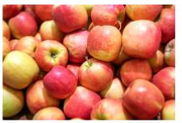
Name: _____________________________
Date: ______________________________

Directions: Choose the correct answer for each question.
- Apples grow on a ___________.
  - tree b. river c. bush

- Pumpkins grow on a __________.
  - tree b. bush c. vine

- ___________ are inside apples and pumpkins.
  - leaves b. seeds c. sticks

- ___________ are on top of apples and pumpkins.
  - stems b. water c. pies
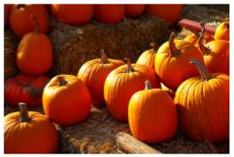
All About Apples and Pumpkins - Level B
Name: _____________________________
Date: ______________________________

Directions: Use the words in the box to help you answer the questions.

seeds | tree | stems | vine

- Apples grow on a ___________.

- Pumpkins grow on a ___________.

- ___________ are inside apples and pumpkins.

- ___________ are on top of apples and pumpkins.

All About Apples and Pumpkins - Level C
Name: ______________________ Date: ___________________

Directions: Answer the following questions.

- Where do apples grow?

- Where do pumpkins grow?

- Name one thing apples and pumpkins have in common.

- Name one thing that is different about apples and pumpkins.

Notes:
This lesson can be broken down to carry out over multiple days.

Integrated Activity:
- Science: VESOL S-8.10 The student will recognize that animals and plants have characteristics related to different functions which can be used to tell these organisms apart.
  - The use of videos will allow for introduction of the science information that is included within the reading lesson.
  - By making connections between the parts of both the apples and the pumpkins, students will be making connections between the reading and science.
    - Ask questions like: What is a part of the apple? What is a smaller part of the pumpkin.
  - Try to include discussions on:
    - How the seeds are the part of the plant that makes new plants.
    - How plants need water, light, and air to survive. (VESOL S-8.11)
    - The role of photosynthesis. (VESOL S-8.11)
- Journal/Writing Assignment
- Topic Suggestions – students can write or tell a story using the following ideas:
- A Trip to the Pumpkin Patch
- A Trip to the Apple Orchard
- Picking Apples
- My Pumpkin
- Making Apple/Pumpkin Pie

Word Wall Cards:
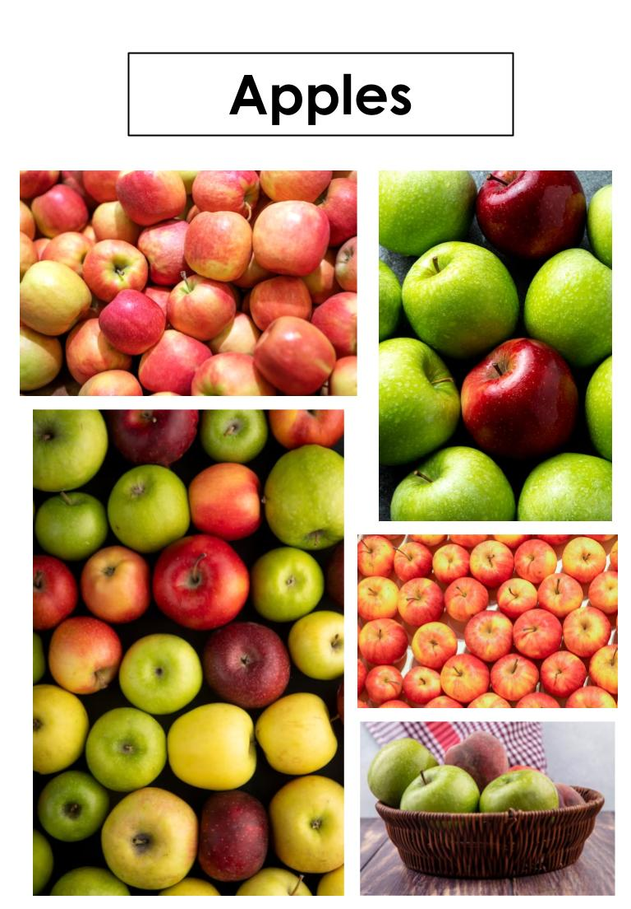
u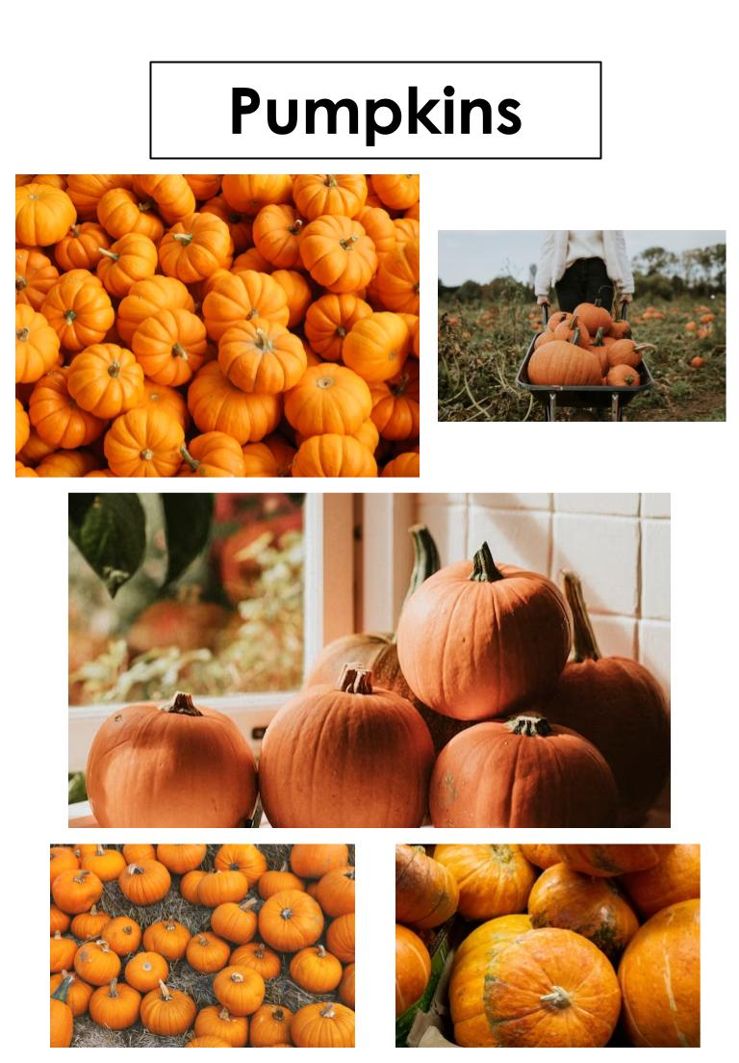
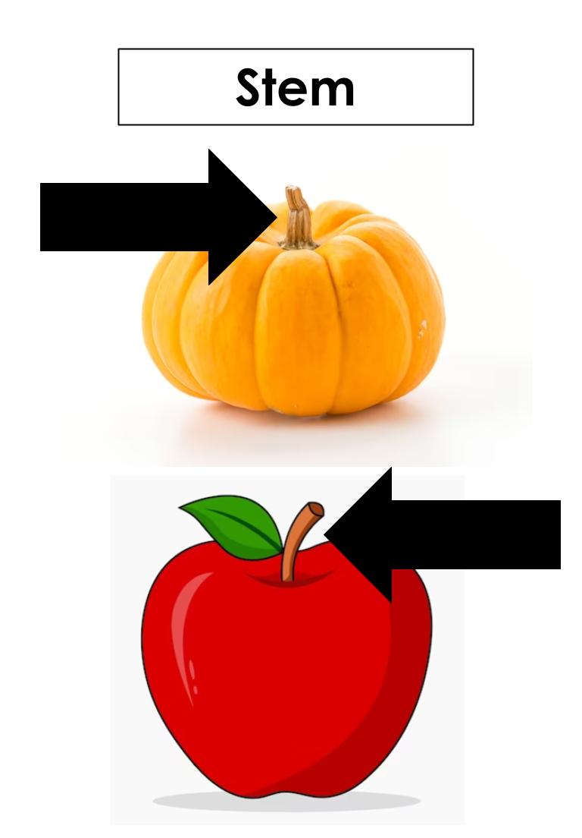
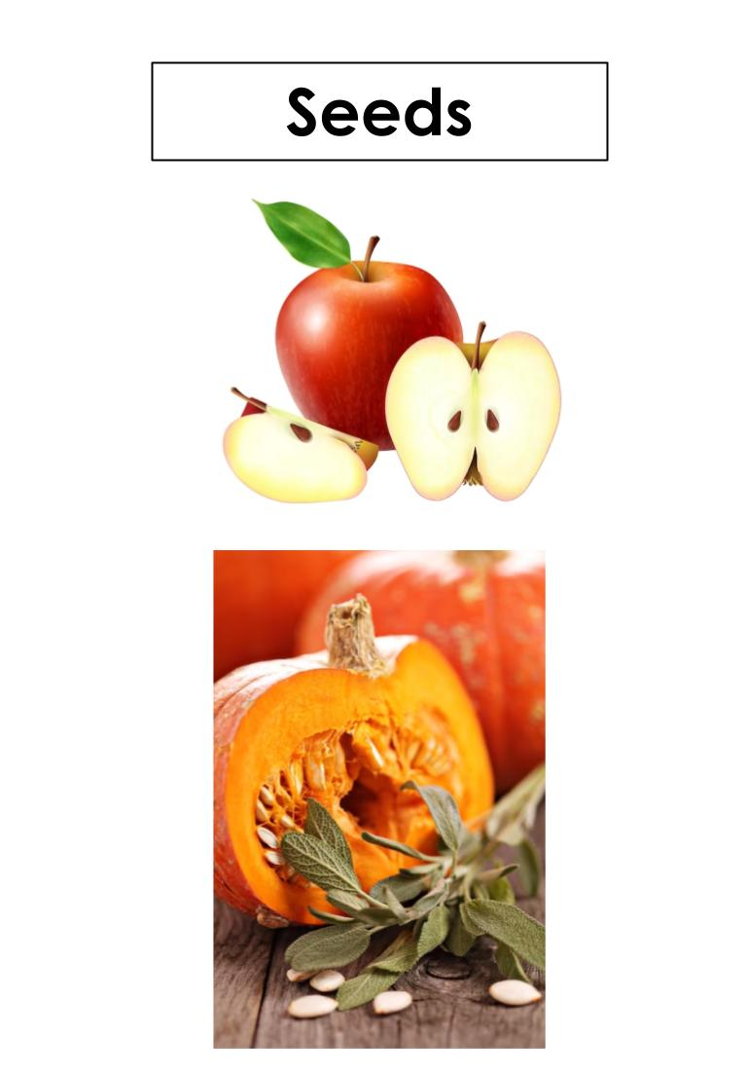
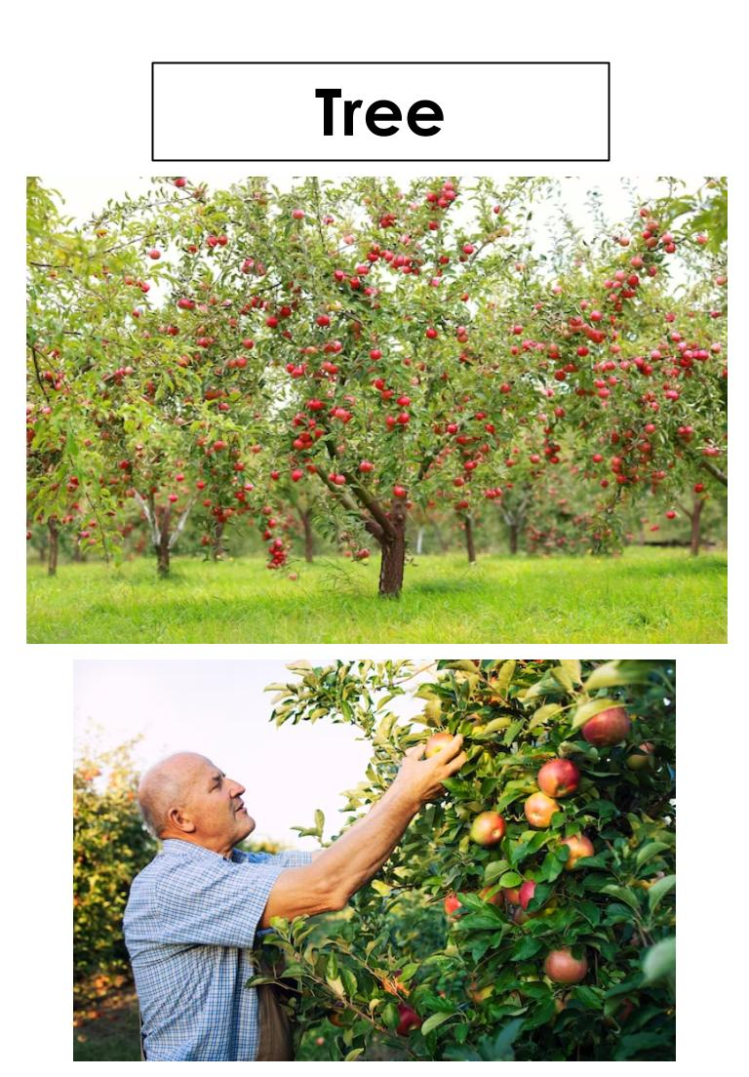
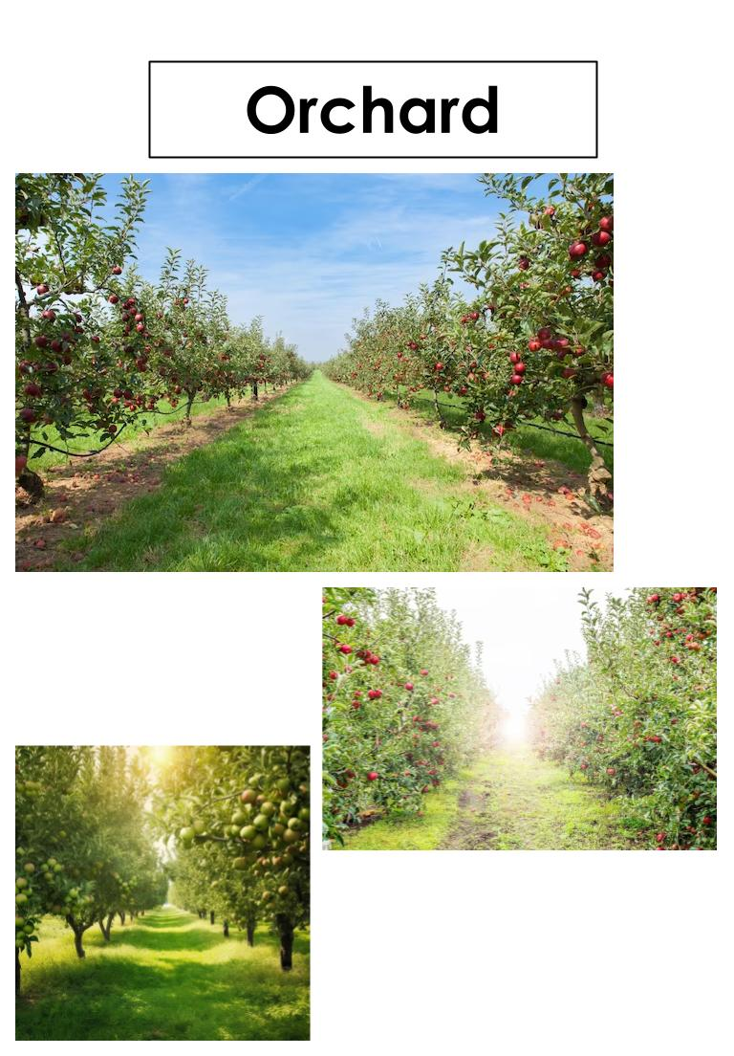
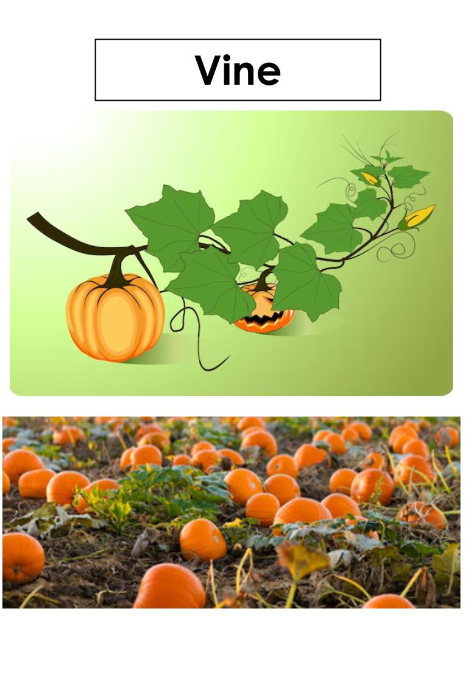
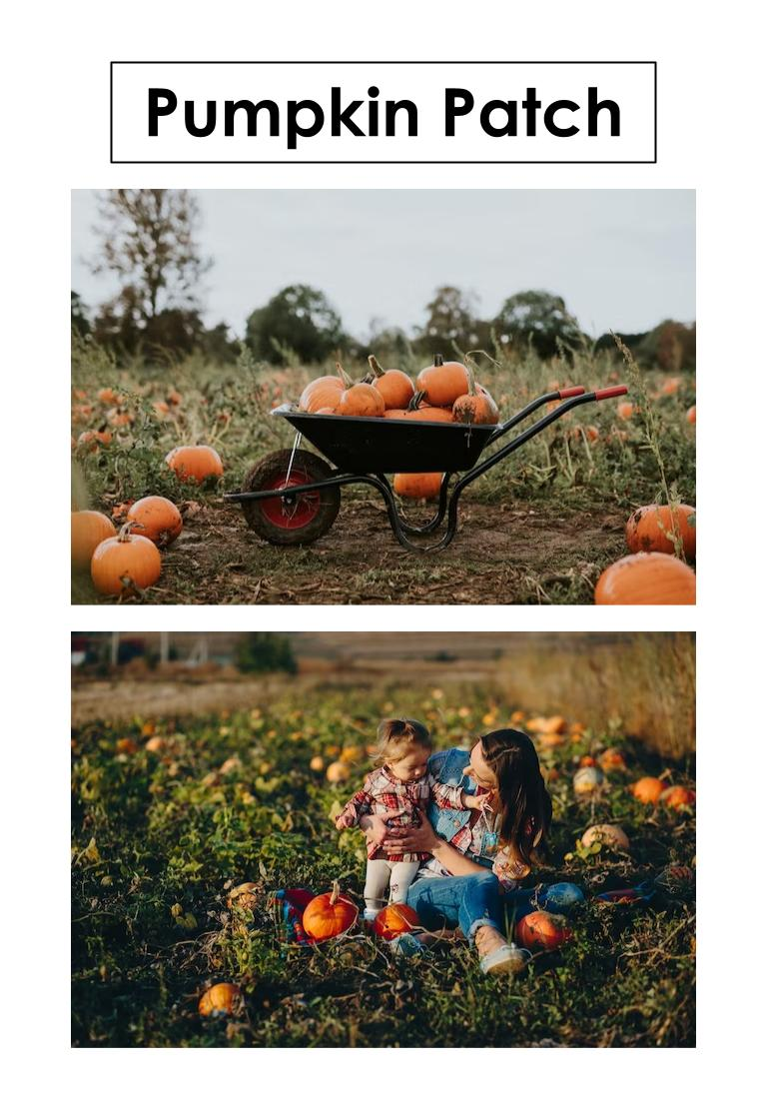
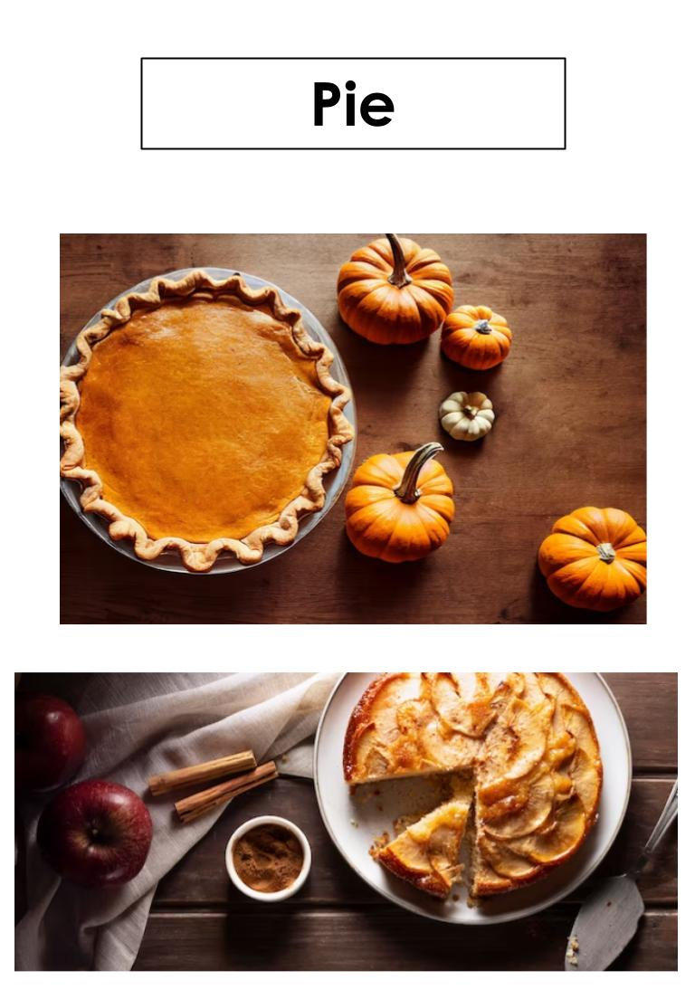

Supplemental Materials:
All About Apples and Pumpkins - Passage A

Apples are fruit. Pumpkins are fruit.

Apples come in many colors. Pumpkins are orange.

Apples grow on branches in trees. Pumpkins grow on vines on the ground.

Apples have seeds and stems. Pumpkins have seeds and stems.

All About Apples and Pumpkins - Passage B

Apples and pumpkins are fruit. They both have seeds and stems.

Apples come in many different colors, but pumpkins are only orange.

Apples grow on trees in an orchard, but pumpkins grow on a vine on the ground in a pumpkin patch.

Apples and pumpkins can be made into pies.

All About Apples and Pumpkins - Passage C

Apples and pumpkins have a lot in common. They are both fruit. Both have seeds inside as well as stems on the top.

Another thing that apples and pumpkins have in common is they can both be made into pies. People make pumpkin pies in the fall around Thanksgiving. Apple pies can be eaten all year, with ice cream or without.

Apples and pumpkins are also different in some ways. Apples come in many different colors, but pumpkins are only orange.

The biggest way in which they are different is how they grow. Apples grow on a tree in an orchard, but pumpkins grow on a vine on the ground in a pumpkin patch.

Name: ____________________________ Date: _________________________
Directions: Use “All About Apples and Pumpkins” to help you fill in the Venn Diagram below. Cut and glue the answer in the correct place.

stem | many colors | pumpkin patch | vines
Orchard | only orange | seeds | trees
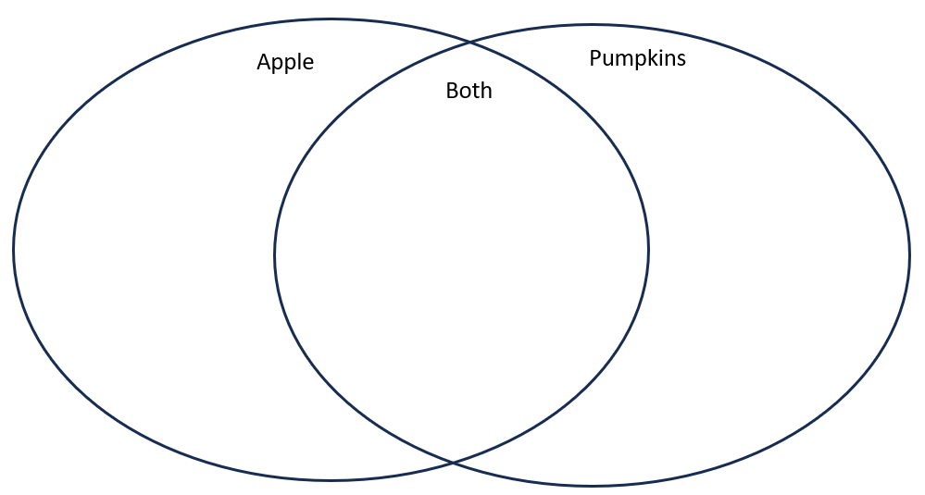A
Name: ____________________________ Date: _________________________
Directions: Use “All About Apples and Pumpkins” and the word bank to help you fill in the Venn Diagram below. Cut and glue the answer in the correct place.
stem | many colors | pumpkin patch | vines
Orchard | only orange | seeds | trees
B

Name: ____________________________ Date: _________________________
Directions: Use “All About Apples and Pumpkins” to help you fill in the Venn Diagram below.
C

Practice Items:
Grade 7, Practice Item 10

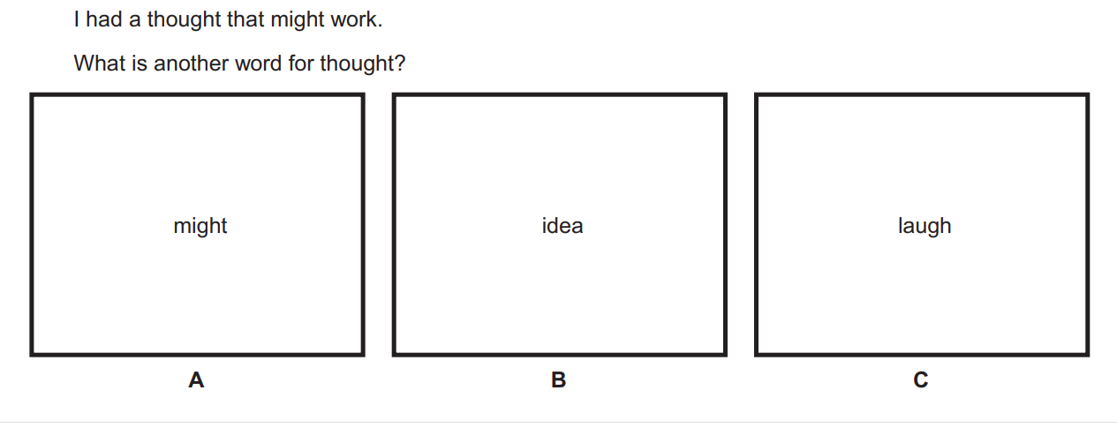

Grade 7, Practice Item 11
