R-6.1 All About Bats and Owls
Grade Level: 6
Subject(s):
Primary: Reading
Integrated Activity: Science
Reporting Category:
Demonstrate comprehension of nonfiction texts and use word analysis strategies.
Lesson Summary and Connections:
Students will listen to a story or read a passage (Reading, Science) about bats and owls and will then answer questions and complete activities related to the reading.
Lesson Components Links
VESOL(s)  Complexity Continuum | Functional Skills | Assistive Technology | Materials
Vocabulary | Common Misconceptions | Student-Friendly Outcome(s) | Introductory Activity
Plan for Instruction | Differentiation | Reflection | Formative Assessment
Word Wall Cards | Supplemental Materials | Practice Items | Integrated Activity

VESOL(s):
R-6.1: Understand the meaning of words in passages that are read to the student or that the student reads.
Complexity Continuum:
The words could be shown with or without a graphic representation or could appear in a sentence.

Functional Skill(s):
- Reading will help students learn about their environment.
- Understanding the meaning of words in what is read or spoken will help students when communicating with others.
- Understanding the meaning of the words “similar/similarities” and “different/differences” will help students organize information.

Assistive Technology/AAC (Augmentative and Alternative Communication):
- Audio books
- Video supplements

Materials:
- Pencils
- Highlighters
- Copy of reading passage(s)
- Blank copy of Venn Diagram
- Word Wall Cards (printed)
- Copy of formative assessment(s)
- Computer (teacher, to project Venn Diagram and show videos)

Vocabulary:
Prior Knowledge
- day | - night | - wings | - birds
- skin | - feathers | - beak | - teeth
Current Vocabulary
- nocturnal | - mammals | - bat | - owl

Common Misconceptions:
- Many students seem to think either the first answer is the correct answer or the last answer is the correct answer.
- The word ‘bat’ is a multiple meaning word so students will need to be sure they understand the lesson is about bats that fly and not bats that we use to play baseball or softball.
- Some students may not understand that bats are not birds because they can fly like birds.

Student-Friendly Outcome(s):
- I will read a story or have it read to me and will pay attention to the details.
- I will identify details in a story.
- I will organize details in a story using a Venn Diagram.
- I will be able to describe words I read in a story.

Introductory Activity:
Display the bat and owl Word Wall Cards and ask students if they’ve ever seen bats or owls at the zoo or in their neighborhood. Those students who have experienced this can then be asked what they know about bats or owls. If no one has anything to say, use the Word Wall cards to start a conversation. These answers will then be the basis for students’ background knowledge going into the lesson.

Plan for Instruction:
- Introduce the lesson by explaining to the students that they will be reading (or be read to) a passage about the similarities and differences between bats and owls. After the reading, they will then use the passage to help them fill out a Venn Diagram and will answer questions for a formative assessment.
- Teacher will refer to the Word Wall Cards and will introduce vocabulary that the students will be using during the lesson. Teacher will define unknown/new words and will keep the visuals posted so that the students will be able to refer back to them.
- Teacher will show students several videos so that the students without prior knowledge will receive an introduction to today’s topic.
- All About Bats for Kids
- All About Owls for Kids
- Bats versus Owls
- Teacher can pause the videos to explain topics, check for understanding, and/or answer/ask questions related to the content of the videos.
- Teacher will hand out a reading passage (Level A and Level B) and a highlighter to each student. Those students who are able to read to themselves will be given the Level C passage and will begin reading independently. Those students who need adult assistance will follow along as the staff member reads to them.
- Throughout and after the reading, the teacher will model good reading strategies and will circulate the room to ensure students are highlighting relevant information or to prompt students to look for and identify segments of the passage they would deem important.
- After passing out copies of the Venn Diagram organizer to each student, the teacher will explain the activity to the class so that they understand what is expected of them. Students who are capable of completing the assignment independently will begin working. For students who need additional assistance, the teacher will project a Venn Diagram to complete with them. The teacher will practice prompting, wait time, and, upon completion, will provide the students that worked independently an opportunity to self-correct. Teacher will ensure that students understand the different components of the Venn Diagram as to how it relates to bats and owls.
- Once the students have completed their Venn Diagrams, the teacher will review the similarities and differences between owls and bats, asking the students questions such as, “What can you tell me about a bat?" or “When do owls and bats sleep?” etc. Teacher will also answer any questions that the students may have before giving them the formal assessment.
- After handing out an assessment (Level A, Level B, Level C) to each student, those who are capable of completing the quiz on their own may begin once they have been given instructions. For those students who may need adult assistance/read aloud, they should wait to begin their assessment.
- After completing the assessment, teacher may choose to show another video of bats and owls (many can be found on YouTube) or read an age-appropriate book (e.g., Tarheel Reader).

Differentiation:
- For students who are able to read on their own, a version of the passage at the appropriate reading level will be given to them.
- For students who are unable to read on their own, an adult staff member will read the passage to them.
- Different versions of the passage and assessment will be available for the students.

Reflection:
Students can reflect on the vocabulary that they have reviewed and/or learned during the day’s lesson, such as “nocturnal” or “mammal”. Questions the teacher may ask students include:
- What do bats and owls have in common? How are they similar?
- How do bats and owls differ from one another?
- What does nocturnal mean?

Formative Assessment:

All About Bats and Owls
Level A
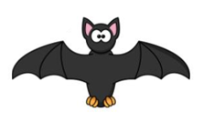
Name: _________________
Date: __________________
Directions: Chose the correct answer for each question.

- Bat wings are made of _____________.
  - wood b. skin c. plastic

- Owl wings are made of ____________.
  - feathers b. plastic c. metal

- Bats eat with _____________.
  - fork b. teeth c. spoon

- Owls eat with a ____________.
  - beak b. spoon c. knife

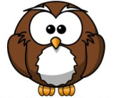

All About Bats and Owls
Level B
Name: _________________
Date: __________________
Directions: Use the words in the box to answer for each question.

teeth feathers beak skin

- Bat wings are made of _____________.

- Owl wings are made of ____________.

- Bats eat with _____________.

- Owls eat with ____________.

All About Bats and Owls
Level C
Name: _________________
Date: __________________
Directions: Answer the questions below.

- Name one thing that bats and owls have in common.

- Name one thing that is different about bats and owls.

- What does “nocturnal” mean?

- How do bats sleep?

Integrated Activity:
The use of videos will allow for introduction of the science information that is included within the reading lesson.

Word Wall Cards:
Bat
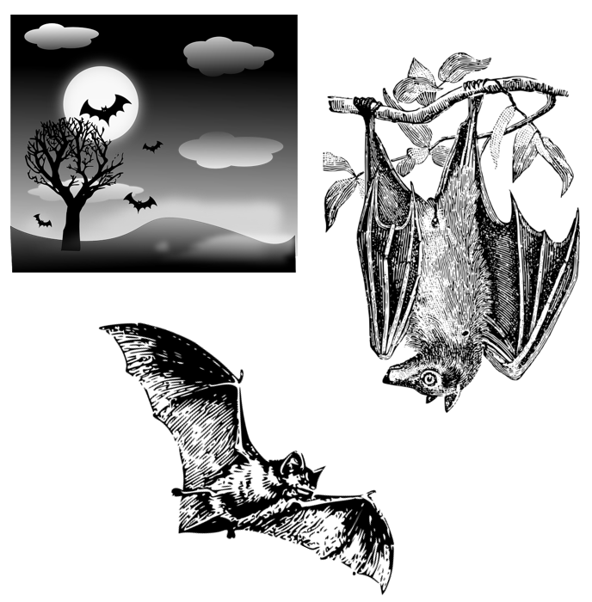

Owl

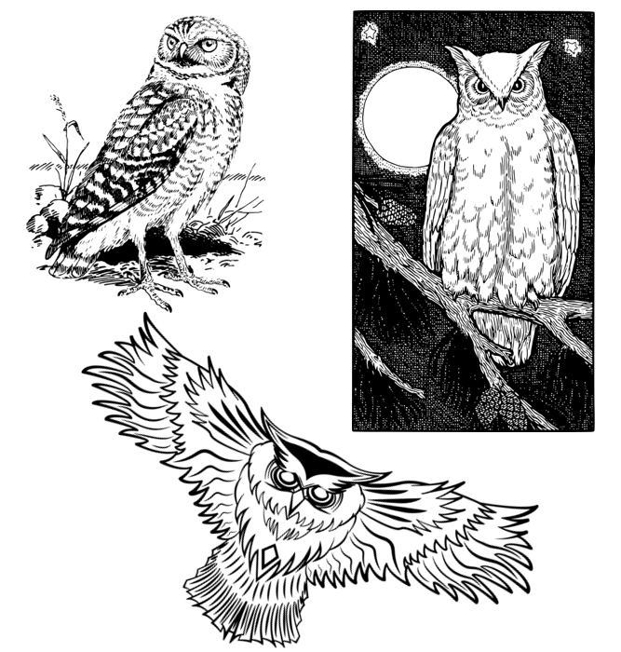

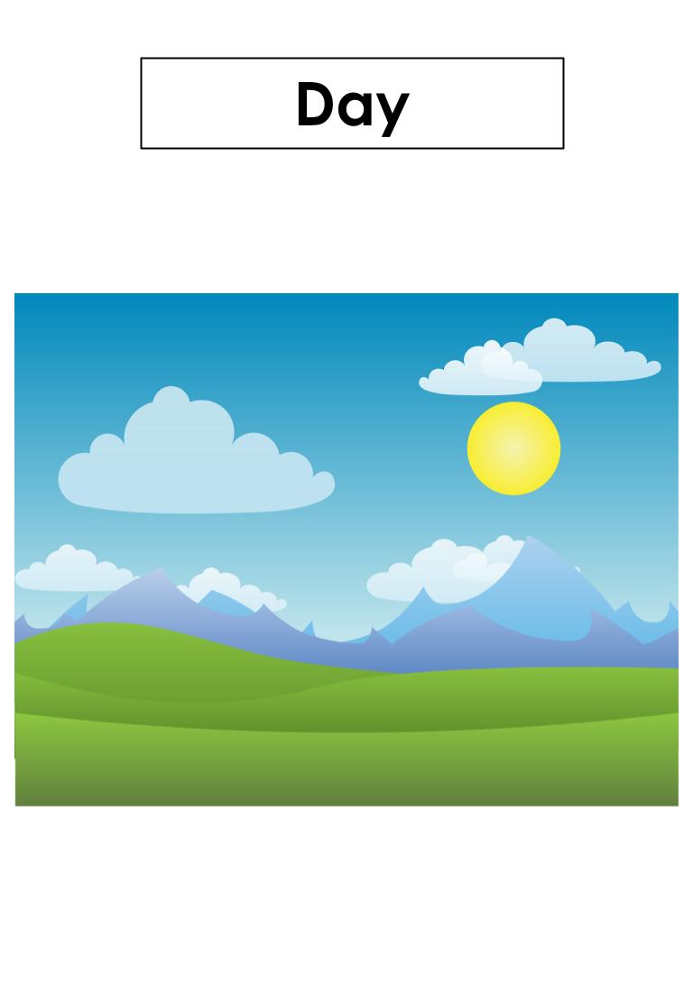
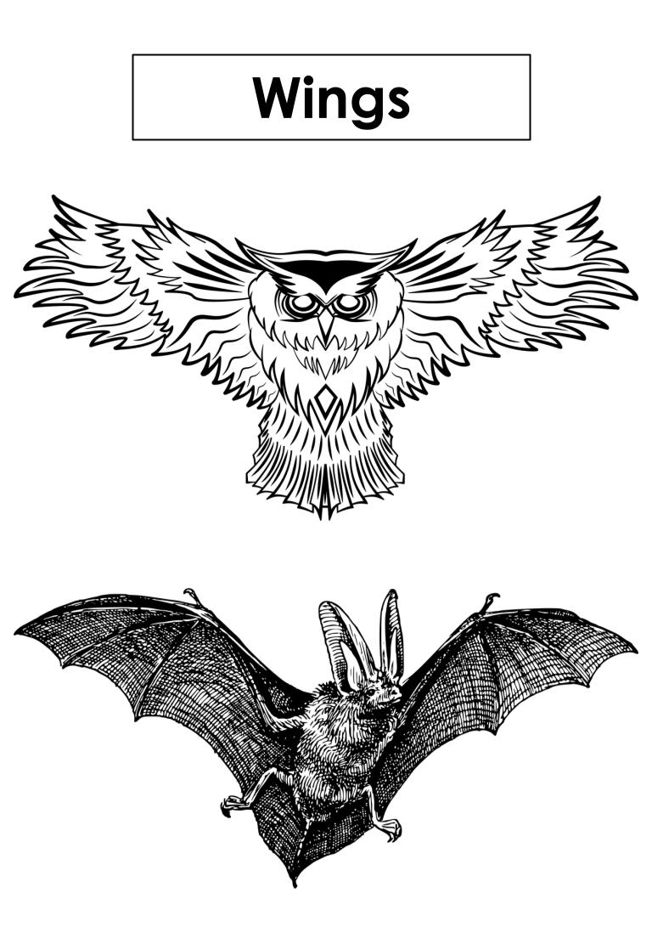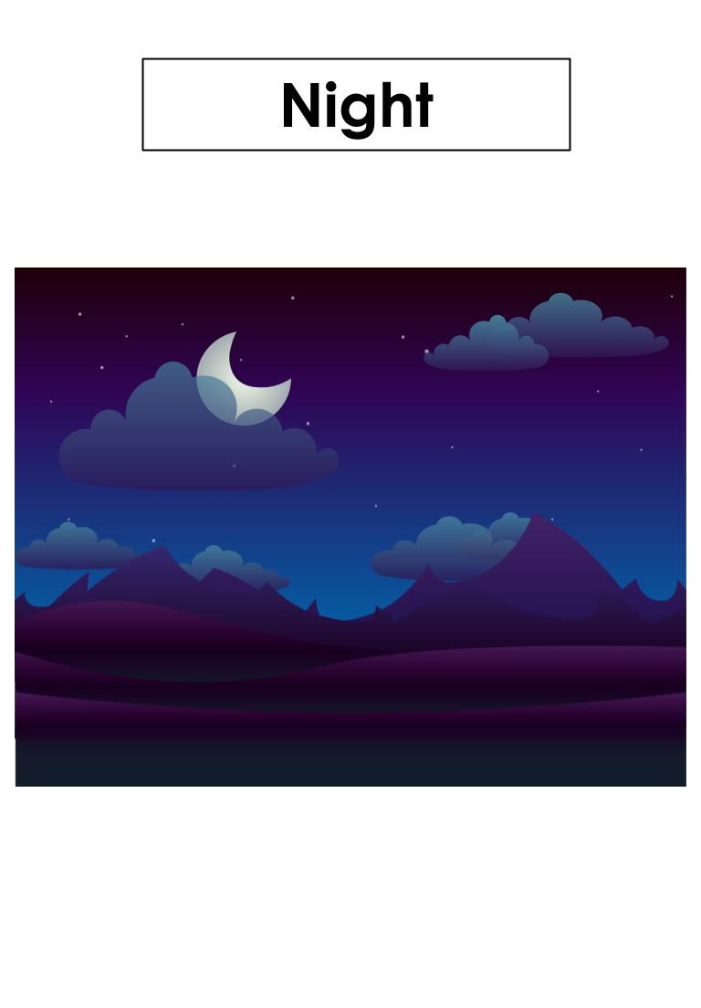
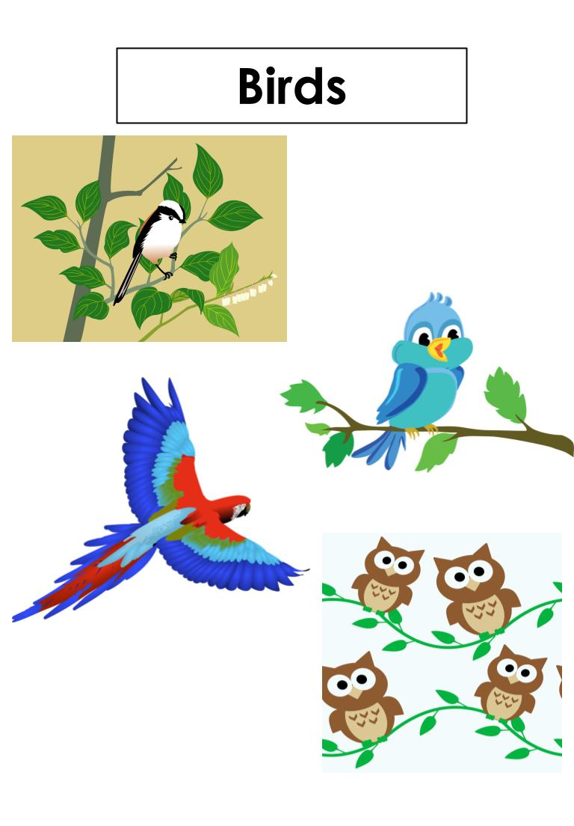
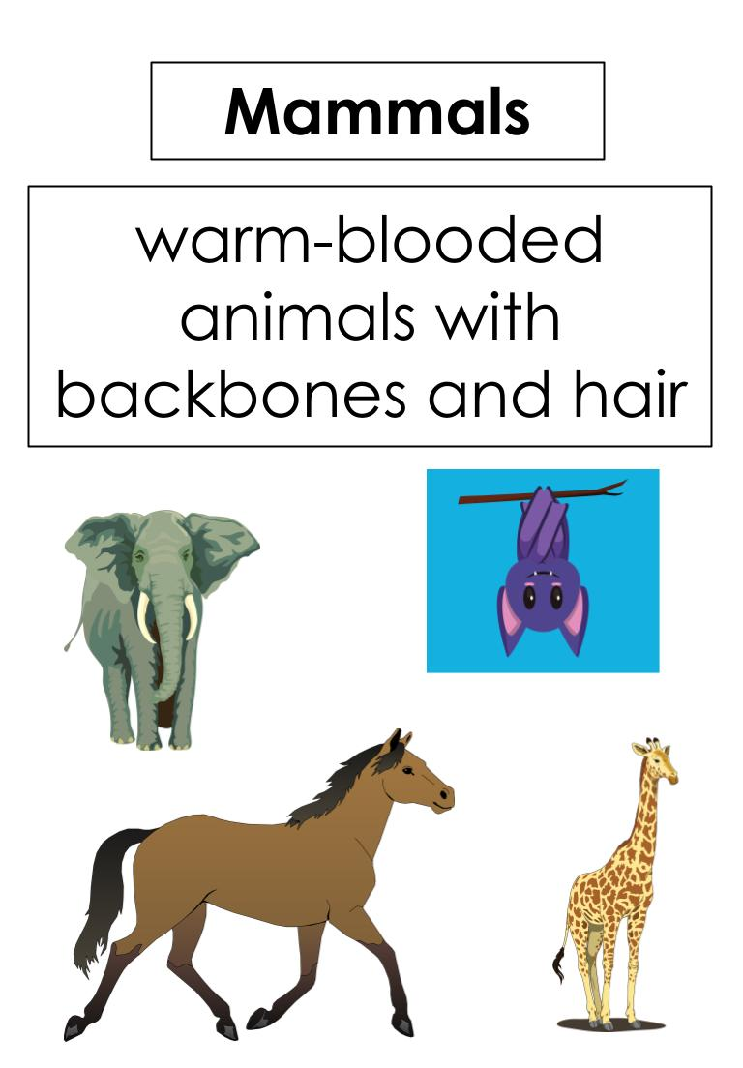
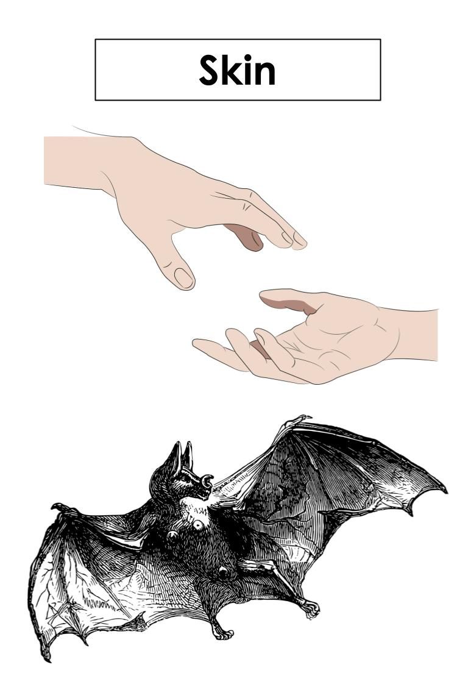
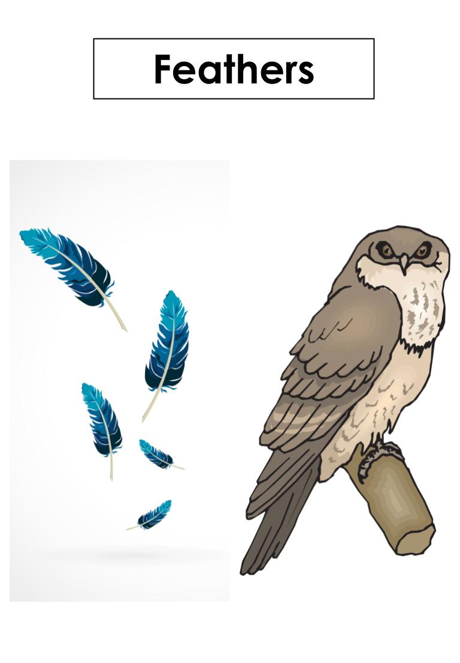
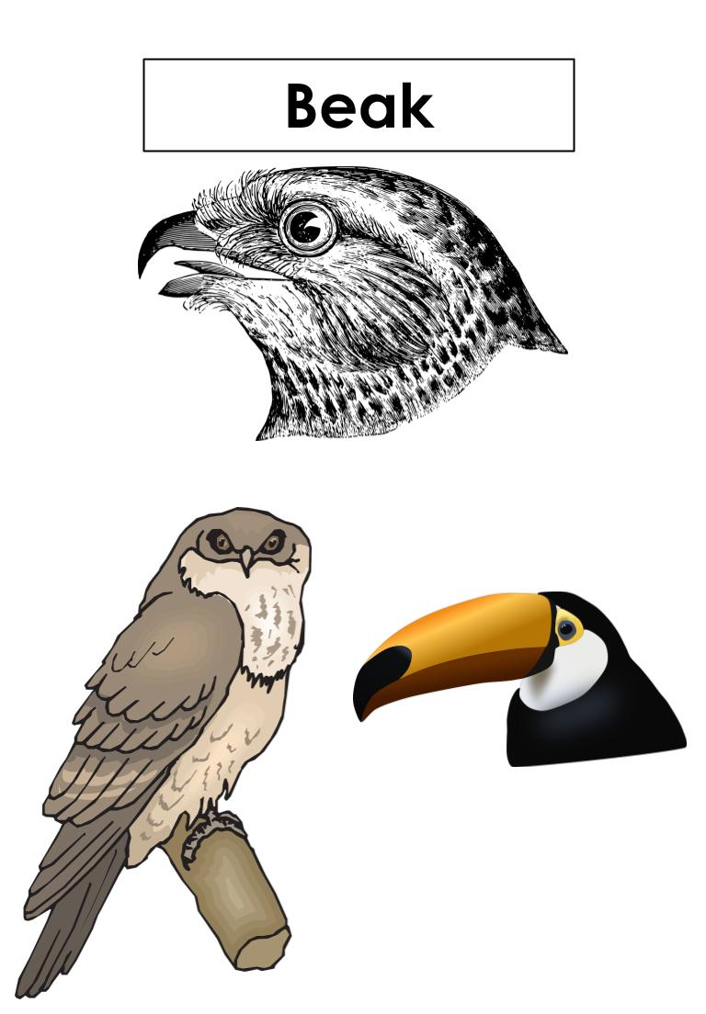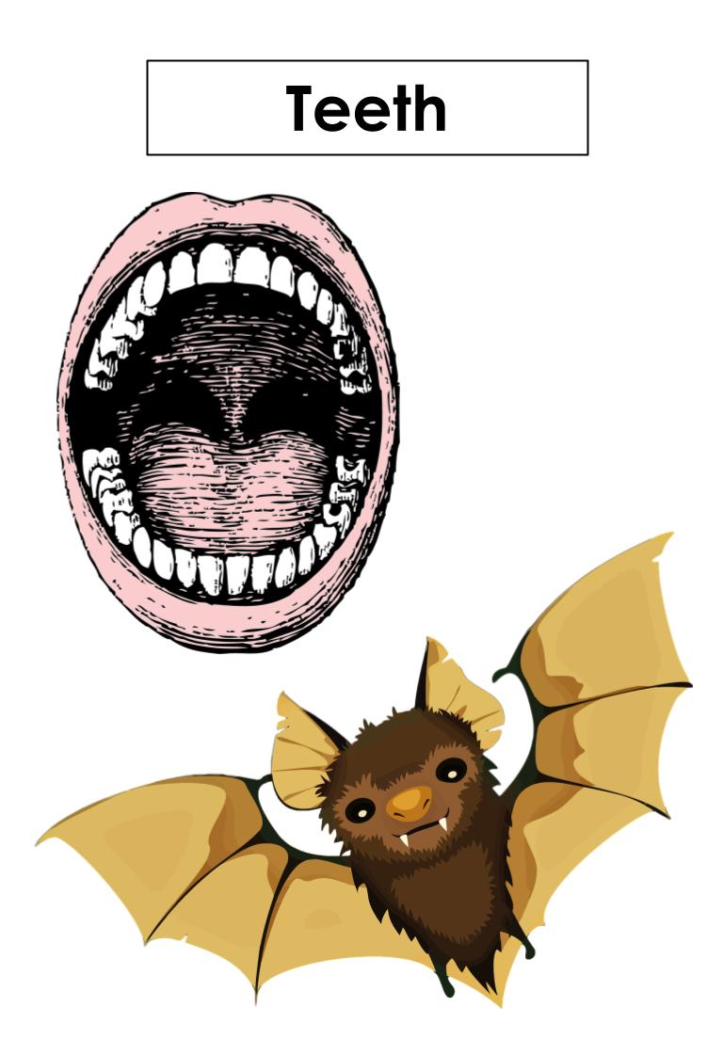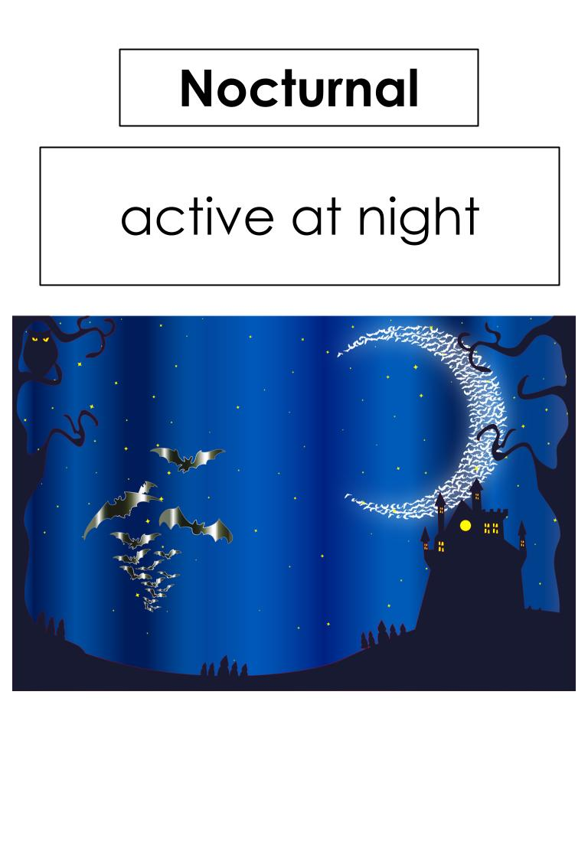

Supplemental Materials: Teacher may choose to check with the school’s library to see if any books related to the topic are available to use in the classroom.

All About Bats and Owls
Level A
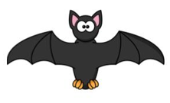
Bats and owls sleep during the day. They are awake at night. They are nocturnal.

Bats and owls have wings. Bat wings have skin. Owl wings have feathers.

Bats are mammals. Owls are birds.

Bats sleep upside down. Owls sleep sitting upright.

All About Bats and Owls
Level B
Bats and owls sleep during the day and are awake at night. This means they are nocturnal.

They both have wings. A bat’s wings are made of skin, but an owl’s wings are made of feathers. Bats are mammals and owls are birds.

Bats can sleep upside down, but owls sleep sitting upright.

All About Bats and Owls
Level C
Bats and owls sleep have a lot in common. They are both nocturnal creatures. “Nocturnal” means that they are awake and active at night, and they sleep during the day.

Another thing that bats and owls have in common is that they both have wings. While a bat’s wings are made of two layers of skin, an owl’s wings are made of feathers. Even though they both have wings, bats are mammals and owls are birds.

Bats and owls are also different in some ways. Bats are known to sleep hanging upside down, but an owl sleeps sitting upright.

When it comes to eating, bats use teeth to chew their food. Owls do not have teeth and so they use their beaks to eat their food.

Name: ______________________________________________________ Date: ________________

Directions: Use the All About Bats and Owls reading passage and the word bank to help you fill in the Venn Diagram below.

Wings mammals birds feathers sleeps sitting upright
Nocturnal teeth skin beaks sleeps upside down

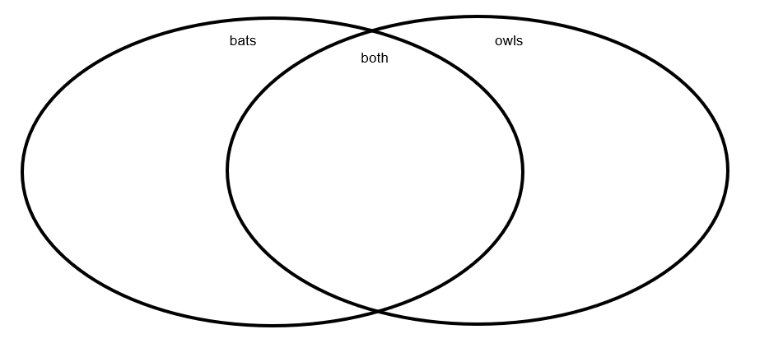

Practice Items:
