A Dog's Day

Grade Level: 3
Subject(s):
Primary: Reading
Integrated Activity: Math
Reporting Category:
Demonstrate comprehension of fictional texts and use word analysis strategies
Lesson Summary and Connections:
Students will identify events by reading a story about a dog's day and make connections to their own daily schedules.
Lesson Components Links
VESOL(s)  Complexity Continuum | Functional Skills | Assistive Technology | Materials
Vocabulary | Common Misconceptions | Student-Friendly Outcome(s) | Introductory Activity
Plan for Instruction | Differentiation | Reflection | Formative Assessment
Word Wall Cards | Supplemental Materials | Practice Items | Integrated Activity

VESOL(s):
R-3.7: Identify an event, idea, or step in a passage that is read to the student or that the student reads.

Complexity Continuum:
The passage could range from a sentence with five or fewer words through a sentence of seven to fourteen words.

Functional Skill(s):
- Interpreting schedules
- Using sequencing words (before, after, next)
- Telling time on a digital clock
- Identifying important information in a text

Assistive Technology/AAC (Augmentative and Alternative Communication):
- Nonspeaking students may use a communication device to answer questions.

Materials:
- Whiteboard or chart paper
- Dry erase or chart paper markers
- Printouts of supplemental materials

Vocabulary:
Prior Knowledge What words will students need to know prior to starting the lesson?
- day | - morning | - night | - nap
- time
Current Vocabulary What words will students learn during the lesson?
- clock | - event | - exhausted | - predict
- schedule

Common Misconceptions:
- Students might not understand the concept of time or know how to read a schedule.
- Student might get the words first, next, and last confused.

Student-Friendly Outcome(s):
- I can identify an event in a story.
- I can read a schedule.
- I can tell time on a digital clock.

Part 1:

Introductory Activity:
- Engage students in a conversation about their daily schedule.
  - Say: Every day at school, we follow a schedule. We have different events at different times throughout the day. Who can tell us how we start our day?
  - Allow students to brainstorm ideas.
- Using chart paper or a whiteboard and write out the class schedule with your students’ help. Make sure to leave a blank next to each event for times. (If all of your students don't have the same schedule, use one student's schedule as an example.)
  - Say: Let's look at our schedule and identify some of the events we have today.
  - Give students a chance to review the class created schedule and then ask them specific questions such as: What is one event that will happen today? How will we start our day? After lunch, what happens next? What is the last event of the day?
- Continue discussion until you feel that students understand the schedule, times, and events throughout the day.

Plan for Instruction:

Before reading have student take a picture walk.
- Say: Today we will be reading a story about a dog's day. This dog has a schedule for her day just like we have a schedule for our day. Let's look through the pictures in our book to make some predictions.
- Display the teacher’s read-aloud book.
- Go through the book one page at a time and have students make predictions of what will happen in the story. If students are struggling to make predictions, model how you would make predictions and comment on the pictures you see.
Part 2:
- Pass out student copies of books and display (or project) the teacher read-aloud book.
- While reading the story, the class will create a schedule for May’s day.
  - Say: As we read, we will be filling out a schedule for May the dog just like we filled out our schedule.
- Create the schedule using the whiteboard or project it on a screen. Use May’s Schedule as a guideline. Incorporate the math standard by reviewing how to read a digital clock and have students use the phrase “o’clock” when reading each time.
  - Say: As we read, we will match the correct picture from May's day with the time in her schedule. Turn to the first page of your book and follow along as I read.
    - You may choose to hand each student a copy of May’s Schedule or complete one as a whole class.
    - You may also choose to create the whole class schedule, then have students re-read the story and fill in May’s Schedule on their own or with a partner.
- When you get to each page with a time, pause and have students help you match the correct schedule picture card with the time. Ask questions such as, “What happened?” “At what time did ____ happen?” “What word told you what happened?” and so on.
- Continue to read the story and model good reading strategies. (Think aloud, ask yourself questions as you read, highlight important words, go back and re-read when something is confusing, write notes in the margins, etc.)
- After reading- reflection
  - Ask students questions from the reflection section of this lesson.

Differentiation:
- Students may work with a peer helper or paraprofessional if needed.
- Students who are distracted by materials on their desk during a lesson or who struggle to follow along with a book might look on with a peer or paraprofessional.
- Students who are able can read the story on their own to themselves or to a partner or paraprofessional.

Reflection:
- Review the book by going through the schedule you made and asking the following questions:
  - What did May do first?
  - What was the time when May ________?
  - What did May do at 8:00? 10:00? etc.
Formative Assessment:
- Formative Assessment 1: Have students use the story and answer the Formative Assessment questions. Remind students to use the strategies you shared while they answer the questions.
- Formative Assessment 2:
- To see if the students can apply what they learned, read (or have the students read) the following passage and answer the questions:
Joleen got home from school at 3:00 p.m. She ate an apple for snack. Joleen went outside to play at 4:00 p.m. She played with Tami. Joleen came home at 5:00.
- Questions:
  - What did Joleen do when she got home from school?
  - What was the time when Joleen got home?
  - Who did Joleen play with outside?
  - When did Joleen go outside to play?

Integrated Activity:

M-3.13 Tell time in whole hour increments using a digital clock, including with context
- While creating the schedule for the story, conduct a mini lesson on how to read a digital clock. Use the Word Wall Card, the class clock, an online clock, etc., to demonstrate the different times and how to read them. Have student practice telling time using the class clock, online clock, or the What Time Is It? worksheet. (There are directions on the worksheet, but you may use it as you see fit for you students.)

Word Wall Cards:

Clock
time

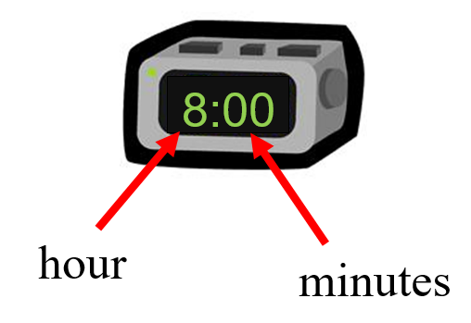

digital

Supplemental Materials:
- Story: May’s Day
- Schedule picture cards
- May’s Schedule
- Formative Assessment
- What Time Is It?

Story

May’s Day

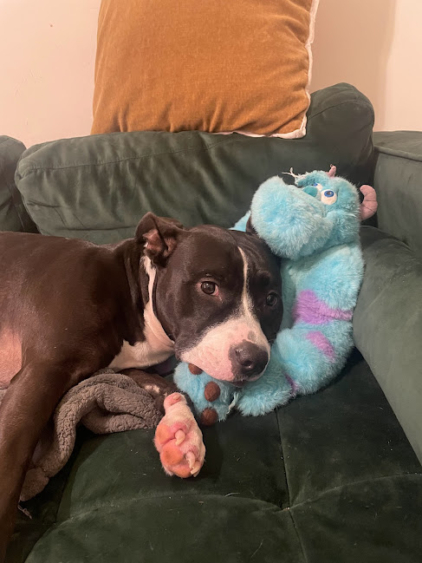

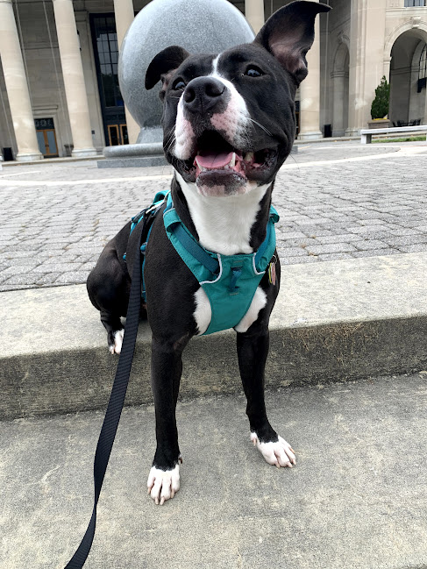

Hi! My name is May. This is a story about my day.

Good morning! It’s eight o’clock. It’s time to wake up!

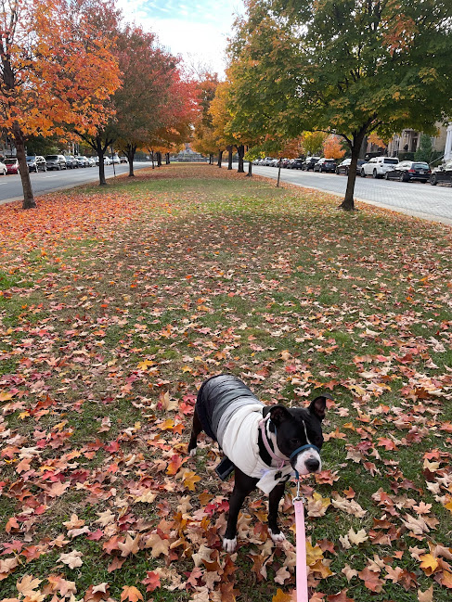

It’s ten o’clock. It’s time for my morning walk!

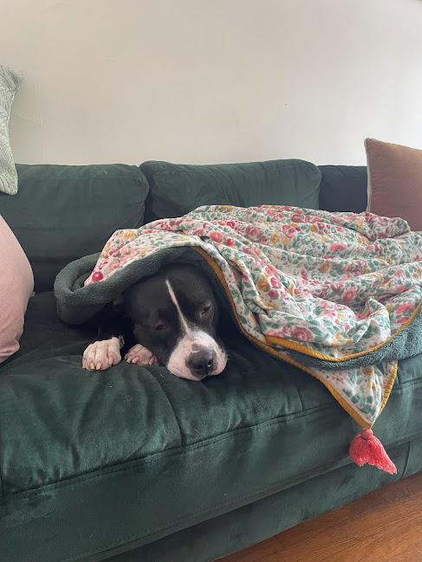

That walk was exhausting! It’s twelve o’clock and it’s time for a nap.

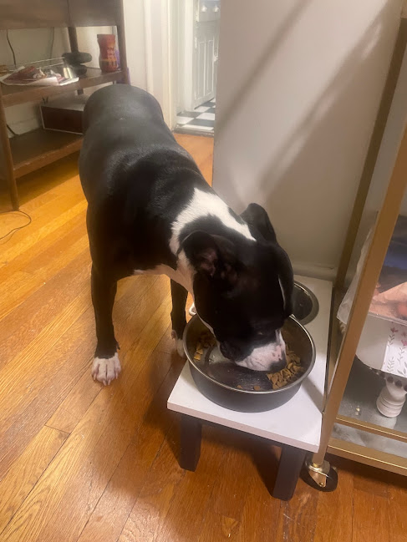

It’s six o’clock. It’s time for dinner! Yum!

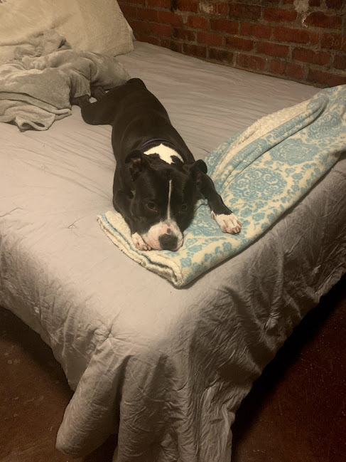

That was a great day! Now it is nine o’clock, and it is time for bed. Goodnight!

Schedule picture cards for “during reading” anchor chart

May’s Schedule
Directions: Fill in May’s schedule as you read the book.

Event | What Happened | Time

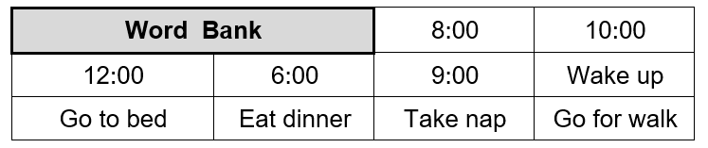

Formative Assessment
Directions: For each question, circle the correct answer.

      - What is the first thing May does in the morning?

 |  | 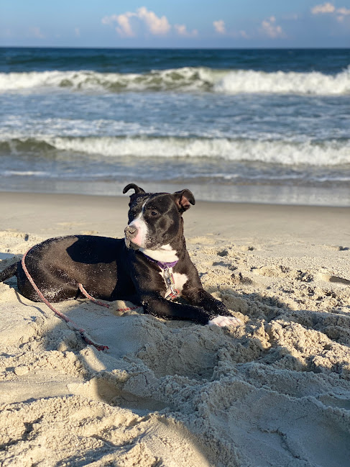
Wake up | Eat dinner | Go to the beach

      - What does May do at ten o’clock?

 |  | 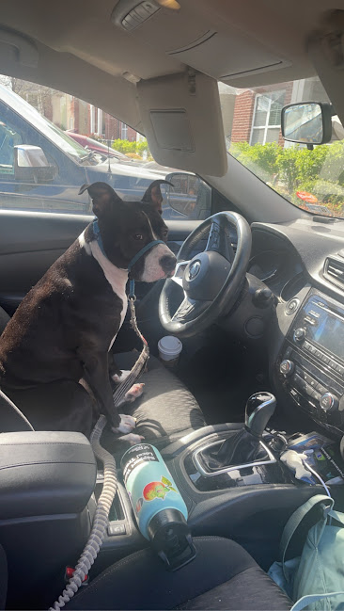
Take a nap | Go for a walk | Drive a car

      - What is the last thing May does during her day?

 |  | 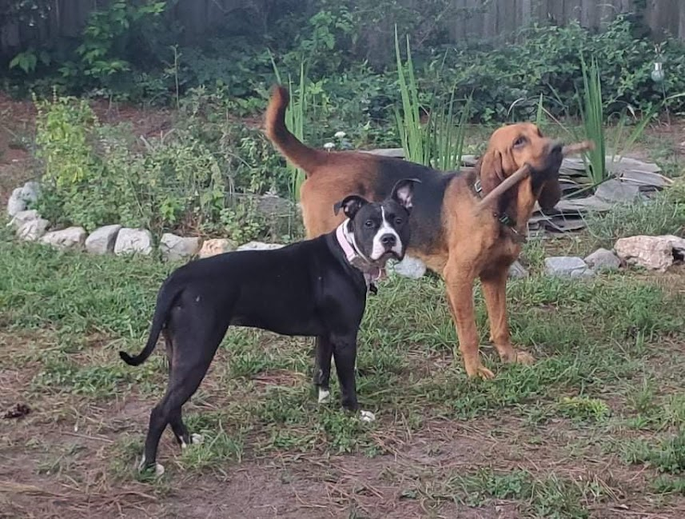
Eat dinner | Go to bed | Paly with a friend

What Time Is It?

Directions: Read each time in the table. Tell something that might happen at that time. (Example: at 5:00 a.m. May is sleeping because it is early in the morning.)

8:00 a.m. | 10:00 a.m.
12:00 p.m. | 6:00 p.m.
9:00 p.m. | 5:00 a.m.
3:00 a.m. | 1:00 p.m.
11:00 p.m. | 4:00 p.m.
2:00 a.m. | 7:00 p.m.

Practice Items:

