All You Have to do is “Tri”
The Mystery of Triangles
Grade Level: 7
Subject(s):
Primary: Math
Integrated Activity: Writing
Reporting Category: Measurement and Geometry
Lesson Summary and Connections:
In this lesson students will identify similar triangles including real world examples.
Lesson Components Links
VESOL(s)  Complexity Continuum | Functional Skills | Assistive Technology | Materials
Vocabulary | Common Misconceptions | Student-Friendly Outcome(s) | Introductory Activity
Plan for Instruction | Differentiation | Reflection | Formative Assessment
Word Wall Cards | Supplemental Materials | Practice Items | Integrated Activity
VESOL(s):
M-7.7 The student will: Identify similar triangles.
Complexity Continuum: N/A
Functional Skill(s):
- Students will recognize and identify similar triangles in their environment such as traffic signs and triangles in designs.

Assistive Technology/AAC (Augmentative and Alternative Communication):
- Create a sentence strip with “The triangles are _______” and two choice cards with “similar” and “different”.
Materials:
- A variety of triangle pictures: Congruent Triangle Signs, Similar Triangles Signs, Triangles in Nature, Triangles Around Us
- Crayons or markers
- Different types of triangles on card stock of different colors and sizes: Congruent Triangles, Similar Triangles, Different Triangles,
- Paper divided into three columns
- Pencil
- Book about triangles
- Word Wall Cards
- Poster size paper or white board
- Triangle video (“I See a Triangle” from tarheelreader.org at https://shared.tarheelreader.org/shared/read/i-see-a-triangle/11)
Vocabulary:
Prior Knowledge
- shape | - same | - angles | - congruent
- triangle | - different | - sides
Current Vocabulary
- similar figures

Common Misconceptions:
- Some students think all triangles look the same or only recognize equilateral triangles as being triangles.
- The orientation of the triangle might make some students misjudge similarity
Student-Friendly Outcome(s):
- I will be able to identify triangles in my environment.
- I will be able to identify similar triangles.
Introductory Activity:
- Begin the lesson with an I-spy game in the classroom. Before the activity, pre-locate or place triangles in the classroom. This activity is to gather and activate prior knowledge. Get the students up and moving (example: I spy something with 3 sides that is pink, I spy a blue triangle…)
- Read aloud a book about triangles.
Questions
    - What do we know about triangles?
    - How many sides does the triangle have?
    - How many angles does the triangle have?
Plan for Instruction:
- Read I See a Triangle – Tarheel Reader or another book about triangles.
- The teacher will work with the class to sort similar triangles. (Congruent triangles, Similar Triangles, Different Triangles, Congruent Triangle Signs, Similar Triangles Signs,) Using a poster size paper or white board, talk about how to sort the triangles by size and shape.
  - Throughout the sort, continue using and display vocabulary words: sides, angles, congruent, similar figure, same, different.
  - The teacher will ask questions like, “Is the triangle big, medium, or small?” “What can you tell me about the sides? Angles? Shape?”
  - The teacher will select two congruent triangles and ask the students what they know about these triangles. The teacher will encourage students to use the vocabulary words while sharing their ideas.
  - The teacher will select two similar triangles and have student describe what they see.
  - The teacher will introduce the vocabulary “similar figures” and discuss that the triangles are similar even though they are different sizes and colors because they are the exact same shape of triangle.
  - Next the teacher will hold up two different triangles that are not similar and ask, “Are these triangles similar or different? What do you notice?”
  - The teacher will ask, “What makes these triangles different/similar?”
  - Repeat showing students two triangles at a time. Have them identify if the pair is similar, congruent, or different. The teacher will make sure students are using vocabulary: sides, angles, same, different, similar, and congruent.
- Hand out pre-cut triangles to each student and a trifolded piece of paper. Use any of the following attachments or create your own:
  - Congruent triangles, Similar Triangles, Different Triangles, Congruent Triangle Signs, Similar Triangles Signs, Triangles in Nature, Triangles Around Us
- Independently, the students will sort triangles any way they wish and describe how they are sorted.
  - The teacher will help as needed.
  - The teacher will ask students questions about their sorting like, “Why did you sort them that way? Is there another way we could sort them? Who sorted by size? Who sorted by color? Did anyone sort into similar not similar?”
  - The teacher will continue to question students until they have all sorted according to size and shape.
  - The teacher will encourage students to compare their sorts with a partner and explain how they sorted.
- When students are finished with the sorting activity, as a class come up with definitions for “congruent triangles” and “similar triangles”. Display the class definition alongside the Word Wall Cards.

Note:
- The sorting activity can be repeated using tangible triangles with or without pasting. Possible ideas include:
  - Plastic triangles
  - Different color and size triangles cut out of cardstock or construction paper
  - Students can decorate small, medium, and large triangles, then sort by size.
Integrated Activity:
- The students will write a story about a triangle. Give an example of different kinds of triangles in our environment and write them on the board.
  - We have triangles all around us. We see them on a sailboat, caution signs, building, safety cones......The list goes on.
  - Write a short story about a triangle...for example, you can write about the orange safety cones that turn pink!!! What could their job be now?
  - Be creative. Write 3-5 sentences.

Differentiation:
- Use visuals for vocabulary.
- Small group with the teacher for all activities
- Sentence strips if needed, “the triangles are …”
- Vocabulary cards to go with sentence strips similar/different
- For writing, some students may need to dictate story, fill in blanks for prewritten story, or create an illustration.
- Plastic triangles for students with visual disabilities (or use pipe cleaners, string, puffy paint to add dimension to pictures of figures)

Reflection:
- Teacher says, “Let’s look around the room again. Do you notice triangles you may have missed the first time?”
- “Can you find two triangles that are similar? How do you know they are similar?”
- “Can you find two triangles that are different? How are they different?”

Formative Assessment:

Show students pairs of triangles, have them identify if the pair is similar or different.
- Place a set of 3-4 triangles in front of the student, have them identify which two triangles are similar. Repeat with several sets of triangles.
- Answer the questions on the Formative Assessment.

Word Wall Cards

Same
same shape
same color

Congruent

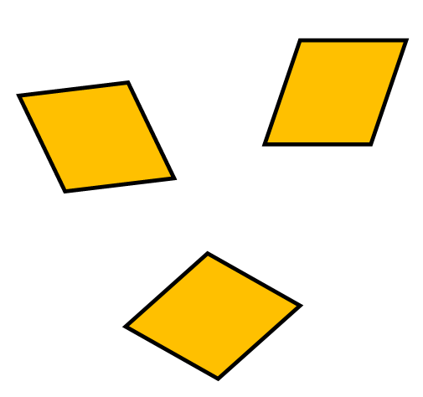

same shape and size

Triangle

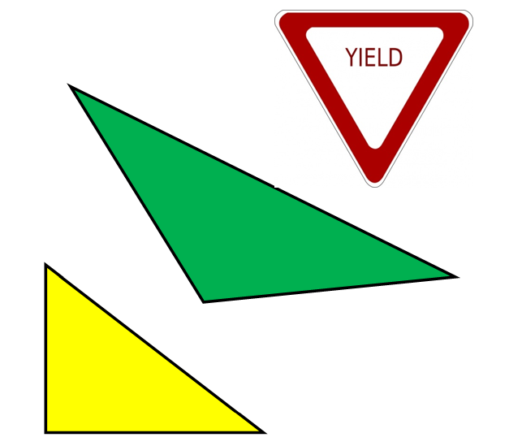

three-sided figure

Similar Figures

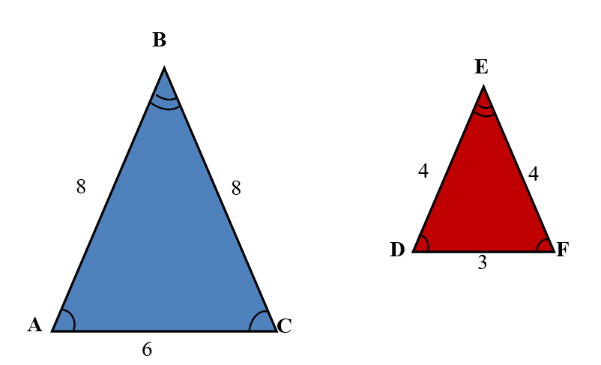

êABC
is similar to
êDEF

Different

not the same type

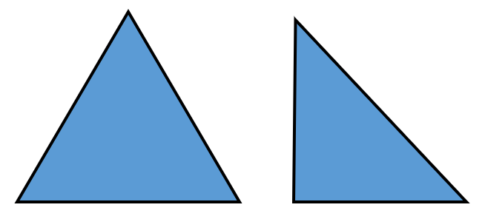

same type not the same size

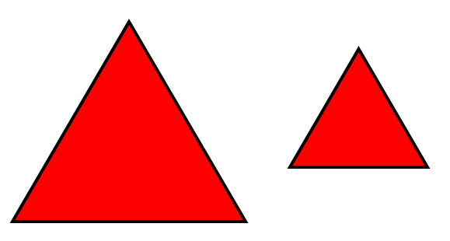

Angles
where sides meet

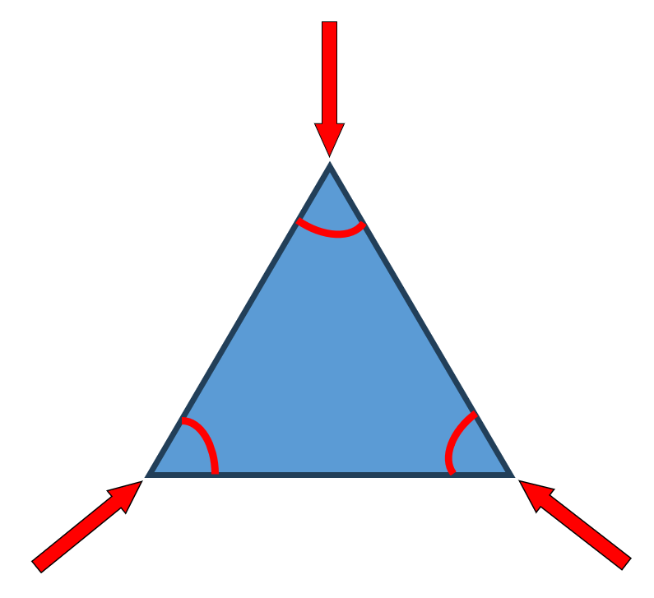
Sides
outside edges

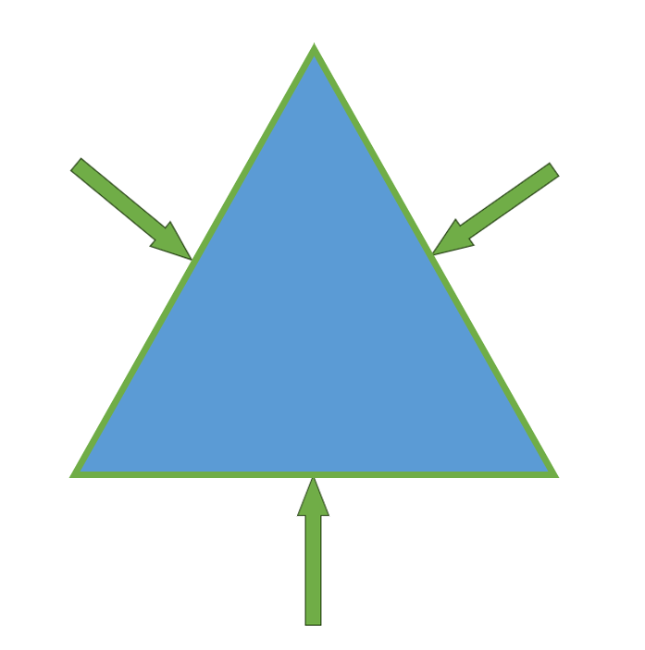
Supplemental Materials:
Congruent Triangle Signs
same size and same shape

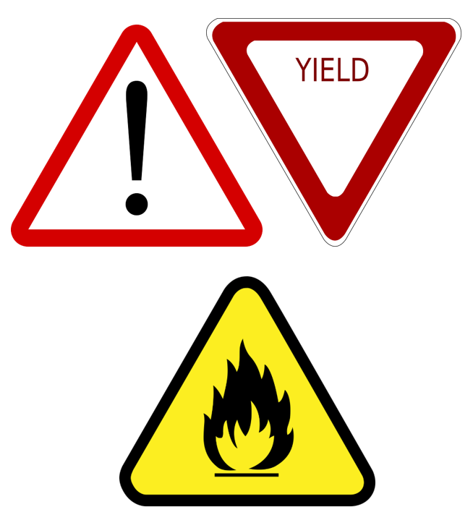

Similar Triangle Signs
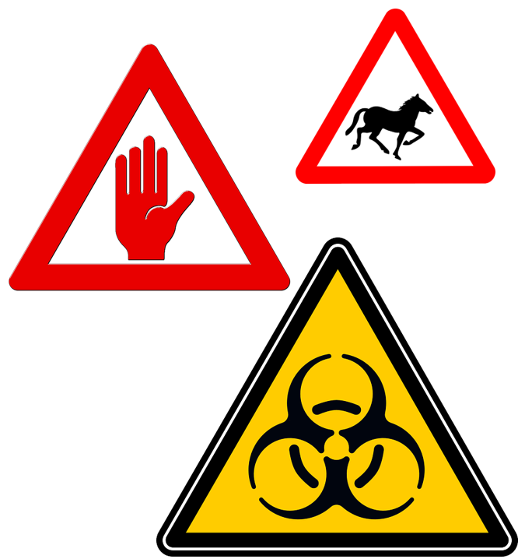
Triangles in Nature

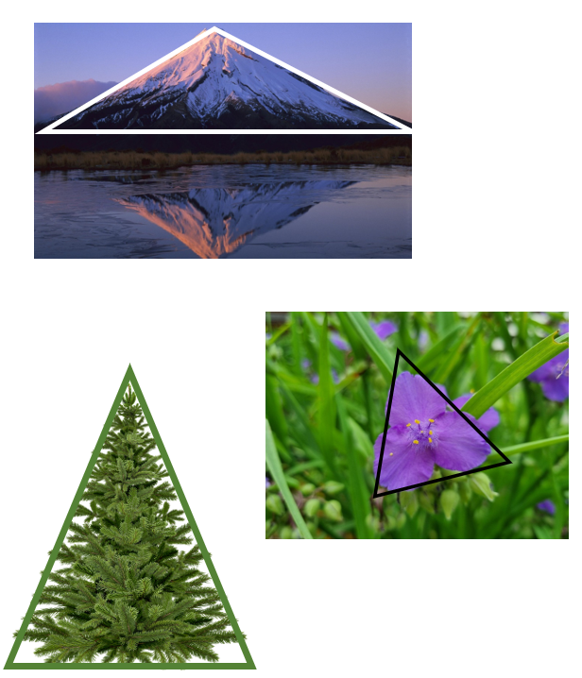

Triangles Around Us

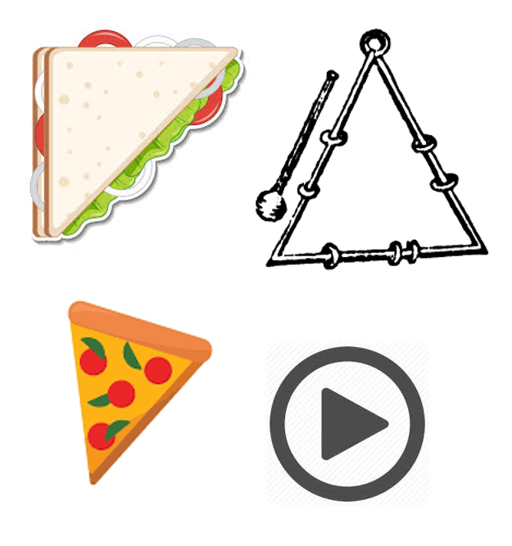

Congruent Triangles
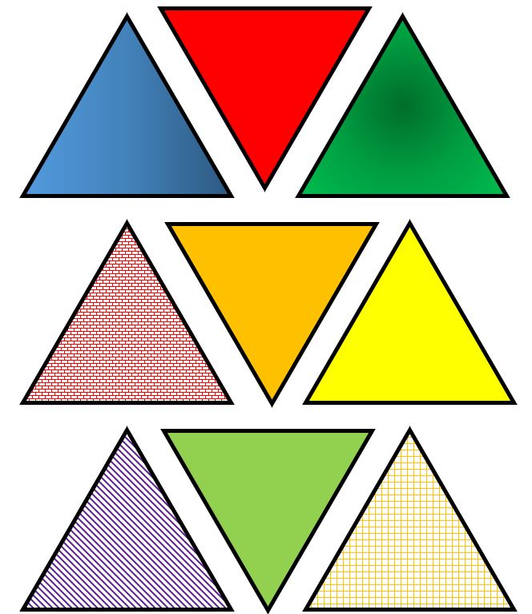
Similar Triangles

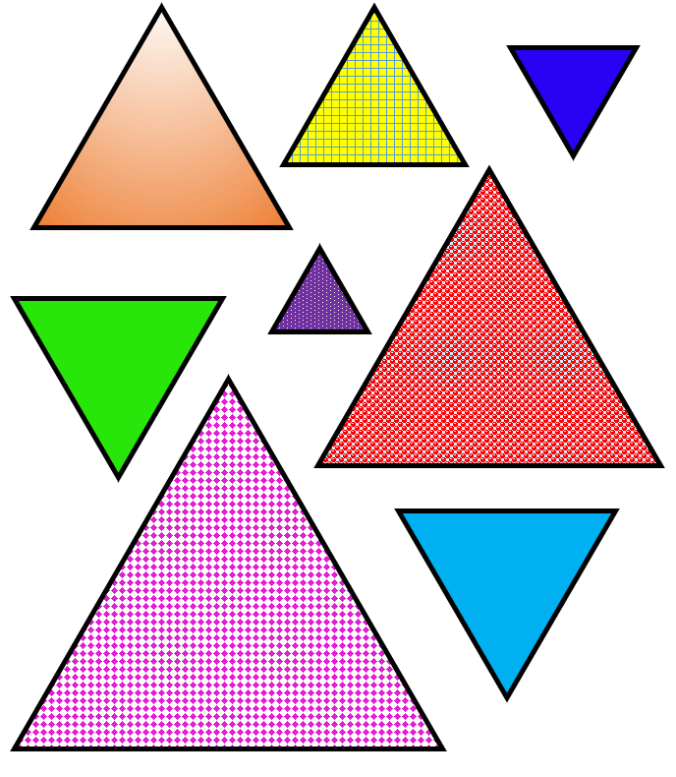
Different Triangles

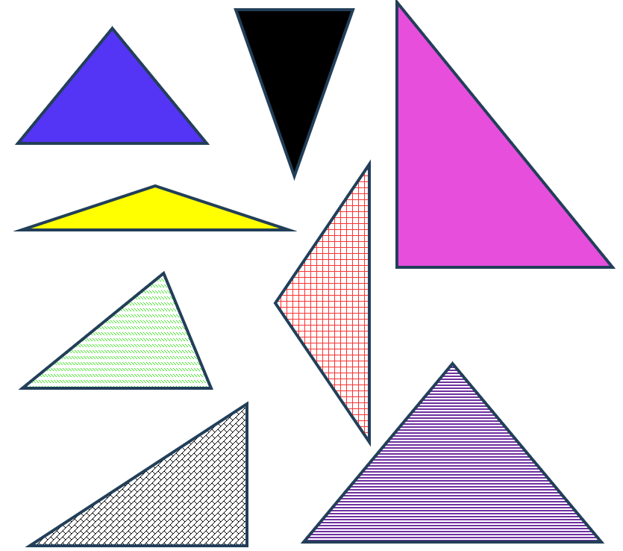

Formative Assessment Name ____________________________
Directions: Answer the following questions.
- Here is a triangle. Which triangle is similar to this triangle?

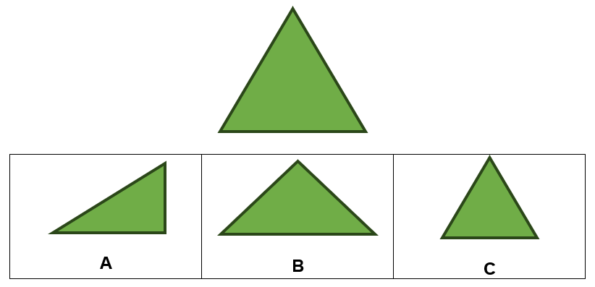
- Which shows two triangles that are similar?

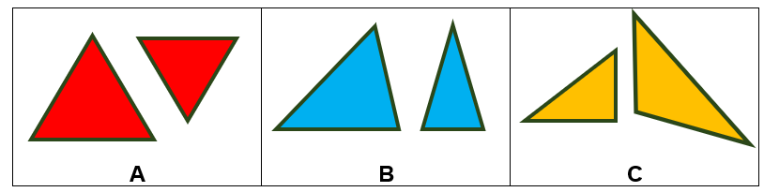

- How do you know these two triangles are similar?
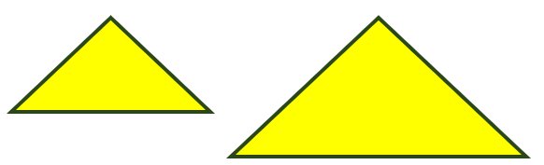

Practice Item
