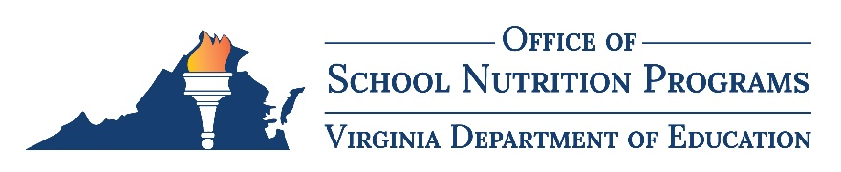

Virginia School Nutrition Programs Approved Equipment List
School Food Authorities (SFAs) must request written approval from the Virginia Department of Education (VDOE) before incurring an acquisition cost for an individual piece of equipment over $5,000. The following list includes items that have already been determined by the VDOE to be allowable and, therefore, prior purchase approval for these items is not necessary. SFAs must purchase these items using proper federal, state, or local procurement procedures. If there is a need to purchase an item not included on this list, the SFA must submit a request using the equipment purchase pre-approval request form.

Approved Equipment List

Carts
Delivery Cart
Heated Transport Cart
Insulated Transport Cart
Trash Cart
Tray Dispenser Cart
Utility Carts

Cleanup
Dish Table
Dishwashers (all types
Disposers
Sinks
Water Booster Heater/Softener

Cooking
Combi-Oven
Convection Oven
Griddle
Kitchen Exhaust System
Microwave Oven
Range
Steamer
Stove Tops
Tilting Kettle
Tilting Skillet/Braising Pan

Food Preparation
Blast Chiller
Blender
Dough Lifter, Rounder Cutter, Sheeter
Food Processors
Food/Meal Packing Machine or Sealer
Mixer (Countertop, Floor, Vertical Cutter)
Produce Sink
Sandwich Station
Thermal Wrap Machine
Worktables

Service
Cashier Station
Condiment Bar
Hot Food Well
Ice Machine
Pre-Pack System
Salad Bar
Sneeze Guard
Serving Line
Steam Table
Tray Line

Storage
Can Dispenser Rack
Chest Freezer
Holding Cabinets
Merchandiser
Milk Cooler
Pass Through Refrigerator
Proofing Cabinets
Reach In Freezers
Reach In Refrigerators
Refrigerated Display Case
Storage Racks
Walk In Freezer
Walk In Refrigerator

Farm to School
Composting Bin
Garden Tiller
Grow Lights
Hydroponic and Aquaponics Systems
Indoor Garden Starting Kit
Irrigation System for Garden
Rain Barrel/ Water Tank
Raised Bed Kit/Supplies
Wagon/Wheelbarrow
For more information, contact Tom Patrick, Procurement and FSMC Contracts Specialist, at Thomas.Patrick@doe.virginia.gov.

