Instructional Supports for Algebra 2 Mathematics Standards of Learning 2023-2024 School Year – Prioritization Notes

This document outlines the prominent content changes between the 2016 Mathematics Standards of Learning (SOL) and the 2023 Mathematics Standards of Learning and includes instructional notes to support school divisions in making decisions about the prioritization of content during the 2023-2024 transition year. In conjunction with the 2023 Mathematics Standards of Learning Overview of Revisions document, this document supports the transition of instruction during the 2023-2024 school year. School divisions may wish to use this document when planning for instruction, based upon the options for transitioning, and determining how to supplement existing curriculum to incorporate content from the 2023 Mathematics SOL. School divisions will determine how best to meet the needs of students when incorporating content during the transition year to prepare for full implementation of the 2023 Mathematics Standards of Learning during the 2024-2025 school year.

CONTENT TRANSITIONS:

Overall Instructional Transitions:
The 2023 Mathematics Standards of Learning incorporate revisions that span across grade levels. Instructional notes have been provided that promote deeper understanding of mathematical concepts and support the transition from the 2016 to the 2023 Mathematics Standards of Learning.
Overall Instructional Transition | Instructional Notes
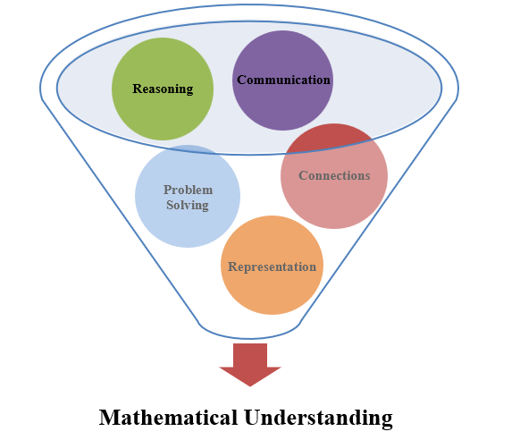 | The five mathematical process goals have been embedded throughout the standards and knowledge and skills. Students should be given opportunities to learn and apply the process goals as they work to achieve the content of the Mathematics Standards.
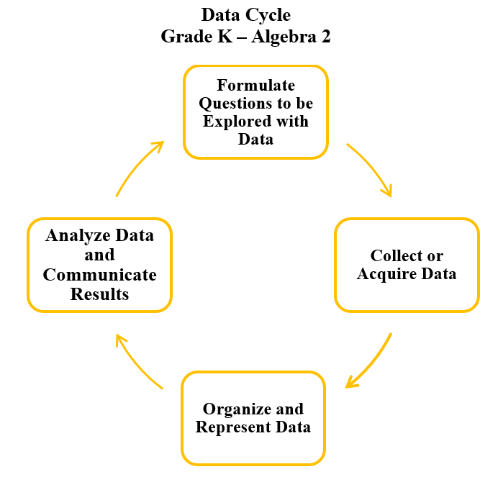 | A process for data analysis is included in the standards as a Data Cycle. Students should be given the opportunity to explore data and data analysis using the data cycle. Analyzing data requires the ability to read, write, and communicate about data in context. The skills needed to analyze data are integrated in the mathematics standards and derived from and build upon a strong mathematical foundation.
Please refer to the Appendix in the 2023 Mathematics Standards of Learning to learn more about the process goals and data cycle.
Specific Instructional Transitions by Strand:
The 2023 Mathematics Standards of Learning incorporate revisions that are specific to a grade level or course. Instructional notes have been provided that support the transition from the 2016 to the 2023 Mathematics Standards of Learning.
Expressions and Operations
2016 SOL | 2023 SOL | Instructional Notes
AII.1a | A2.EO.1 | While students are adding, subtracting, multiplying, dividing, and simplifying rational expressions, provide opportunities for students to recognize that the result is an equivalent form of the original expression. Have students justify that the forms are equivalent and discuss what information may be revealed by having the expression written in a variety of different but equivalent forms.
AII.1b | A2.EO.2 | While students are adding, subtracting, multiplying, dividing, and simplifying radical expressions, provide opportunities for students to recognize that the result is an equivalent form of the original expression. Have students justify that the forms are equivalent and discuss what information may be revealed by having the expression written in a variety of different but equivalent forms.
AII.1c | A2.EO.3 | While students are factoring polynomials, provide opportunities for them to recognize that the factored form is an equivalent form of the original expression. Have students justify that the forms are equivalent using algebraic and graphical methods, including with technology. Discuss what information may be revealed by having the expression written in a variety of different but equivalent forms.
AII.2 | A2.EO.4 | While students are adding, subtracting, multiplying, and simplifying radical expressions containing negative rational numbers provide opportunities for students to recognize that the result is an equivalent form of the original expression. Have students justify that the forms are equivalent and discuss what information may be revealed by having the expression written in a variety of different but equivalent forms.

Equations and Inequalities
2016 SOL | 2023 SOL | Instructional Notes
AII.3a | A2.EI.1 | Consider giving students a contextual situation that can be modeled by an absolute value equation or inequality and then find the solution. For absolute value inequalities, encourage students to represent their solution using set notation and interval notation in addition to representing the solution graphically on a number line.
AII.3b | A2.EI.2 | Consider giving students a contextual situation that can be modeled by a quadratic equation and then find the solution. While students are solving quadratic equations, consider extending this to solving a quadratic inequality.
AII.3c | A2.EI.4 | Consider giving students a contextual situation that can be modeled by a rational equation and then find the solution. Students would benefit from experiences where an equation containing a rational expression has a solution set with an extraneous solution. In these experiences, have students justify why the possible solution is extraneous.
AII.3d | A2.EI.5 | Students would benefit from experiences where an equation containing a square root has a solution set with an extraneous solution. In these experiences, have students justify why the possible solution is extraneous.
AII.4 | A2.EI.3 | Consider giving students a contextual situation that can be modeled by a linear-quadratic or quadratic-quadratic system of equations and then find the solution.
AII.8 | A2.EI.6 | Students would benefit from experiences in which they are first presented with a polynomial equation while they are working with polynomial functions. Graphing the corresponding polynomial function would allow students to find any rational solutions to the polynomial equation.  Students should be able to recognize whether the polynomial equation has complex solutions based on the degree of the equation and the zeros that are seen on the graph. Consider providing an extension where students use division techniques, the quadratic formula, and/or completing the square to identify the complex solutions.

Functions
2016 SOL | 2023 SOL | Instructional Notes
AII.6 | A2.F.1b,c | While students work with transformations of the parent function to be able to write an equation from a given graph or graph the function; provide opportunities for transformations to be expressed in function notation which includes f(x) + k, f(kx), f(x+k), and kf(x); where k is limited to rational values.
AII.7 | A2.F.2f,i | While students are working with square root, cube root, rational, polynomial, exponential, logarithmic, and now piece-wise functions in this standard, provide students with the opportunity to not only determine f(x) for any given value of x in the domain but also provide students with the opportunity to explain the meaning of x and f(x) in a context.  While students are finding the inverse of a function, which is now limited to linear and quadratic functions but will also include square roots as they are the inverse of a quadratic, provide students with the opportunity to be able to justify and explain why those two functions would be inverses of each other.
AII.10 | A2.F.1d | While students investigate, analyze, and compare function families and specifically the relationship between two variables which are now limited to only determining if they are directly proportional, inversely proportional, or neither when given a table of values. Also provide students with the opportunities to work with these variables in a contextual situation. This will now be students first experience with inverse variation as it was removed from Algebra 1, and direct variation has also been removed from Algebra 1 into Grade 7 Mathematics Standards of Learning.

Statistics
2016 SOL | 2023 SOL | Instructional Notes
AII.9 | A2.ST.2b,d,e,f | While students are working with sets of bivariate data, provide opportunities for students to collect the bivariate data through research or with the use of surveys, observations, scientific experiments, polls, or questionnaires. Students should also have the opportunity to experience data sets where the curve of best fit could be represented by a piecewise-defined function of linear, quadratic, and/or exponential functions. In addition, as students work with linear regression, provide them the opportunity to use the correlation coefficient to designate the goodness of fit of a linear function using technology.
AII.11 | A2.ST.1a,b,c,e,i | While students are working with univariate data in the data cycle, provide students the opportunities to formulate investigative questions that will receive the collection or acquisition of a large set of quantitative data or summary statistics of a large set of data that can be used to investigate the questions. In addition, students will need to be provided the opportunity to collect or acquire this data through research or by using surveys, observations, scientific experiments, polls, or questionnaires.  While students are working with data sets, provide opportunities for students to examine the shape of a data set, that might be skewed or symmetric, that can be represented by a histogram, and sketch a smooth curve to model the distribution. In addition, data sets represented by a smooth curve should be part of what students work with to describe and interpret; not just normally distributed data. If students have the opportunity to answer investigative questions about data sets that are normally distributive, probabilities should be limited to the application of the Empirical Rule. Students should also be given the opportunity to compare two data points from two different distributions using z-scores.

