Instructional Supports for Geometry Mathematics Standards of Learning 2023-2024 School Year – Prioritization Notes

This document outlines the prominent content changes between the 2016 Mathematics Standards of Learning (SOL) and the 2023 Mathematics Standards of Learning and includes instructional notes to support school divisions in making decisions about the prioritization of content during the 2023-2024 transition year. In conjunction with the 2023 Mathematics Standards of Learning Overview of Revisions document, this document supports the transition of instruction during the 2023-2024 school year. School divisions may wish to use this document when planning for instruction, based upon the options for transitioning, and determining how to supplement existing curriculum to incorporate content from the 2023 Mathematics SOL. School divisions will determine how best to meet the needs of students when incorporating content during the transition year to prepare for full implementation of the 2023 Mathematics Standards of Learning during the 2024-2025 school year.

CONTENT TRANSITIONS:

Overall Instructional Transitions:
The 2023 Mathematics Standards of Learning incorporate revisions that span across grade levels. Instructional notes have been provided that promote deeper understanding of mathematical concepts and support the transition from the 2016 to the 2023 Mathematics Standards of Learning.
Overall Instructional Transition | Instructional Notes
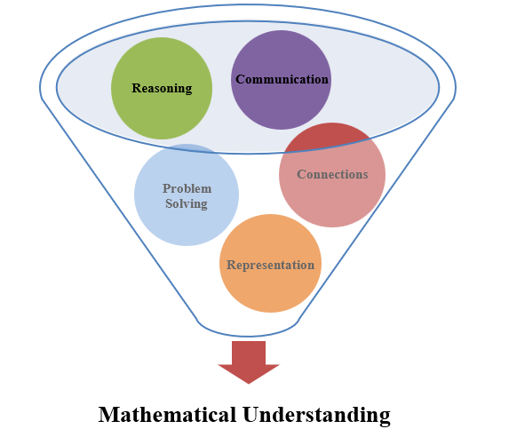 | The five mathematical process goals have been embedded throughout the standards and knowledge and skills. Students should be given opportunities to learn and apply the process goals as they work to achieve the content of the Mathematics Standards.
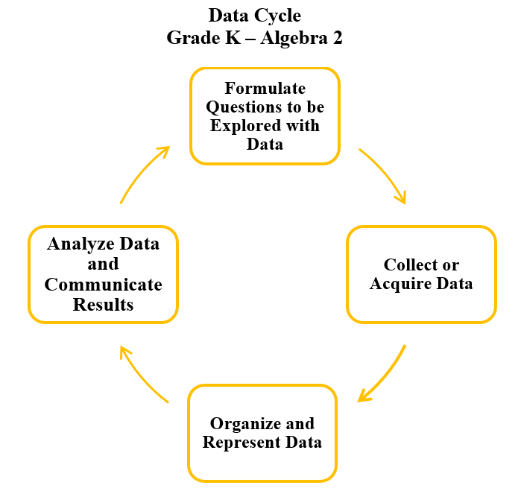 | A process for data analysis is included in the standards as a Data Cycle. Students should be given the opportunity to explore data and data analysis using the data cycle. Analyzing data requires the ability to read, write, and communicate about data in context. The skills needed to analyze data are integrated in the mathematics standards and derived from and build upon a strong mathematical foundation.
Please refer to the Appendix in the 2023 Mathematics Standards of Learning to learn more about the process goals and data cycle.
Specific Instructional Transitions by Strand:
The 2023 Mathematics Standards of Learning incorporate revisions that are specific to a grade level or course. Instructional notes have been provided that support the transition from the 2016 to the 2023 Mathematics Standards of Learning.
Reasoning, Lines, and Transformations
2016 SOL | 2023 SOL | Instructional Notes
G.1 | G.RLT.1 | While identifying the converse, inverse, and contrapositive of a conditional statement, students should also have experiences with biconditionals, including recognizing the connection between a biconditional statement and a true conditional statement with a true converse.
G.3 | G.RLT.3 | While students are determining line symmetry, they should also have experiences locating, counting, and drawing lines of symmetry.
G.4 | G.TR.2  G.PC.1 | Constructions of congruent segments (G.4a), perpendicular lines (G.4c and G.4d), and congruent angles (G.4f), are incorporated into the content of proving triangles congruent (G.TR.2).  Constructions of congruent segments (G.4a), perpendicular lines (G.4c and G.4d) angle bisectors (G.4e), congruent angles (G.4f), and parallel lines (G.4g) are incorporated into the content of proving, verifying, and using theorems and properties of quadrilaterals (G.PC.1).
Triangles
2016 SOL | 2023 SOL | Instructional Notes
G.5 | G.TR.1 | While students are solving problems concerning the lengths of sides and/or measures of angles in triangles, they should also have experiences solving for interior and exterior angles of a triangle, when given two angles.
G.6 | G.TR.2 | While students are proving two triangles are congruent, they should also have experiences constructing a congruent triangle using congruent segment, congruent angle, and/or perpendicular line constructions.
G.7 | G.TR.3 | While students are proving two triangles are similar, they should also have experiences describing a sequence of transformations that can be used to verify similarity of triangles located in the same plane and solving problems, including those in context involving attributes of similar triangles.
G.8 | G.TR.4 | While students are solving problems involving right triangles applying the Pythagorean Theorem and its converse, they should also have experiences recognizing Pythagorean Triples.  While students are solving problems involving right triangles applying trigonometric ratios, they should also have experiences modeling those problems and finding and verifying trigonometric ratios of right triangles.

Polygons and Circles
2016 SOL | 2023 SOL | Instructional Notes
G.9 | G.PC.1 | While students verify and use properties of quadrilaterals to solve problems, they should also have experiences in justifying the theorems and properties of quadrilaterals and experiences in using geometric constructions including congruent segment, congruent angle, angle bisector, perpendicular line, and/or parallel line constructions to verify properties of quadrilaterals. Students would benefit from having experiences using Venn diagrams to compare and contrast quadrilateral properties.
G.10 | G.PC.2 | While students solve problems involving angles and sides of convex polygons, they should also have experiences in verifying the relationships involving the number of sides and measure of angles of convex polygons.
G.11 | G.PC.3 | While students solve problems involving circles by applying circle properties, they should also have experiences in determining the proportional relationship between the arc length or area of a circle and other parts of the circle. Additionally, students’ experiences should include applying arc length or sector area to solve for other unknown parts of the circle.
G.12 | G.PC.4 | While students solve problems involving equations of circles, these problems should include work in the coordinate plane. Students should also have experiences in deriving the equation of a circle from the Pythagorean Theorem when given the center and the radius of a circle.
Three-Dimensional Figures
2016 SOL | 2023 SOL | Instructional Notes
G.13 | G.DF.1 | While students use surface area and volume to solve problems with three-dimensional figures, they should also have experiences in creating models involving surface area and volume and identifying the shape a two-dimensional cross section of a three-dimensional figure.
G.14 | G.DF.2 | While students determine the effects of changing one or more dimension of a three-dimensional figure, they should also have experiences in describing the relationship between the original and change figures and recognizing when two- and three-dimensional figures are similar.

