Instructional Supports for Algebra 1 Mathematics Standards of Learning 2023-2024 School Year – Prioritization Notes

This document outlines the prominent content changes between the 2016 Mathematics Standards of Learning (SOL) and the 2023 Mathematics Standards of Learning and includes instructional notes to support school divisions in making decisions about the prioritization of content during the 2023-2024 transition year. In conjunction with the 2023 Mathematics Standards of Learning Overview of Revisions document, this document supports the transition of instruction during the 2023-2024 school year. School divisions may wish to use this document when planning for instruction, based upon the options for transitioning, and determining how to supplement existing curriculum to incorporate content from the 2023 Mathematics SOL. School divisions will determine how best to meet the needs of students when incorporating content during the transition year to prepare for full implementation of the 2023 Mathematics Standards of Learning during the 2024-2025 school year.

CONTENT TRANSITIONS:

Overall Instructional Transitions:
The 2023 Mathematics Standards of Learning incorporate revisions that span across grade levels. Instructional notes have been provided that promote deeper understanding of mathematical concepts and support the transition from the 2016 to the 2023 Mathematics Standards of Learning.
Overall Instructional Transition | Instructional Notes
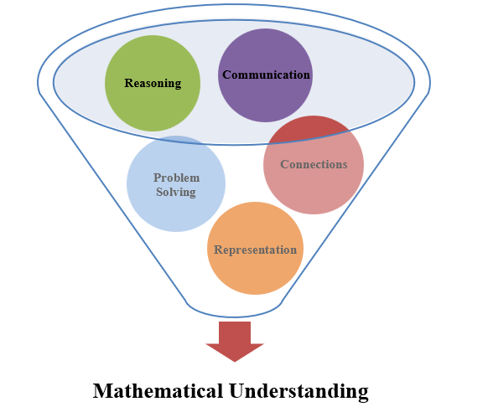 | The five mathematical process goals have been embedded throughout the standards and knowledge and skills. Students should be given opportunities to learn and apply the process goals as they work to achieve the content of the Mathematics Standards.
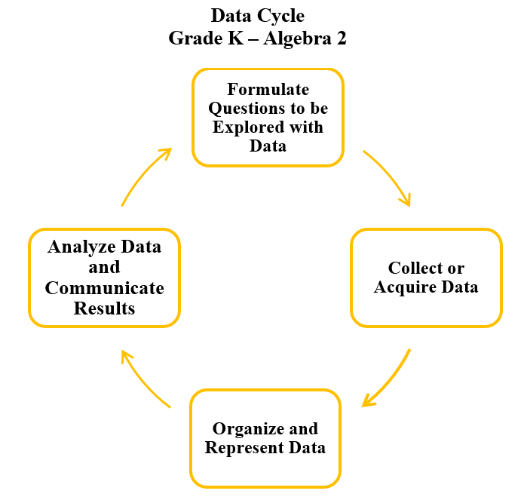 | A process for data analysis is included in the standards as a Data Cycle. Students should be given the opportunity to explore data and data analysis using the data cycle. Analyzing data requires the ability to read, write, and communicate about data in context. The skills needed to analyze data are integrated in the mathematics standards and derived from and build upon a strong mathematical foundation.

Specific Instructional Transitions by Strand:

Expressions and Operations
2016 SOL | 2023 SOL | Instructional Notes
A.2a | A.EO.3 | While working with laws of exponents students will continue to apply the laws and additionally derive these laws. Students should have experiences allowing them to explore these laws through patterns by expanding the terms.
A.2b,c | A.EO.2 | While working with the distributive property, students should have experiences with concrete objects, as well as pictorial & symbolic models, including area models for polynomial multiplication.
A.3a-c | A.EO.4 | While simplifying radical expressions, students should have experiences performing operations on square and cube roots. Students should be given experiences to use rational exponents to express square and cube roots ($a^{\frac{1}{2}}$ or $a^{\frac{1}{3}}$) and to explore the equivalence between these two forms.

Equations and Inequalities
2016 SOL | 2023 SOL | Instructional Notes
A.4b,e | A.EI.3 | While students are determining the solutions to quadratics, students should be given experiences identifying the number of solutions of a quadratic equation and justify their reasoning. (no real, one, or two real solutions) Students should also be given problems in context, providing the students with solutions to interpret based on the contextual situation.

Functions
2016 SOL | 2023 SOL | Instructional Notes
A.6a-c | A.F.1 | While working with linear functions in two variable, students should be given experiences working with linear functions written in all forms to include point-slope form as it is now used with linear functions. Students should make connections between the different forms of linear functions, assess their applications and analyze the various information each form provides.
A7a-f | A.F.2 | While working with non-linear functions, students will identify the vertex of a quadratic function as well as compare non-linear functions including quadratic and exponential. Students should be given experiences graphing quadratic and exponential functions, determining the domain and range of such functions, and opportunities to compare and contrast the characteristics of the functions in a variety of forms.

Statistics
2016 SOL | 2023 SOL | Instructional Notes
A.9 | A.ST.1 | While working with bivariate data, students should be given experiences working through the data cycle, including:  - Formulate questions that require the collection or acquisition of bivariate data; and  - Determine what variables could be used to explain a given contextual problem or situation or answer investigative questions.  Additionally, provide opportunities for students to:  - Determine an appropriate method to collect a representative sample, which could include a simple random sample, to answer an investigative question.  - Given a table of ordered pairs or a scatterplot representing no more than 30 data points, use available technology to determine whether a linear or quadratic function would represent the relationship, and if so, determine the equation of the curve of best fit.  - Use linear and quadratic regression methods available through technology to write a linear or quadratic function that represents the data where appropriate and describe the strengths and weaknesses of the model.  - Use a linear model to predict outcomes and evaluate the strength and validity of these predictions, including through the use of technology.  - Investigate and explain the meaning of the rate of change (slope) and y-intercept (constant term) of a linear model in context.  - Analyze relationships between two quantitative variables revealed in a scatterplot.  - Make conclusions based on the analysis of a set of bivariate data and communicate the results.

