Instructional Supports for Prioritization of Content during the 2023-2024 School Year
Grade 8 Mathematics Standards of Learning

This document outlines the prominent content changes between the 2016 Mathematics Standards of Learning (SOL) and the 2023 Mathematics Standards of Learning and includes instructional notes to support school divisions in making decisions about the prioritization of content during the 2023-2024 transition year. In conjunction with the 2023 Mathematics Standards of Learning Overview of Revisions document, this document supports the transition of instruction during the 2023-2024 school year. School divisions may wish to use this document when planning for instruction, based upon the options for transitioning, and determining how to supplement existing curriculum to incorporate content from the 2023 Mathematics SOL. School divisions will determine how best to meet the needs of students when incorporating content during the transition year to prepare for full implementation of the 2023 Mathematics Standards of Learning during the 2024-2025 school year.

CONTENT TRANSITIONS:

Overall Instructional Transitions:
The 2023 Mathematics Standards of Learning incorporate revisions that span across grade levels. Instructional notes have been provided that promote deeper understanding of mathematical concepts and support the transition from the 2016 to the 2023 Mathematics Standards of Learning.
Overall Instructional Transition | Instructional Notes
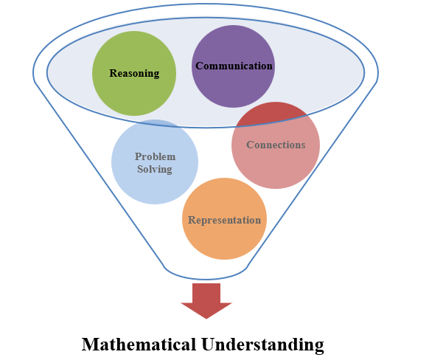 | The five mathematical process goals have been embedded throughout the standards and knowledge and skills. Students should be given opportunities to learn and apply the process goals as they work to achieve the content of the Mathematics Standards.
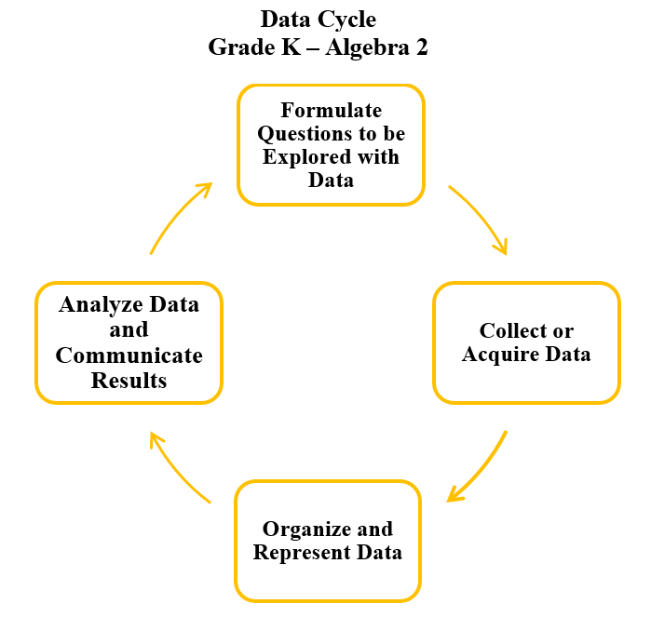 | A process for data analysis is included in the standards as a Data Cycle. Students should be given the opportunity to explore data and data analysis using the data cycle. Analyzing data requires the ability to read, write, and communicate about data in context. The skills needed to analyze data are integrated in the mathematics standards and derived from and build upon a strong mathematical foundation.
Please refer to the Appendix in the 2023 Mathematics Standards of Learning to learn more about the process goals and data cycle.
Specific Instructional Transitions by Strand:
The 2023 Mathematics Standards of Learning incorporate revisions that are specific to a grade level or course. Instructional notes have been provided for specific standards that support the transition from the 2016 to the 2023 Mathematics Standards of Learning.
Number and Number Sense
2016 SOL | 2023 SOL | Instructional Notes
8.1 | 8.NS.1c | While students are comparing and ordering, provide opportunities to use multiple strategies such as benchmarks, number lines, and equivalency, as well as to justify their solutions orally, in writing, or with a model.

Computation and Estimation
2016 SOL | 2023 SOL | Instructional Notes
8.4 | 8.CE.1 | While students are solving practical problems involving tax, tip, discount, and percent increase and decrease, provide opportunities for students to estimate the solution by using strategies such as benchmark percentages.

Measurement and Geometry
2016 SOL | 2023 SOL | Instructional Notes
8.6 | 8.MG.2c | While students are working with the volume formulas for cones and square based pyramids, provide opportunities for them to investigate and determine the proportional relationship (of $\frac{1}{3}$ ) between the volume of cones and cylinders, and the volume of rectangular prisms and square based pyramids.
8.9 | 8.MG.4c | As students are verifying and applying the Pythagorean theorem, include opportunities to identify the legs and hypotenuse of a right triangle when presented in various orientations.

Probability and Statistics
2016 SOL | 2023 SOL | Instructional Notes
8.11a | 8.PS.1a | While students are determining whether two events are dependent or independent, provide opportunities for them to explain how replacement impacts the probability.
8.12abc | 8.PS.2 | While students are representing numerical data and making observations and inferences using boxplots, provide opportunities for students to incorporate additional components of the data cycle, including:  - Formulate questions that require the collection or acquisition of data; and  - Determine the data needed to answer a formulated question and collect the data or acquire existing data using various methods (observations, measurement, surveys, experiments).  Additionally, provide opportunities for students to:  - Create boxplots using technology;  - Determine how statistical bias might affect whether the data collected from the sample is representative of the larger population;  - Describe how the presence of an extreme data point (outlier) affects the shape and spread of the data distribution of a boxplot;  - Given a contextual situation, justify which graphical representation (e.g., pictographs, bar graphs, line graphs, line plots/dot plots, stem-and-leaf plots, circle graphs, histograms, boxplots) best represents the data; and  - Identify components of graphical displays that can be misleading.
8.13abc | 8.PS.3 | While students are representing data and making observations about scatterplots, provide opportunities for students to incorporate additional components of the data cycle, including:  - Formulate questions that require the collection or acquisition of data; and  - Determine the data needed to answer a formulated question and collect the data or acquire existing data using various methods (observations, measurement, surveys, experiments).  Additionally, provide opportunities for students to:  - Create scatterplots using technology;  - 8.PS.3e Analyze and justify the relationship of the quantitative bivariate data represented in scatterplot

Patterns, Functions, and Algebra
2016 SOL | 2023 SOL | Instructional Notes
8.14b | 8.PFA.1a | When students represent algebraic expressions with concrete manipulatives or pictorial representations, include expressions that apply the distributive property. Highlight that students are generating equivalent expressions through the simplification process.
8.16 | 8.PFA.3 | While students are making connections between and among representations of linear functions, provide opportunities to explore how adding a constant (b) to the equation of a proportional relationship y = mx will translate the line on a graph. Also provide opportunities for students to create tables of values, as well as contexts, to represent linear functions.
8.17 | 8.PFA.4c,d,f | As students are writing verbal expressions and sentences as algebraic expressions and equations, provide opportunities for students to write multi-step equations for verbal situations in context. Additionally, provide opportunities for students to create a situation in context given a multistep linear equation, as well as interpret algebraic solutions in context to linear equations in one variable.
8.18 | 8.PFA.5d,e,g | As students are writing verbal expressions and sentences as algebraic expressions and inequalities, provide opportunities for students to write multistep inequalities for verbal situations in context. Additionally, provide opportunities for students to create a situation in context given a multistep linear inequality, as well as interpret algebraic solutions in context to linear inequalities in one variable.

