Instructional Supports for Prioritization of Content during the 2023-2024 School Year
Grade 7 Mathematics Standards of Learning

This document outlines the prominent content changes between the 2016 Mathematics Standards of Learning (SOL) and the 2023 Mathematics Standards of Learning and includes instructional notes to support school divisions in making decisions about the prioritization of content during the 2023-2024 transition year. In conjunction with the 2023 Mathematics Standards of Learning Overview of Revisions document, this document supports the transition of instruction during the 2023-2024 school year. School divisions may wish to use this document when planning for instruction, based upon the options for transitioning, and determining how to supplement existing curriculum to incorporate content from the 2023 Mathematics SOL. School divisions will determine how best to meet the needs of students when incorporating content during the transition year to prepare for full implementation of the 2023 Mathematics Standards of Learning during the 2024-2025 school year.

CONTENT TRANSITIONS:

Critical Instructional Transitions:
The 2023 Mathematics Standards of Learning include critical content, as shown below, that could cause gaps in student learning if instruction is not provided during the transition year.
Applying dilations of polygons in the coordinate plane, which was previously included in SOL 8.7 in the 2016 standards, has moved to 7.MG.4 in the 2023 SOL.
2016 SOL | 2023 SOL | Instructional Notes
8.7 | 7.MG.4 | While students are applying translations and reflections of right triangles or rectangles in the coordinate plane, provide opportunities for students to identify the coordinates of an image of a polygon that has been dilated given the preimage; sketch the image of a dilation of a polygon; and then identify and describe dilations in context.

Overall Instructional Transitions:
The 2023 Mathematics Standards of Learning incorporate revisions that span across grade levels. Instructional notes have been provided that promote deeper understanding of mathematical concepts and support the transition from the 2016 to the 2023 Mathematics Standards of Learning.
Overall Instructional Transition | Instructional Notes
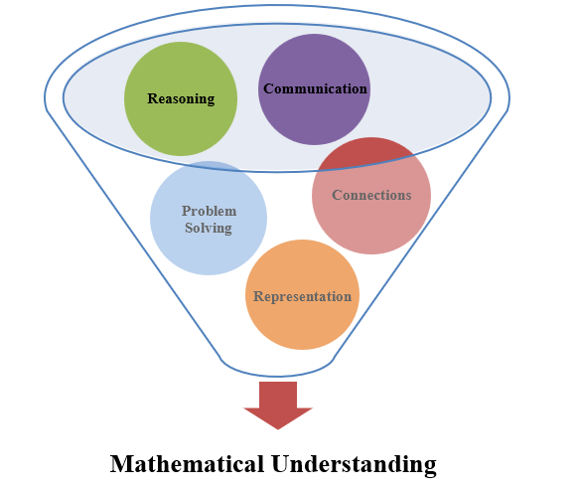 | The five mathematical process goals have been embedded throughout the standards and knowledge and skills. Students should be given opportunities to learn and apply the process goals as they work to achieve the content of the Mathematics Standards.
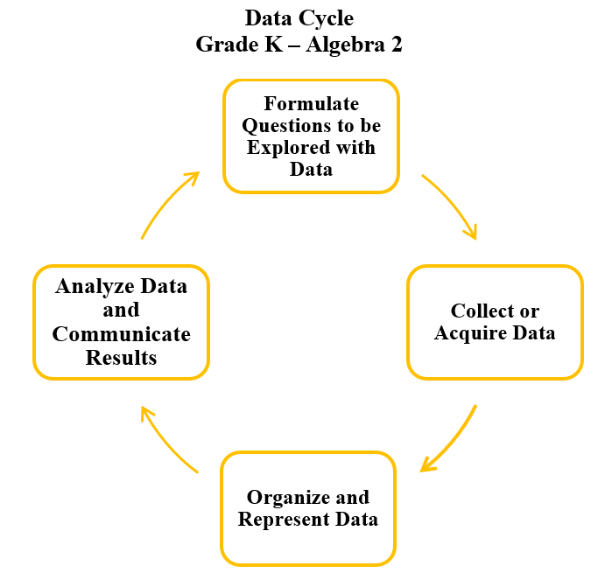 | A process for data analysis is included in the standards as a Data Cycle. Students should be given the opportunity to explore data and data analysis using the data cycle. Analyzing data requires the ability to read, write, and communicate about data in context. The skills needed to analyze data are integrated in the mathematics standards and derived from and build upon a strong mathematical foundation.
Please refer to the Appendix in the 2023 Mathematics Standards of Learning to learn more about the process goals and data cycle.

Specific Instructional Transitions by Strand:
The 2023 Mathematics Standards of Learning incorporate revisions that are specific to a grade level or course. Instructional notes have been provided for specific standards that support the transition from the 2016 to the 2023 Mathematics Standards of Learning.
Number and Number Sense
2016 SOL | 2023 SOL | Instructional Notes
7.1c,e | 7.NS.2 | While students are comparing and ordering rational numbers, provide opportunities for students to use multiple strategies, such as benchmarks, number lines, and equivalency. Additionally provide students the opportunity to justify their solutions in writing or with a model.
7.1d | 7.NS.3b | While students are determining the square root of a perfect square from 0 to 100, have them describe the relationship between square roots and perfect squares.

Computation and Estimation
2016 SOL | 2023 SOL | Instructional Notes
7.2 | 7.CE.1 | While students are solving contextual multi-step problems with rational numbers, provide opportunities for students to estimate and justify solutions.
7.3 | 7.CE.2d | While students are using benchmarks to compute 5%, 10%, 15%, or 20% of a given whole number, provide opportunities to estimate and determine percentages of a whole number not limited to the use of benchmark percentages.

Measurement and Geometry
2016 SOL | 2023 SOL | Instructional Notes
7.4 | 7.MG.1 | While investigating right cylinders and rectangular prisms, provide opportunities for students to develop the formulas for volume and surface area and apply the formulas in context including how changing one attribute of a rectangular prisms affects the volume and surface area.
7.5 | 7.MG.2a,e | When students are identifying corresponding angles of similar quadrilaterals and triangles, provide figures that include geometric markings. Additionally, provide students experience recognizing and justifying if two quadrilaterals or triangles are similar using the ratios of the corresponding side lengths.

Probability and Statistics
2016 SOL | 2023 SOL | Instructional Notes
7.9 | 7.PS.2 | While students are representing numerical data and making observations and inferences using histograms, provide opportunities for students to incorporate additional components of the data cycle, including:  - Formulate questions that require the collection or acquisition of data; and  - Determine the data needed to answer a formulated question and collect the data or acquire existing data using various methods (observations, measurement, surveys, experiments).  Additionally, provide opportunities for students to:  - Create histograms using technology;  - Determine how sample size and randomness will ensure that the data collected is a sample that is representative of a larger population;  - Investigate and explain how using different intervals could impact the representation of the data in a histogram;  - Determine how histograms reveal patterns in data that cannot be easily seen by looking at the corresponding given data set; and  - Justify which graphical representation (e.g. line plots (dot plots), circle graphs, and stem-and-leaf plots) best represents the data.

Patterns, Functions, and Algebra
2016 SOL | 2023 SOL | Instructional Notes
7.10 | 7.PFA.1 | Provide students with graphs in addition to tables of values and practical situations when students are determining the slope as a rate of change in a proportional relationship between two quantities and writing an equation in y=mx form. Include graphs, tables of values, and equations in the form y=mx where slope is both positive and negative. Provide opportunities for students to identify and describe a line with a slope that is positive, negative, or zero (0), given a graph.
7.11 | 7.PFA.2c | While students are evaluating algebraic expressions, provide opportunities for students to simplify and generate equivalent algebraic expressions that may require combining like terms.
7.12 | 7.PFA.3d,e | As students are writing verbal expressions and sentences as algebraic expressions and equations, provide opportunities for students to write two-step equations for verbal situations in context. Additionally, provide opportunities for students to create a situation in context given a two-step linear equation.
7.13 | 7.PFA.4b,d,e,h | While students are solving one and two-step inequalities, provide opportunities for them to investigate and explain how the solution set is affected by multiplying or dividing both sides of an inequality statement by a rational number less than zero. Additionally, provide opportunities for students to create verbal situations in context given a one or two-step inequality and to write inequalities to represent verbal situations in context. Encourage students to describe the differences and similarities between solving equations and inequalities.

