Instructional Supports for Prioritization of Content during the 2023-2024 School Year
Grade 6 Mathematics Standards of Learning

This document outlines the prominent content changes between the 2016 Mathematics Standards of Learning (SOL) and the 2023 Mathematics Standards of Learning and includes instructional notes to support school divisions in making decisions about the prioritization of content during the 2023-2024 transition year. In conjunction with the 2023 Mathematics Standards of Learning Overview of Revisions document, this document supports the transition of instruction during the 2023-2024 school year. School divisions may wish to use this document when planning for instruction, based upon the options for transitioning, and determining how to supplement existing curriculum to incorporate content from the 2023 Mathematics SOL. School divisions will determine how best to meet the needs of students when incorporating content during the transition year to prepare for full implementation of the 2023 Mathematics Standards of Learning during the 2024-2025 school year.

CONTENT TRANSITIONS:

Overall Instructional Transitions:
The 2023 Mathematics Standards of Learning incorporate revisions that span across grade levels. Instructional notes have been provided that promote deeper understanding of mathematical concepts and support the transition from the 2016 to the 2023 Mathematics Standards of Learning.

Overall Instructional Transition | Instructional Notes
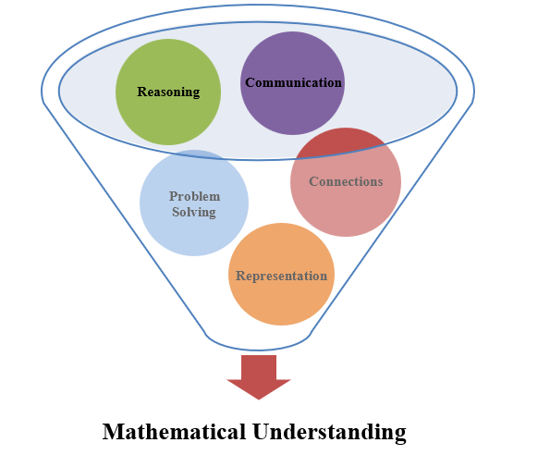 | The five mathematical process goals have been embedded throughout the standards and knowledge and skills. Students should be given opportunities to learn and apply the process goals as they work to achieve the content of the Mathematics Standards.
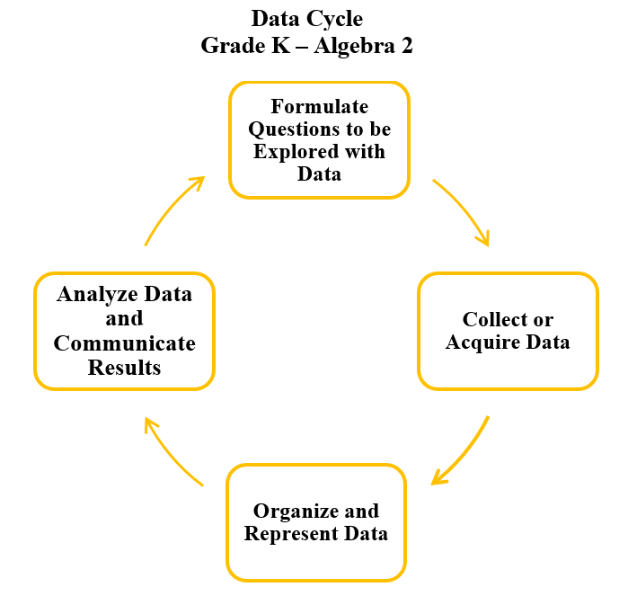 | A process for data analysis is included in the standards as a Data Cycle. Students should be given the opportunity to explore data and data analysis using the data cycle. Analyzing data requires the ability to read, write, and communicate about data in context. The skills needed to analyze data are integrated in the mathematics standards and derived from and build upon a strong mathematical foundation.
Please refer to the Appendix in the 2023 Mathematics Standards of Learning to learn more about the process goals and data cycle.
Specific Instructional Transitions by Strand:
The 2023 Mathematics Standards of Learning incorporate revisions that are specific to a grade level or course. Instructional notes have been provided for specific standards that support the transition from the 2016 to the 2023 Mathematics Standards of Learning.

Number and Number Sense
2016 SOL | 2023 SOL | Instructional Notes
6.2a | 6.NS.1 | While students are working with equivalencies among decimals, percents and fractions provide opportunities to use multiple strategies and representations, such as benchmarks, number lines, and equivalency, and encourage them to justify their solutions in writing or with a model. Additionally, provide students with opportunities to estimate and determine percents represented by a model, including percents greater than 100% and less than 1%.
6.4 | 6.NS.3c | As students are recognizing and representing patterns of perfect squares, provide opportunities for students to justify whether a number is a perfect square using a model or mathematical reasoning.

Computation and Estimation
2016 SOL | 2023 SOL | Instructional Notes
6.5a | 6.CE.1c | As students are multiplying and dividing fractions, have them explore what happens when they multiply or divide different fractional numbers by each other. For example, what happens when you divide a whole number by a fraction or multiply a fraction by a fraction? Have students consider whether the solution is larger or smaller than the dividend/divisor or multiplier/multiplicand and whether that is true for all examples of that type of problem.
6.5b | 6.CE.1d | Prior to determining the solution to single-step and multistep practical problems with fractions and mixed numbers, ask students to estimate a reasonable solution. After students determine a solution, provide opportunities for them to justify their solution.
6.6a,b | 6.CE.2 | When students are simplifying expressions using the order of operations, include absolute value bars as a grouping symbol. When problem solving with integers, incorporate opportunities for students to estimate and justify their solutions.

Measurement and Geometry
2016 SOL | 2023 SOL | Instructional Notes
6.7a, b | 6.MG.1 | As students are exploring circles to derive pi, include examples of the following vocabulary:  - chord  - diameter  - radius  Provide opportunities for students to investigate and describe the relationship between diameter and radius, radius and circumference and diameter and circumference. Also consider providing opportunities for students to investigate the relationship between diameter, radius and pi in reference to developing the formula for circumference of a circle.
6.7c | 6.MG.2 | Prior to solving problems involving triangles and rectangles, provide opportunities for students to develop the formula for determining area using pictorial representations and concrete manipulatives. Extend students’ understanding of area of rectangles and triangles by introducing parallelograms and allowing students to develop a formula for finding the area of parallelograms. Additionally, provide students experience solving problems in context involving the perimeter and area of parallelograms.

Probability and Statistics
2016 SOL | 2023 SOL | Instructional Notes
6.10a, b, c | 6.PS.1 | While students are representing data and making observations about circle graphs, provide opportunities for students to incorporate additional components of the data cycle, including:  - Formulate questions that require the collection or acquisition of data; and  - Determine the data needed to answer a formulated question and collect the data or acquire existing data using various methods (observations, measurement, surveys, experiments).  Additionally, provide opportunities for students to:  - Create circle graphs using technology;  - Determine the factors that will ensure that the data collected is a sample that is representative of a larger population; and  - Justify which graphical representation best represents the data.
6.11b | 6.PS.2c | While students are determining the effect on statistical measures when a single value is added, removed, or changed, also ask them to identify outliers and determine their effect on the mean, median, mode, or range.

Patterns, Functions, and Algebra
2016 SOL | 2023 SOL | Instructional Notes
6.13 | 6.PFA.3 | While students are solving one-step linear equations, provide opportunities for them to confirm solutions using a variety of concreate manipulatives and pictorial representations such as colored chips, algebra tiles, and weights on a balance scale. Additionally, provide opportunities for students to write a one-step linear equation to represent a verbal situation and to create verbal situations in context when given a one-step linear equation.

