Instructional Supports for Prioritization of Content during the 2023-2024 School Year
Grade 5 Mathematics Standards of Learning

This document outlines the prominent content changes between the 2016 Mathematics Standards of Learning (SOL) and the 2023 Mathematics Standards of Learning and includes instructional notes to support school divisions in making decisions about the prioritization of content during the 2023-2024 transition year. In conjunction with the 2023 Mathematics Standards of Learning Overview of Revisions document, this document supports the transition of instruction during the 2023-2024 school year. School divisions may wish to use this document when planning for instruction, based upon the options for transitioning, and determining how to supplement existing curriculum to incorporate content from the 2023 Mathematics SOL. School divisions will determine how best to meet the needs of students when incorporating content during the transition year to prepare for full implementation of the 2023 Mathematics Standards of Learning during the 2024-2025 school year.

CONTENT TRANSITIONS:

Overall Instructional Transitions:
The 2023 Mathematics Standards of Learning incorporate revisions that span across grade levels. Instructional notes have been provided that promote deeper understanding of mathematical concepts and support the transition from the 2016 to the 2023 Mathematics Standards of Learning.
Overall Instructional Transition | Instructional Notes
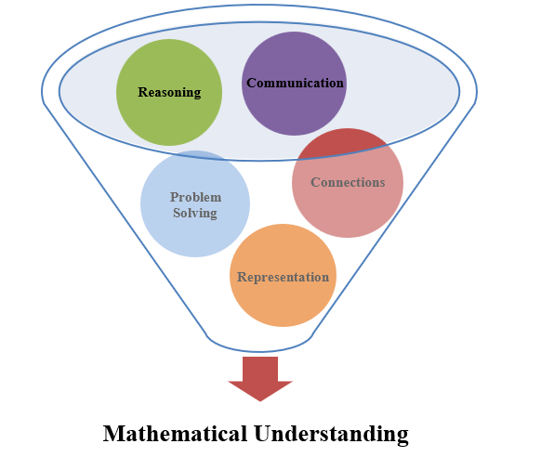 | The five mathematical process goals have been embedded throughout the standards and knowledge and skills. Students should be given opportunities to learn and apply the process goals as they work to achieve the content of the Mathematics Standards.
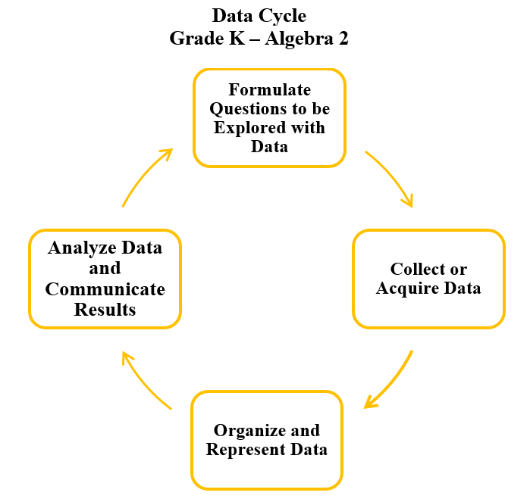 | A process for data analysis is included in the standards as a Data Cycle. Students should be given the opportunity to explore data and data analysis using the data cycle. Analyzing data requires the ability to read, write, and communicate about data in context. The skills needed to analyze data are integrated in the mathematics standards and derived from and build upon a strong mathematical foundation.
Please refer to the Appendix in the 2023 Mathematics Standards of Learning to learn more about the process goals and data cycle.
Specific Instructional Transitions by Strand:
The 2023 Mathematics Standards of Learning incorporate revisions that are specific to a grade level or course. Instructional notes have been provided for specific standards that support the transition from the 2016 to the 2023 Mathematics Standards of Learning.
Number and Number Sense
2016 SOL | 2023 SOL | Instructional Notes
5.2b | 5.NS.1d | While students are comparing and ordering fractions and decimals, provide them with opportunities to justify their solutions orally, in writing, or with a model.
5.3a | 5.NS.2 | While students are learning about prime and composite numbers, provide opportunities for students to explore prime factorization of a whole number up to 100.

Computation and Estimation
2016 SOL | 2023 SOL | Instructional Notes
5.4 | 5.CE.1 | While students solve single-step and multistep problems with whole numbers, provide opportunities for them to justify and represent their solutions.
5.5 | 5.CE.3 | While students solve single-step and multistep problems with decimals, provide opportunities for them to justify and represent their solutions. When multiplying decimals provide opportunities for three-digit by one-digit multiplication.
5.6 | 5.CE.2 | While students are adding and subtracting two fractions with unlike denominators, provide opportunities for them to find the least common multiple when determining a common denominator.

Measurement and Geometry
2016 SOL | 2023 SOL | Instructional Notes
5.8 | 5.MG.2 | While developing a procedure for finding the area of a right triangle, provide students with opportunities to have hands-on explorations to investigate and develop the formula for finding area.  While developing a procedure for finding volume, provide opportunities for students to describe volume as a measure of capacity and give examples of volume as a measurement in contextual situations.
5.9 | 5.MG.1 | When solving practical problems that involve length, mass, and liquid volume, provide students with opportunities to choose the most appropriate unit of measure to use in the problem.
5.12, 5.13 | 5.MG.3 | While students classify and measure angles and triangles, provide opportunities for them to solve problems in context with angles and triangles.

Probability and Statistics
2016 SOL | 2023 SOL | Instructional Notes
5.16 | 5.PS.1 | While students are representing data and making observations about line plots (dot plots) and stem-and-leaf plots, provide opportunities for students to incorporate additional components of the data cycle, including:  - Formulate questions that require the collection or acquisition of data;  - Determine the data needed to answer a formulated question and collect the data or acquire existing data using various methods; and  - Analyze data and communicate results.  Additionally, provide opportunities for students to solve single-step and multistep addition and subtraction problems using data from line plots (dot plots) and stem-and-leaf plots.

Patterns, Functions, and Algebra
2016 SOL | 2023 SOL | Instructional Notes
5.18 | 5.PFA.1 | While students are working with patterns, provide opportunities for them to work on patterns in context and with various representations.  While students are working with patterns, provide opportunities for them to work with patterns that use division of whole numbers.
5.19 | 5.PFA.2 | While students are working with variables, provide opportunities to investigate and use variables in contextual problems.

