Instructional Supports for Prioritization of Content during the 2023-2024 School Year
Grade 4 Mathematics Standards of Learning

This document outlines the prominent content changes between the 2016 Mathematics Standards of Learning (SOL) and the 2023 Mathematics Standards of Learning and includes instructional notes to support school divisions in making decisions about the prioritization of content during the 2023-2024 transition year. In conjunction with the 2023 Mathematics Standards of Learning Overview of Revisions document, this document supports the transition of instruction during the 2023-2024 school year. School divisions may wish to use this document when planning for instruction, based upon the options for transitioning, and determining how to supplement existing curriculum to incorporate content from the 2023 Mathematics SOL. School divisions will determine how best to meet the needs of students when incorporating content during the transition year to prepare for full implementation of the 2023 Mathematics Standards of Learning during the 2024-2025 school year.

CONTENT TRANSITIONS:

Overall Instructional Transitions:
The 2023 Mathematics Standards of Learning incorporate revisions that span across grade levels. Instructional notes have been provided that promote deeper understanding of mathematical concepts and support the transition from the 2016 to the 2023 Mathematics Standards of Learning.
Overall Instructional Transition | Instructional Notes
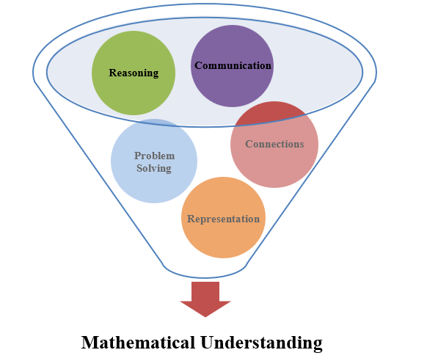 | The five mathematical process goals have been embedded throughout the standards and knowledge and skills. Students should be given opportunities to learn and apply the process goals as they work to achieve the content of the Mathematics Standards.
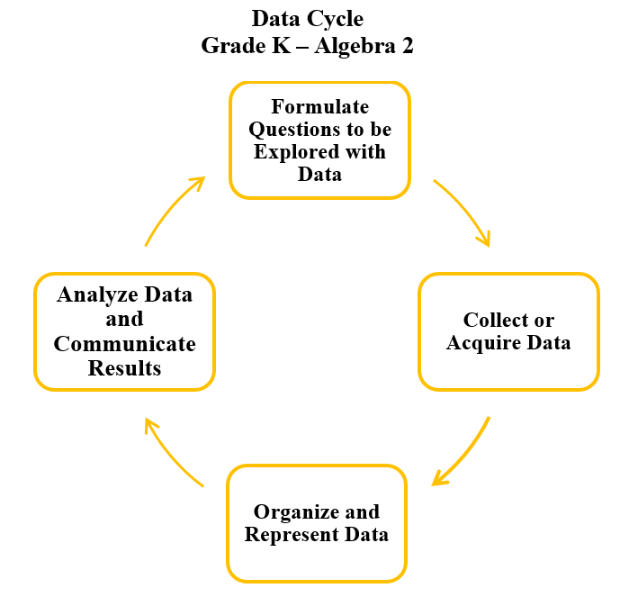 | A process for data analysis is included in the standards as a Data Cycle. Students should be given the opportunity to explore data and data analysis using the data cycle. Analyzing data requires the ability to read, write, and communicate about data in context. The skills needed to analyze data are integrated in the mathematics standards and derived from and build upon a strong mathematical foundation.
Please refer to the Appendix in the 2023 Mathematics Standards of Learning to learn more about the process goals and data cycle.

Specific Instructional Transitions by Strand:
The 2023 Mathematics Standards of Learning incorporate revisions that are specific to a grade level or course. Instructional notes have been provided for specific standards that support the transition from the 2016 to the 2023 Mathematics Standards of Learning.
Number and Number Sense
2016 SOL | 2023 SOL | Instructional Notes
4.1a | 4.NS.1 | While exploring place and value of each digit in a nine-digit whole number, students should apply patterns within the base 10 system.
4.2 | 4.NS.3 | While comparing fractions using benchmarks, students should have opportunities to decompose fractions (proper or improper) to help determine how close the fraction is to the benchmarks of ½ or 1 whole.  While comparing fractions (proper or improper) and mixed numbers, students should justify their solutions orally, in writing, or with a model.

Computation and Estimation
2016 SOL | 2023 SOL | Instructional Notes
4.1c | 4.CE.1 | When estimating and determining sums, differences, products, and quotients, incorporate rounding as an estimation strategy. Provide opportunities for students to make sense of rounding using the context of the problem.
4.4 | 4.CE.1  4.CE.2 | When solving contextual problems, students should determine and justify whether an estimate or an exact answer is appropriate before students estimate, represent, solve, and justify solutions.
4.5 | 4.CE.2f | When determining common factors and the greatest common factor, students should have opportunities to explore and determine all possible factor pairs for a whole number up to 100.
4.16 | 4.CE.2c,d | When using strategies and properties to find sums, differences, products, and quotients, include opportunities for students to work with expressions that are equal and not equal, and to determine the appropriate use of the equal sign and not equal sign.
4.5b | 4.CE.3c | When adding fractions with like denominators, students have opportunities to use models to explore multiplying unit fractions by whole numbers, limited to 12 or less. This will help students foster connections between repeated fraction addition and multiplication of a unit fraction by a whole number.

Measurement and Geometry
2016 SOL | 2023 SOL | Instructional Notes
4.7 | 4.MG.3d,e | When determining the area and perimeter of squares and rectangles, students should have opportunities to explore the concept that rectangles can have the same perimeter but different areas or the same area but different perimeters.
4.10 | 4.MG.4c | When identifying and describing points, lines, line segments, rays, and angles, students should have opportunities to draw representations of points, line segments, rays, angles, and lines, using a ruler or straightedge.
4.11 | 4.MG.6 | When identifying, describing, comparing, and contrasting plane and solid figures with concrete models and pictorial representations, students should also have opportunities to identify, describe, compare, and contrast plane and solid figures without models.
4.12 | 4.MG.5f | While classifying and describing quadrilaterals, students should be able to name line segments and angles using symbolic notation.

Probability and Statistics
2016 SOL | 2023 SOL | Instructional Notes
4.13 | 4.PS.2 | When determining the likelihood of an outcome of a simple event and representing probability as a number between 0 and 1, students should have opportunities to describe probability using terms such as impossible, unlikely, equally likely, likely, and certain.
4.14 | 4.PS.1 | While students are representing data and making observations about line graphs, provide opportunities for students to incorporate additional components of the data cycle, including:  - Formulate questions that require the collection or acquisition of data;  - Determine the data needed to answer a formulated question and collect the data or acquire existing data using various methods; and  - Analyze data and communicate results.  Additionally, provide opportunities for students to solve single-step and multistep addition and subtraction problems using data from line graphs.

Patterns, Functions, and Algebra
2016 SOL | 2023 SOL | Instructional Notes
4.15 | 4.PFA.1c | While working with patterns, students should have opportunities to create an increasing and decreasing pattern using numbers and input/output tables (including function machines) when given a rule.

