Instructional Supports for Prioritization of Content during the 2023-2024 School Year
Grade 3 Mathematics Standards of Learning

This document outlines the prominent content changes between the 2016 Mathematics Standards of Learning (SOL) and the 2023 Mathematics Standards of Learning and includes instructional notes to support school divisions in making decisions about the prioritization of content during the 2023-2024 transition year. In conjunction with the 2023 Mathematics Standards of Learning Overview of Revisions document, this document supports the transition of instruction during the 2023-2024 school year. School divisions may wish to use this document when planning for instruction, based upon the options for transitioning, and determining how to supplement existing curriculum to incorporate content from the 2023 Mathematics SOL. School divisions will determine how best to meet the needs of students when incorporating content during the transition year to prepare for full implementation of the 2023 Mathematics Standards of Learning during the 2024-2025 school year.

CONTENT TRANSITIONS:

Overall Instructional Transitions:
The 2023 Mathematics Standards of Learning incorporate revisions that span across grade levels. Instructional notes have been provided that promote deeper understanding of mathematical concepts and support the transition from the 2016 to the 2023 Mathematics Standards of Learning.
Overall Instructional Transition | Instructional Notes
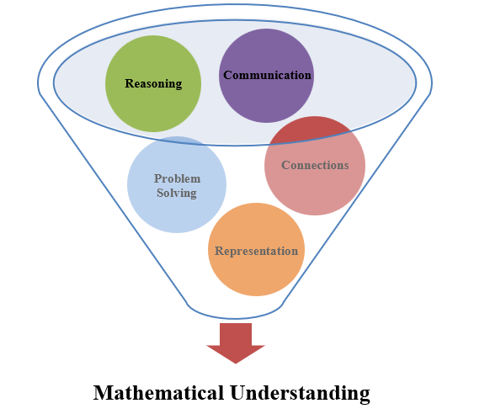 | The five mathematical process goals have been embedded throughout the standards and knowledge and skills. Students should be given opportunities to learn and apply the process goals as they work to achieve the content of the Mathematics Standards.
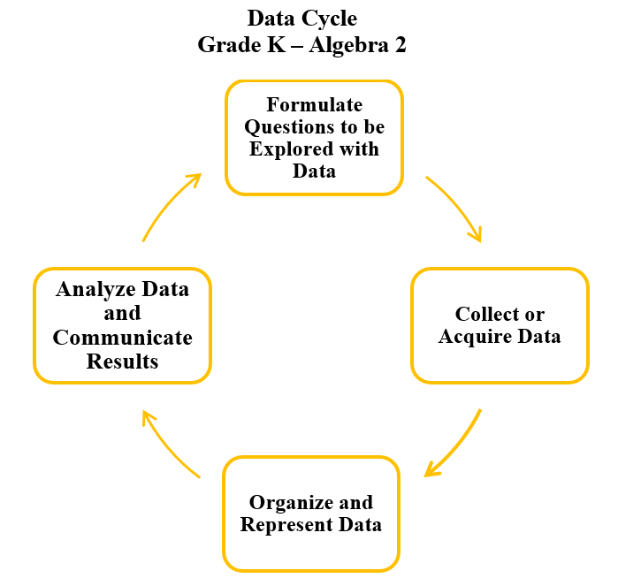 | A process for data analysis is included in the standards as a Data Cycle. Students should be given the opportunity to explore data and data analysis using the data cycle. Analyzing data requires the ability to read, write, and communicate about data in context. The skills needed to analyze data are integrated in the mathematics standards and derived from and build upon a strong mathematical foundation.
Please refer to the Appendix in the 2023 Mathematics Standards of Learning to learn more about the process goals and data cycle.
Specific Instructional Transitions by Strand:
The 2023 Mathematics Standards of Learning incorporate revisions that are specific to a grade level or course. Instructional notes have been provided for specific standards that support the transition from the 2016 to the 2023 Mathematics Standards of Learning.
Number and Number Sense
2016 SOL | 2023 SOL | Instructional Notes
3.1 | 3.NS.1a | When reading and writing six-digit whole numbers using standard and word form, students should have opportunities to read and write six-digit whole numbers in expanded form.
3.2 | 3.NS.3d | After using models to count the fractional parts to name and write a fraction, students should spend time breaking apart fractions into non-unit fractions to explore composing and decomposing fractions with models.
3.2 | 3.NS.3f,g | When comparing two fractions, students should have opportunities to compare proper fractions, improper fractions, and mixed numbers (previously limited to proper fractions).
3.2 | 3.NS.3h | When modeling fractions using region/area and length models, students should have opportunities to model equivalent fractions.
3.6 | 3.NS.4b | While working with collections of money, students should have opportunities to construct sets of bills and coins to total a given amount of money whose value is $5.00 or less.

Computation and Estimation
2016 SOL | 2023 SOL | Instructional Notes
3.1b | 3.CE.1b | When estimating and determining sums and differences, students should incorporate rounding as an estimation strategy, and should have opportunities to make sense of rounding using the context of the problem.
3.4 | 3.CE.1a-e | When solving problems, students should be expected to estimate, represent, solve, and justify solutions.
3.4 | 3.CE.2c, d, e, f | When working with multiplication and division concepts, students should have opportunities to apply reasoning strategies and practice for multiplication facts through 10 × 10 and the corresponding division facts in order to develop fluency and automaticity.
3.17 | 3.CE.1d  3.CE.2g | When working with related facts or using strategies and properties to find sums, differences, products, and quotients, students should have opportunities to work with expressions that are equal and not equal and to determine the appropriate use of the equal sign and not equal sign.

Measurement and Geometry
2016 SOL | 2023 SOL | Instructional Notes
3.7 | 3.MG.1a | When estimating and measuring, provide opportunities for students to use mathematical reasoning to justify whether an estimate or exact measurement is needed.
3.7 | 3.MG.1b | In addition to estimating and measuring length and liquid volume, provide opportunities for students to estimate and measure weight/mass of an object to the nearest U.S. Customary unit (pound) and metric unit (kilogram).
3.7 | 3.MG.1c | When estimating and measuring, provide opportunities for students to use mathematical reasoning to compare estimates of length, weight/mass, or liquid volume with the actual measurements.
3.8 | 3.MG.2b | When measuring perimeter of polygons, include examples where students are given the lengths of all sides to determine the perimeter.
3.8 | 3.MG.2a-b | When measuring area and perimeter, incorporate examples of measuring area and perimeter in contextual situations.
3.12 | 3.MG.4e | When naming and identifying polygons, provide opportunities for students to classify and compare polygons.
Probability and Statistics
2016 SOL | 2023 SOL | Instructional Notes
3.15 | 3.PS.1a-e | While students are representing and interpreting data using pictographs and bar graphs, provide opportunities for students to incorporate additional components of the data cycle, including:  - Formulate questions that require the collection or acquisition of data; and  - Determine the data needed to answer a formulated question and collect the data or acquire existing data using various methods (observations, measurement, surveys, experiments).  Additionally, provide opportunities for students to:  - Describe the categories of data and the data as a whole;  - Identify parts of the data that have special characteristics;  - Make inferences about the data;  - Use characteristics of the data to draw conclusions and make inferences; and  - Solve one and two step addition and subtraction problems using data from pictographs and bar graphs.
3.15 | 3.PS.1b,c,d | While representing data in pictographs and bar graphs, provide opportunities for students to work with larger data sets (30 or fewer data points for no more than eight categories).

Patterns, Functions, and Algebra
2016 SOL | 2023 SOL | Instructional Notes
3.16 | 3.PFA.1a-e | While identifying, describing, creating and extending patterns, provide opportunities for students to explain connections between various representations of increasing and decreasing patterns

