Instructional Supports for Prioritization of Content during the 2023-2024 School Year
Grade 2 Mathematics Standards of Learning

This document outlines the prominent content changes between the 2016 Mathematics Standards of Learning (SOL) and the 2023 Mathematics Standards of Learning and includes instructional notes to support school divisions in making decisions about the prioritization of content during the 2023-2024 transition year. In conjunction with the 2023 Mathematics Standards of Learning Overview of Revisions document, this document supports the transition of instruction during the 2023-2024 school year. School divisions may wish to use this document when planning for instruction, based upon the options for transitioning, and determining how to supplement existing curriculum to incorporate content from the 2023 Mathematics SOL. School divisions will determine how best to meet the needs of students when incorporating content during the transition year to prepare for full implementation of the 2023 Mathematics Standards of Learning during the 2024-2025 school year.

CONTENT TRANSITIONS:

Critical Instructional Transitions:
The 2023 Mathematics Standards of Learning include critical content, as shown below, that could cause gaps in student learning if instruction is not provided during the transition year. The following 2016 Mathematics Standards of Learning content has been moved from Grade 3 to Grade 2:
2016 SOL | 2023 SOL | Instructional Notes
3.9c | 2.MG.2a | Identify the number of minutes in an hour and the number of hours in a day has moved from Grade 3 to Grade 2. Instruction on this change during the 2023-2024 school year will ensure there is not a gap in understanding these equivalencies. When teaching time to the nearest five minutes develop the understanding of number of minutes in an hour using analog clocks. Use a variety of ways to describe 24 hours in a day to include a discussion about the amount of time you spend in school and at home, awake and asleep. 2.MG.2a is a critical skill as it was removed from third grade content.
3.13 | 2.MG.3c | Identify examples of congruent figures has been moved from Grade 3 to Grade 2. As students develop an understanding of symmetry, they will need to define congruency as same shape and size. Instruction on this change during the 2023-2024 school year will ensure there is not a gap in understanding the vocabulary term congruent.

Overall Instructional Transitions:
The 2023 Mathematics Standards of Learning incorporate revisions that span across grade levels. Instructional notes have been provided that promote deeper understanding of mathematical concepts and support the transition from the 2016 to the 2023 Mathematics Standards of Learning.
Overall Instructional Transition | Instructional Notes
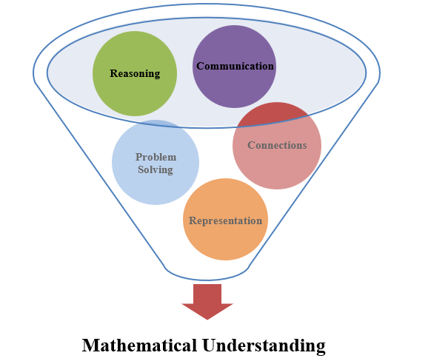 | The five mathematical process goals have been embedded throughout the standards and knowledge and skills. Students should be given opportunities to learn and apply the process goals as they work to achieve the content of the Mathematics Standards.
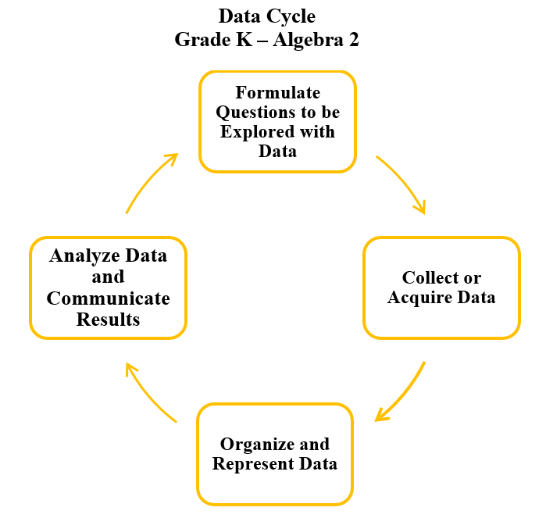 | A process for data analysis is included in the standards as a Data Cycle. Students should be given the opportunity to explore data and data analysis using the data cycle. Analyzing data requires the ability to read, write, and communicate about data in context. The skills needed to analyze data are integrated in the mathematics standards and derived from and build upon a strong mathematical foundation.
Please refer to the Appendix in the 2023 Mathematics Standards of Learning to learn more about the process goals and data cycle.

Specific Instructional Transitions by Strand:
The 2023 Mathematics Standards of Learning incorporate revisions that are specific to a grade level or course. Instructional notes have been provided for specific standards that support the transition from the 2016 to the 2023 Mathematics Standards of Learning.
Number and Number Sense
2016 SOL | 2023 SOL | Instructional Notes
2.1 | 2.NS.2e | When students are composing and decomposing whole numbers up to 200, have them make connections between a variety of models and strategies. Give students a number in standard form. Have them build the number using base 10 blocks and writing the expanded form of the number. Using the same number and base 10 blocks, decompose the number a different way and write the expanded form. Have students justify their thinking to make connections. Ask, “are there other ways to show the same number using base 10 blocks?”
2.1d | 2.CE.1a | When students are estimating and determining sums and differences, incorporate rounding as an estimation strategy. Provide opportunities for students to make sense of rounding using the context of the problem.
2.2a | 2.NS.1a-c | While forward counting with groups of 2s to at least 50, and groups of 5s, 10s, and 25s to at least 200 students will represent, describe, and use patterns. Note that the language of at least, indicates that students can generalize the patterns to count beyond the expectation. Tools such as objects, number lines, calculators, and hundred charts can be used to support the understanding of this standard.
 | 2.NS.1d | Students will represent when using forward counting patterns to count by groups of 100 up to at least 1,000. Being able to count by 100 will develop skills necessary for place value and computation. Tools such as objects, base 10 flats, number lines, calculators, and thousands charts can be used to support the understanding of this standard.
2.2b | 2.NS.1e,f | Represent, describe, and use patterns in skip counting backwards by 10's to justify the number in the counting sequence. Being able to count backwards is an essential skill for subtraction. Tools such as objects, number lines, calculators, and hundred charts can be used to support the understanding of this standard.
1.5a | 2.NS.1.g | While students work with estimating, use relatable contexts such as the number of students in your classroom versus the number of students in the school to support students in choosing reasonable estimates up to 1,000.
2.2c | 2.NS.1h,i | While students are working with determining/representing even/odd numbers up to 50, have students use concrete objects to divide collections into two equal groups or pair objects. Then have students justify that a number is even when each object has a pair or partner or odd when an object is leftover or does not have a pair.
 | 2.NS.2f | Plot and justify the position of a given number up to 100 on a number line with pre-marked benchmarks of 1s, 2s, 5s, 10s, or 25s. Count and discover patterns on a number line and ask students, “If 30 is here on this number line, where would 31 be? Where would 29 be? Expand to additional numbers.
2.4c | 2.NS.3b | Describe the relationship between the number of fractional parts needed to make a whole and the size of the parts. This will develop a sense of the fraction magnitude and the understanding of when the whole is divided into more parts, each part becomes smaller. Have students take a paper rectangle that represents the whole and fold into strips to divide it into 2 equal pieces. Label each piece as ½ as it represents 1 of 2 equal pieces. Do the same with 4 equal pieces. Label each piece represents ¼ . Do the same to another rectangle to divide into 8 equal pieces. Have students label each as 1/8 as it represents 1 of 8 equal pieces. Ask students, “What do you notice about each?” “What do you wonder?”
 | 2.NS.3c | Compose the whole for a given fractional part and its value (in context) for halves, fourths, eighths, thirds, and sixths (e.g., when given 1/4, determine how many pieces would be needed to make 4/4).
 | 2.NS.3d | Counting by unit fractions up to two wholes is included so students are able to count by the number of unit fractions separately and together. For example, they will count zero one-fourths, one one-fourth, two one-fourths, three one fourths as well as zero-fourths, one-fourth, two-fourths, and three-fourths. Using fraction manipulatives representing the region/area model will help develop this understanding.

Computation and Estimation
2016 SOL | 2023 SOL | Instructional Notes
2.5 | 2.CE.1d,e | Teach and reinforce the basic facts reasoning strategies such as doubles, near doubles, make-a-ten, compensation, and inverse relationships. Provide opportunities for students to practice hands-on games based on targeted addition and subtraction strategies to develop fluency and automaticity with addition and subtraction facts within 20.
2.6 | 2.CE.1c | When solving problems, estimate, represent, solve, and justify solutions for addition and subtraction problems where addends and minuends do not exceed 100. This means in an addition problem, the sum of two numbers can go up to 200.

Measurement and Geometry
2016 SOL | 2023 SOL | Instructional Notes
2.7a | 2.NS.4a | Identify a quarter and its value and determine multiple ways to represent the value of a quarter using pennies, nickels, and/or dimes. This can be connected to counting patterns in 2.NS.1. Use multiple representations to count including coins, number lines and hundreds charts.
2.7a | 2.NS.4c | While working with collections of money, construct sets of bills and coins, in multiple ways, to total a given amount of money whose value is $2.00 or less.
2.8a,b | 2.MG.1a,b | When teaching measurement include measuring liquid volume to the nearest whole unit. Students should have the opportunity to explain that measuring cups are a tool to measure liquid volume. They should be exposed to a variety of measuring cups when estimating, measuring liquid volume, and comparing the estimate with the actual measure.
2.9 | 2.MG.2a | When teaching time to the nearest five minutes develop the understanding of the number of minutes in an hour using analog clocks. Use a variety of ways to describe 24 hours in a day to include a discussion about the amount of time you spend in school and at home, awake and asleep. 2.MG.2a is a critical skill as it moved from third grade content to second grade.
2.9 | 2.MG.2b | When determining the best unit of time (minutes, hours, days, or weeks) to measure a given activity or context, start with common activities students experience such as: brushing their teeth, traveling to a given destination, or a project that would take days or weeks to complete. This part of the standard would allow for discussion of the number of hours in a day which is expected in 2.MG.2a.
2.12 | 2.MG.3c | While working with symmetry, students will need to describe figures as congruent (same shape and size) when determining a line of symmetry that results in two figures. This is a critical skill as it moved from third grade content to second grade.
 | 2.MG.4b | While working with 3D figures, students will also need to compare and contrast models and nets of cubes and rectangular prisms. Nets are cutouts of the 3D figures. Students can make nets by tracing the faces, cutting out the pieces and putting them back together. The vocabulary of face, edge, vertex (plural vertices) will need to be developed.

Probability and Statistics
2016 SOL | 2023 SOL | Instructional Notes
2.15a,b | 2.PS.1a-e | While students are representing and analyzing data in pictographs and bar graphs, provide opportunities for students to incorporate additional components of the data cycle, including:  - Pose questions given a predetermined context, that require the collection of data.  - Determine the data needed to answer a posed question and collect the data using various methods (e.g., voting; creating lists, tables, or charts; tallying).  - Organize and represent a data set using a pictograph or bar graph  Additionally, students will need opportunities for students to:  - Analyze data and communicate the results by asking and answering questions about the data presented; and  - Draw conclusions about the data and make predictions based on the data
2.15a,b | 2.PS.1a | While working with data, increase the number of data points from 16 to 25. This gives the opportunity to collect data from a classroom of students using voting; creating lists, tables, or charts; tallying.

Patterns, Functions, and Algebra
2016 SOL | 2023 SOL | Instructional Notes
2.16 | 2.PFA.1a | While teaching growing patterns use the word “increasing” interchangeably with growing patterns as first grade limits growing patterns to increasing patterns.
2.16 | 2.PFA.1d | While students transfer a given increasing pattern from one form to another have them explain the connection between the two patterns.
2.17 | 2.CE.1f-j | While teaching expressions, include discussions about expressions that are equal and not equal and the appropriate use of the equal sign and not equal sign when working with related facts or using strategies and properties to find sums and differences. Students need to be able to justify these relationships.

