Instructional Supports for Prioritization of Content during the 2023-2024 School Year
Grade 1 Mathematics Standards of Learning

This document outlines the prominent content changes between the 2016 Mathematics Standards of Learning (SOL) and the 2023 Mathematics Standards of Learning and includes instructional notes to support school divisions in making decisions about the prioritization of content during the 2023-2024 transition year. In conjunction with the 2023 Mathematics Standards of Learning Overview of Revisions document, this document supports the transition of instruction during the 2023-2024 school year. School divisions may wish to use this document when planning for instruction, based upon the options for transitioning, and determining how to supplement existing curriculum to incorporate content from the 2023 Mathematics SOL. School divisions will determine how best to meet the needs of students when incorporating content during the transition year to prepare for full implementation of the 2023 Mathematics Standards of Learning during the 2024-2025 school year.

CONTENT TRANSITIONS:

Overall Instructional Transitions:
The 2023 Mathematics Standards of Learning incorporate revisions that span across grade levels. Instructional notes have been provided that promote deeper understanding of mathematical concepts and support the transition from the 2016 to the 2023 Mathematics Standards of Learning.
Overall Instructional Transition | Instructional Notes
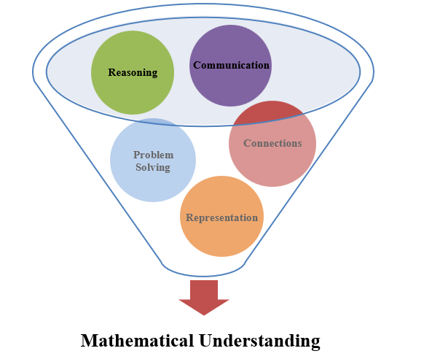 | The five mathematical process goals have been embedded throughout the standards and knowledge and skills. Students should be given opportunities to learn and apply the process goals as they work to achieve the content of the Mathematics Standards.
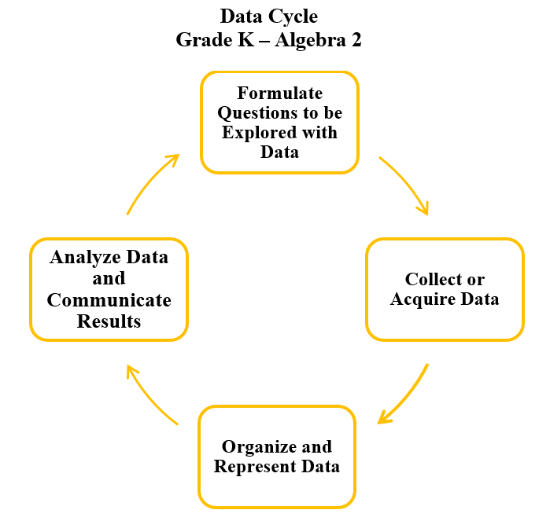 | A process for data analysis is included in the standards as a Data Cycle. Students should be given the opportunity to explore data and data analysis using the data cycle. Analyzing data requires the ability to read, write, and communicate about data in context. The skills needed to analyze data are integrated in the mathematics standards and derived from and build upon a strong mathematical foundation.
Please refer to the Appendix in the 2023 Mathematics Standards of Learning to learn more about the process goals and data cycle.
Specific Instructional Transitions by Strand:
The 2023 Mathematics Standards of Learning incorporate revisions that are specific to a grade level or course. Instructional notes have been provided for specific standards that support the transition from the 2016 to the 2023 Mathematics Standards of Learning.
Number and Number Sense
2016 SOL | 2023 SOL | Instructional Notes
1.5 | 1.NS.2.b and 1.NS2.d | When having students estimate the number of objects (up to 120) in a given collection and justify the reasonableness of an answer, provide opportunities to estimate items in a jar or other transparent container up to 120 objects. Students can dump the jar and group by tens and ones to determine the total and justify the reasonableness of their estimate.

Computation and Estimation
2016 SOL | 2023 SOL | Instructional Notes
1.7 | 1.CE.1b,c | When working on building automaticity with addition and subtraction facts within 10, teach and reinforce the basic fact reasoning strategies such as counting on, counting back, one more, one less, doubles, and making 10. Provide opportunities for students to practice hands-on games based on targeted addition and subtraction strategies.
1.6 | 1.CE.1g | When working with students to determine the unknown whole number that will result in a sum or difference of 10 or 20 (e.g., 14 - __ = 10 or 15 + __ = 20), provide opportunities for students to anchor to 10 or 20 using manipulatives such as math racks to 20, double ten frames, and number paths to 20 or 120 charts.

Measurement and Geometry
2016 SOL | 2023 SOL | Instructional Notes
1.9 | 1.MG.3 | When working with time, include students in conversations about the units of time represented on a clock as minutes and hours. In additions, students need opportunities to describe the location of the hour hand or minute hand relative to time to the hour and half-hour on an analog clock. Consider using a one-handed clock to have students predict what the missing hour or minute hand could be.
1.10 | 1.MG.1b | While measuring objects with nonstandard units, measure the same object with two different units and discuss why the measurements are different.
1.11 | 1.MG.2f | While working with plane figures, students need to explore how to combine two or three simple plane figures to compose larger plane figures (triangles, squares, and/or rectangles).

Probability and Statistics
2016 SOL | 2023 SOL | Instructional Notes
1.12 | 1.PS.1a-g | While students are representing and interpreting data using object graphs, pictographs and tables, provide opportunities for students to incorporate additional components of the data cycle, including:  - formulate questions that require the collection or acquisition of data; and  - determine the data needed to answer a formulated question and collect the data or acquire existing data using various methods (observations, measurement, surveys, experiments).  Additionally, provide opportunities for students to:  - ask and answer questions about the data; and  - draw conclusions about the data and make predictions based on the data.
1.12 | 1.PS.1c | While collecting data and representing data in object graphs, pictographs and tables, increased data collection to 25 or fewer data points for no more than four categories. (previously 16 or fewer data points for no more than four categories)

Patterns, Functions, and Algebra
2016 SOL | 2023 SOL | Instructional Notes
1.14 | 1.PFA.1a | While students are working with growing patterns use the word “increasing” interchangeably with growing patterns as first grade limits growing patterns to increasing patterns.

