Instructional Supports for Prioritization of Content during the 2023-2024 School Year
Kindergarten Mathematics Standards of Learning

This document outlines the prominent content changes between the 2016 Mathematics Standards of Learning (SOL) and the 2023 Mathematics Standards of Learning and includes instructional notes to support school divisions in making decisions about the prioritization of content during the 2023-2024 transition year. In conjunction with the 2023 Mathematics Standards of Learning Overview of Revisions document, this document supports the transition of instruction during the 2023-2024 school year. School divisions may wish to use this document when planning for instruction, based upon the options for transitioning, and determining how to supplement existing curriculum to incorporate content from the 2023 Mathematics SOL. School divisions will determine how best to meet the needs of students when incorporating content during the transition year to prepare for full implementation of the 2023 Mathematics Standards of Learning during the 2024-2025 school year.

CONTENT TRANSITIONS:

Overall Instructional Transitions:
The 2023 Mathematics Standards of Learning incorporate revisions that span across grade levels. Instructional notes have been provided that promote deeper understanding of mathematical concepts and support the transition from the 2016 to the 2023 Mathematics Standards of Learning.
Overall Instructional Transition | Instructional Notes
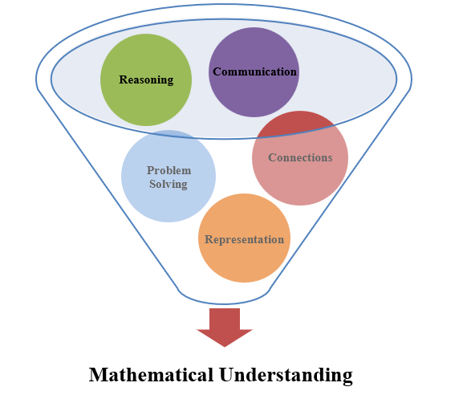 | The five mathematical process goals have been embedded throughout the standards and knowledge and skills. Students should be given opportunities to learn and apply the process goals as they work to achieve the content of the Mathematics Standards.
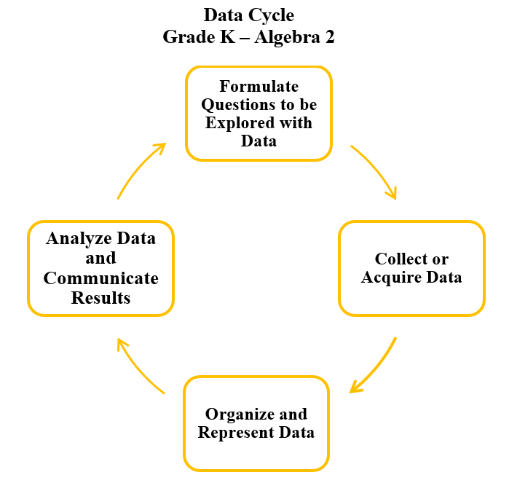 | A process for data analysis is included in the standards as a Data Cycle. Students should be given the opportunity to explore data and data analysis using the data cycle. Analyzing data requires the ability to read, write, and communicate about data in context. The skills needed to analyze data are integrated in the mathematics standards and derived from and build upon a strong mathematical foundation.
Please refer to the Appendix in the 2023 Mathematics Standards of Learning to learn more about the process goals and data cycle.

Specific Instructional Transitions by Strand:
The 2023 Mathematics Standards of Learning incorporate revisions that are specific to a grade level or course. Instructional notes have been provided for specific standards that support the transition from the 2016 to the 2023 Mathematics Standards of Learning.
Number and Number Sense
2016 SOL | 2023 SOL | Instructional Notes
K.1a | K.NS.1 | When asking students to count objects, extend the number of counted objects to 30.  When the student finishes counting the number of objects in a set, the teacher should then ask, “How many are there?” After students count a set of objects, the teacher should rearrange the objects while the student watches and ask, “Now how many are there?”
K.1b | K.NS.2a-c | While students are reading, writing, and representing numbers include numbers through 30.
K.2a | K.NS.2d-g | While students are comparing quantities up to 30 provide students the opportunity to:  - Look at a set of objects and construct another set which has more, fewer, or the same number of objects using concrete or pictorial models.  - Look at a numeral and construct another set which has more, fewer, or the same.  - Compare two sets using the terms more, fewer, or the same as (equal to).  - Compare to benchmarks of five and ten using various models (e.g. five frames, ten frames, number paths, beaded racks, hands) using the terms greater than, less than, or the same as (equal to).
K.3ab | K.NS.1c-f | While counting, students could represent forward counting by ones using a variety of tools, including five-frames, ten-frames, and number paths. Students could be asked to count forward orally by ones to 100 starting at any number and to count backward given any number between 1 and 20.
K.3c | K.NS.1g,h | While exploring numbers, students should be able to state the number after, without counting, when given any number between 0 and 30 and the number before any number between 1 and 20.
K.3d | K.NS.1i,j | When learning about the numbers between 11 and 19 students could use objects, drawings, words or numbers to compose and decompose the number into a ten and some ones. When grouping objects by ten to count, students could determine the total number of objects in the group. For example, there are 3 groups of ten and 6 leftovers, 36 total objects.
K.4ab | K.CE.1a-e | When exploring part-part whole relationships to 5, students could model and identify the number that makes 5 when added to a given number less than or equal to 5. While investigating part-whole relationships to ten, students could model and identify the number that makes 10 when added to a given number less than or equal to 10. Students could also use objects, drawings, words, or numbers to compose and decompose numbers less than or equal to 10 in multiple ways.

Measurement and Geometry
2016 SOL | 2023 SOL | Instructional Notes
K.7 | K.PS.1 | While students are sorting objects include coins for students to describe and label.
K.8 | K.MG.3 | When discussing the calendar:  - Ask students, “What is the purpose of the calendar?” Students will identify a calendar as a tool to measure time.  - Ask students, “How many days are in one week?”  - Ask students, “How many months are in one year?”  - Provide opportunities for students to distinguish between days of the week and months of the year by asking questions such as, “What is Monday?” or “Is June a day of the week or a month of the year?”
K.9 | K.MG.1 | While students are making direct comparisons between two objects or events ask them to justify their comparison.
K.10 | K.MG.2 | When exploring plane figures, ask students to construct them using a variety of materials. Additionally, encourage students to identify, name and describe plane figures in the environment.

Probability and Statistics
2016 SOL | 2023 SOL | Instructional Notes
K.11 | K.PS.1 | When collecting and organizing data, students:  - Sort, describe, and label the attributes of coins as well as other counters.  - Pose questions to determine the data to be collected.  - Collect up to 25 data points in no more than four categories.  After the data is organized:  - Provide opportunities for students to ask and answer questions such as, “How many are in each category?” and “Which categories have the greatest, least, or the same amount of data?”  - Ask students to draw conclusions and make predictions about the data.

