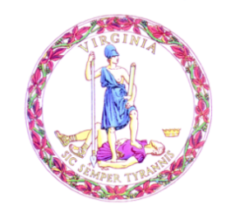

Commonwealth of Virginia

College Partnership Laboratory Schools Standing Committee Agenda

Date of Meeting: October 3, 2023 Time: 9:45 a.m.

Location: Board Room, 22nd Floor, James Monroe Building

10:00 a.m. STANDING COMMITTEE CONVENES

MOMENT OF SILENCE

PLEDGE OF ALLEGIANCE

APPROVAL OF THE AGENDA

APPROVAL OF MINUTES
PUBLIC COMMENT ON AGENDA ITEMS
ACTION/DISCUSSION ITEMS
- First Review of College Partnership Laboratory School Application from Germanna Community College

- First Review of College Partnership Laboratory School Application from University of Mary Washington

- Proposed Revisions to the College Partnership Laboratory School Application

- Proposed 2024 Calendar of College Partnership Laboratory Schools Standing Committee Meetings

PRESENTATIONS AND WRITTEN REPORTS
- Staffing and Workflow Update

- Per-Pupil Funding of College Partnership Laboratory Schools

- Update on College Partnership Laboratory School Planning Grant Expenditures

- College Partnership Laboratory School Application Pipeline

DISCUSSION OF CURRENT ISSUES
PUBLIC COMMENT ON NON-AGENDA ITEMS

ADJOURNMENT

