Harvest of the Month
Try January's Feature: Sweet Potato
Brought to your school by your local farm

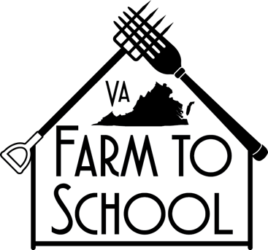

Harvest of the Month
Try February's Feature: Butternut Squash
Brought to your school by your local farm

Harvest of the Month
Try March's Feature: Kale
Brought to your school by your local farm

Harvest of the Month
Try April's Feature: Lettuce
Brought to your school by your local farm

Harvest of the Month
Try May's Feature: Strawberries
Brought to your school by your local farm

Harvest of the Month
Try June's Feature: Cucumbers
Brought to your school by your local farm

Harvest of the Month
Try July's Feature: Zucchini
Brought to your school by your local farm

Harvest of the Month
Try August's Feature: Tomato
Brought to your school by your local farm

Harvest of the Month
Try September's Feature: Sweet Bell Peppers
Brought to your school by your local farm

Harvest of the Month
Try October's Feature: Virginia Grown Apples
Brought to your school by your local farm

Harvest of the Month
Try November's Feature: Cabbage
Brought to your school by your local farm

Harvest of the Month
Try December's Feature: Spinach
Brought to your school by your local farm

