Energizer Sunny
Grade Level: 5
Subject(s):
Primary: Science
Integrated Activity: Math
Reporting Category: Earth/Space Systems and Earth Resources
Lesson Summary and Connections:
Students will learn that the sun provides Earth with light and energy.
Lesson Components Links
VESOL(s)  Complexity Continuum | Functional Skills | Assistive Technology | Materials
Vocabulary | Common Misconceptions | Student-Friendly Outcome(s) | Introductory Activity
Plan for Instruction | Differentiation | Reflection | Formative Assessment
Word Wall Cards | Supplemental Materials | Practice Items | Integrated Activity

VESOL(s):
S-5.7: The student will recognize that the sun provides Earth with light and energy.
Complexity Continuum:
- recognizing the difference between day and night (e.g., daylight and the sun versus darkness, the moon, and stars) to
- recognizing that the sun provides the vast majority of light and heat energy to Earth (compared to the moon and other objects in the solar system) to
- understanding that the sun gives light and heat energy to Earth and its organisms and influences the four major seasons.

Functional Skill(s):
- Independent skills- By learning that the sun provides the Earth with heat, students will learn about weather and seasons. This will allow students to learn how to dress themselves appropriately.
- Independent skills- Students will learn about scheduling their day/different activities as they learn the difference between day and night to include but not limited to, when to wake up and go to bed, appropriate times to eat, when they go to school, etc.

Assistive Technology/AAC (Augmentative and Alternative Communication):
- For your students who may be blind or visually impaired, create the visuals for the assessments and the true and false board with raised line drawings or tactile models.
- An iPad can be used for eye gaze if needed to answer questions and/or you can create an interactive quiz instead of a paper pencil one.
- Chromebook or iPad may be used to utilize speech-to-text technology.
- Closed captioning is available on the video.

Word Wall Cards:
- sun | - moon | - Earth | - stars | - heat | - cold | - solar system
- energy | - seeing | - darkness | - rain | - daytime | - nighttime | - small items

Materials:
- Lamination (optional)
- Velcro (optional)
- Two pieces of large paper
- Paper and pencil/pen
- Clear plastic cups OR a muffin cooking sheet
- Four things that melt
- Four things that do not melt
- Four pictures of daytime (showing the sun in them)
- Four pictures of nighttime (showing the moon in them)
- Globe and a flashlight (optional - for extension)

Vocabulary:
Prior Knowledge (What words will students need to know prior to starting the lesson?)
- Sun | - Light | - Heat | - Night
- Moon | - Warm | - Day
Current Vocabulary (What words will students learn during the lesson?)
- True | - Solar System | - Rotation
- False | - Energy

Common Misconceptions:
- The sun is only out in the summer.
- The sun is close to Earth.
- The sun is not a star.

Student-Friendly Outcome(s):
- I can identify the sun.
- I can identify the Earth.
- I know the sun gives the Earth heat.
- I know the sun gives the Earth light.
- I know the sun gives the Earth energy.
- I know the sun is out during the day.

Introductory Activity:
Have the students complete a pre-assessment. The pre-assessment should include:
- Have the students identify the sun.
  - Present them with multiple pictures of the sun, moon, stars, etc., (use the Word Wall Cards or create your own) and ask the students to identify the sun.
- Have the students identify the Earth.
  - Present them with multiple pictures of the sun, moon, stars, etc., (use the Word Wall Cards or create your own) and ask the students to identify the Earth.
- Have the student identity what the sun gives us/ the Earth.
  - Present them with pictures showing energy, light, and heat, etc. Use the Word Wall Cards or create your own.
- Have the students identify the moon.
  - Present them with multiple pictures of the sun moon, stars, etc., (use the Word Wall Cards or create your own) and ask the students to identify the moon.
  - If you wanted to extend the rigor of the question you can ask the students, “What comes out at night?” or “When can we see the moon in the sky?”
Use the pre-assessment questions and activities to determine each student’s level of understanding and starting point for instruction.

Plan for Instruction:
Teacher prep for lesson:
- Prior to starting the lesson, create a True/False chart (Facts About the Sun). This can be made on a large piece of paper. (If you do not have a resource like this, it can easily be created on a whiteboard.)
- Print and cut out Word Wall Cards (or pictures from the Word Wall Cards). Laminate and Velcro (optional).
  - If you do not have the resources to laminate and Velcro, you can glue them to the chart.
The Lesson:
Open the lesson by clicking on the link below. It is a short video (6:02) talking about the sun.
- Prior to the video, give your students a piece of paper. Direct them to record anything they may hear about the sun while they watch the video.
  - Let your students know that they may record their answers by writing them down or drawing a picture. If you have students who require visual supports, have that ready for them to glue as a way to record their answers.
- Have your students watch The Sun for Kids-
  - As you watch the video, pause to let students have a chance to record what they learned.
  - This is a time to restate information presented in the video.
    - Suggested places in the video to pause, discuss, and encourage students to write down the information:
      - 0:03 - The sun is a star.
      - 0:11 - The sun is the only star in our solar system.
      - 0:30 - The sun is a star.
      - 0:44 - The sun is a star that is in the center of the solar system.
      - 2:00 - The sun is far away from the Earth.
      - 2:34 - The sun helps us see.
      - 3:17 - The sun provides us energy.
    - Once you have completed the video, you may replay it one more time without pausing if you think your students require it.
- Present your Facts About the Sun chart.
  - If you would like to make this interactive, place your pictures in a bag that is not see-through.
  - Have students volunteer (or call on them) to come up and take a picture out of the bag.
  - Once they take their picture out, assist if needed by explaining what the picture is. Have them place it under “true” or “false.”
  - Continue this until all of pictures have been placed on the true/false board.
  - This activity could also be done in small groups. With this plan, you will need to make a set of the picture cards and a Facts About the Sun chart for each group.
- Once the students have learned about the sun, introduce the class experiment.
  - The class experiment is going to test the heat energy that comes from the sun. You will need a muffin tray or clear plastic cups.
    - Pick 8 different items to set out into the sun. Four of those items should be items that can melt and four of them should be items that will not melt. Examples of items are listed below:
      - Butter
      - Ice
      - Crayons
      - Chocolate
      - Lego
      - Pencil
      - Marble
      - Block (wooden)
  - Create a chart (Do You Think it Will Melt?) for the students with all of the items you chose listed in the first column.
  - Prior to setting out the tray of materials, give students the pre-created chart and display a copy of the same chart in the front of the room. Go down the list of items you chose and ask them, “Do you think it will melt?”
    - Have the students make a prediction by answering “yes” or “no” in the prediction column. Create a tally chart (or write the number of students voting “yes” or “no”) beside each item on the class’s chart in the front of the room.
  - Once you have completed the chart, set the items outside or on a window ledge, and set the timer for 10 minutes.
  - Have students observe what happened to each object. Have them record their observation in the chart.
  - Repeat at 20 minutes and an hour.
  - When the hour is up, have the students record their findings (conclusions) on the chart in the column; Conclusion “Did it melt?”
  - Have a group discussion on the findings. Encourage students to explain why they think the items melted or did not melt.
  - Next, pose the question, “Do you think the moon would cause some of the items to melt, too?” Encourage students to tell why they think it would or would not.
  - To close the lesson, talk about how even though the sun may be far away, it is the perfect distance from the Earth to provide us the heat we need to keep us warm and provide us (and the Earth) with energy.
  - To reinforce this lesson, activities with the sun can be included into the classroom daily routines when talking about the season, the weather outside, time of day, etc.

Differentiation:
- For your students who may have difficulty understanding the facts about the sun, create a day/night picture sort. This will allow you to discuss how the sun is out during the day and the moon is out at night.
- To extend the lesson- Introduce (or provide a quick mini-lesson to review) the four seasons (summer, fall, winter, and spring).
  - Provide students with the information such as:
    - The Earth’s rotation causes the sun to rise and set.
    - Earth's rotation causes the seasons of the year.
  - Have the students watch this short (4 minutes) video- Earth's Rotation & Revolution.
- This video gives good visuals of the Earth rotating on its axis around the sun and explains how and why we have 4 seasons.
- You may choose to have your students complete the experiment that is performed in the video. (You will need a globe and a flashlight to conduct the experiment shown in the video.)

Reflection:
- Ask students:
    - What caused some of the items to melt in our experiment?
    - Why is it warmer during the day than it is at night?
    - Is the sun close to us or far away? How do you know?

Formative Assessment:
- Give students multiple-choice questions asking:
- What star do we see during the day?
  - Answer options: Moon, Earth, Sun
- Which word describes our sun?
  - Answer options: Warm, Cold, Small
- What does the sun give us?
  - Answer options: Light, Dark, Wind
- What else does the sun give us?
  - Answer options: Storms, Heat, Water

Integrated Activity:
Math:
- Have students create a bar graph for the “Do you think it will melt?” predictions using either their individual predictions or the tally chart created by the class. Graph the number of students who said “yes” as their prediction for each item.
- Ask the students questions regarding the bar graph such as:
    - What item had the most votes?
    - What item had the least votes?
  - You may come back to discuss the graph after the class has the findings of the experiment. Students could make a tally chart to show what was observed during the experiment and use the new tally to create a new bar graph. Questions could include:
    - How many items melted or changed?
    - How many items did not melt/stay the same?
    - Did more items melt or stay the same? How can you tell this from the bar graph?

Supplemental Materials:
Facts About the Sun

What do you know about the sun. Fill in the True/False table with ideas you know to be true about the sun and those you know to be false about the sun.

True | False

Do You Think It Will Melt?

Select 8 items to set out in the sun, including some that you think will melt and some you think will not melt. Fill in the table with the items you selected. Make a prediction of what you think the sun will do to each item. Place the items in the sun and make observations for each item. After 1 hour tell what happened to the item. Did it melt, get soft, stay the same, etc.…

Item | Prediction  Did it Melt? | Observation After 10 minutes | Observation After 30 minutes | Observation After  1 hour | Conclusion:  Did it Melt?

Sun

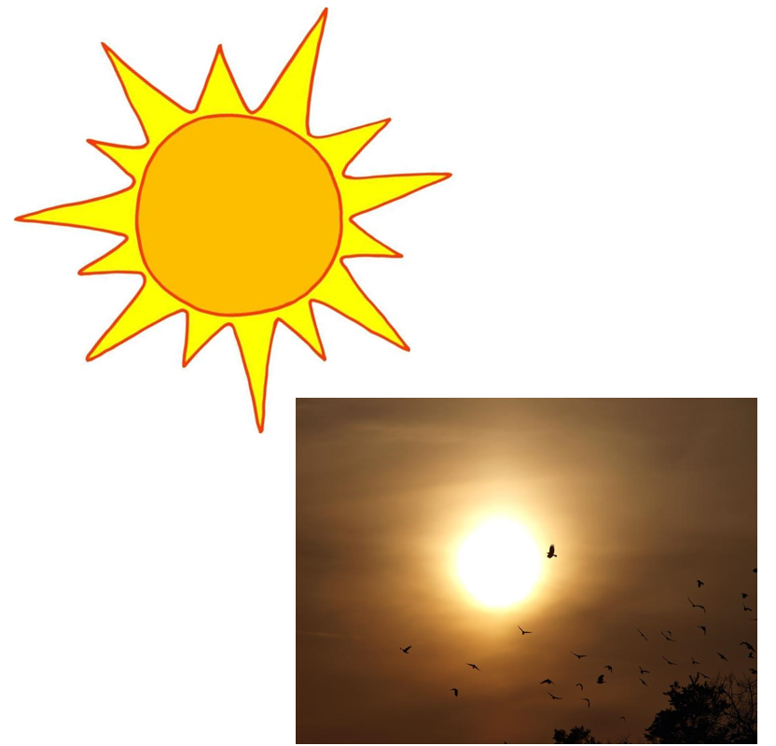
Moon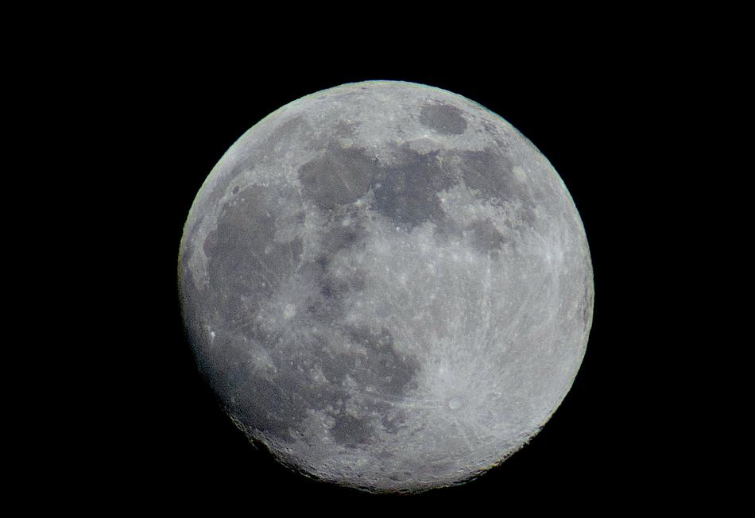

Earth

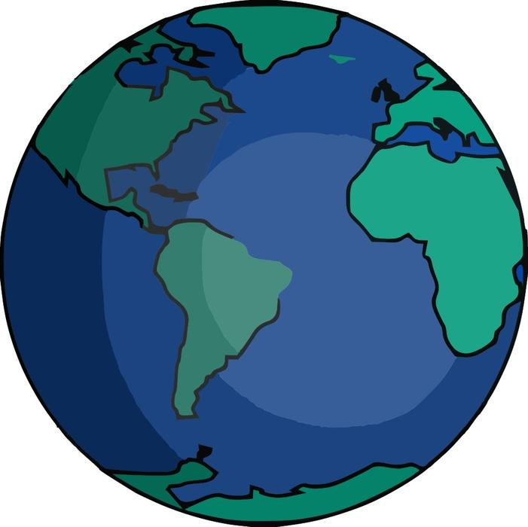

Stars
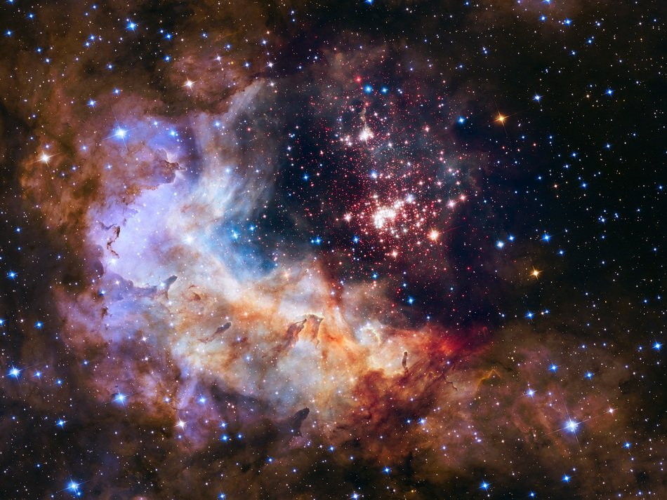

Solar System

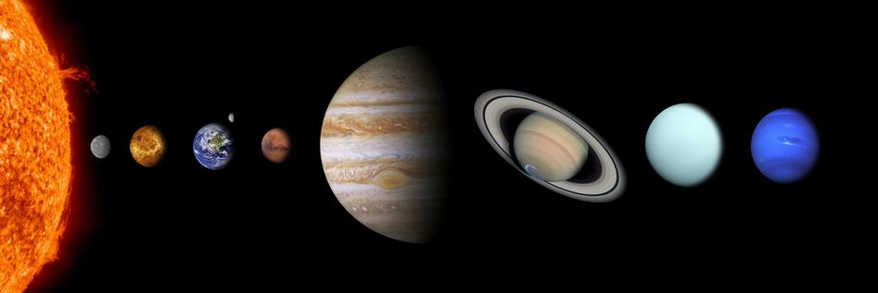

Heat

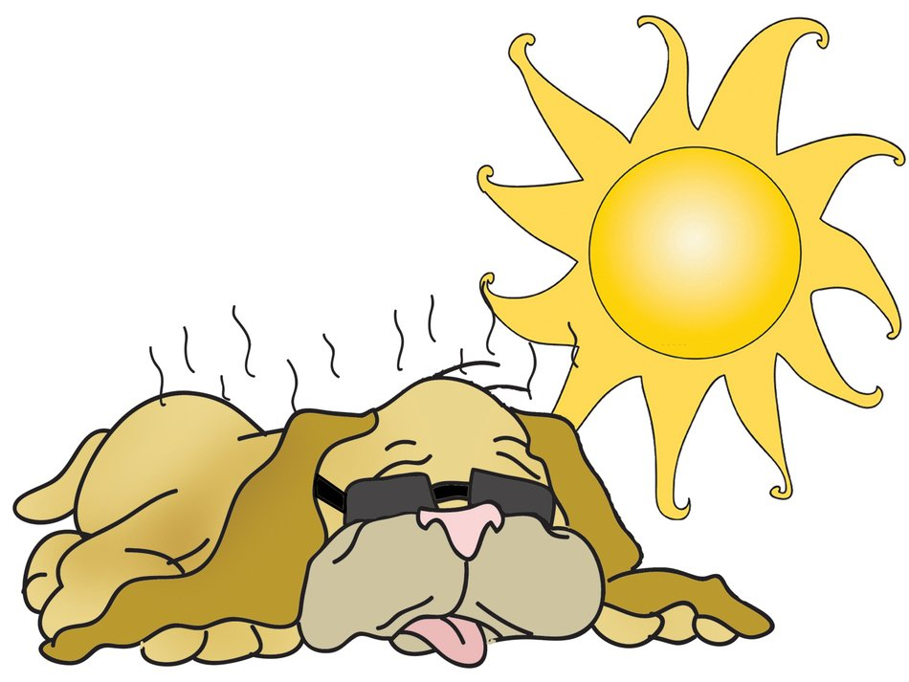

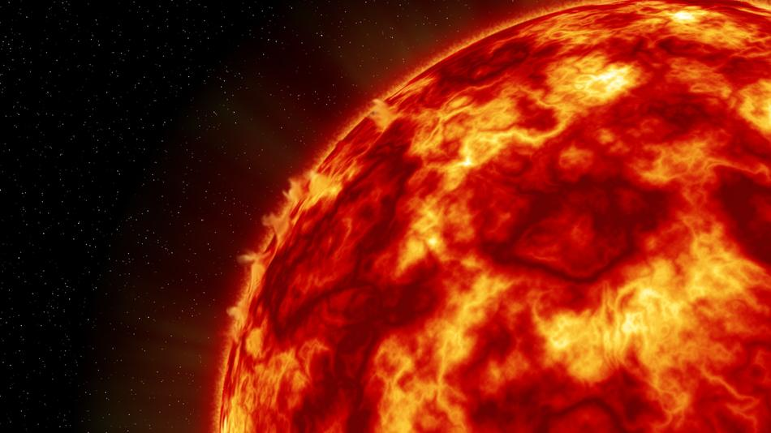

Cold
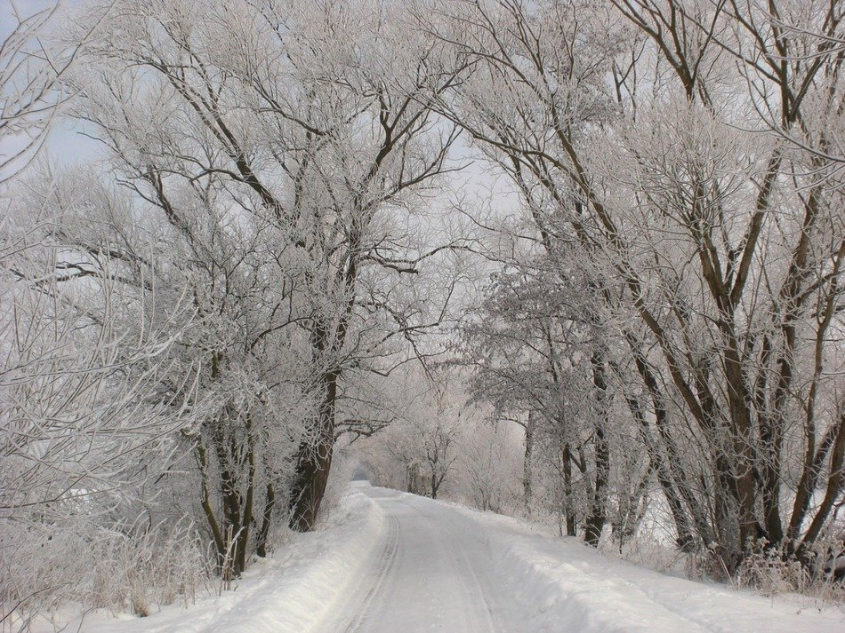

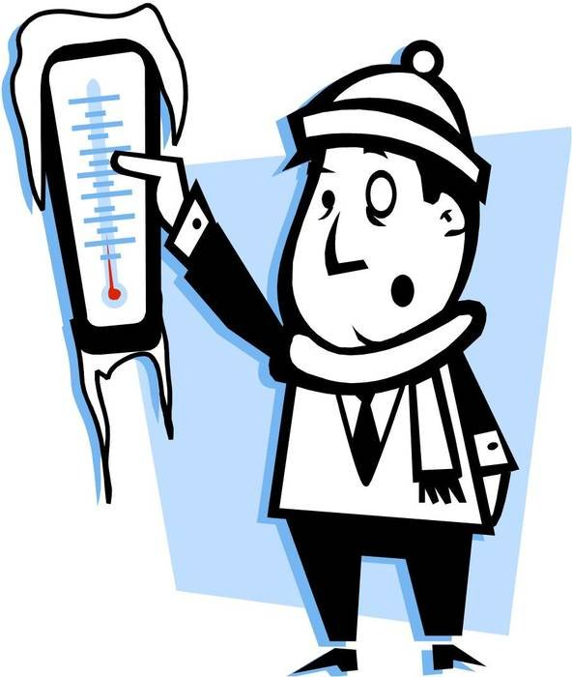
Energy

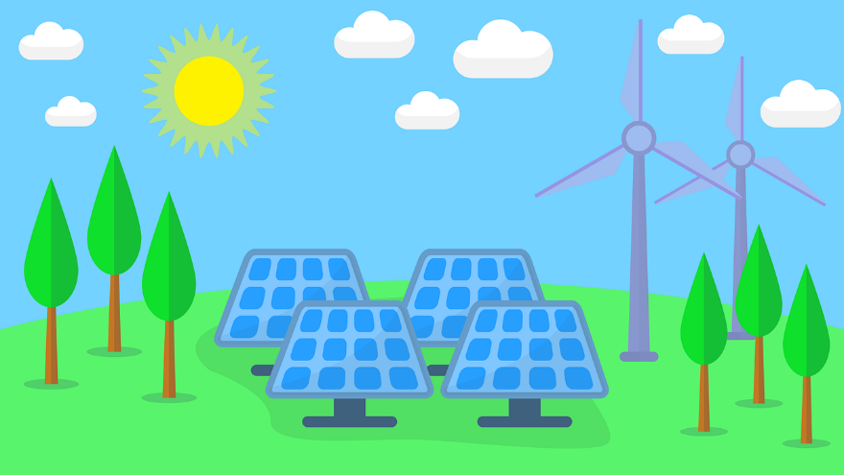

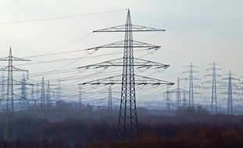

Seeing

Darkness

Rain
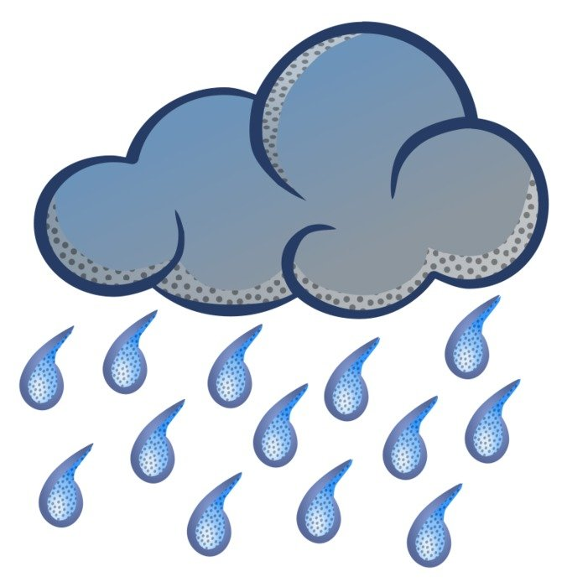

Small Items

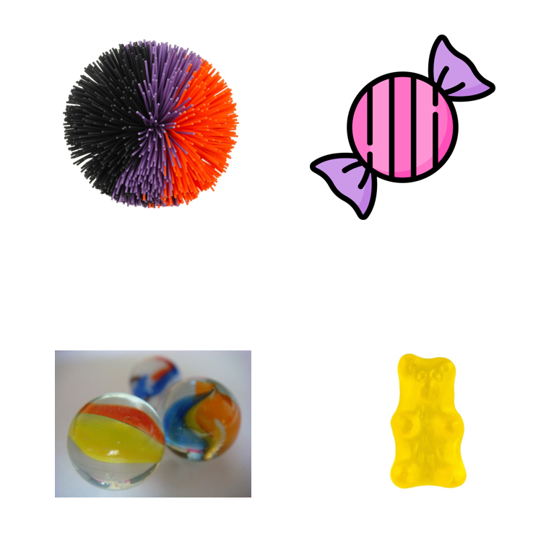

Daytime
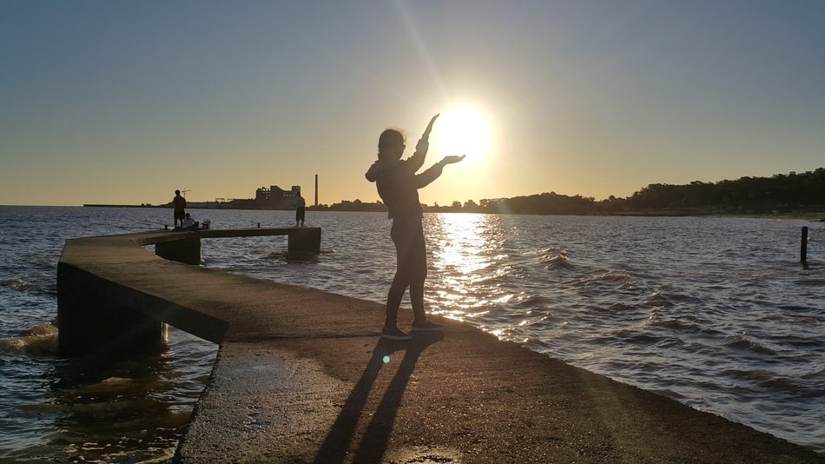
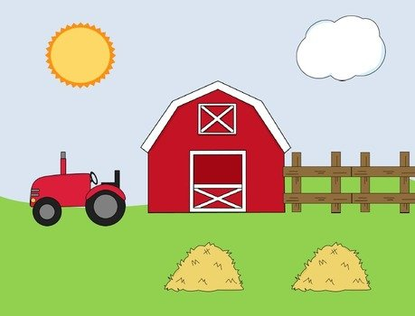
Nighttime
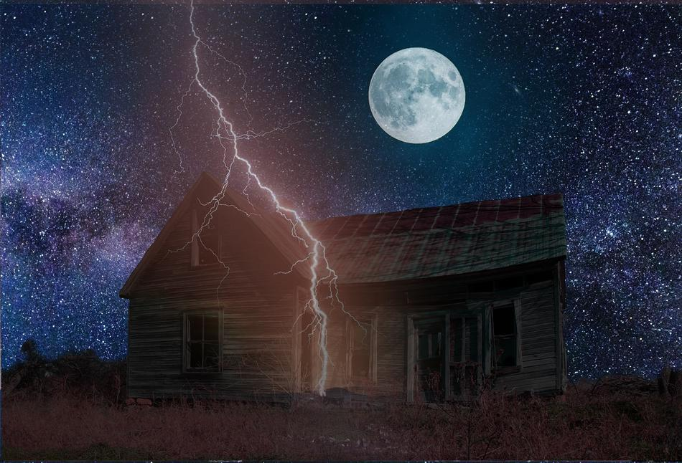 | 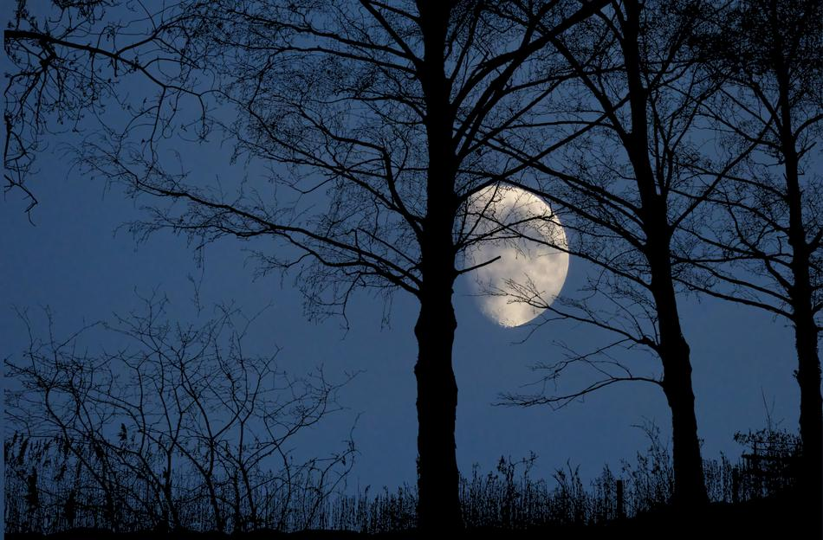

Practice Items:

