All About Dogs and Cats

Grade Level: 8
Primary: Reading
Integrated Activity: Science, Writing
Reporting Category:
Demonstrate comprehension of nonfiction texts and use word analysis strategies.
Lesson Summary and Connections:
Students will listen to a story or read a passage (Reading, Science) about dogs and cats and will then answer questions and complete activities related to the reading.
Lesson Components Links
VESOL(s)  Complexity Continuum | Functional Skills | Assistive Technology | Materials
Vocabulary | Common Misconceptions | Student-Friendly Outcome(s) | Introductory Activity
Plan for Instruction | Differentiation | Reflection | Formative Assessment
Word Wall Cards | Supplemental Materials | Practice Items | Integrated Activity

VESOL(s):
R-8 1: The student will: Understand the meaning of words in passages that are read to the student or that the student reads.
Complexity Continuum:
The words could be shown with or without a graphic representation or could appear in a sentence.

Functional Skill(s):
- Use word recognition, practice decoding, and develop vocabulary
- Become more fluent readers by reading more frequently and engaging in everyday reading.
- Improve reading comprehension to better understand common daily activities involving reading.

Assistive Technology/AAC (Augmentative and Alternative Communication):
- Audio books, text-to-speech assistive technology
- Video supplements
- Dictation or speech-to-text assistive technology

Materials:
- Pencils
- Highlighters
- Copy of reading passage(s)
- Blank copy of Venn Diagram
- Word Wall Card printouts
- Copy of formative assessment(s)
- Computer (teacher, to project Venn Diagram and show videos)
- Writing paper/journal

Vocabulary:
Prior Knowledge
- Dogs | - Cats | - Bark | - Meow
- Tail  - Same | - Kitten  - Different | - Puppy | - Similar
Current Vocabulary
- Veterinarian | - Groom

Common Misconceptions:
- Some students may think that all dogs are puppies.
- Some students may think all cats are kittens.

Student-Friendly Outcome(s):
- I will read a passage or have it read to me and will pay attention to the details so I can answer questions.
- I will be able to tell how dogs and cats are similar.
- I will be able to tell how dogs and cats are different.

Introductory Activity:
- Ask students if they have a pet cat or dog. To the ones that answered yes, follow up by asking which one they have, if they’ve been to the vet with their pet, what their pet looks like, size of pet, things their pet likes to play, eat, etc. To those that answered no, ask if they know someone who has a cat or dog, or if they have ever seen a cat or a dog.
- Ask students how dogs and cats are similar/same. How they are different?
- Writing Activity- Instruct students to draw a picture of their pet dog/cat. If they do not have a dog or cat, have them draw a picture of one they have seen or one they think they would like to have. Instruct students to write about their pet or a dog/cat they would like to have based on their individual writing ability. Students who are unable to draw can use the pictures from the attached Word Wall Cards.

Plan for Instruction:
- Introduce the lesson by explaining to the students that they will read (or someone will read to them) a passage about the similarities and differences between cats and dogs. After the reading, they will use the passage to help them fill out a Venn Diagram and answer questions about the passage for a formative assessment.
- Teacher will refer to the Word Wall Cards and will introduce Vocabulary that the students will use during the lesson. Ask students what they already know about the vocabulary words. Teacher and students will discuss and define/illustrate unknown/new words. Keep the visuals posted so that the students will be able to refer back to them.
- If there are students in your class who do not have background knowledge about both cats and dogs, the teacher can show students one or more of these videos to help build the students’ understanding prior to reading.
  - All About Cats for Kids
  - All About Dogs for Kids
  - Cats and Dogs (contains only music and subtitles)
  - The teacher can pause the videos to check for understanding, ask questions about the video, explain topics or answer/ask questions related to the content of the videos. The teacher will model good listening/reading strategies such as pausing and asking questions, jotting notes down, etc.
- The teacher will hand out one of the reading passages (Differentiated Passages/ Stories) and a highlighter to each student. Those students who are able to read by themselves will be given the appropriate level passage and will begin reading independently. Those students who need adult assistance will follow along as the staff member reads to them. The teacher will model good reading strategies such as pausing and asking questions, highlighting important information, writing notes in the margin, putting a sticky note on the passage to mark where it is confusing, etc.
- Throughout and after the reading, the teacher will circulate around the room to ensure students are highlighting relevant information or to prompt students to look for and identify segments of the passage they would deem important.
- After passing out copies of the Venn Diagram organizer to each student, the teacher will explain how the organizer works and how to fill in each part. (To help students understand the organizer, the teacher may need to create an example using two different objects such as a cup and a glass.) Students who are capable of completing the assignment independently will begin working. For students who need additional assistance, the teacher will project a Venn Diagram to complete with them. The teacher will practice prompting and wait time and, upon completion, will provide the students that worked independently an opportunity to self-correct. Teacher will ensure that students understand the different components of the Venn Diagram as to how it relates to cats and dogs.
- Once the students have completed their Venn Diagrams, the teacher will review the similarities and differences between cats and dogs, asking the students questions such as, “Why did you write that in the center oval?”, “Could that have gone in a different section?” The teacher may also pose specific questions about the story read. The teacher will also answer any questions that the students may have before giving them the formal assessment.
- After handing out a formal assessment/quiz to each student, those who are capable of completing the quiz on their own may begin once they have been given instructions. Students who may need adult assistance/read aloud should wait to begin their assessment so it can be read to them individually. Students should be able to refer to the passage as they are answering questions about the reading.

Differentiation:
- For students who are able to read on their own, a more difficult version of the passage will be provided at the appropriate reading level.
- For students who are unable to read on their own, an adult staff member will read the passage to them.
- Different versions of the passage and assessment will be available for the students.
- Different versions of the Venn Diagram will be available for the students.

Reflection:
- Students can reflect on the vocabulary they have reviewed and/or learned during the day’s lesson, such as “veterinarian” or “groom.”
- Have students share new facts about dogs and/or cats.
- Ask students how dogs and cats are similar/same and how they are different.

Formative Assessment:
All About Dogs and Cats
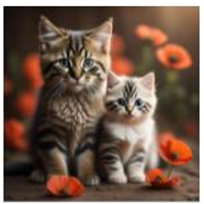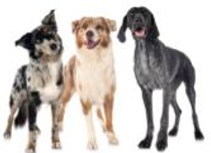
Level A
Name: _______________________________
Date: ________________________________

Directions: Choose the correct answer for each question.

- When dogs speak, they _____________.
  - bark b. moo c. ribbit

- When cats speak, they ______________.
  - moo b. quack c. meow

- Baby dogs are called _______________.
  - ducklings b. puppies c. calves

- Baby cats are called _______________.
  - kittens b. tadpoles c. kids

All About Dogs and Cats
Level B
Name: _______________________________
Date: ________________________________

Directions: Use the word box to help answer the questions.

puppies | meow | kitten | bark

- When dogs speak, they _____________.

- When cats speak, they ______________.

- Baby dogs are called _______________.

- Baby cats are called _______________.

All About Dogs and Cats
Level C
Name: _______________________________
Date: ________________________________
Directions: Answer the questions below.

- What are baby dogs called?

- What are baby cats called?

- What do cats do when they are dirty and need to get clean?

- What is the name of the doctor where dogs and cats go when they are sick or need a check-up?

Notes:
This lesson plan can be broken down and completed over multiple days.

Integrated Activity:
Science:
- VESOL S-8.16 Recognize that reproduction produces offspring with similar though varied traits.
- Throughout the videos and reading, the teacher can reinforce the science concept by asking questions like “Who are the parents of the kitten?”, “Dogs have offspring that are called what?”, “If the kitten has spots, what do you think the parents look like?” etc…

Word Wall Cards:
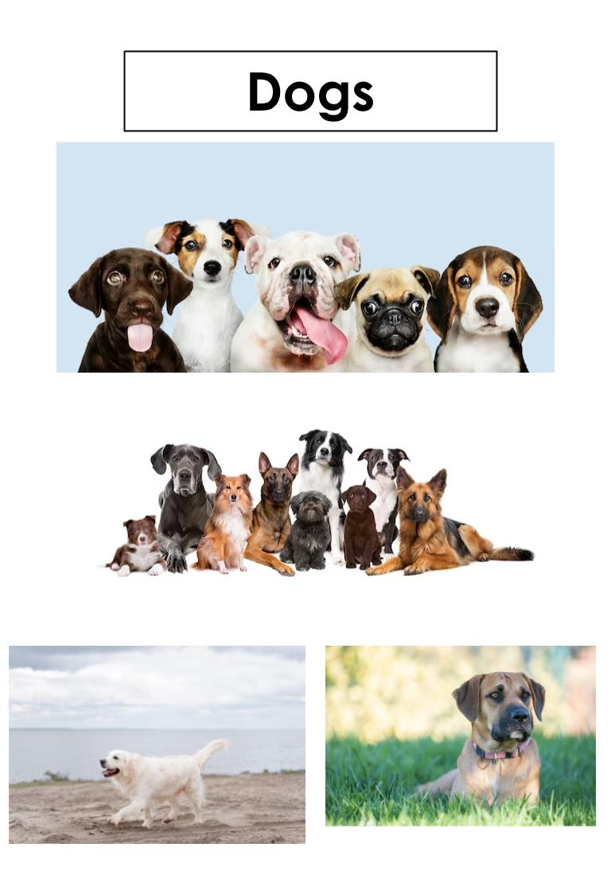
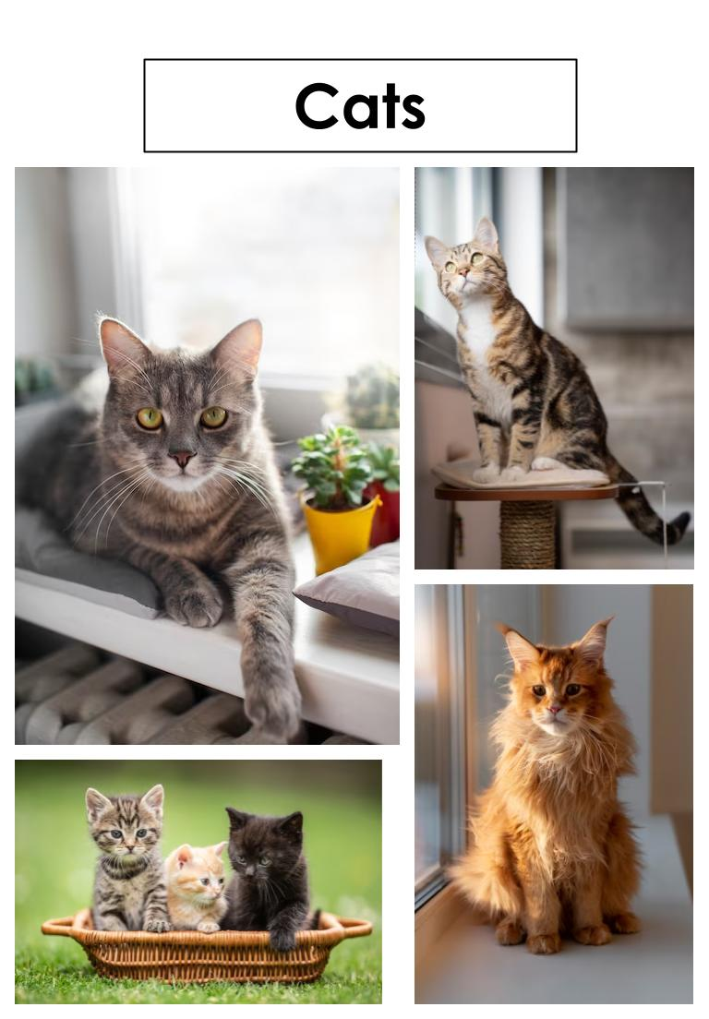
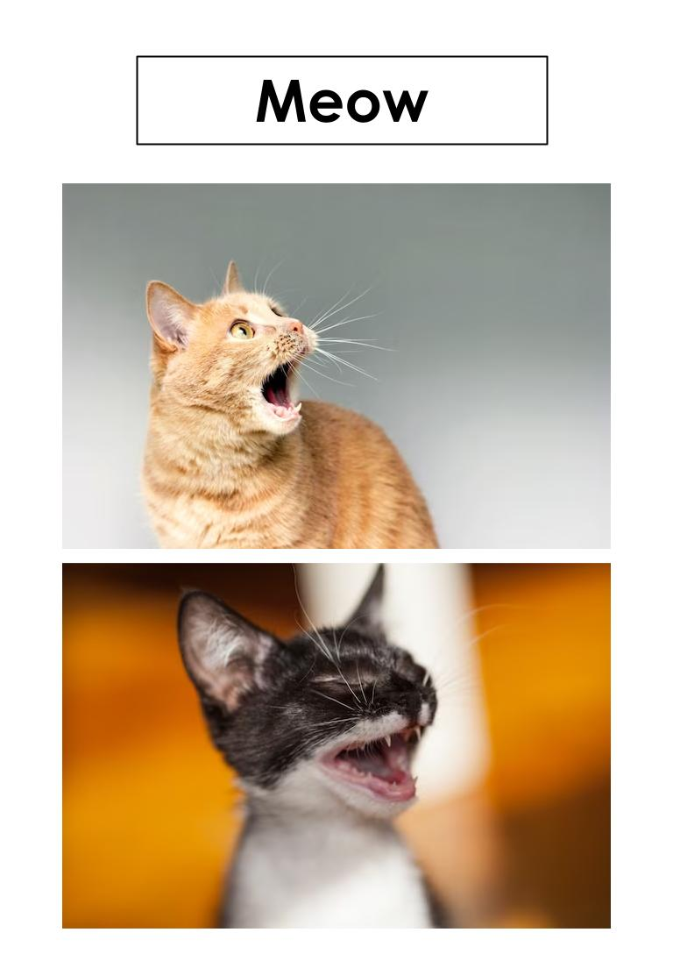
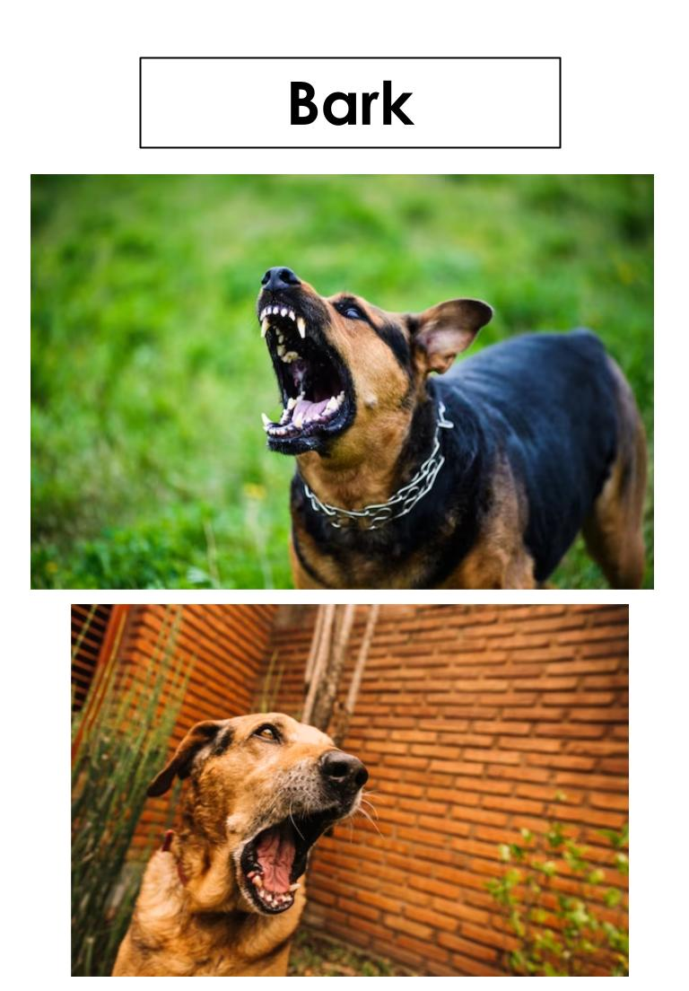
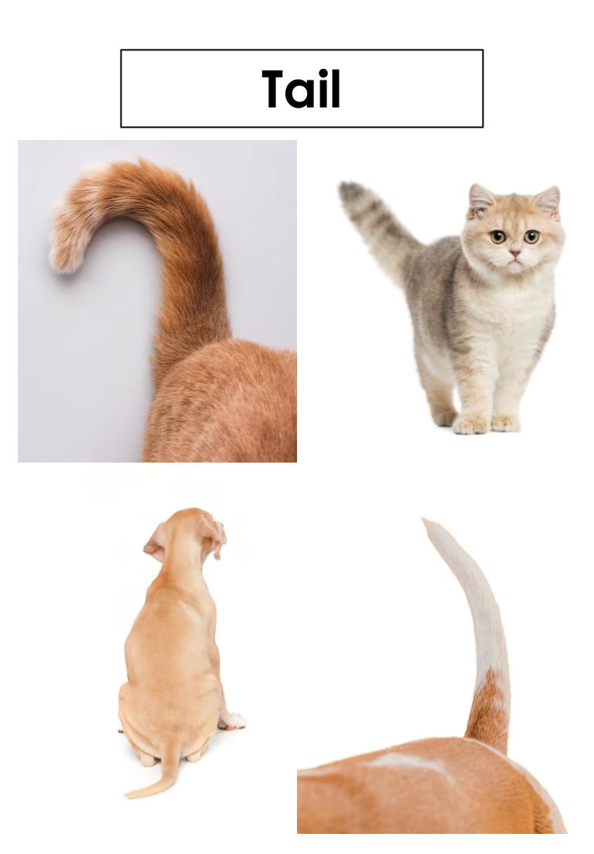
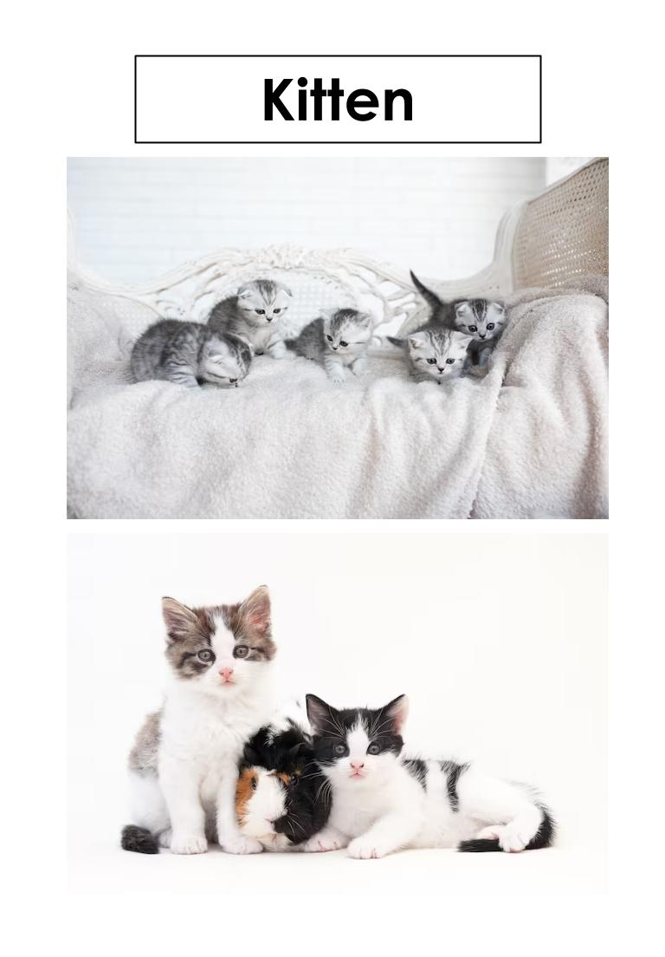
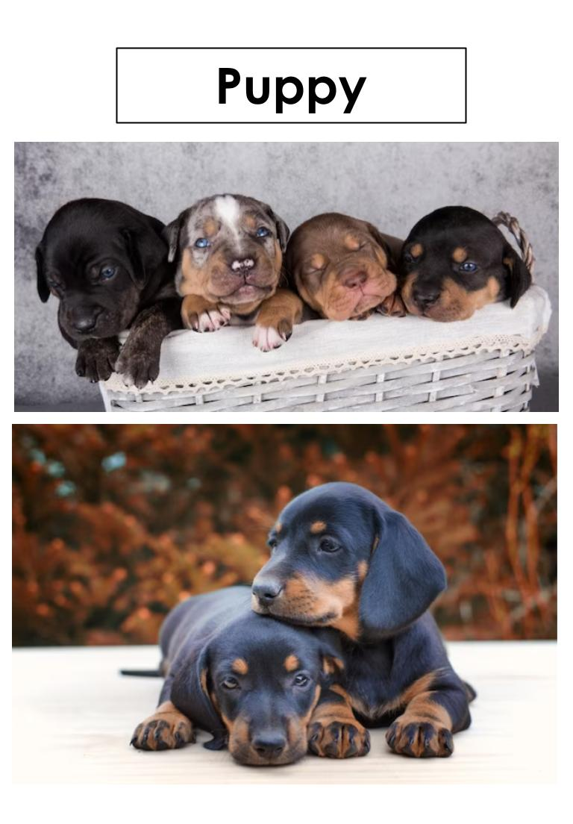
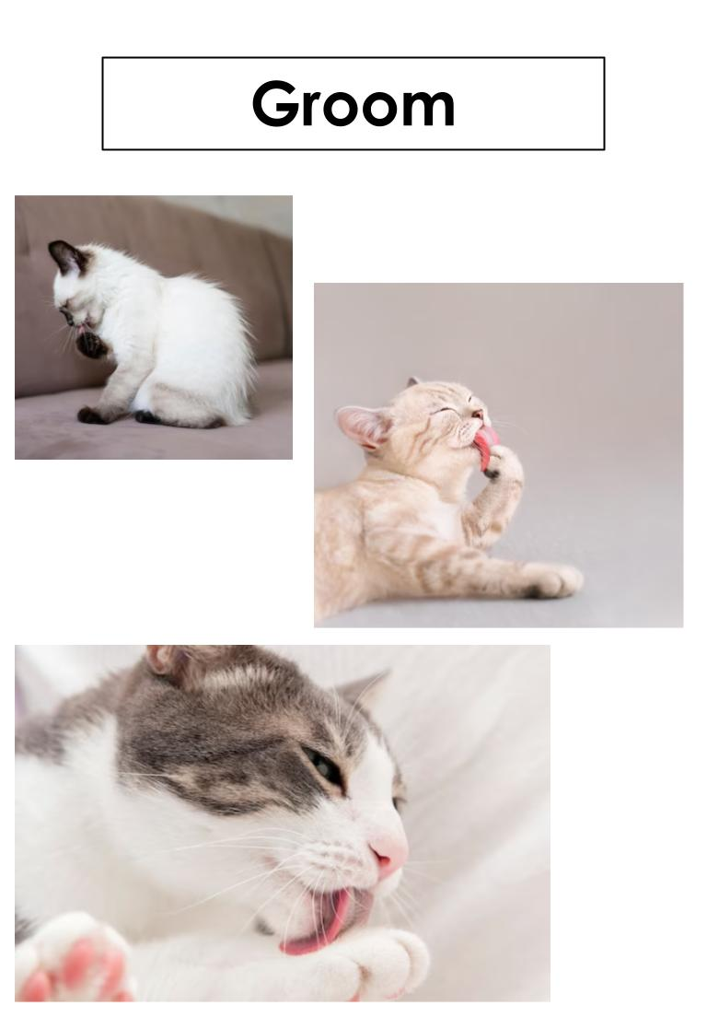
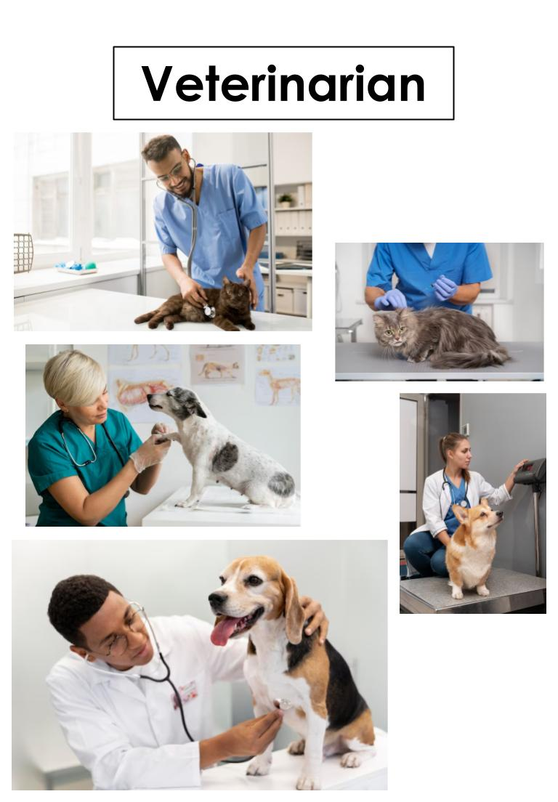

Supplemental Materials:
Teacher may choose to check with the school’s library to see if any books related to the topic are available to use in the classroom.
Online books:
https://tarheelreader.org/2014/05/14/cats-and-dogs-9/
https://tarheelreader.org/2011/10/20/dogs-and-cats-4/
https://tarheelreader.org/2011/01/27/cats-and-dogs-3/
https://tarheelreader.org/2010/05/27/dogs-and-cats-have-fun-time/

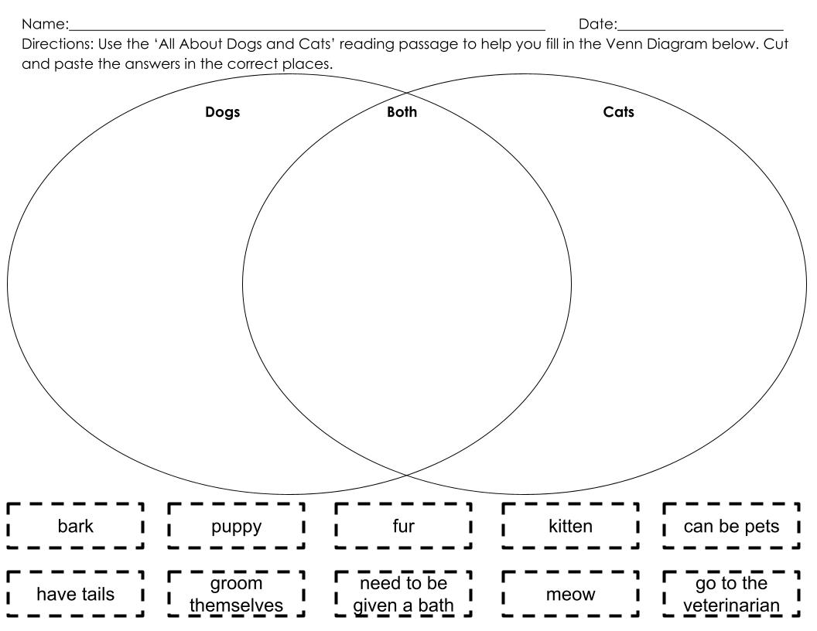

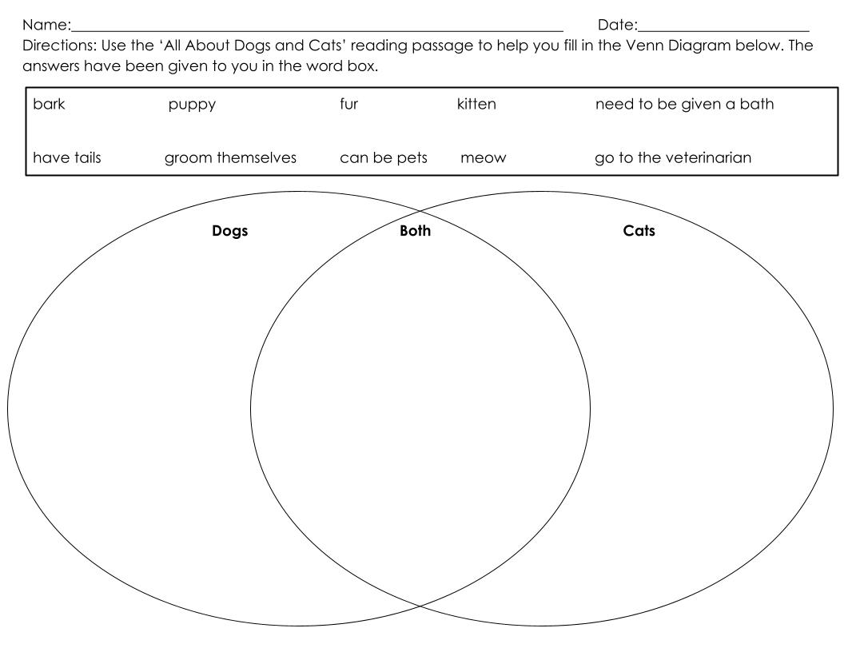

All About Dogs and Cats

Level A

Dogs are animals. Cats are animals.

Dogs have tails. Cats have tails.

Dogs bark. Cats meow.

Baby dogs are called puppies. Baby cats are called kittens.

Dogs have to take a bath. Cats groom themselves.

All About Dogs and Cats

Level B

Dogs and cats are both animals. They both have tails and fur.

Dogs and cats need to go to the veterinarian, who is a doctor for animals.

When they speak, dogs bark and cats meow.

Baby dogs are called puppies, but baby cats are called kittens.

Dogs need to be given a bath, but cats can groom themselves.

All About Dogs and Cats

Level C

Dogs and cats have a lot in common. They are both animals and have four legs, fur, and tails.

Another thing that dogs and cats have in common is that when they are sick or need a check-up, they have to go to a veterinarian, who is a doctor for animals.

Dogs and cats are also different in some ways. When they speak, dogs will bark, and cats will meow.

Baby dogs are called puppies and baby cats are called kittens.

Another way in which they are different is that dogs need to be given a bath when they are dirty, but cats are able to groom themselves to get clean.

Practice Items:
