Not So Differently Shaped
Grade Level: 6
Subject(s):
Primary: Mathematics
Integrated Activity: Science and Life Skills
Reporting Category:
Measurement and Geometry
Lesson Summary and Connections:
Students will review basic shapes and learn what makes two or more shapes congruent.
Lesson Components Links
VESOL(s)  Complexity Continuum | Functional Skills | Assistive Technology | Materials
Vocabulary | Common Misconceptions | Student-Friendly Outcome(s) | Introductory Activity
Plan for Instruction | Differentiation | Reflection | Formative Assessment
Word Wall Cards | Supplemental Materials | Practice Items | Integrated Activity

VESOL(s):
M-6.11: The student will identify congruent shapes.

Complexity Continuum:
Identification of congruent shapes could include triangles, circles, squares, rectangles, and/or pentagons.

Functional Skill(s):
- Recognizing basic shapes with and without context
- Identifying similarities among and differences between shapes

Assistive Technology/AAC (Augmentative and Alternative Communication):
- Materials presented on computer or paper
- Digital or physical presentation of shapes
- Alternative methods of responses

Materials:
- Computer
- Projector, speakers
- White board and markers
- Physical or virtual two-dimensional shapes
- Introduction materials (linked within description, some need to be cut out before lesson)
- Practice worksheets

Vocabulary:
Prior Knowledge
- shape | - square | - triangle | - circle
- rectangle | - pentagon | - same | - different
Current Vocabulary
- congruent | - side | - angle

Common Misconceptions:
- Students could think shapes are congruent when they are different sizes of the same shape.
- Students could be confused when shapes that are congruent are turned or have different spatial orientations.
- Students may believe shapes are the same because they’re the same shape overall or have the same number of sides.

Student-Friendly Outcome(s):
- I can identify triangles, circles, squares, rectangles, and pentagons.
- I can identify congruent shapes.
- I can describe what makes two shapes congruent.

Introductory Activity:
- Place or locate items around the room that are concrete examples of the basic shapes (square, rectangle, triangle, circle, and pentagon) and have students go on a scavenger hunt.
- Once students have had enough time to find several shapes, hand each student a shape that has been cut out for them. (When selecting the shape for each student, keep in mind their ability level.)
- Each student will take turns describing their shape (number of sides, angles, size, color etc.) and, if they are able, say its name. (Some students may need supports when it is their turn to share.)
- Once all students have shared and all shapes have been described and identified, pull out the Word Wall Cards for the shapes that were hidden and display them for the students.

Plan for Instruction:
- Have students practice identifying and naming the shapes (Name That Shape). Have them state or count the number of sides and the number of angles. Students can practice drawing or tracing the shapes to review (Tracing Activity).
- Activity: Show two congruent shapes and tell students these shapes are congruent. (You can use manufactured shapes or these congruent shapes.) Ask students what they notice about the two congruent shapes. Write “What we notice about Congruent Shapes” on the board, then accept and write all answers or descriptions that students provide on the board or chart paper. If the following is not said by students, make sure you include it in your discussion:
- Both shapes are the same shape and the same size.
- Both shapes have the same number of sides and the same number of angles.
- The sides are the same size on both shapes.
- The angles are the same size on both shapes.
- If you placed one of the shapes on top of the other shape, with the same angles and sides touching/covering, it would be a perfect match.
- Have students practice identifying and matching congruent shapes. Cut sets of these congruent shapes, enough for either each student to have a set or for partners to share. Encourage students to talk about the:
- number of sides and angles,
- size of the sizes and angels, and
- size of each shape.
- Students who are able can write their description on a piece of paper.
- After students have had plenty of time to explore with the congruent shapes, include the noncongruent shapes. Have them compare the shapes that look similar and those that do not. Tell them they will be coming up with a definition for the word congruent after they have had time to compare all shapes
- Once students have finished exploring with the congruent and noncongruent shapes, have a whole class discussion and create a class definition. Prompt students as needed to look at the list of what they noticed about the shapes or to use the examples they have sorted. Write this definition on the board or chart paper. Include the “Congruent” Word Wall Card with the class definition.
- Some students may need more time practicing and sorting with the shapes while other may be ready to practice on paper. (Congruent Shapes Practice 1 and Congruent Shapes Practice 2)

Differentiation:
- Manipulatives can be provided for students with fine motor needs, as well as having materials presented on and iPad or computer.
- Students requiring more of a challenge can be introduced to additional shapes.
- A lesson can be done on “angles” and the types of angles and sides in terms of more specific vocabulary (e.g., parallel).
- Students can develop a definition for “noncongruent” using the materials from the lesson.

Reflection:
- What shapes did we review?
- How do we know what a shape is? (number of sides, number of angles)
- What shape has…? (no sides same length/3 sides same, 1 side different/ all sides same length)
- What makes a shape “congruent”? (same size and same shape)

Formative Assessment:
- Use this Formative Assessment as a pre-test, post-test or an assessment along the way.

Notes:
- This lesson will likely take more than one class period depending on the amount of prior knowledge. Some students may require additional practice on one skill before going onto the next. Time required to complete the lesson may also depend on severity of disability.
- Additional activities could be done independently, with a partner, or as a group.

Integrated Activity:
Science:
VESOL S-5.14 Recognize that objects, animals, and plants are made of smaller parts and identify various parts visible to the naked eye.
- Throughout the lesson, have student look for body parts that are congruent on themselves. Have them match their hands and feet and make observations about congruency and how they are part of their body. Have them look at other students to find congruent parts like eyes and ears.
Life Skills:
- Take a look around your classroom and look for shapes you might find.
  - Where do you see (name certain shapes)?
  - What other shapes do you see?
- Take a look around your school as you go to different activities during the school day.
  - What shapes do you see? Where do you see a (name certain shape)?
  - Are there any patterns?
- What shapes did you see the most?
- If you were going to make a pattern in your school, what shapes would you use?

Word Wall Cards:

Angle

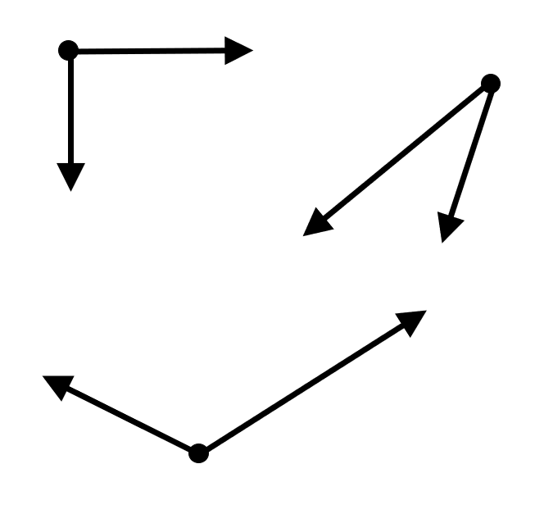

Circle
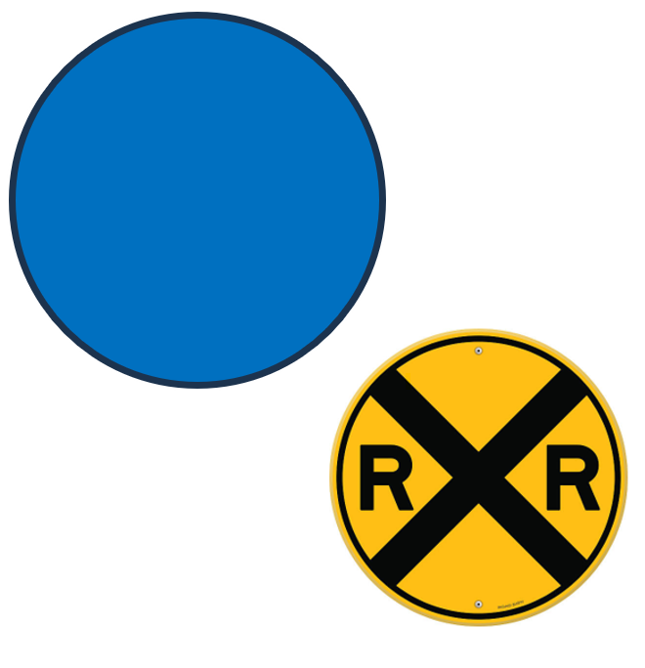

Triangle

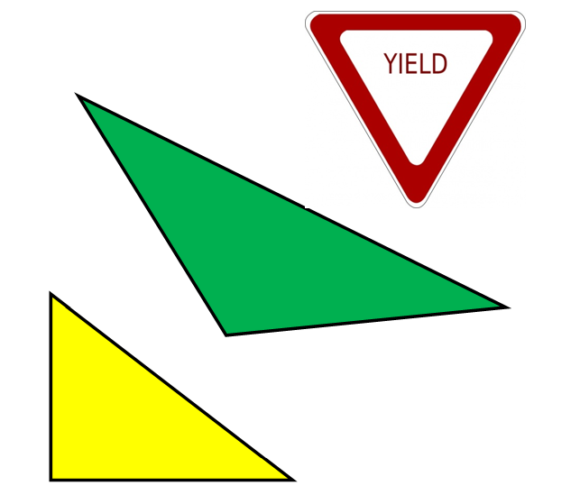

three-sided figure

Square

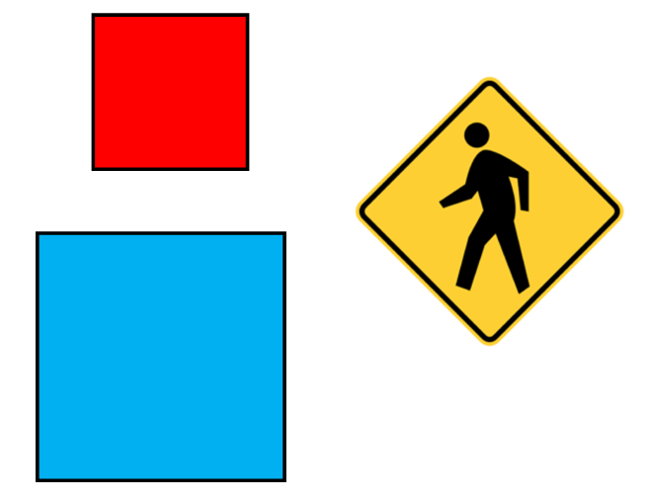

five-sided figure

Square
all angles are right angles
all sides are congruent

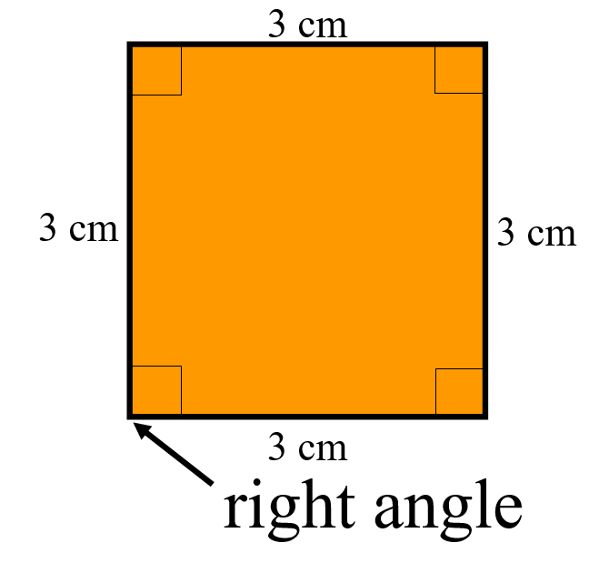

Rectangle

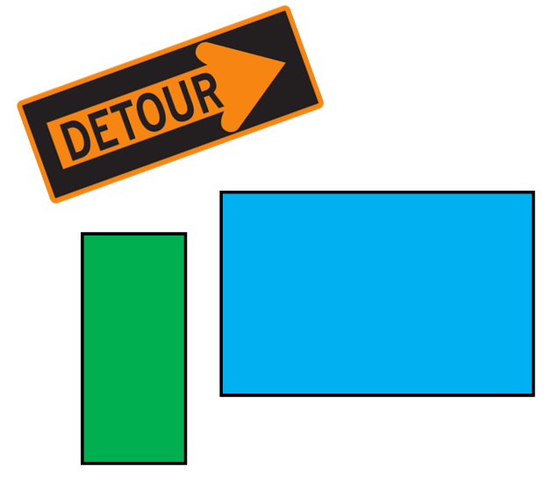

four-sided figure

Rectangle
All angles are right angles.
Opposite sides are congruent.

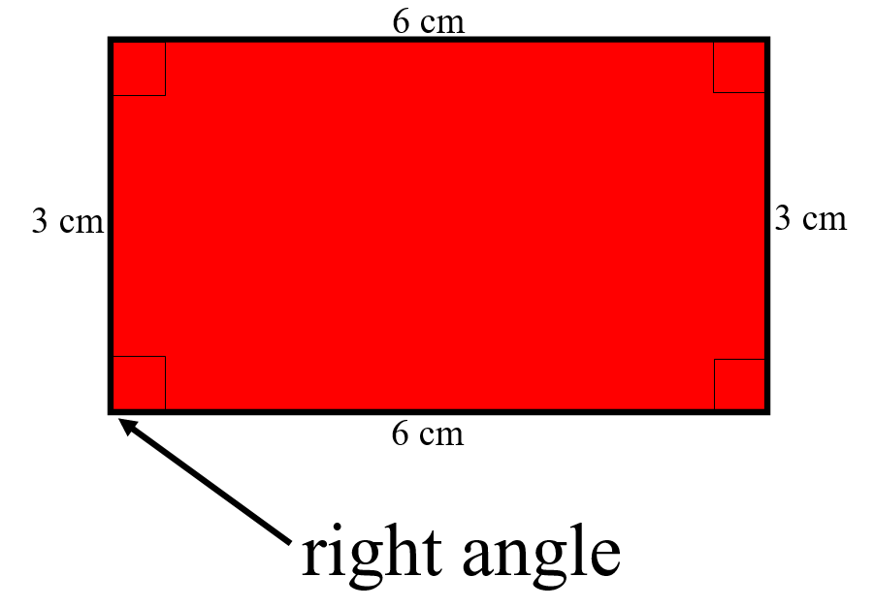
Pentagon

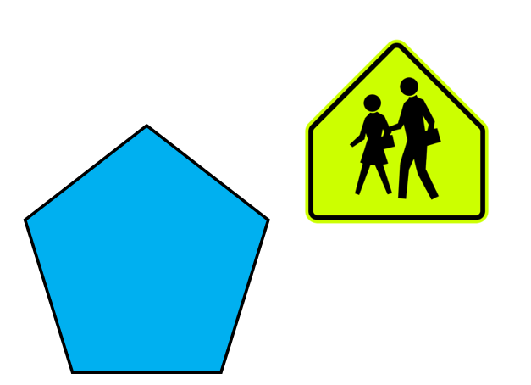

five-sided figure

Smaller/Larger

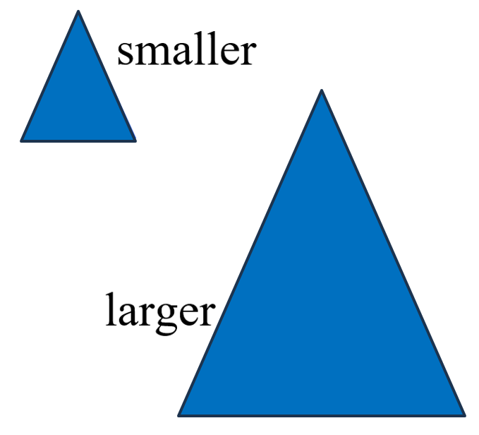

Same

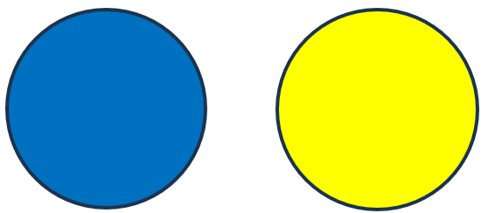
same shape

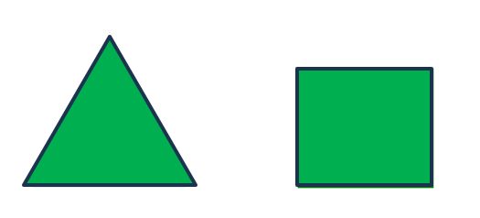
same color

Congruent

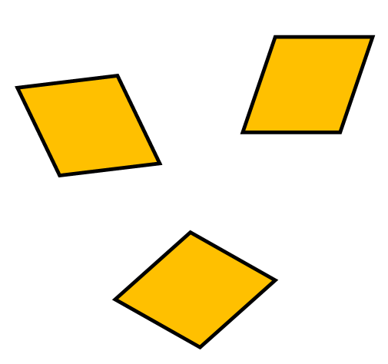

same shape
and same size

Supplemental Materials:

Formative Assessment
Directions: Circle “yes” if the shapes are congruent. Circle “no” if the shapes are noncongruent.
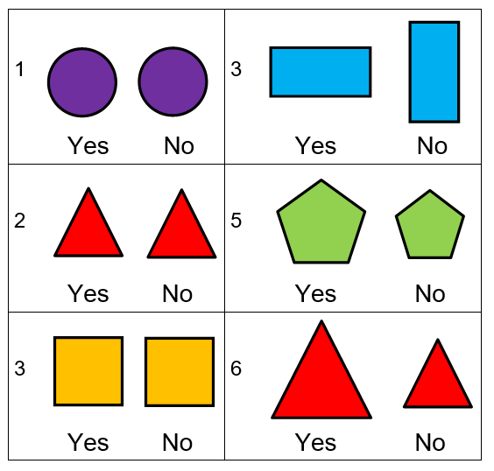

Name That Shape

- Which shape is a triangle?
- Which shape is a square?
- Which shape is a circle?

Name That Shape

- Which shape is a triangle?
- Which shape is a rectangle?
- Which shape is a pentagon?

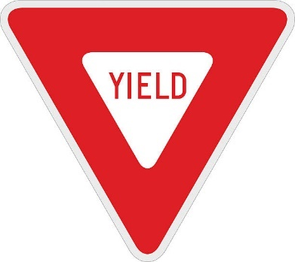 | 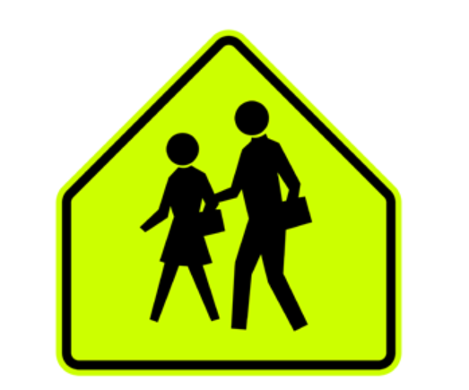

Introduction Materials: Congruent Shapes These shapes can be printed and laminated to be used during instruction (by teacher and student).

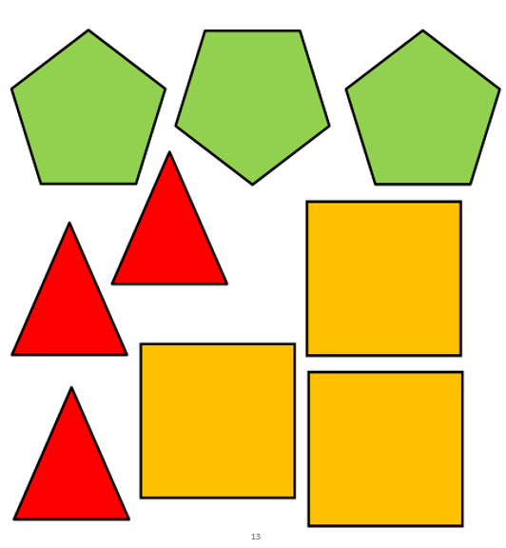

Congruent Shapes Continued
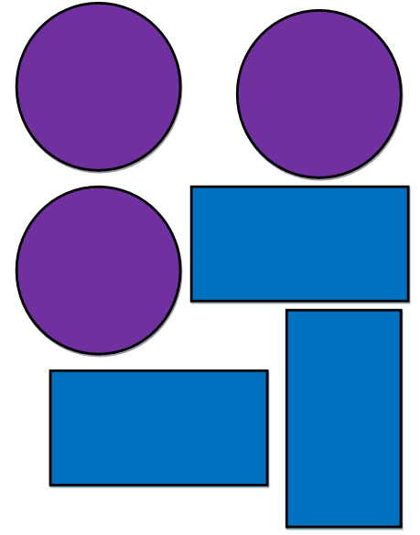

Noncongruent Shapes
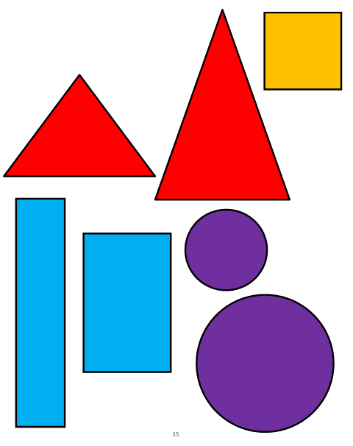
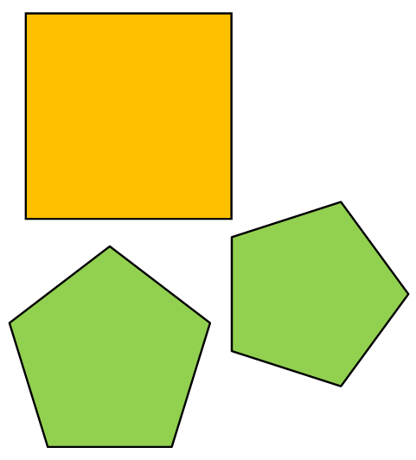

Shape Review Tracing Activity

Square
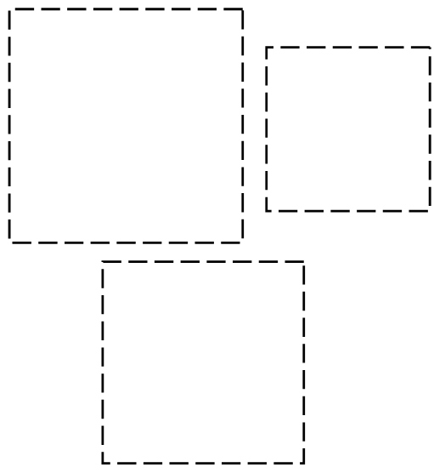

Rectangle
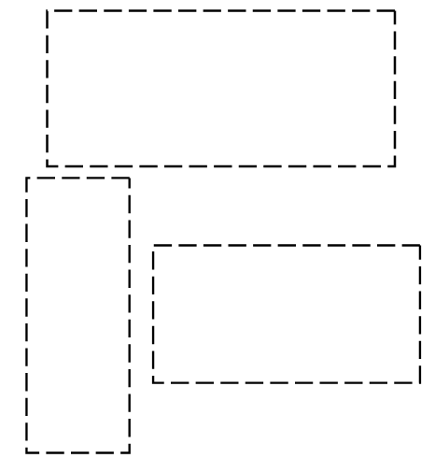

Pentagon
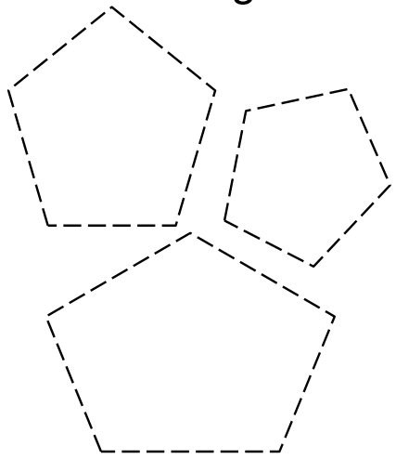
Triangle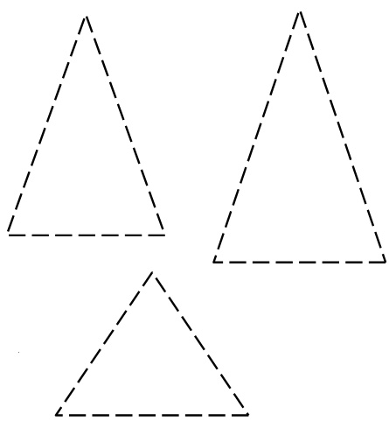

Circle

Congruent Shapes Practice 1

Directions: Draw a line to match the congruent shapes.

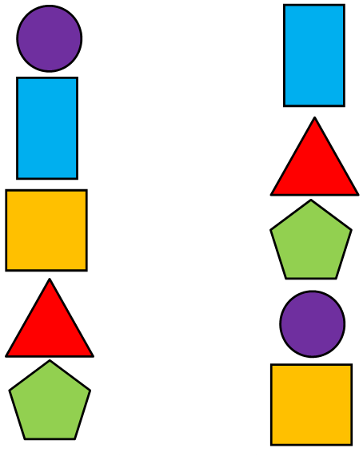

Congruent Shapes Practice 2

Directions: In each line, circle or mark the shapes that are congruent to the first shape (underlined) in the line.

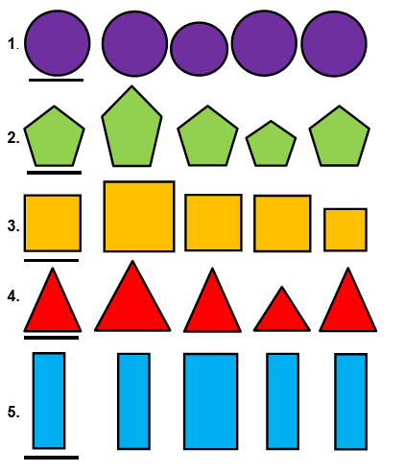

Practice Items
