What’s the Point?
Identifying points, line segments, and rays

Grade Level: 4
Subject(s):
Primary: Math
Integrated Activity: Virginia Studies
Reporting Category: Measurement and Geometry
Lesson Summary and Connections:
Students will learn to identify points, line segments, and angles. Students will identify these using pictures, real items, by touch, vocalization, eye gaze or a preferred communication device. They will explore the topic through hands-on manipulation of objects and by creating an art project.
Lesson Components Links
VESOL(s)  Complexity Continuum | Functional Skills | Assistive Technology | Materials
Vocabulary | Common Misconceptions | Student-Friendly Outcome(s) | Introductory Activity
Plan for Instruction | Differentiation | Reflection | Formative Assessment
Word Wall Cards | Supplemental Materials | Practice Items | Integrated Activity

VESOL(s):
M-4.19 (SOL 4.10a): The student will identify points, line segments, and angles.
- Complexity Continuum: Using simple pictures, diagrams, models, or representations, identify points, line segments, or angles.

Functional Skill(s):
- Students will practice writing and cutting skills during fine motor activities.
- Students will learn new vocabulary words: point, line segment and angle.
- Students will practice sorting, discrimination, visual discrimination, and hand-eye coordination through daily work activities.

Assistive Technology/AAC (Augmentative and Alternative Communication):
- Word/picture cards
- Classroom items to sort
- Enlarged materials for vision impaired students
- White boards and markers
- Communication devices appropriate for individual student, programmed with vocabulary for responding

Materials:
- Vocabulary cards for sorting or matching

- Introductory Activity Materials:
- Materials such as popsicle sticks, pipe cleaner/chenille wire, pom poms, modeling clay, and/or pencils and cap erasers to make models of points, line segments, and angles.
- Anchor chart paper for KWL Chart
- Cards for matching and sorting (found in the supplemental materials at the end of the lesson) (Laminating these cards allows for reuse across multiple activities.)

- Materials for Lesson:
- Index cards (colored and white) or construction paper, pre-cut into quarters (or students can cut to practice cutting skills)
- Pencil or other writing instrument to make lines on paper
- Scissors
- Glue stick
- Ruler
- Construction or colored paper for background

- Materials for Integrated Activity
- Blank map of Virginia
- Writing instruments to make dots (e.g., colored pencils, markers, crayons, dot markers or stickers as appropriate for student abilities and needs)
- Pencil to draw lines
- Ruler to make straight lines when connecting dots
- Scissors and glue or glue sticks for attaching labels to map

Vocabulary:
Prior Knowledge
- Line
Current Vocabulary
- Point | - Line Segment | - Angle

Common Misconceptions:
- When students draw a line, they are frequently wavy or curved and they have a starting and stopping point. In geometry, lines are perfectly straight and they go on forever.
- “Angles” may be confused with “triangles.”
- Line segments may be confused with lines.

Student-Friendly Outcome(s):
- I can identify a point.
- I can identify a line segment.
- I can identify an angle.
- I can sort points, line segments, and angles.

Introductory Activity: Exploring Geometry
- Collect and create examples of the key vocabulary words (points, line segments, and angles) using materials found in your classroom:

  - Pipe cleaner/chenille wires
  - Modeling clay/play dough
  - Popsicle sticks or toothpicks
  - Pencil and cap erasers

- Students should describe and name each example that is collected or created.

  - Give students time to answer (wait time and/or prompts as appropriate to each student), then provide the answer.
  - Provide redirection to the correct answer as needed.
    - Provide errorless learning (provide the correct answer prior to the student response)
    - Correct the answer (after student response).

- Questions to ask:

  - Do you know what this is called?
  - What does it look like?
  - Where do we see this in the classroom?
  - Can you make one just like it?

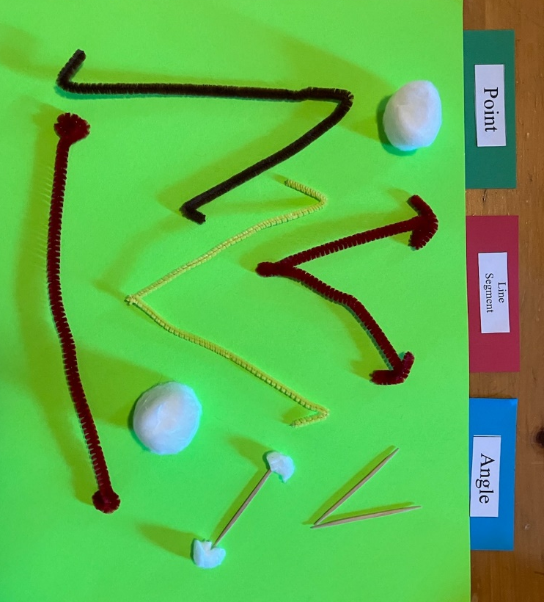

- Create a Know/Want to Know/Learned chart

Example:
Know | Want to Know | Learned
- Straight line  - Dot  - I see one on the board!  - We use that at the end of a sentence! | - What’s it called?  - Why are there dots on the end?  - Why isn’t it curvy? | - That’s a line!  - That’s an angle!

- Revisit this KWL chart in the middle and/or at the end of the unit to determine growth in learning.

Plan for Instruction:
- Present the Word Wall Cards, one at a time.
  - Read the word and talk about the picture.
  - Teach a body motion to go with the picture.
    - Point: Squeeze hands in front of your body.
    - Line Segment: Place arms straight out to the left and right (at right angles to your body, parallel to the ground), hands squeezed into fists.
    - Angle: Place one hand straight out to the side of your body (arm at a right angle to your body, parallel to the ground), and the other at an angle (toward the sky).
  - After discussing all 3 vocabulary terms move on to making the windmill.

- Windmill:
  - Materials:
    - Index cards (colored and white) or construction paper cut into quarters
    - Pencil or other writing instrument to make lines on paper
    - Scissors
    - Glue stick
    - Ruler
    - Sheet of paper for background

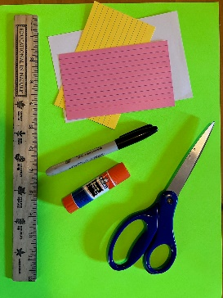

  - Draw line segments on colored index cards.
    - Practice using a ruler to make the line segment straight.
    - Talk about line segments, which have a beginning and an end. They are also straight.
    - Cut along the line segments to make strips of paper.
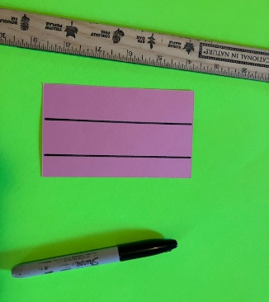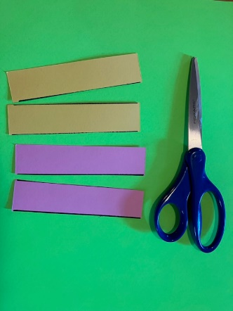

  - Draw an angle on the white index card.
    - Place a point in the middle on one edge, and on the opposite corners.
    - Draw a straight line (use a ruler) to make the line segments from the center point to the corner point, creating an angle once both line segments are drawn.
    - Talk about the angle and how the two line segments share the same point at the angle.
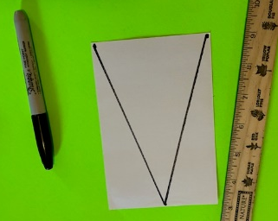
  - Cut on the line segments to make the base of the windmill. (The base of the windmill will be in the shape of a triangle.)

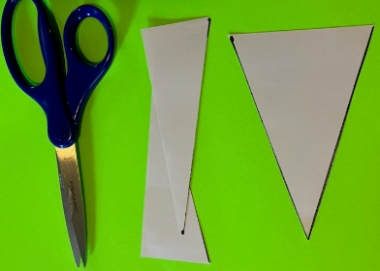
  - Glue the white triangle-shaped windmill base to the paper.
  - Glue the colored index card strips on the top point of the base to make the arms of the windmill.
  - Talk about a point, and how it is the smallest part of a line. A point is shared by the two line segments that form the angle that is the tip of the windmill base.
  - Label the point (where the arms cross), the line segments (arms and sides of base) and the angles (where the arms cross).

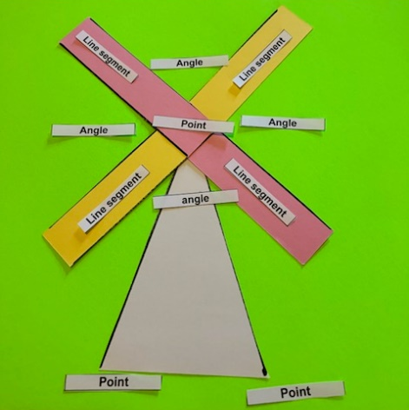

- Sort
  - Set up a sort that works for your classroom (you may use the sort cards provided). Suggestions to consider:
    - Copy into a slides or PowerPoint presentation
    - Make into a file folder activity
    - Make into a sort activity
    - Create an activity that is most appropriate for the student’s method of communication.

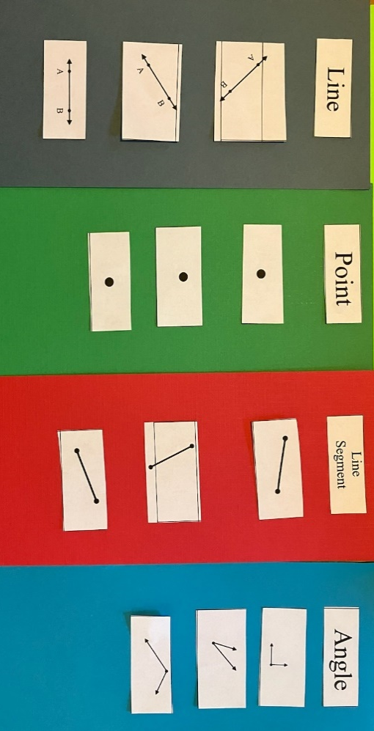

  - Assess student knowledge based on their ability to complete the assignment

Assessment Recording Sheet:
+ = student correctly identifies the card
- = student incorrectly identifies the card

 | Pre-assessment | Post Assessment
Line
Point
Line Segment
Angle

Differentiation:
- Kinesthetic learners can:
  - Use hands-on materials such as modeling clay, chenille stems (pipe cleaners), or wiki sticks to make examples points, line segments, and angles.
  - Use dot markers to trace, copy, or produce examples of the vocabulary words.
  - Complete a matching game (word to picture, different pictures of the same word, or identical pictures).
  - Post the Word Wall Cards on a wall. Give students the opportunity to match cards or mimic/act out (with their bodies) the vocabulary words,
- Visual learners can:
  - Sort or match cards into categories (points, line segments, and angles).
  - Play bingo to practice identifying picture examples of the vocabulary words.
- Auditory learners can:
  - Sing songs and watch videos about geometry.
- Multi-sensory learners can:
  - Use modeling dough to make points, line segments, and angles.
  - Use sidewalk chalk to draw examples of the vocabulary words. Student will label the picture as they walk/jump/hop/roll over each one.
  - Create a picture using only real-world examples of the vocabulary words. These could be drawings or a multimedia creation.
  - Use arm motions to mimic or act out the vocabulary words:
    - Squeeze hands in front of your body to make a point
    - Place arms straight out to the left and right (at right angles to your body, parallel to the ground), hands squeezed into fists, to make a line segment
    - Place one hand straight out to the side of your body (arm at a right angle to your body, parallel to the ground), and the other at an angle (toward the sky) to create an angle.
- Students who require repeated practice can:
  - Include creating file folders (from materials below) to be used as guided and/or independent practice.
- Extend beyond the parameters of the lesson:
  - Students who are able to independently and spontaneously identify points, line segments, and angles can work on other parts of the grade level SOL:
    - 4.10 The student will identify and describe points, lines, line segments, rays, and angles, including endpoints and vertices; and identify and describe intersecting, parallel, and perpendicular lines. (Note that this extends beyond the parameters of the VESOL.)
  - When instruction for VESOL M-4.20 (The student will identify circles, triangles, squares, and rectangles) is provided, it is an opportunity to review the vocabulary from this lesson when talking about those shapes and look for examples of points, line segments, and angles within those shapes.

Reflection:
- Students will complete a sort demonstrating the level of understanding.
- Encourage students to find and identify points, line segments, and angles as they go through their day. Where can they find these items in the school building?

Formative Assessment:
- Review the KWL chart several times throughout the unit.
- Observe students while they sort cards or items representing the vocabulary words.
- Ask students to identify or match the vocabulary words.

Notes:
- Geometry lends itself to hands on-activities. Be creative and use readily available materials to make this unit fun and interactive for your students.
- Reinforce the concepts in teachable moments as they present themselves throughout the school year.

Integrated Activity:
- Virginia Studies: Students can combine geometry and Virginia Studies by making a map and using points, line segments, and angles. The project can include basic map symbols as well as labeling the geometry components.

- Pass out a map of Virginia. Students will make a point at the place where the state capital, Richmond, is located.

Example: The star is Richmond.

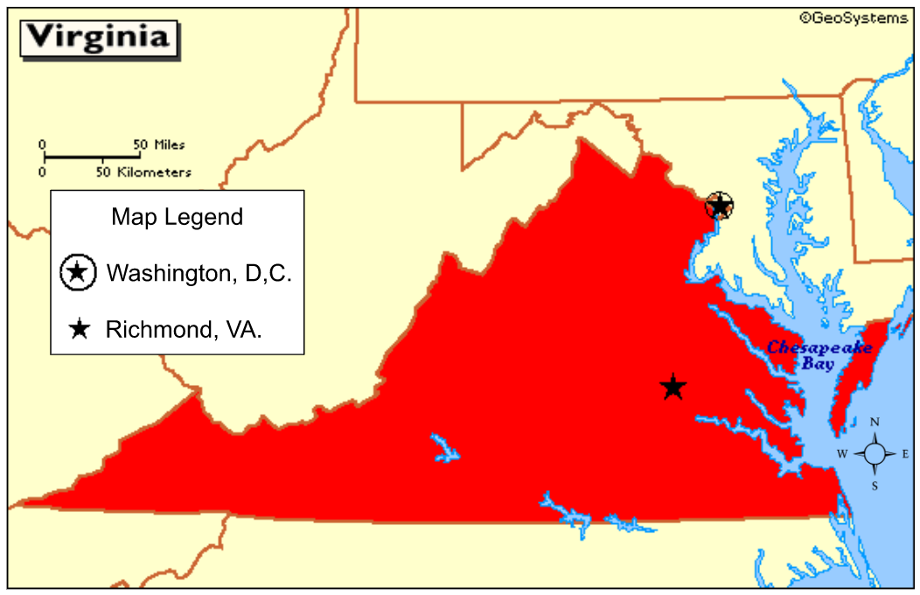

- Add a point where the student lives. Add a line to create a line segment.

Example: Richmond (star) and Chesterfield (dot) are points. The line between them creates a line segment.

- Add a third point for another familiar landmark. Add a line between two points to create an angle.

Example: Richmond (star), Chesterfield (dot), and Virginia Beach (triangle) are points. The line between them creates line segments. The 2 line segments that share the same point create an angle.

Blank map of Virginia for the activity:

Home | Richmond | Virginia Beach | Washington, D.C.
point | line segment | angle | line segment

Word Wall Cards:

Line

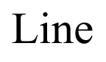

Point

Line Segment

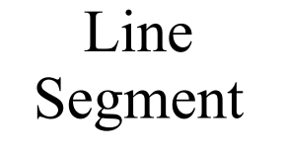

Angle

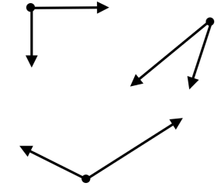

Supplemental Materials:

Vocabulary Cards for sorting or matching

Labels for pinwheel project

Point | Point | Point | Point
Line segment | Line segment | Line segment | Line segment
Angle | Angle | Angle | Angle

Sort

Practice Items:

