# Can I Buy That? (part 1)

**Grade Level: 4**

*Note: A lesson named “Can I Buy That?” is available for grade 5 and aligned to grade 5 VESOL.*

**Subject(s):**

Primary: Mathematics

Integrated Activity: Mathematics, Reading

**Reporting Category:**

Number, Number Sense, Computation, and Estimation

**Lesson Summary and Connections:**

Students will learn about coins, their values, and how to use them to buy an object.

**Lesson Components Links**

|  |  |  |  |
| --- | --- | --- | --- |
| **[VESOL(s)](#_VESOL(s):)**  **[Complexity Continuum](#_VESOL(s):)** | [**Functional Skills**](#_Functional_Skill(s):_1) | [**Assistive Technology**](#_Assistive_Technology/ACC_(Augmentat) | **Materials** |
| **Vocabulary** | **Common Misconceptions** | [**Student-Friendly Outcome(s)**](#_Student_Friendly_Outcome(s):_1) | **Introductory Activity** |
| **Plan for Instruction** | **Differentiation** | **Reflection** | **Formative Assessment** |
| **Word Wall Cards** | **Supplemental Materials** | **Practice Items** | **Integrated Activity** |

## VESOL(s):

**M-4.14 – Use a variety of coins to count the value through 50 cents.**

* **Complexity Continuum**: Coins could include pennies, nickels, dimes, and quarters. Same or different coins could be counted with a total value of 50 cents or less.

## Functional Skill(s):

* Students will identify coins as money and that money is used to buy things.
* Students will identify the values of a penny, nickel, dime, and quarter.
* Students will identify whether they have enough money to make a small purchase (up to 50 cents) using coins.

## Assistive Technology/ACC (Augmentative and Alternative Communication):

* Students with weak fine motor skills may benefit from having the coins on a screen to manipulate virtually.

## Materials:

* A mix of pennies, nickels, dimes, quarters, Word Wall Cards

## Vocabulary:

**Prior Knowledge**

|  |  |  |
| --- | --- | --- |
| * penny | * nickel 1 | * nickel 2 |
| * dime 1 | * dime 2 | * quarter 1 |
| * quarter 2 |  |  |

**Current Vocabulary**

|  |  |  |
| --- | --- | --- |
| * Value | * equals |  |

## Common Misconceptions:

* Some students think smaller coins have a smaller value (size of coin determines value).
* Some students think the number of coins is more important than the value of the coin(s). For example, some students think having a greater number of coins means having a greater amount of money, so they might think they 3 nickels is a greater among of money than 1 quarter.

## Student-Friendly Outcome(s):

* I can name my coins and say their values.
* I know how much money I have because I can add the values of my coins.
* I know whether I have enough money to buy something I want.

## Introductory Activity:

Show students an assortment of coins. Ask questions such as:

* What are these called?
* Do you know the names of any of these coins?
* What do we do with them?
* Do you know how much each coin is worth?
* Which coin has the greatest value?
* Which one has the least value?
* How many pennies does it take to be the same value as a nickel?

Use the answers to these questions to determine each student’s level of understanding and starting point for instruction.

**Starting Point for Instruction (Level A, Level B, or Level C)**

**Level A -** **for students with very limited knowledge of money [Refer to the grade 3 lesson on money.]**

* Students at this level do not know the names or values of the coins. They will begin by sorting the coins to determine how they are alike/the same and different.

**Level B - for students with some knowledge of money [Refer to grade 3 lesson on money.]**

* Students at this level know that money is used to buy things, recognize that the coins are different from each other, and know that coins have different values. They may not know the name and value of each coin.

**Level C – for students who know the name and value of each coin**

* Students at this level can identify the name and value of each coin. They may not know how to find the value of a set of coins. This level should be the appropriate learning level for students who successfully learned the grade 3 VESOL.

## Plan for Instruction:

**Level C:**

**Find the value of a set of coins that are all the same. The maximum value of the set of coins is 50 cents.**

* Students should first review one-to-one correspondence by counting a set of pennies.
* Once students are comfortable with counting a set of pennies, the next step is to find the value of a set of nickels. Students will use and reinforce VESOL M-3.17 (skip counting by 5’s) to find the total value of their set of nickels up to 50 cents.
* Once students are comfortable counting pennies and then nickels, they should find the value of a set of dimes.
* Finally, students will discuss and find the value of two quarters.

**When students are comfortable finding the value of a set of coins that are alike, they should begin finding the value of a set of coins that are different.**

* Once students can count 5 pennies and know that the value is 5 cents, they can make the connection that there is another coin that has a value of 5 cents.

Nickel
Image of a nickel.
one nickel equals five pennies
image of 5 pennies
5 cents.

* Students can practice trading pennies for nickels. Students can also practice trading nickels for pennies.
* Students can then combine a nickel with pennies to find the total value.
  + At first, some students may need to exchange the nickel for 5 pennies to find the value. This will help them develop the concept of equality. Students can also practice “counting on” by starting with the nickel, worth 5 cents, and then counting up to find the total value.
  + For example, students can be given sets of money like the ones shown, with the nickel first and then the pennies. They can practice counting together starting with 5 and adding on the number of pennies.

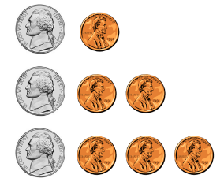

* Once students become more comfortable with adding these two different coins, they should be given nickels and pennies in random order and asked to count them.
* After students are familiar with nickels and pennies, the dime should be added to the set.

Dine
image of a dime
one dime equals ten pennies
image of 10 pennies
ten cents

* The relationships between pennies, nickels, and dimes is more complex and may require frequent practice. One of the best ways to practice this concept is to have students gather coins that represent a given total. This will help the teacher to see which students use only one type of coin and which students mix the coins.

**For example:**

Ask students to show you coins that add up to 10 cents.

* Which students show a dime?
* Which students show two nickels?
* Which students show only pennies?
* Which students show a nickel and five pennies?

Next ask students to show you coins that add up to 14 cents.

* Which students use only pennies?
* Which students use nickels and pennies?
* Which students use a dime and pennies?

Next ask students to show you coins that add up to 18 cents.

* Which students use only pennies?
* Which students use nickels and pennies?
* Which students use a dime, a nickel, and pennies?

Next, give students a dime and ask them to add other coins to combine with the dime to make 25 cents.

* Which students “add on” to get to 25 cents?
* Do any students try to use only dimes?
* Do students use only pennies to add to the dime?
* Once students are comfortable working with pennies, nickels, and dimes, they should investigate to discover the relationship these coins have with a quarter.

Quarter
image of a quarter
one quarter equals twenty five pennies
Image of 25 pennies
25 cents

* At this point, students should be given opportunities to show how to combine nickels, dimes, and/or pennies to equal a quarter. In addition, students should be shown that 2 quarters add to 50 cents. Some students may need to use a calculator to see that 25 + 25 = 50.

## Differentiation:

* For students who show proficiency in adding coins with different values, ask them to show you two different sets of coins that have the same value. For example, show students a picture of an item with a price tag of 45₵. Ask students to show coins that they could use to buy the item. They can also be asked to find a different set of coins that will also allow them to buy the item. Ask, “Is there another way to show 45₵? Can you make a different set of coins that is also equal to 45₵?” If students show coins that equal more than 45₵, ask questions to determine whether they are aware that their coins have a value greater than they need.
* Students can also be shown a picture of an item with a price tag less than or equal to 50₵ and a coin or set of coins with a total value less than what they need. Students should be asked to identify which other coins they can combine with the given coins to have the correct amount of money for the item. For example, students can be given an item with a price tag of 33₵ and a quarter. They should choose coins to combine with the quarter to make 33₵.

## Reflection:

* Show students a mixed set of coins having a value up to 50₵ (differentiate based on the combinations students have worked with successfully during the lesson).
  + Have students say, write, or show one thing they know about each coin.
  + Have students say, write, or show one thing they know about the set of coins.
  + Teachers may also ask students to say, write, or show one thing they are still working on learning.
* Activities with money can be included in daily routines. Students might “purchase” treats from a treat box, earn money by helping with classroom tasks, or play games such as “Who Has More?” or “I Have/Who Has?” with the group.

## Formative Assessment:

* **Outcome Activity to Assess Learning:** Give students a collection of mixed coins.
* Say: Show me coins that make 35 cents.
* Say: Now show me a different way to make 35 cents.
* Say: Here are a quarter and a dime. Show me which other coins can be put with these coins to make 50 cents.
* Say: This object costs 43 cents. Show me the correct coins to buy the object.
* Say: This pencil costs 18 cents. Show me the correct coins to buy the pencil.

**Mastering the Skills**

A table can be used to keep a running record of student progress over time. Students may master these skills at different times, and that progress could be documented with the date the student demonstrated the skill. Different skills can be added to the table over time.

|  |  |  |  |  |  |  |
| --- | --- | --- | --- | --- | --- | --- |
| **Skill** | **Student 1** | **Student 2** | **Student 3** | **Student 4** | **Student 5** | **Student 6** |
| Tell value of two or more of the same coin. |  |  |  |  |  |  |
| Tell the value of two or more different coins. |  |  |  |  |  |  |
| Given a coin, identify additional coins to combine with it to make a value. |  |  |  |  |  |  |
| Given two or more coins, identify other coins to make a total of 50 cents. |  |  |  |  |  |  |
| Tell value of mixed coins up to 50 cents |  |  |  |  |  |  |
| Show correct coins to make a purchase up to 50 cents. |  |  |  |  |  |  |
|  |  |  |  |  |  |  |
|  |  |  |  |  |  |  |

## Integrated Activity:

**Buying a Treat**

Read this story to students. Have a set of coins available for each student.

Rachel, Rico, and Anita have earned coins to use for the treat box. Their teacher, Mr. Smith, said they can buy a treat from the box after lunch. Rachel has 1 quarter and 1 dime. Rico has 3 dimes. Anita has 2 nickels and 2 dimes. Anita feels like she has been waiting forever to buy a treat from the box. She really wants some new stickers to add to her binder. Rico wants to buy a new fun eraser in the shape of a dog. Rachel hopes she has enough money to buy a Pop It toy.

At left Pope  it toy, 35 cents, 
at center dog eraser, 40 cents
at right, stickers, 32 cents.

Reading Questions:

1. Who wants to buy the eraser?
2. Who wants to put stickers on their binder?
3. What does Rachel want to buy?
4. Who feels like they have been waiting forever to buy a treat from the box?
5. When can buy a treat from the box? How do you know?

Math Questions:

1. Show the coins that Rachel has.
2. Show the coins that Anita has.
3. How much money does Rico have?
4. Whose coins have the greatest total value?
5. Show coins to buy the stickers. Can you show a different set of coins to buy the stickers? Does Anita have enough money to buy the stickers?
6. Which two students have the same amount of money?
7. Does Rachel have enough money to buy the Pop It toy? Why or why not?
8. Does Rico have enough money to buy the dog eraser? How do you know?

**Word Wall Cards:**

Penny

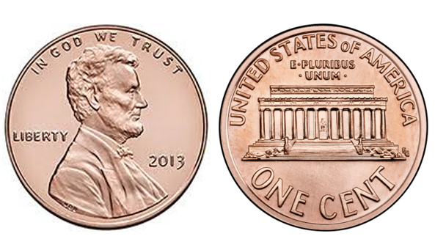

1¢

one cent

Nickel

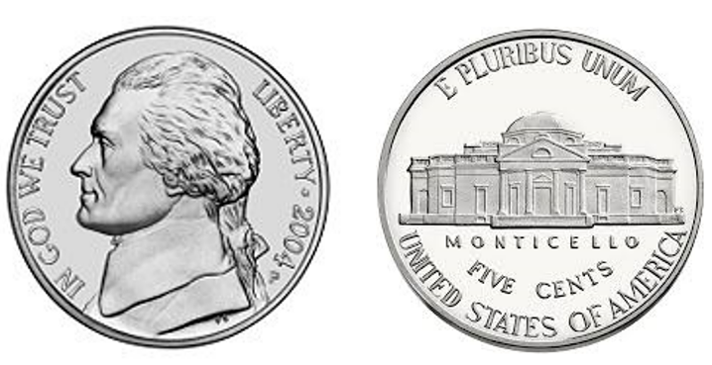

5¢

five cents

Nickel

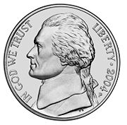

one nickel equals five pennies



5 cents

Dime

Image of the back of a dime.

Image of the front of a dime.

10¢

ten cents

Dime

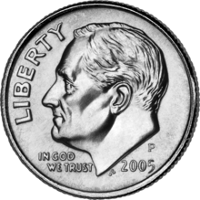

one dime equals ten pennies



10 cents

Quarter

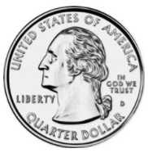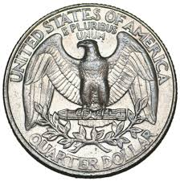

25¢

twenty-five

cents

Quarter



one quarter equals twenty-five pennies



25 cents

### Practice Item

