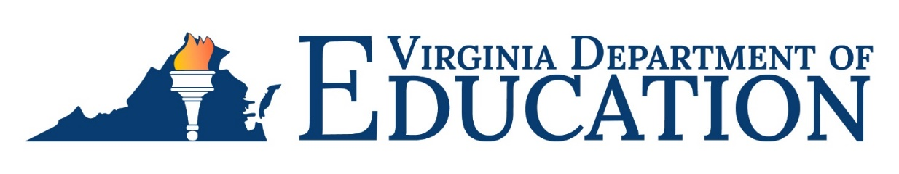

2023-2024 Title V, Part B, Allocations under Provisions of the Elementary and Secondary Education Act of 1965 (ESEA), as Amended
The Elementary and Secondary Education Act of 1965 (ESEA), as amended by the Every Student Succeeds Act of 2015 (ESSA), authorizes funding under the Title V, Part B, Subpart 2, Rural and Low-Income School Program for eligible school divisions.
Eligibility
ESEA specifies the following eligibility criteria for Title V, Part B, Subpart 2, funds: 1) 20 percent or more of the children ages 5-17 served by the division are from families with incomes below the poverty line; and 2) all public schools in the division have a locale code of 32, 33, 41, 42, or 43. Locale codes are assigned to schools by the National Center for Education Statistics according to the physical address of each school that is matched against a geographic database maintained by the U.S. Census Bureau. The locale code definitions are listed below.
- Locale code “32” (Town-Distant): Territory inside an Urban Cluster that is more than 10 miles and less than or equal to 35 miles from an Urbanized Area.
- Locale code “33” (Town-Remote): Territory inside an Urban Cluster that is more than 35 miles from an Urbanized Area.
- Locale code “41” (Rural-Fringe): Census-defined rural territory that is less than or equal to 5 miles from an Urbanized Area, as well as rural territory that is less than or equal to 2.5 miles from an Urban Cluster.
- Locale code “42” (Rural-Distant): Census-defined rural territory that is more than 5 miles but less than or equal to 25 miles from an Urbanized Area, as well as rural territory that is more than 2.5 miles but less than or equal to 10 miles from an Urban Cluster.
- Locale code “43” (Rural-Remote): Census-defined rural territory that is more than 25 miles from an Urbanized Area and also more than 10 miles from an Urban Cluster

Unliquidated Funds
To minimize the occurrence of unliquidated funds due to school divisions failing to expend and/or request reimbursement for the full amount of funds that they are awarded, school divisions are required to encumber 85 percent of each award year’s Title V, Part B, Subpart 2, allocation by September 30 of the following year (within 15 months). School divisions are permitted to carry over up to 15 percent of their allocation for any fiscal year. The Department will reallocate funds that have not been encumbered within the allotted 15-month period of each program year to other eligible school divisions.
Supporting Documents

The following supporting documents, Additional Required Special Terms and Conditions for Grant Awards or Cooperative Agreements and Terms and Conditions of the grant award are provided on the ESEA webpage.
The procedures and forms for submitting an application for Title V, Part B, Subpart 2, were previously provided to school division program coordinators. Applications were due on July 1, 2023.

For more information

If you have questions about the Title V, Part B, Subpart 2, allocations or application process please contact Latonia Anderson, at latonia.anderson@doe.virginia.gov or at (804) 750-8173.

