Team Nutrition Readiness and Retention Training Program: Instructions for Accessing the Cafeteria Manager Online Training
- Go to https://vdoelearning.catalog.instructure.com/courses/team-nutrition.
- Click on Enroll.

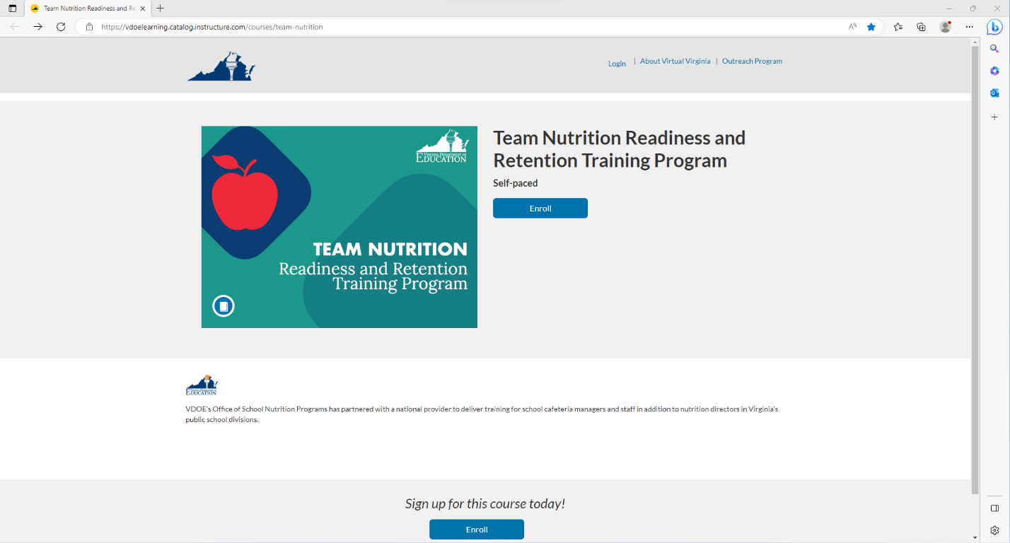

- Under Choose your program, select Virtual Virginia Professional Learning from the dropdown menu, and then click on Login.
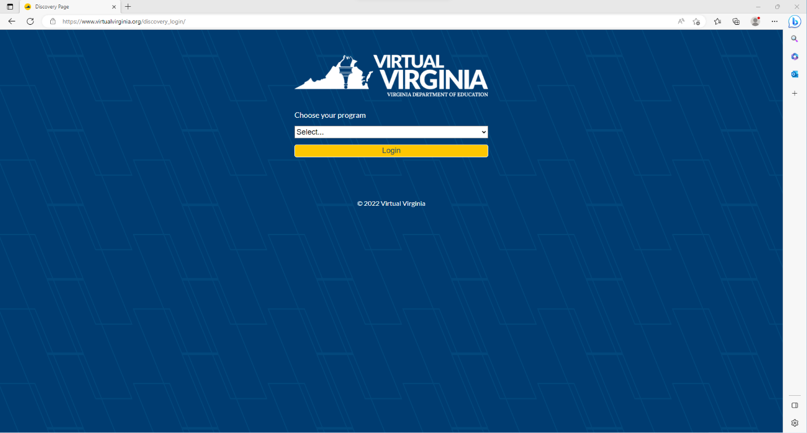

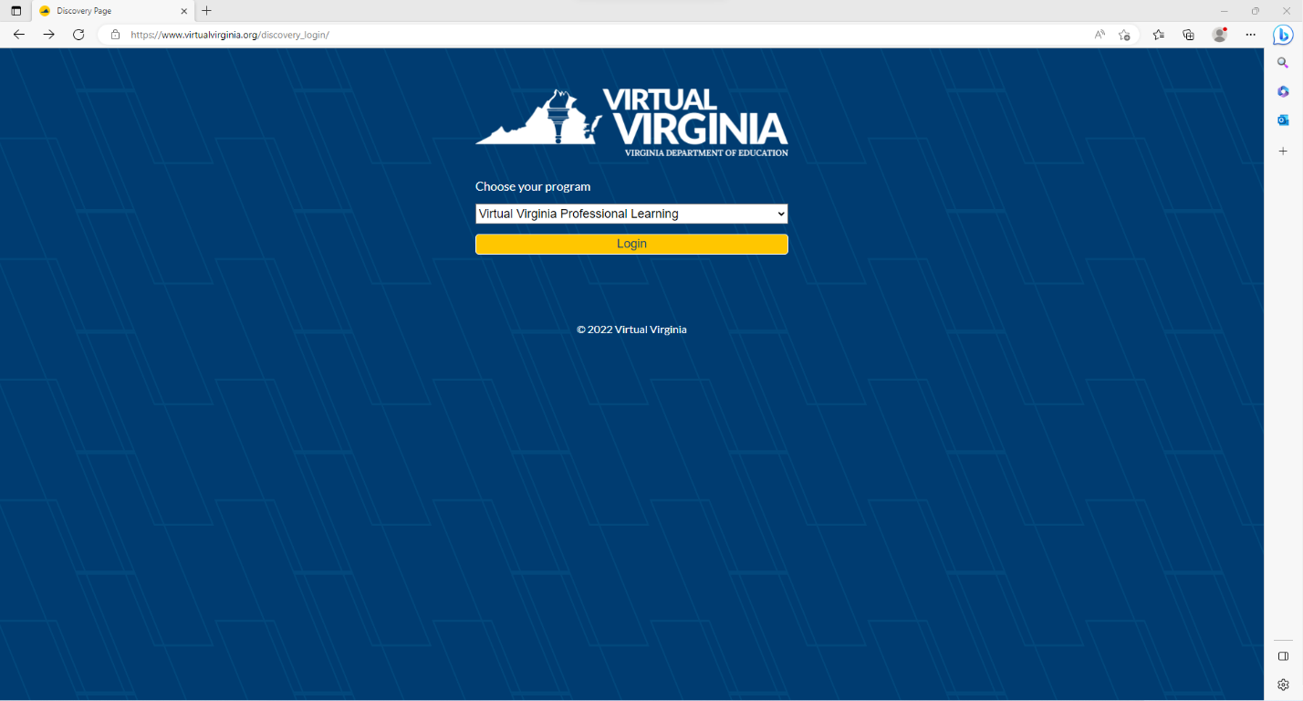

- If you already have a Virtual Virginia account, click on Sign in to Enroll. If you do not have an account, complete the initial registration information, and click on Register New Account.
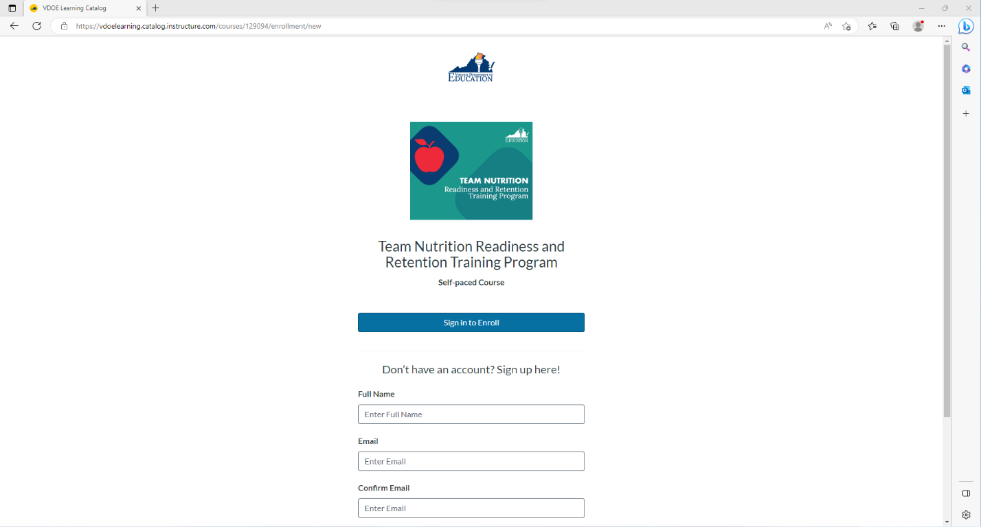

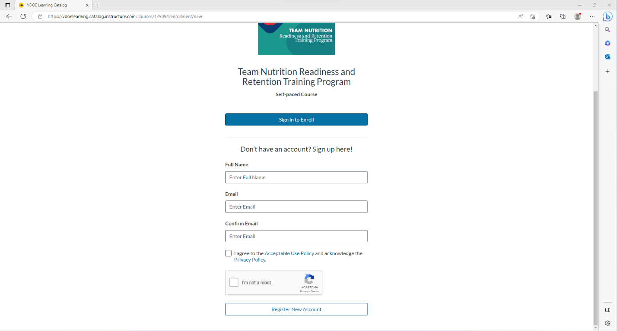

- Now when you follow the link to log in, you will click on the dropdown next to your name, and then click on Canvas.
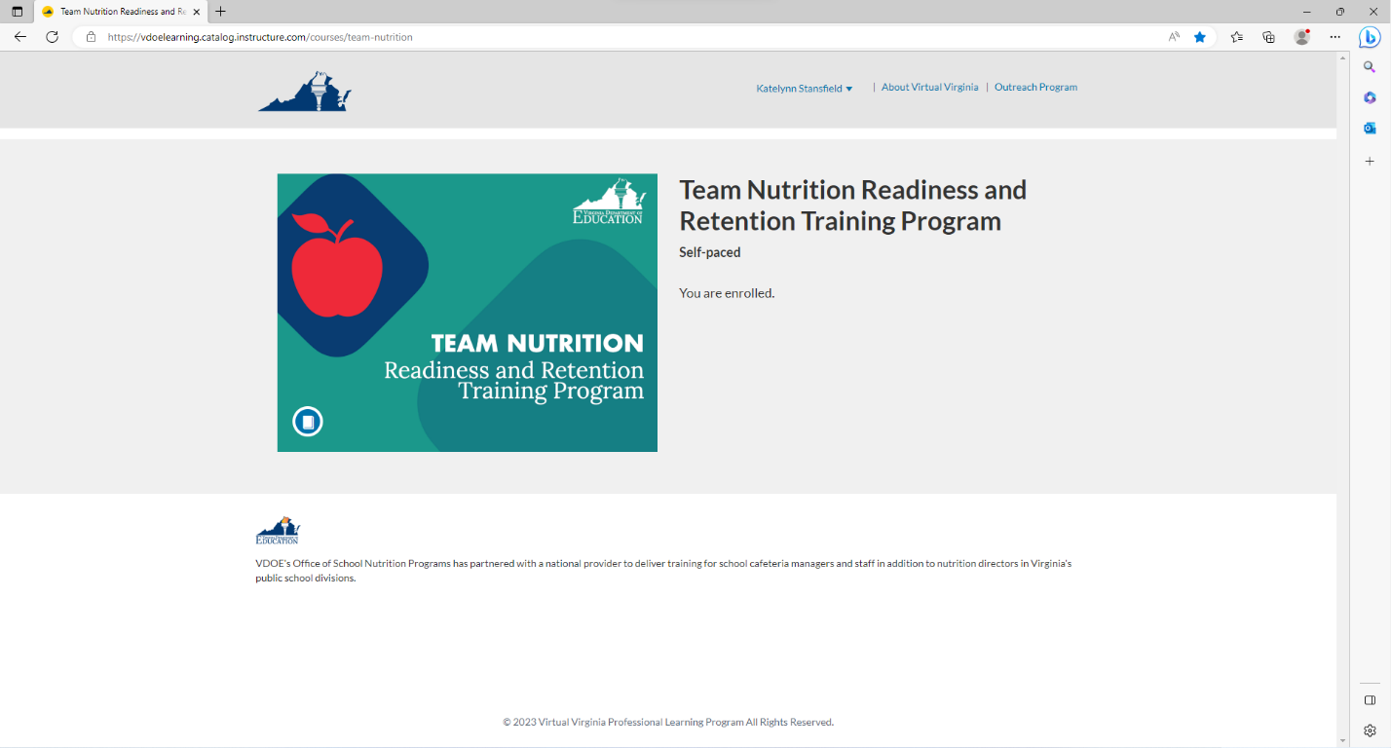

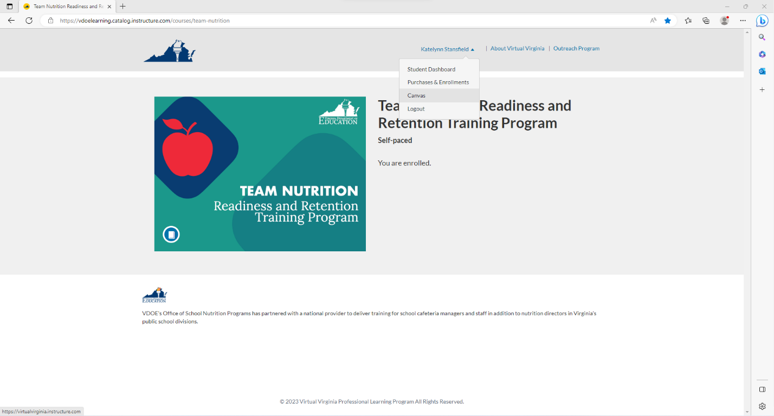

- You will now be on your Virtual Virginia Dashboard. Click on Courses, then click on VDOE Team Nutrition Readiness and Retention Training Program.
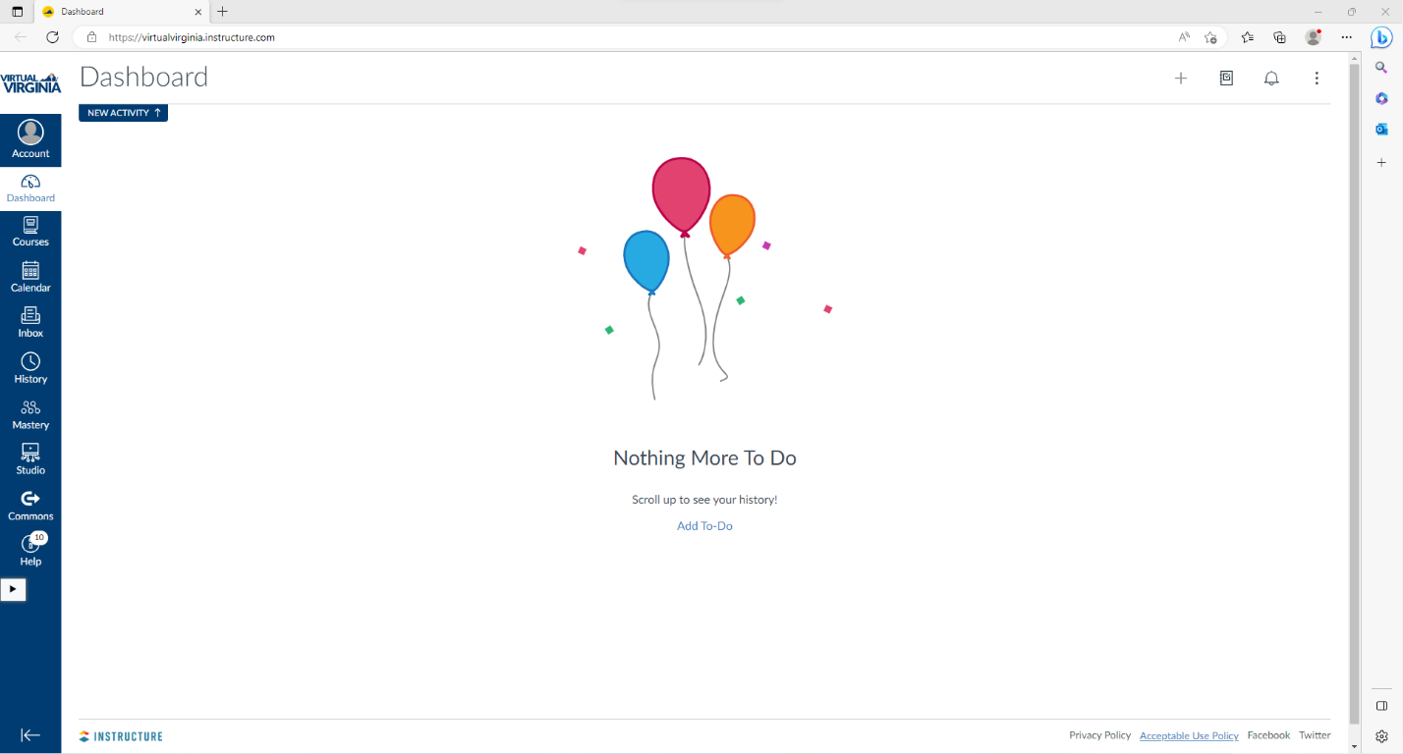

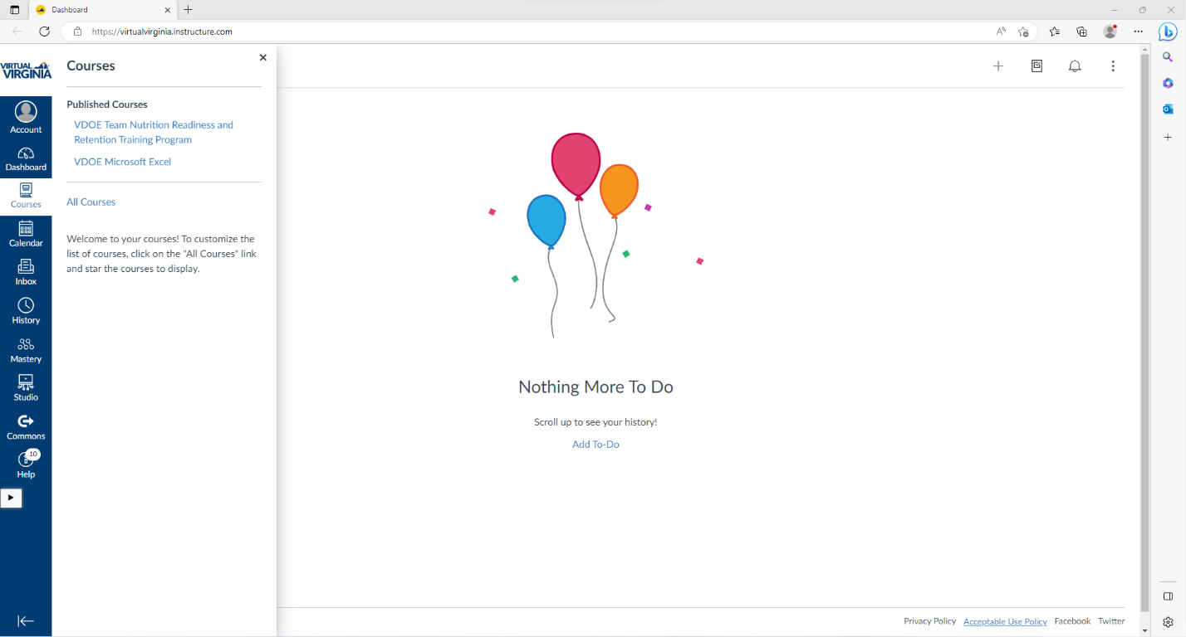

- You will now be on the Home page for the Team Nutrition Readiness and Retention Training Program course. Read the information on the Home page and then select Start the Course Questionnaire.
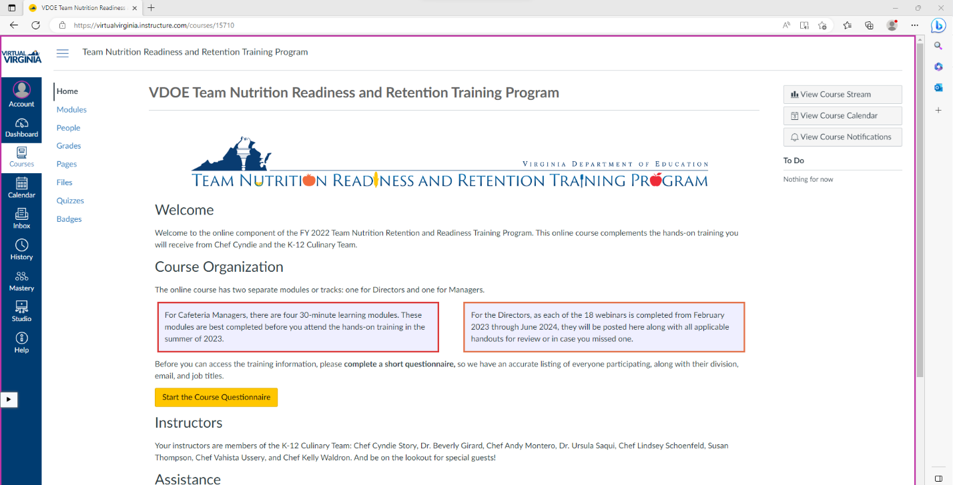

- Click on Take the Survey.

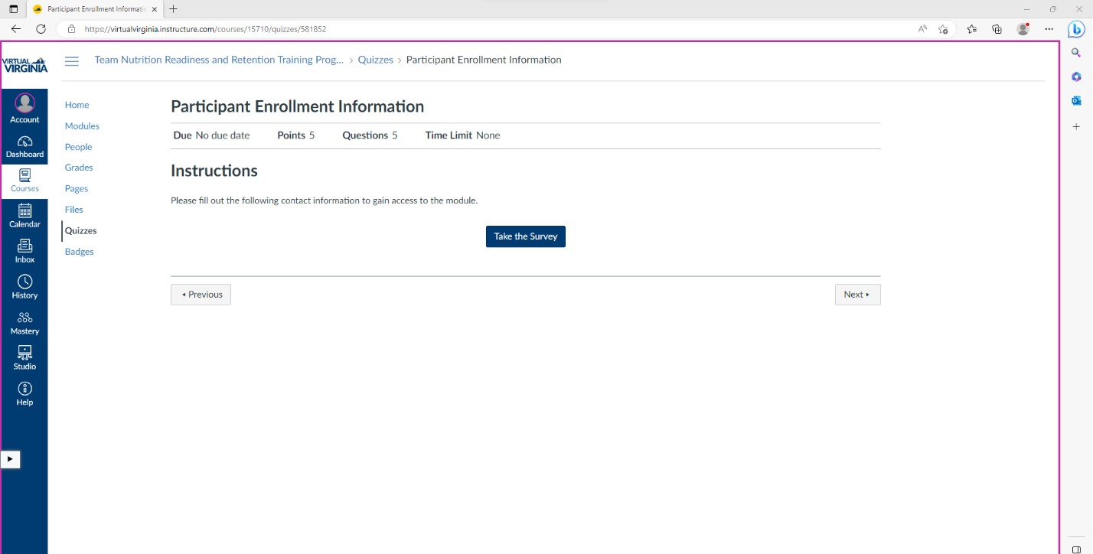

- Complete each question. Once you’ve completed the quiz, click on Submit Quiz.
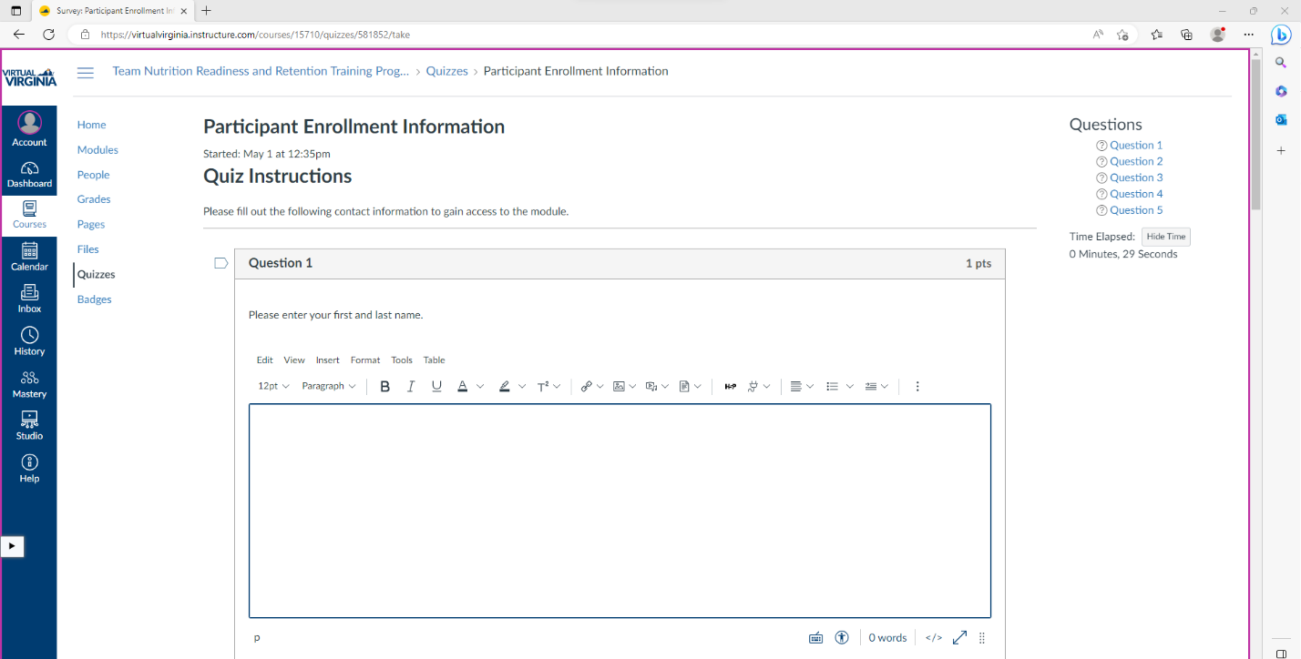

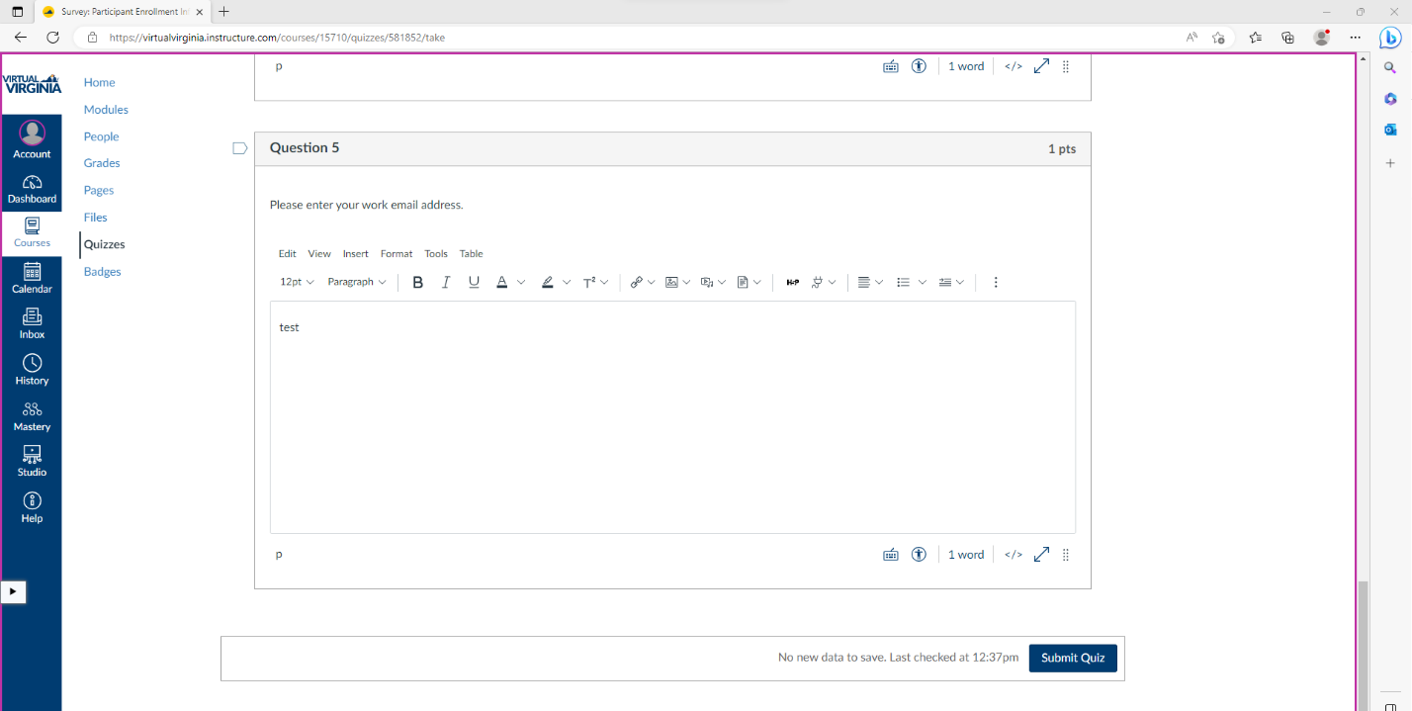

- Once your quiz is submitted, you will be brought to a page that has your responses. Scroll down and click on Next.
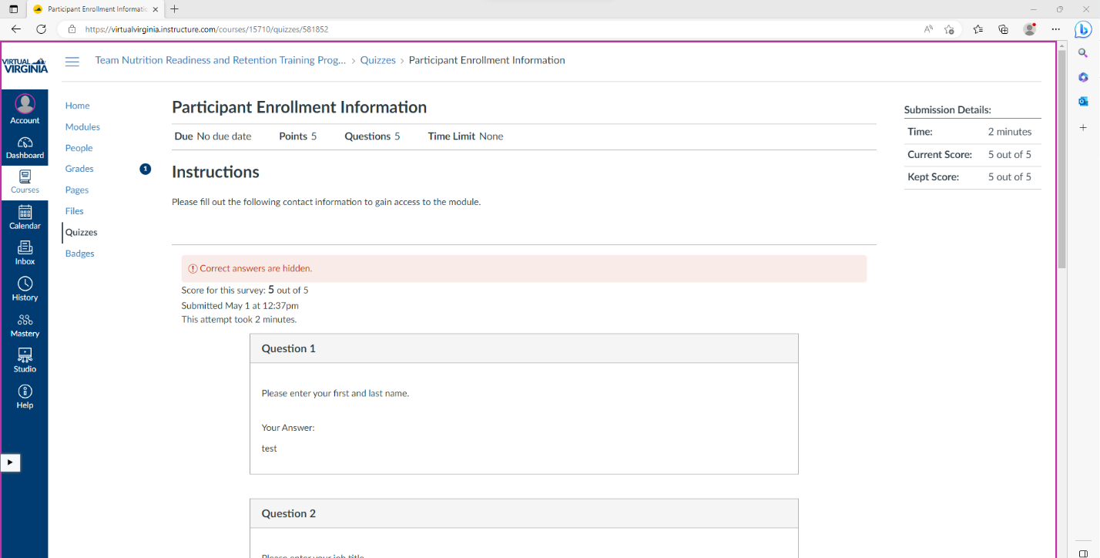

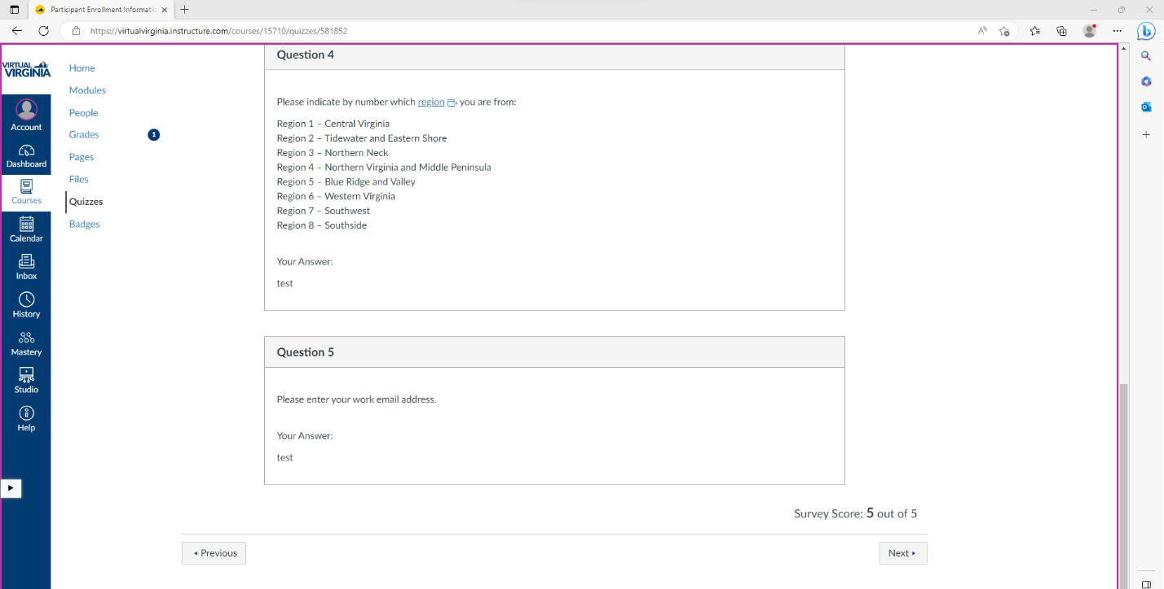

- On the Next Steps page, select Start Training for Cafeteria Managers.
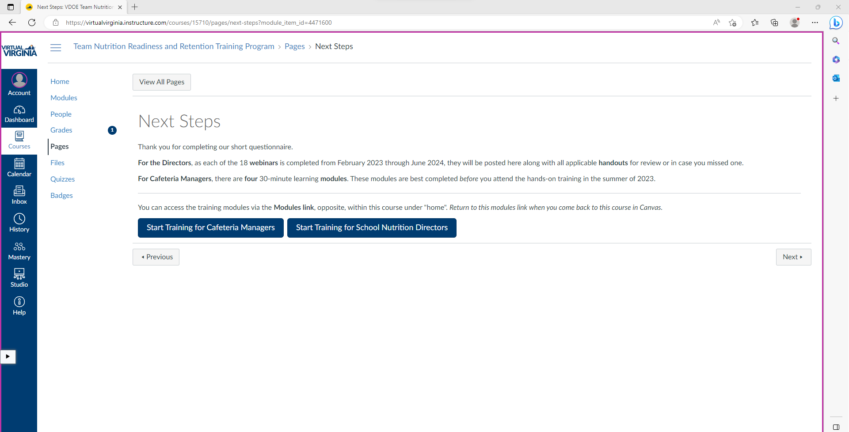

- On the Modules page, view the heading titled Cafeteria Managers: Overview with Chef Cyndie, and select How to Use Canvas + Overview Video.

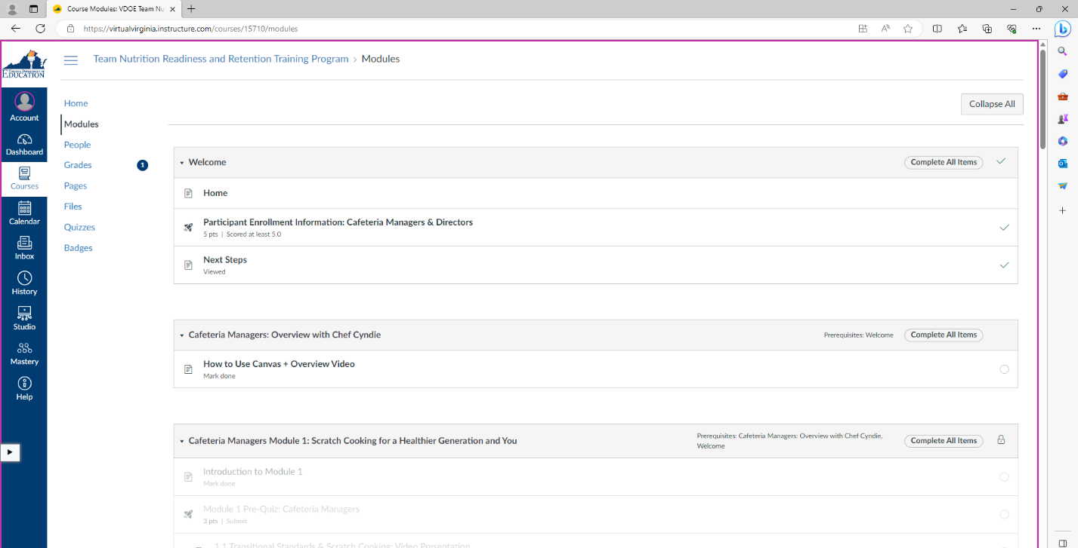

- On the How to Use Canvas + Overview Video page, read the information and watch the video. Once you complete this, scroll down and select Mark as done. Then, select Next.

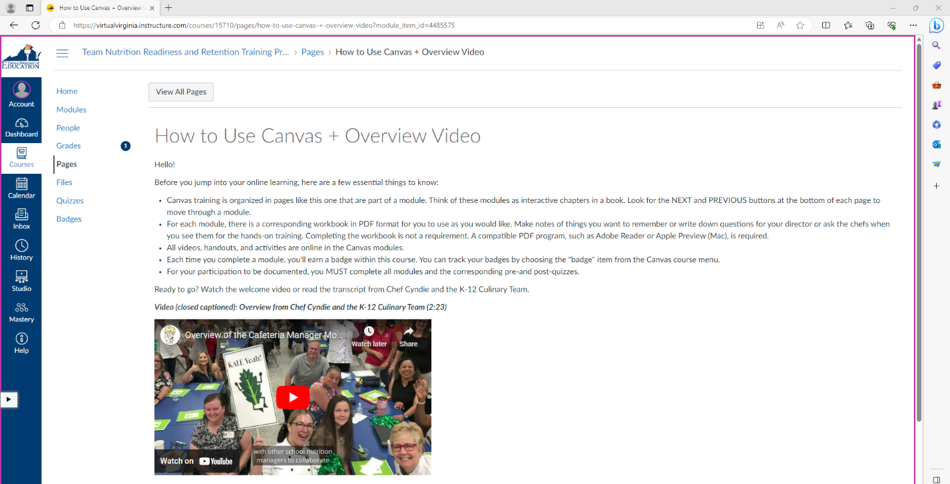

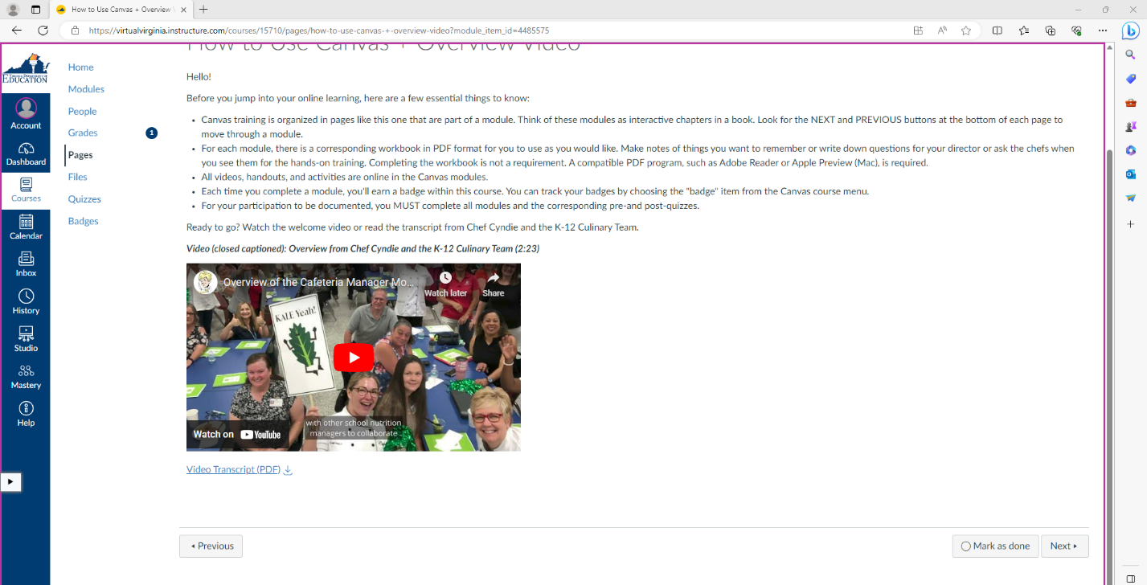

- On the Modules page, scroll down to the heading titled Cafeteria Managers Module 1: Scratch Cooking for a Healthier Generation and You and select the first item, Introduction to Module 1.

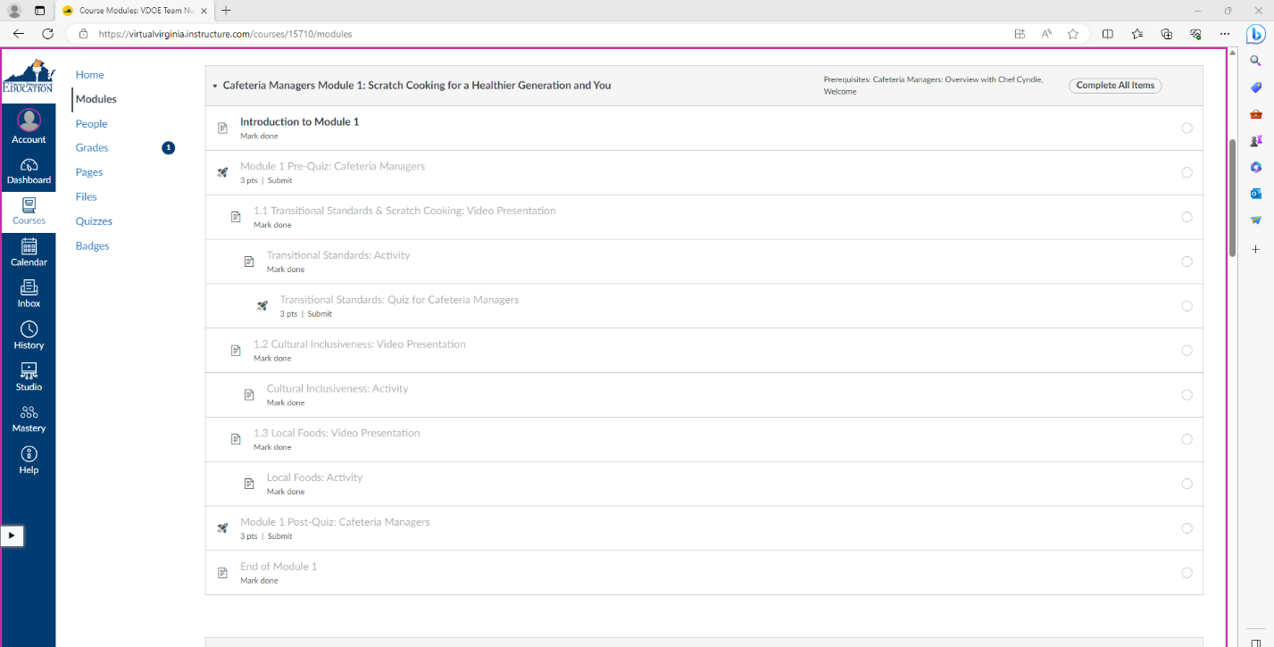

- On the next page, read the information to learn about the module. Scroll down and click on the link below Workbook and PowerPoint Presentations to view the associated handouts or click the download icon next to a handout title to download the handout. Then, select Mark as done and Next.

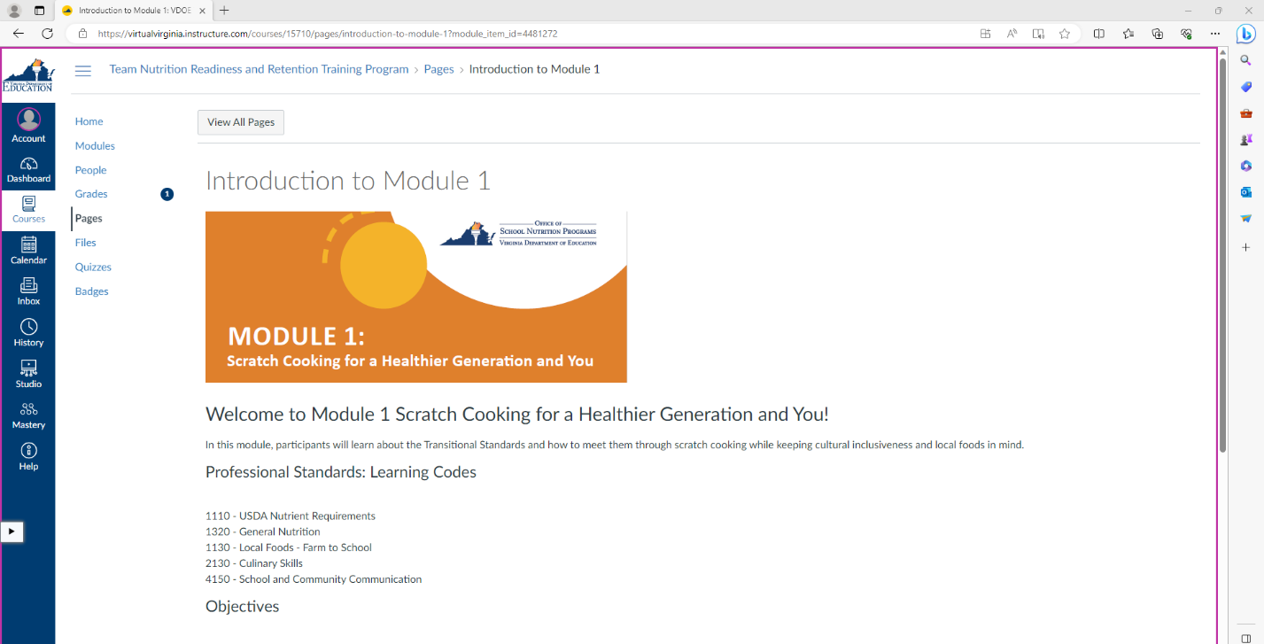

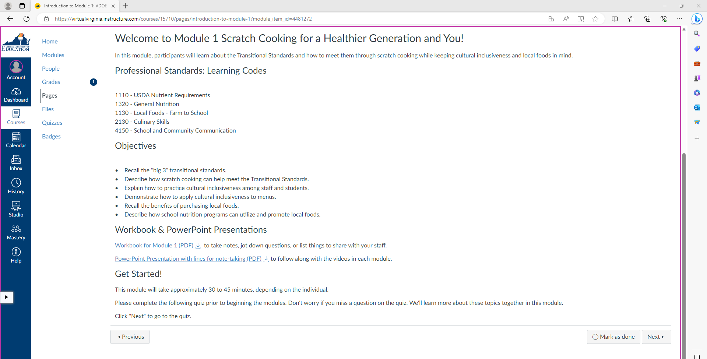

- On the next page, click Take the Quiz.

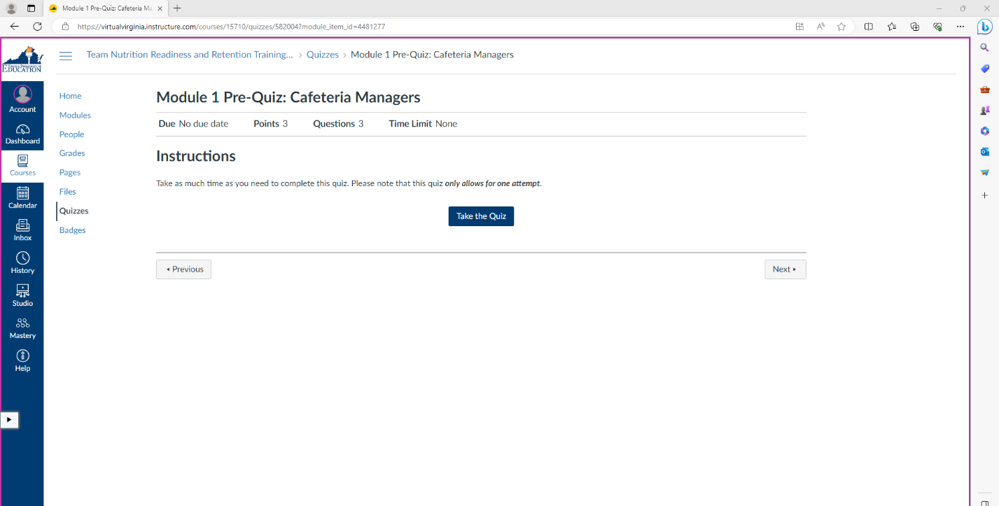

- On the next page, select your answers for the quiz by clicking on the circle next to your answer choice. After you have selected a response for each question, click Submit Quiz. You will then be on a page that has your responses. Review the feedback for each question. Then, scroll down to the bottom of the page and click Next.

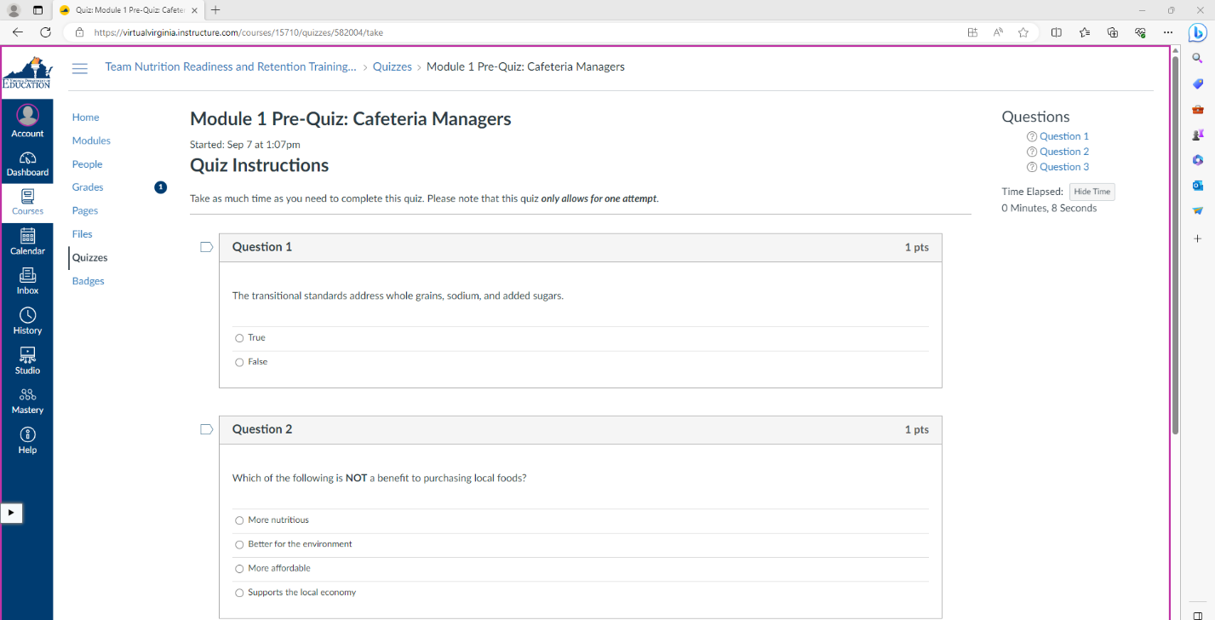

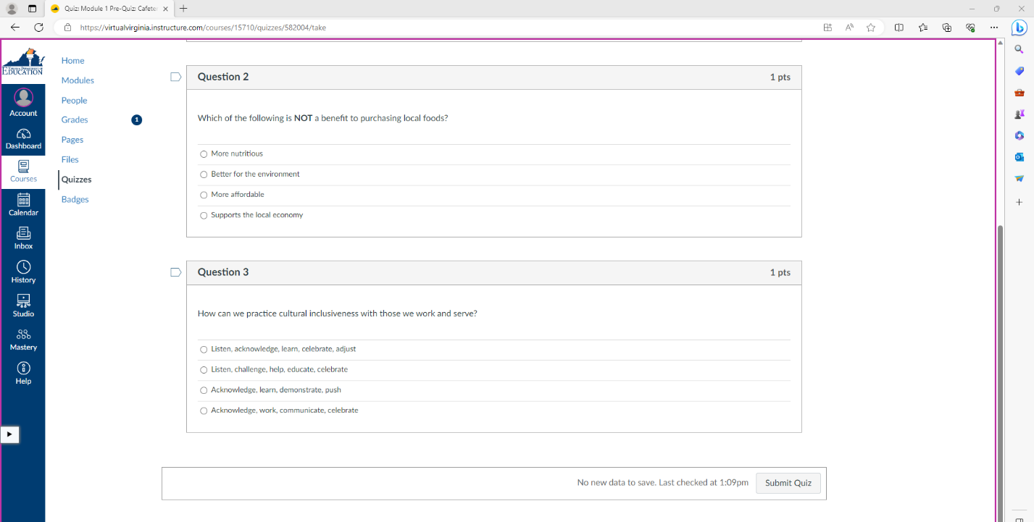

- On the next page, read the objectives and instructions. Click on the video to view the video. After you have watched the video, scroll down to the bottom of the page, and click Mark as done and Next.

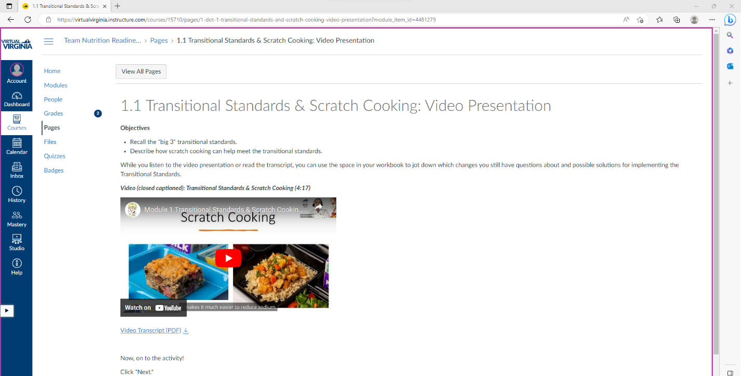

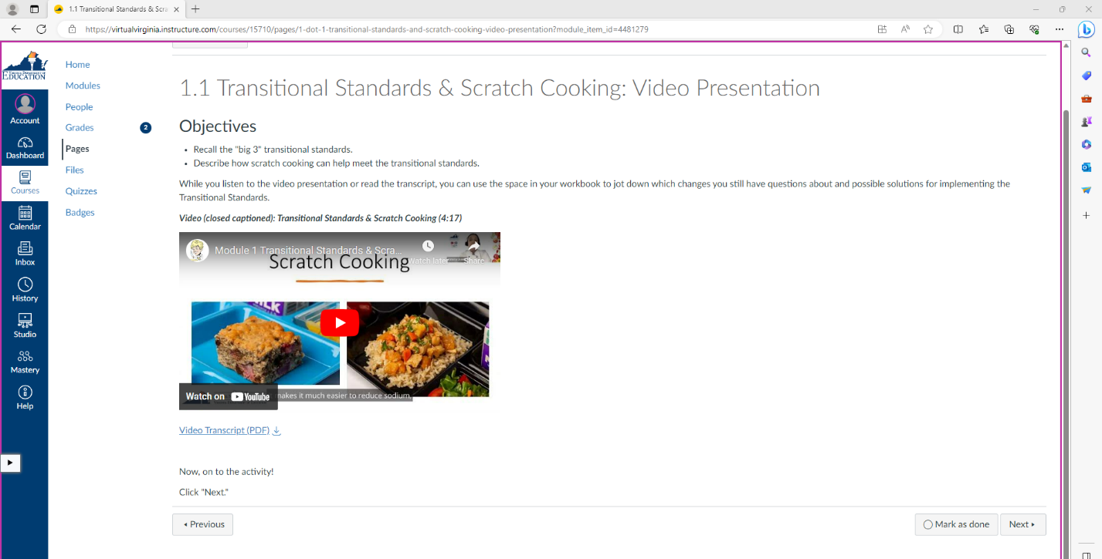

- On the next page, read the instructions for the activity. Click on the link to view the handout or download the handout by clicking on the download icon. After reviewing the handout, click Mark as done and Next.

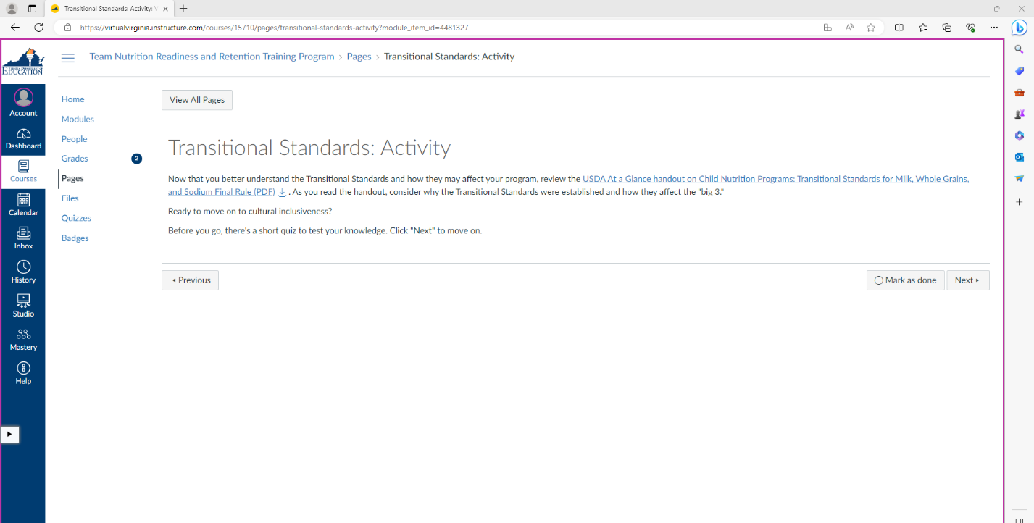

- On the next page, click Take the Quiz.

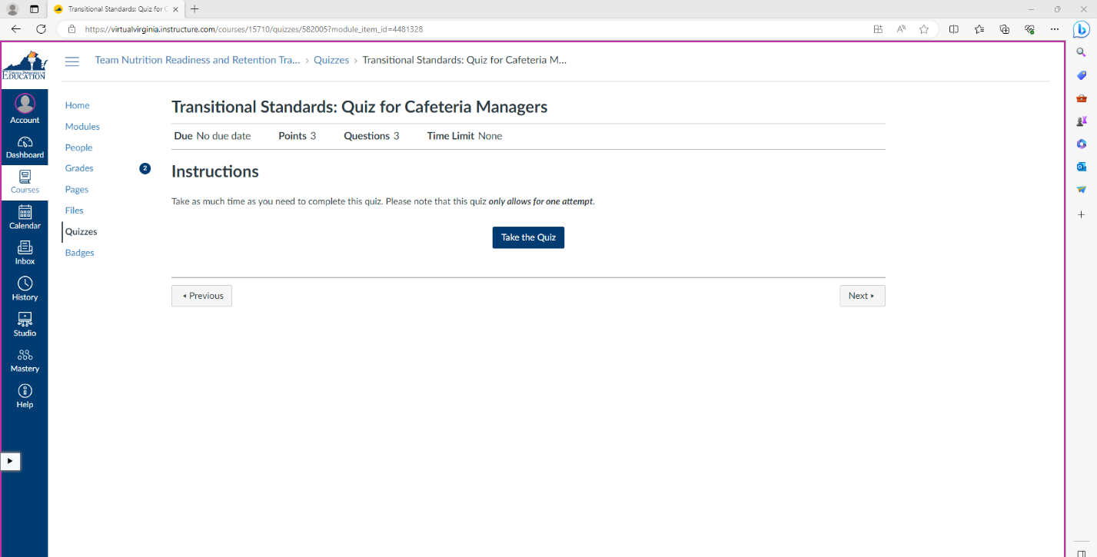

- On the next page, select your answers for the quiz by clicking on the circle next to your answer choice. After you have selected a response for each question, click Submit Quiz. The next page will have your responses. Review the feedback for each question. Then, scroll down to the bottom of the page and click Next.

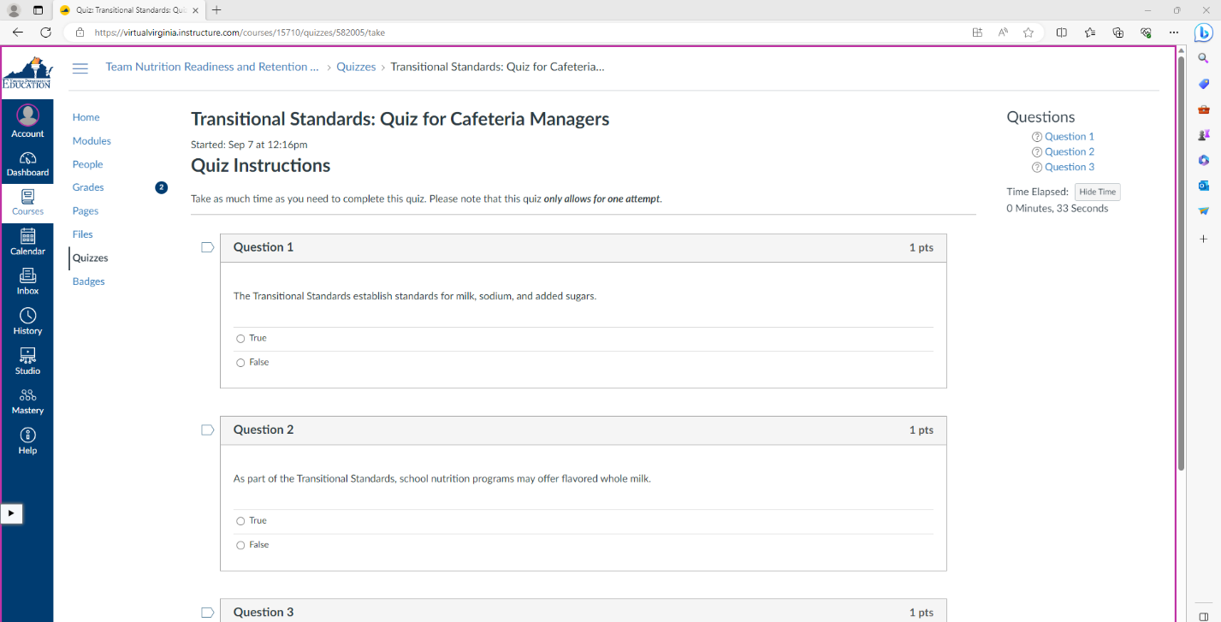

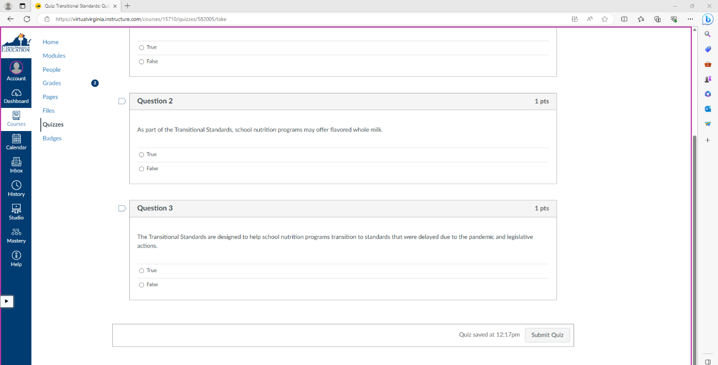

- Continue progressing through the module. Once you are at the end of a module, you will see the End of Module page. Clicking Mark as Done and Next will progress you to the next module.

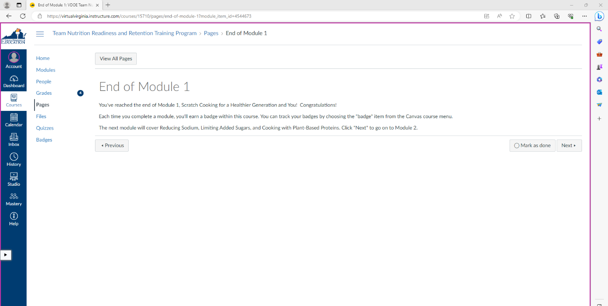

- At any point in the course, you can use the left-sided navigation bar to view pages. Clicking on Home will take you to the Home page, and clicking on Modules will take you to the Modules page.

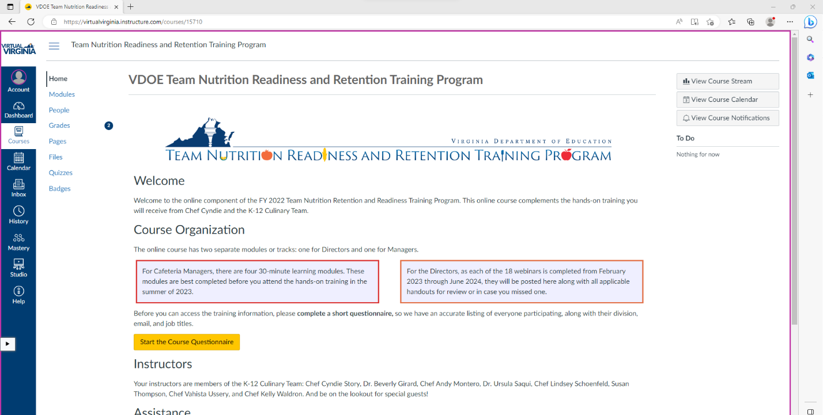

- When you click on Grades, you will be able to view the past quizzes you have completed. Keep in mind that you will also see quizzes that are part of the director training. These quizzes are not required as part of the cafeteria manager training. Only complete the quizzes that are part of your modules and include “Cafeteria Managers” in the title.

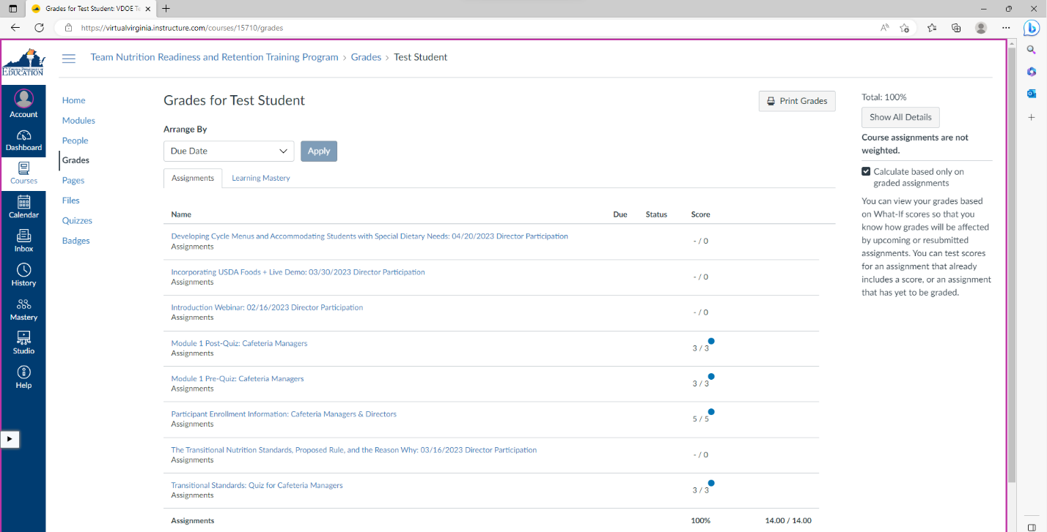
- To log out of Virtual Virginia, click on Account then Logout.

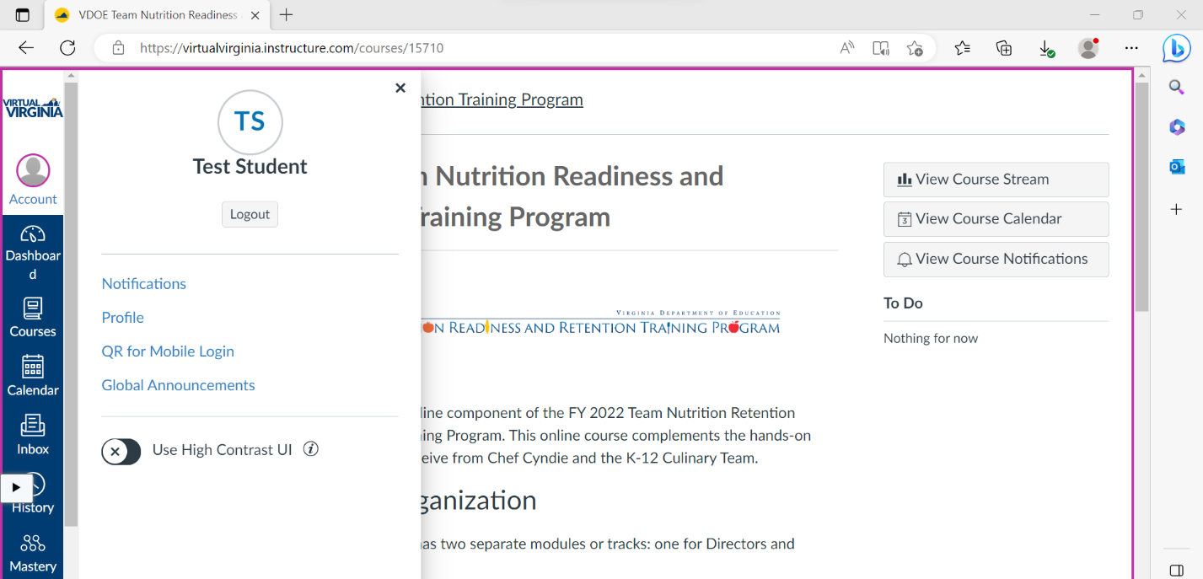

Should you have any questions about navigating Virtual Virginia for the Team Nutrition Readiness and Retention Training Program, please contact Katelynn Stansfield, Team Nutrition Training Grant Project Specialist, at katelynn.stansfield@doe.virginia.gov.

