Make It STICK!
Grade Level: Grade 5
Subject(s):
Primary: Mathematics
Integrated Activity: Occupational Therapy, Reading, Science, History
Reporting Category:
Number, Number Sense, Computation, and Estimation
Lesson Summary and Connections:
Students will use place value to identify numbers that are multiples of ten and understand the difference between the ones and tens place.
Lesson Components Links
VESOL(s)  Complexity Continuum | Functional Skills | Assistive Technology | Materials
Vocabulary | Common Misconceptions | Student-Friendly Outcome(s) | Introductory Activity
Plan for Instruction | Differentiation | Reflection | Formative Assessment
Word Wall Cards | Supplemental Materials | Practice Items | Integrated Activity

VESOL(s):
M-5.3 The student will use place value to identify numbers that are multiples of 10 and understand the difference between ones and tens place.
Complexity Continuum: Whole numbers presented as multiples of 10 could range from 0 through 60. Understanding place value could include identifying the digit in the ones or tens place or its value.

Functional Skill(s):
- Students will use a clock to identify multiples of ten when working on time/clock skills.
- Students will use manipulatives to model numbers that are meaningful in the lives of the students (ages, dates, etc.)
- Students will use a calendar and model dates using a place value mat.
- Recognizing multiples of 10 and numbers in the ones or tens place in the community (i.e. prices in a grocery store or on a scoreboard at a basketball or football game at their school).

Assistive Technology/AAC (Augmentative and Alternative Communication):
- Hundreds chart (highlight multiples of ten)
- Base ten blocks *if available or you could use graph paper to create them or virtual at Didax.com and click on base ten blocks or Toytheater.com several place value virtual tools
- Manipulatives like straws or crayons

Materials:
- Place value mat with a tens and ones sections
- Craft wooden sticks
- Small rubber bands

Vocabulary:
Prior Knowledge What words will students need to know prior to starting the lesson?
- number
Current Vocabulary What words will students learn during the lesson?
- tens (place value) | - place value | - value
- ones (place value) | - digit

Common Misconceptions:
- Students may transpose numbers like 10 and 1 or 20 and 2
- Students might think two-digit numbers such as 32 the three represents a value of 3 not 30.

Student-Friendly Outcome(s):
- I can identify multiples of ten up to 60 (or 100 if applicable for student level).
- I can count by tens.
- I can identify the ones place and tens place on a place value mat.
- I can bundle sticks, or other items like straws, to make a bundle of ten items.
- I know that a digit in the ones place is less than the same digit in the tens place.

Introductory Activity:
Using craft sticks, label ten of the sticks 1 -10. Mix the sticks up and hand one to each student.
- Play “Who Has?”
- Teacher starts by asking “Who has the number one?”
- The student who has the number one lays that stick down on the table or raises the stick in the air and asks, “Who has the number two?”
- The student who has the number two lays that stick down on the table or raises the stick in the air and asks, “Who has the number three?”
- Repeat until you reach ten and all sticks are ordered 1-10.
- Ask students questions such as, “Which number is greater or larger 4 or 10?”
- Ask students questions such as, “Which number is greater or larger 7 or 2?”
Using craft sticks, label ten of the sticks as multiples of ten (i.e. 10, 20, 30, 40, 50, 60, 70, 80, 90, 100). Mix the sticks up and hand one to each student. Before starting, skip count by tens out loud and ask the students to join you in counting by tens for review.
- Play “Who Has?”
- Teacher starts by asking “Who has the number ten?”
- The student who has the number ten lays that stick down and asks, “Who has the number twenty?”
- The student who has the number twenty lays that stick down and asks, “Who has the number thirty?”
- Repeat until you reach ten and all sticks are ordered 10-100.
- Ask students questions such as, “Which number is greater or larger 10 or 20?”
- Ask students questions such as, “Which number is greater or larger 30 or 60?”

Use the answers to these questions to determine each student’s level of understanding and starting point for instruction.

Plan for Instruction:
- Use these videos to supplement your lesson: can be used to introduce concepts after introductory activity or throughout the lesson to reinforce vocabulary and concepts.
Introductory Videos:
- Place Value First Grade – Tens and Ones -
- Place Value for Kids: Ones and Tens
  - The lesson runs to 6:46 in the video and practice is provided in the remainder of the video
  - FYI at 10:12 the video goes beyond the standard but may be helpful for students that have more background knowledge
- Place Value: Ones and Tens – Kids Academy place value (tens and ones)
- Place Value Grouping - place value bundling/grouping
  - at 2:45 seconds this video goes beyond the standard
- Show students a box of 60 craft sticks. Tell them that they will be using place value to count the sticks.
- Using a place value mat, begin counting and placing craft sticks in the ones section as you count. It can be helpful to place the sticks down as if you were drawing tally marks. This will reinforce the utility of tally marks in counting and cue students when they have created a group of ten that needs to be bundled and moved. **students will be seated at table for small group instruction during this time – it may be helpful to project your actions onto your screen
- As you start to place the tenth stick in the ones place, pause and tell students that there is a rule that only nine sticks can be in the ones place. (if students are catching on, this could be posed as a question: “What do we do if we have ten sticks in the ones column?”) When you have ten sticks in the ones place you must gather them, group them with a rubber band and place them in the tens place. Write the number ten on the board and show them how it matches the sticks: 0 sticks in the ones place and one group of ten sticks in the tens place.
- Continue counting and bundling sticks until you have counted all 60 sticks. Pause frequently to write the number counted and show how the digits in the tens and ones place match the sticks on the place value mat. **might be a great time for questioning: “Why did I bundle these sticks?” “What number comes next?”
- Provide students with 15 sticks and a place value mat.
- Ask students to put down sticks on their mat as you count aloud to 15.
- Assist students as needed to bundle their sticks and move the bundle to the tens place when they count 10.
- Once students are able to do this increase the total number of sticks, they must count until they are able to model counting to 60.
- When student have enough time exploring using the sticks, have them complete the formative assessment sot see who has mastered the skill and who might need extra practice.

Differentiation:
- Numbers could be increased or decreased depending on the present level of the students.
  - Remember, the complexity continuum has a range from 0-60. It is okay to go beyond that standard but it is not required.
- Use a place value chart with hundreds, tens, and ones to extend the level for students with advanced knowledge or focus on tens frames and having students match numbers to model in tens frame.
- In the introductory activity/pre-assessment, students who struggle with number recognition could be prompted with a matching visual to get them to respond. (i.e. “Who has the number three?” – if they don’t realize they are holding that stick with the number 3 written on it, hold up an index card with the number three on it to prompt a response)
- Students can work in small groups to accomplish the task of counting to a target number. Jobs (counter, bundler, and supervisor) can be assigned according to strengths or needs.
- For students who catch on quickly you could group those students/get them moving and have them find “numbers around the room” using sticky notes. Ex. Have a staff member say, “Find the number with 5 tens and 2 ones” – then the students will search the room for a sticky note that corresponds to that number. If a sticky note is too small (visually) then use larger paper and tape around the room.

Reflection:
- Teachers: Are students able to respond to these questions to various different numbers?
- How many sticks are in the ones place?
- How many bundles of ten are in the tens place?
- How many sticks are in the tens place?
- Teachers: How could you extend this lesson? What areas need repeating?
- Students can reflect on numbers in the daily life. Some leading questions.
  - How old are you? Show me using your place value mat
  - What is today’s date? Show me using your place value mat.

Formative Assessment:
Video review and assessment: Base Ten blocks (Pause the video to give students a chance to figure out the number prior to the narrator telling the number.)
- Give students a number between 1 and 60 written on the board, an index card, or sticky note. Have them model that number on their place value mat. Then have them write the number and model it in their math journal or on a whiteboard by drawing a picture of their sticks. Have them answer these questions:
  - How many sticks are in the ones place? What number does that represent?
  - How many bundles of ten are in the tens place? What number does that represent?
  - How many sticks are in the tens place?
- Administer the Formative Assessment.

Notes:
Since many students struggle to transfer knowledge from one activity and apply it to different problems, lessons, activities, or scenarios, it will be important to model this activity with different manipulatives (i.e. straws, coins, crayons, base ten blocks etc.) so that students are able to transfer this skill and knowledge to other items.

Integrated Activity:
- This lesson provides an opportunity for co-teaching with the Occupational Therapist for students with fine motor deficits. Therapist could have students work individually or in small groups. Students can practice counting and bundling or grouping various items including craft sticks, straws, coins, crayons, or markers into groups of ten. (You could use paper or plastic cups or an ice cube tray to hold the coins.)
- Read the following passage and answer the accompanying questions.
Counting pumpkin seeds Counting Pumpkins Seeds video to activate knowledge:

One very sunny day in the week before Halloween, John and Hunter counted the seeds in their orange pumpkin. They asked their mom for help when cutting it open. As they scooped out the seeds and laid them out, Hunter started counting the seeds one by one. John stopped him and said, “I know a better way! My teacher taught me that grouping items in groups of ten makes it easier to count large numbers.” So, they counted the seeds and placed them in groups of ten until they didn’t have enough to make a ten. They then started counting, “ten, twenty, thirty, forty,” until all the seeds had been counted. They were shocked to learn they had 57 seeds in their pumpkin!

Sample Reading Questions:
1. When did they count the pumpkin seeds?
a. the day after Christmas b. John’s birthday c. a day before Halloween
2. What color is their pumpkin?
a. orange b. green c. red
3. How many seeds did they count in all?
a. 47 b. 57 c. 60
4. Who taught John that grouping items in groups of ten made it easier to count large numbers?
a. his mom b. his teacher c. his brother
5. In the sentence, “They were shocked to learn they had 347 seeds in one pumpkin!” what does
the word shocked mean? They were
a. frustrated b. mad c. surprised
Sample Math Questions:
1. How many seeds did they count?
2. If they added ten to their 57 seeds, how many seeds would they have?
3. If they subtracted ten from their 57 seeds, how many seeds would they have?
4. If their friends counted 48 seeds in their pumpkin, do John and Hunter have more or less than
their friends?
Sample Science Questions: (If you have covered plant life cycles and energy, these might be great questions to ask.)
1. Which is first in the pumpkin life cycle, a vine or a seed?
2. What does a pumpkin need to grow?
3. Is the sun considered a source of sound energy or heat energy?
More advanced History activity (**goes beyond the standard): Have students practice reading dates from American history.
- 1776 – The American colonies declared their independence from Great Britain
- 1789 – George Washington became the first President of the United States
- 1865 – Slavery was outlawed by the Thirteenth Amendment

Word Wall Cards:
Number

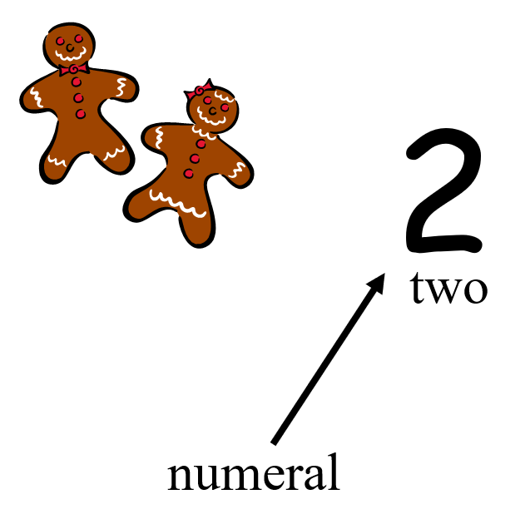

Number

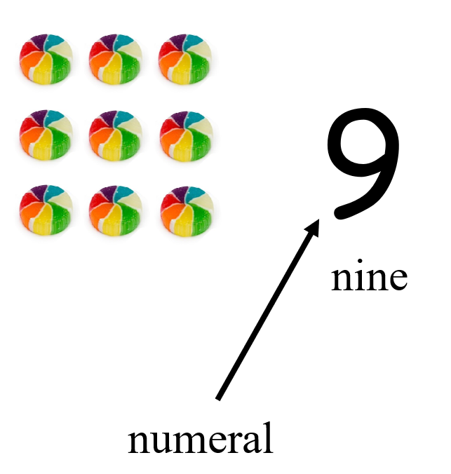

Number

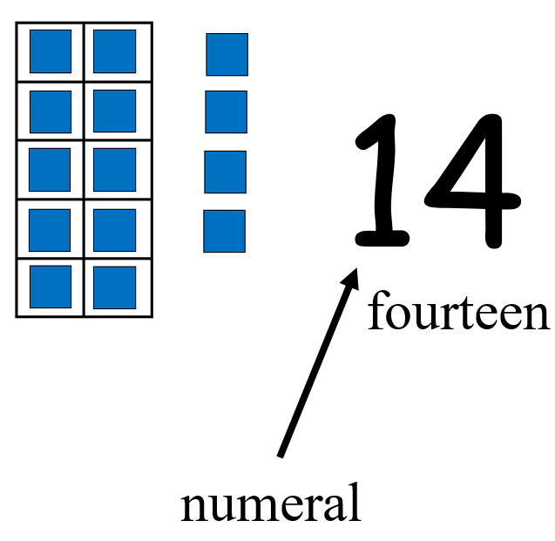

Place Value

Tens Ones

4 7
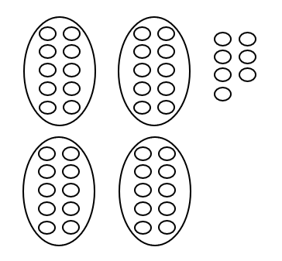
40 and 7

Counting by Ones

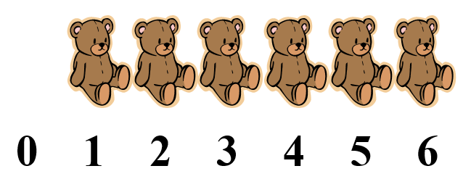
Counting by Tens

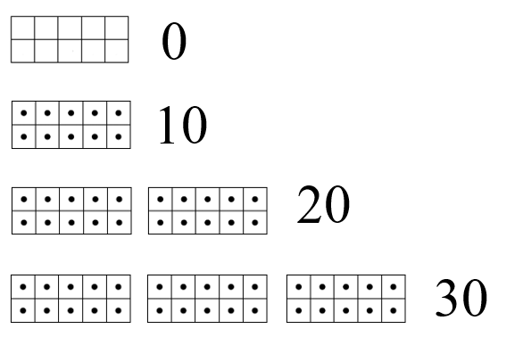

Supplemental Materials
Formative Assessment
Directions: For each question, select the best answer.

- Which number has 5 bundles of 10 in the tens place and 3 ones in the ones place?

A. 33 B. 53 C. 43

- Which number has 2 bundles of 10 in the tens place and 8 ones in the ones place?

- 28 B. 29 C. 43

- Which number has 3 bundles of 10 in the tens place and 1 one in the ones place?

- 41 B. 53 C. 31

- Which number has a 5 the tens place and 3 one’s place? Use sticks to model the number.
- B. C.
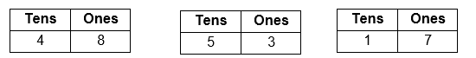

- Which number has a 4 the tens place and 9 one’s place? Use sticks to model the number.
A. B. C.
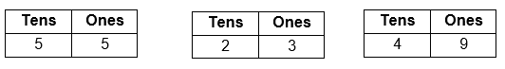

- Which number has a 1 the tens place and 6 one’s place? Use sticks to model the number.
A. B. C.
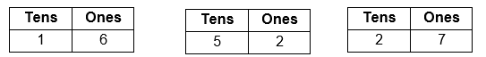

Practice Items:

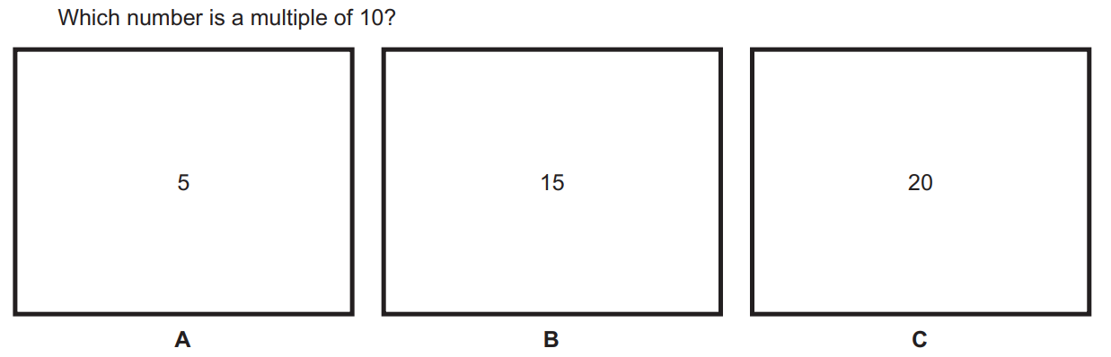

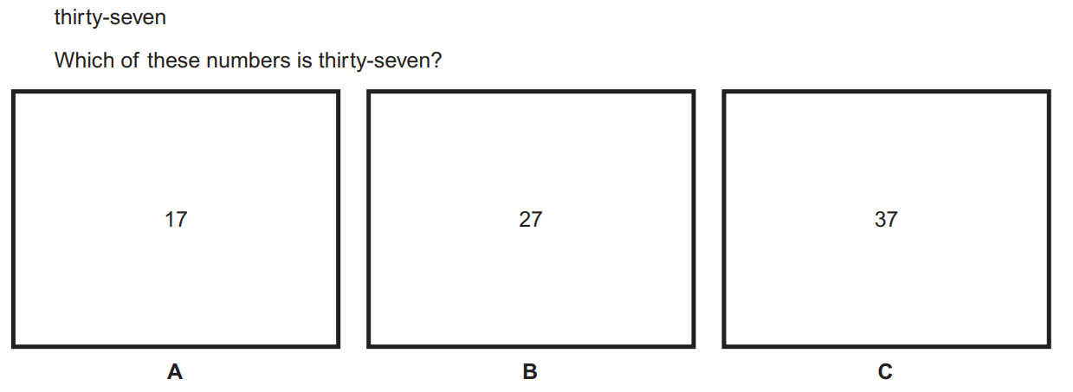**although this is not part of the standard, it is related and may help students make connections to understanding place value in different forms (standard form: word form)
**although this is not part of the standard, it is related and may help students make connections to understanding 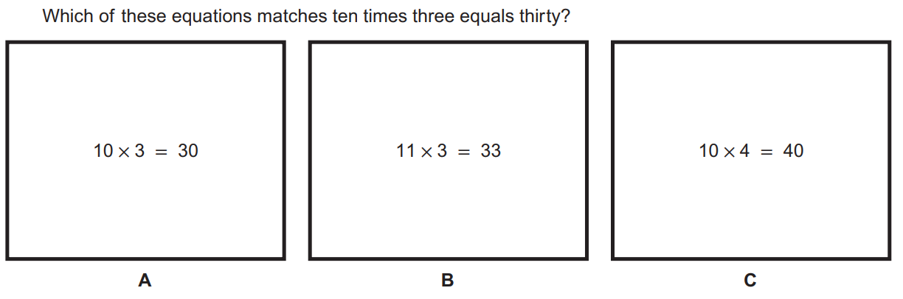multiplication as it relates to multiples of ten and place value

