And the Character is….
Grade Level: 4
Subject(s):
Primary: Reading
Integrated Activity: Math & Art
Reporting Category:
Demonstrate comprehension of fictional texts and use word analysis strategies.
Lesson Summary and Connections:
In this lesson, students will use picture books and other tools to help them understand the characters in a story.
Lesson Components Links

VESOL(s)  Complexity Continuum | Functional Skills | Assistive Technology | Materials
Vocabulary | Common Misconceptions | Student-Friendly Outcome(s) | Introductory Activity
Plan for Instruction | Differentiation | Reflection | Formative Assessment
Word Wall Cards | Supplemental Materials | Practice Items | Integrated Activity

VESOL(s):
R-4.6: Identify the narrator or a character in a story that is read to the student or that the student reads.
Complexity Continuum:
The story containing a character or narrator could range from a sentence of six or fewer words to a sentence of seven words or more or two short sentences.

Functional Skill(s):
- Students will learn how to identify a character in a fictional story.

Assistive Technology/AAC (Augmentative and Alternative Communication):
- (TTS) Text-to-speech assistive technology that reads digital text aloud (“read aloud” technology)
- Audiobooks and digital TTS books
- (OCR) Optical Character Recognition
- Student - (AAC) Augmentative and Alternative Communication devices

Materials:
- Laptop/tablet/iPad
- Headphones
- Graphic organizers (Characters, comprehension, Narrator)
- Paper
- Graph paper
- Crayons, markers, pencils, paint (paint brushes)
- Coloring pages – characters
- Scissors
- Reading Material
  - Wordless fiction picture book – (Large - whole group)
  - Wordless fiction picture books - Individual
  - Books – Fictional stories – As few as two short sentences
  - Online stories (free to use)
  - Online YouTube videos books to consider–
    - Vooks
    - Kids One
    - Reading Made Easy
    - KiddoStories

Vocabulary:
Prior Knowledge
- story | - read | - listen
- beginning | - end | - page
- book | - picture(s) | - sentence
Current Vocabulary
- predict | - picture book | - character | - characters
- picture walk | - wordless | - record | - data
- graph | - tally marks | - graph paper | - sort

Common Misconceptions:
- During the “picture walk” of the story, the student may want to try to read the words to tell what the story is about or what the character’s name is.
- Students may think an inanimate object is a character in a story such as a pencil or bike.

Student-Friendly Outcome(s):
- I can identify the characters in a story.

Starting Point for Instruction (Level A, Level B, or Level C)
Level A. = (1) – Lowest Skill Level - Students at this level will:
- Have all books and passages read to them or they will have access to technology that will read to them (e.g., voice output device, eye gaze choice board).
- Respond to an explicit question about a fictional story by choosing from a narrowed field or errorless choice(s) - (e.g., AAC device, voice output device, eye gaze choice board).
- With technical or differentiated prompting hierarchy support, point to, or select a picture in response to a who, what, or where explicit question about characters in a fictional story.
- Identify a character from a fictional story by selecting a picture from a narrowed field or errorless choice(s) (e.g., AAC device, voice output device, eye gaze choice board).

Level B. = (2) – Middle Skill Level – Students at this level will:
- Have all books and passages read to them or they can have access to technology that will read to them (e.g., voice output device).
- Practice reading skills by attempting to read the story or passage, with coaching.
- With technical or differentiated prompting hierarchy support, point to, or select a picture in response to a who, what, or where explicit question about characters in a fictional story.
- Have explicit questions about a story read to them, and they will write, speak, or select an answer.
- Use picture supports to identify characters from a fictional story.
Level C. = (3) – Highest Skill Level – Students at this level will:
- Independently read (differentiated reading level) fictional stories or passages,
- Independently read explicit questions about a story, and write, speak, or select an answer.
- Identify characters from a fictional story.
- Describe characters in a story.

Introductory Activity:
Before introducing the lesson, administer the pre-test and introduce the objective. For the introductory activity, choose an activity from the list below that fits the dynamic of your group. These activities can also be used during group rotations. There will be times when an activity will be completed very quickly, so having extra activities prepared will give you the flexibility to use these some of these activities as an enrichment activity opportunity.
- Pre-Test (provided)
- Wordless Picture Book – Flip the pages and let the students tell the story.
- Distribute wordless coloring picture books and have students flip through the pages.
- Distribute Coloring Pages – Color the character in the picture.
- Take “Picture Walk” of a story - Let the students make predictions and identify the characters.
- YouTube videos about “Characters”
- Picture Cards (provided)– Choose the Character
- Draw a picture of the character after the teacher reads a description of a character to the student(s).
- Guess who the character is after the teacher reads a short passage about a character.

Plan for Instruction:
- First Session:
- Open the discussion by referring to the group as “Characters” (Example: “Good morning. What a good-looking group of Characters. I want to find out what type of characters are in this group. When I call on you, please tell me what your favorite thing to do when you go outside to play.” The teacher will write the activity on the white board, draw a line under the activity and put the student’s name under the activity. If another student names the same activity, put that student’s name under the same category. When a new activity is named, write the new activity on the white board beside the first activity, underline the activity and put the name under the new activity. If another student names the same activity, put their name under the new category. Continue with this process until all students have given a response and all categories and names are on the white board. (Do not erase the information; this is data that can be used to make a graph during math).

  - Math activity – create a chart using the categories on the white board – differentiate by giving students with a higher skill a blank chart – the students can write the categories in – for the highest level, the students can be given a blank sheet of graph paper to create a graph using the data on the board. Take a picture of the data on the board and make an anchor chart to display so that students can access the data later, if needed.

- Once all of the students have answered the question, create a story with the information that is written on the board: Say “I want to tell you a story about the characters in my class.”
  - Tell the story - Example: The students in Mr. George’s class were very good today. They got extra time to play on the playground. Anna wanted to jump rope. She asked Michael and Cynthia if they wanted to jump rope too. Cynthia did not want to jump rope. She said that Adam loves to jump rope. When Anna asked Adam to jump rope with them, he was very happy. He did a cartwheel to show he was happy. Adam, Anna, and Michael had fun playing together.
    - Ask the question – “Who are the characters in my story?” Call on students randomly – and write their answers on the board. If the same name is given more than once, put a tally mark beside the name.
    - Ask students, “What do you think the word character means?” Give students a chance to think and then have them tell you their ideas. Write them down on the board or chart paper. If the definition is not said, write it on the board and connect it to the students’ thoughts. Place the Character Word Wall card near the student-created definition.
    - Next, if you use the above story, ask questions like; “Who did not want to jump rope?”, What did Adam do to show he was happy?”, “Who got extra time on the playground because they were good?” If you make up your own story, ask similar questions based on the story.
- Break into small groups by skill level. Teacher will Model/think aloud for the groups.
- Level C (3) – Highest Skill Level
- Draw a character on the Playground Worksheet and color the character. Display your artwork and let the students know how proud you are of your own work.
- Hand out paper, pencils, markers and/or crayons. Instruct the students to draw and color a picture of a boy and a girl character playing on the playground.
- Have students use their coloring page to orally tell a story to you. Ask them questions like “Who is/are the characters in your story?” “How do you know they are the characters?”
- Level A and B (1 & 2) – Lower Skill Levels.
- Color a character on the “Character Cards” worksheet, cut out the character and glue it onto the “playground” worksheet.
- Hand out worksheets of the playground, coloring pages of the playground characters, glue, scissors, crayons, and/or markers. Instruct the students to color four characters then cut out the characters and glue the characters onto the Playground Worksheet. Students may need assistance with coloring and or cutting. The teacher may cut the characters out in advance if this is the first time using a cutting activity.
  - Have students use their coloring page to orally tell what is going on in their story. Have students point to the “characters” in their story.

- Second Session
- Introductory Activity: Whole Group
  - Tell students they will be creating a story from a wordless picture book. Turn the pages of a wordless picture book and encourage different students to tell you the story.
      - Ask the questions – “Who are the characters in the story?”, “How do you know they are the characters?”

- Practice Activity: “Pick the Character”
  - Use the following video: Story Elements for Kids to introduce and define a character in a story.
  - Create sets of cards by cutting apart the “Pick the Character” picture cards (Provided). Make enough sets for each student to have a set and one for the teacher to use on the board.
      - Display the image of a person and an inanimate object on the white board. Call on students randomly to choose which image could be a character in a story. Encourage students to explain why they think the one they chose is a character and the other image is not.
      - Have students sort their cards either independently or with a partner. Walk around assisting students as needed. Ask questions like: “Why did you choose <select a card> for a character and not <select a card>?”, “What would need to happen for <one of the noncharacters cards> to become a character?”
      - Once students have finished sorting, display several sets on the board and select students to explain how they chose the characters and noncharacters.

- Small Group Activity: By Skill Level. Teacher will Model for the group.
- Level C (3) – Highest Skill Level
  - Read a short passage (provided) to the student. Teacher should model good reading habits, like pausing and asking herself questions, highlighting words she thinks are important, Jotting a note in the margin, etc. Once the passage has been read, ask students to name the characters that are in the passage and explain how they know they are characters. Ask questions about the actions happening with each character. “Who did <what activity>”, “What did <character name>do with <item or activity>?” etc.
  - Continue to read short passages as time allows. There are 6 different passages provided.

- Level A and B (1 & 2) – Lower Skill Levels.
- Use a set of Character Cards from the previous activity.
    - Select two different cards. One image of a person and one an inanimate object. Place the cards, face up, side by side in front of the student.
    - Have the student choose which card would be a character. If the student makes the right choice, place the picture of the image in front of the student. Have the student respond until they have three correct answers.
    - Once the sets are completed, create a story with the student using two or more cards. As you and the student are creating, write the story on a piece of paper. After the story is completed, read the story to the student, and have them explain who the character(s) is/are and why they are the character. As an extension, use each student’s story with other students in the class.

- Third Session
  - Introductory Activities:
    - Play the video “Characters” for students. At the end of the video ask students to tell you in their own words what they think a character is in a story. Write down their ideas on the board.
  - Activity 1:
    - Re-Introduce the vocabulary words – character, wordless, picture book
      - In advance, create sets of cards by cutting out each section of the Word Wall cards. (Remove the word Predict – it is part of the enrichment activity). Separate the image from the picture of the word (You will have the vocabulary word, the icon of the word, and the meaning of the word.) Give a set to each student (two vocabulary words, definition of each, and icon for each).
    - Lead a whole group discussion about the meaning of each word – display the vocabulary words on the white board, point to the vocabulary word as you discuss each one.
    - Distribute a sheet of construction paper and a stick of glue to each student (let them pick the color of the construction paper they like the most). Students will sort the vocabulary word, the icon for the word, and the meaning of the word and glue them to the construction paper. The teacher will monitor the students and give assistance where needed.
- Activity 2:
    - Take a “Picture Walk” of a story of your choosing. Before you read the story to the student(s) for the first time– (whole group, small group, or one-to-one), turn the pages and let the students point to the pictures and tell you what they think is happening in the story and who the characters are in the story (Do not read any words that are on the pages). Encourage students to not try to read the words. Use a card to cover the words on each page.
    - After the “Picture Walk” is done, read the story to the students (Whole group, small group, or one-to-one): Pause to ask questions about the story and the characters in the story. “Who are the characters in the story?”, “Who did what activity”, “What did <character name>do with <item or activity>?” etc. Discuss predictions that were made and if the predictions were correct.
- Assessment - Formative or Summative
- Level C (3) – Highest Skill Level
  - Give students the Formative Assessment – small group, or one-to-one.
    - Have students respond to the multiple-choice questions.
    - When possible, give students feedback before they leave for the day.
- Level A and B (1 & 2) – Lower Skill Levels.
- Use the coloring pages and / or Wordless books.
    - Distribute Character Cards or wordless picture books to students.
    - Students will “read” the pages of the wordless picture books. Once they have “read” them once or twice, the student must tell who the characters are and what each one was doing in the story. If there is time, lets students color the pictures.

Differentiation:
- Use the Starting Point for instruction (Level A, Level B, and Level C) at the beginning of the lesson to group your students. Each session contains a section for the different levels.

Enrichment (Goes beyond the VESOL)
  - Model making predictions:
    - Present the video of “Bloopers”. Pause the video when the black screen with the words “What will happen?” appears. At this point, ask the students; “What do you predict will happen next?”

  - Activity - Practice the new vocabulary word – Predict.
    - Ask the students to “predict” which letter of the alphabet would there be more of if we put all of the letters from our first names on a graph.
    - Explain that a prediction is a guess.
    - Call on students randomly, to predict which letter of the alphabet would there be more of in the names of all students in the class.
    - Put the word “Predictions” on the white board and underline it. As the students make their predictions, put their initials on the white board and write their prediction next to their initials.
    - Once all of the predictions have been made, take a picture of the answers on the white board. (Do not erase the information; this is data that can be used to make a graph during math).
    - Give each student a set of “post-it notes” to equal the number of letters in their first name. Instruct the students to make their name by putting one letter on each post-it note (model the instructions by writing your first name on the post-it notes).
  - Place the letters of your name above the corresponding letters on the white board. Have the students place the letters from their names above the letters – duplicate letters are placed above each other (creating a graph).
  - Once all of the letters from the students’ names have been added to the board (a graph has been made) – take a picture to use as data to have students make a graph during math.
  - Have a whole group discussion. Ask the question: “Which letter had the highest number?” Ask: “Whose prediction was correct? Did anyone predict the exact amount?” Explain that it is ok not to get it right – a prediction is just a really good guess. You don’t have to be right.
    - Note: Prepare your white board in advance – write the letters of the alphabet - a-z - across the bottom of the white board – space the letters to equal the distance of the width of the post-it notes (leave out letters of the alphabet that you know will not be in the students’ names).

- Enrichment Review: Characters in a story (Whole Group):
  - Tell a story of what happened when the class predicted which letter would have the highest number once we made a graph of the letters in our names.
Today the students in my class predicted which letter would have the highest number in their names. Each student made a prediction. Each student wrote the letters in their name on post-it notes. Next, they placed them on the white board above the correct letter. Most of the students predicted “e” or “t” to be the highest. They found that “a” had the highest number. Jacob and Marion made the correct prediction.
  - Ask questions like – “Who are the characters in my story?” , “Which character(s) made the correct prediction?”, “What do you think will happen next in the story?” etc.

- Small Group Activity: By Skill Level. Teacher will Model for the group –
  - Level C (3) – Highest Skill Level - Teacher will Model for the group – The teacher will go to the board, count the number of “A” letters on the graph and record that number on the graph paper by writing the letter “A” in one of the cells on the graph paper, skip a couple of cells across from the “A” and place the total on the cell. The teacher will display this to the students and ask if there are any questions about how to record the alphabet information.
- Hand out graph paper, pencils, markers and/or crayons. Instruct the students to count the number of “B” letters on the graph and record that number on the chart paper by writing the letter “B” in one of the cells on the chart paper, skip a couple of cells across from the “B” and place the total on the cell. Continue counting and recording the data for each alphabet until all alphabet totals have been recorded.

  - Level A and B (1 & 2) – Teacher will Model for the group – The teacher will go to the board, count the number of “A” letters on the graph and record that number on the prepared data sheet paper, on the line, next to the letter “A”. The teacher will display this to the students and ask if there are any questions about how to record the alphabet data.
- Hand out the prepared data recording sheets, pencils, and/or crayons to each student. Instruct the students to work with a peer – one will count the letters and one will record the data - count and record the total number for each letter from the graph on the board onto the recording sheet. The students will continue counting and recording the data for each letter until all totals have been recorded. The teacher will monitor and help where needed.
- Note: Prepare a data recording system in advance for the students by writing all alphabets that are on the board onto a sheet of paper. There should be one alphabet on each line of the paper. The teacher should draw a line next to each alphabet (where the answer should be recorded.)

Reflection:
- Each day:
  - Determine what strategies worked best for the students.
    - Were the students engaged? Did the strategies work?
    - Did the students participate in the activity? At what level did the students participate?
  - Assessments - Collect data daily – Data will drive instruction.
    - Formative assessments are informal and can be observational. They should be done daily and used to drive instruction.
      - Does not have to be multiple questions.
      - Can be individual, one-on-one, or whole group.
      - Low score = reteach / retest
    - Summative assessment – Formal assessment –
      - Measures how much a student has learned.
      - Has the student reached completion of the unit?

Formative Assessment:
- Give a pre-test to students before the objective is introduced. And use the same assessment as a post test.
- Have students Guess the Character from a short passage (with pictures).
- Put students into small groups or one-to-one and have them respond to multiple-choice questions.
- Use a set of picture cards and have the student identify which is a character.
- Throughout the lesson ask the questions– “Who are the characters in my story?” and indicate responses on an observational checklist.

Notes:
- Notes are infused in each section of the lesson.
- Prompting Hierarchy - A prompt is used to move or assist an action by providing verbal or gestural suggestions to elicit the desired response. A hierarchy is simply a ranked series of something. So, a prompting hierarchy in special education is a ranked series of different types and levels of prompts. It provides a structured and systematic way for us to reach and teach our students. Anything after a provided direction is considered a prompt. As the teacher, we provide a series of prompts to help the student complete the given task. We first want to provide the amount of prompting our students need. Our end goal is to ultimately fade these prompts until our students are completing the task on their own.

Integrated Activity:
- M-4.21 VESOL the student will: Interpret and compare data values represented in a picture or bar graph using simple terms: same, more, less.
- Students will be using data collected about characters in the first session to create and analyze a picture graph.

Word Wall Cards

predict

make a very good guess

character

people in a story

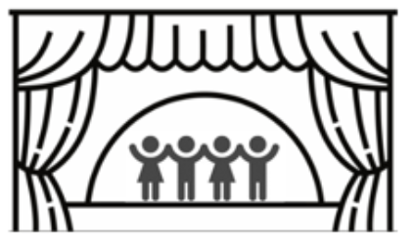

wordless

only pictures, no words

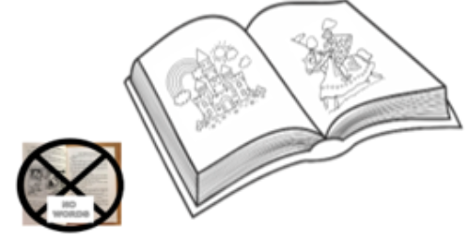

picture book

a book with pictures and no words

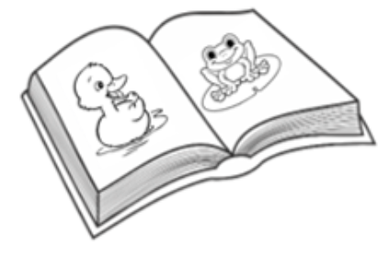

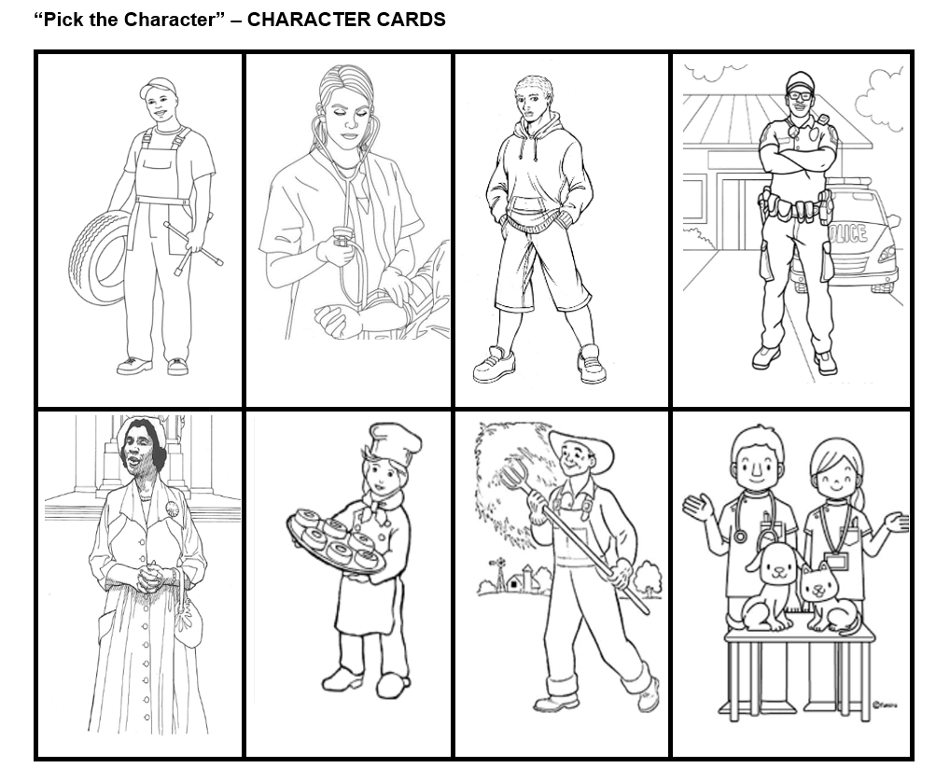
Supplemental Materials:

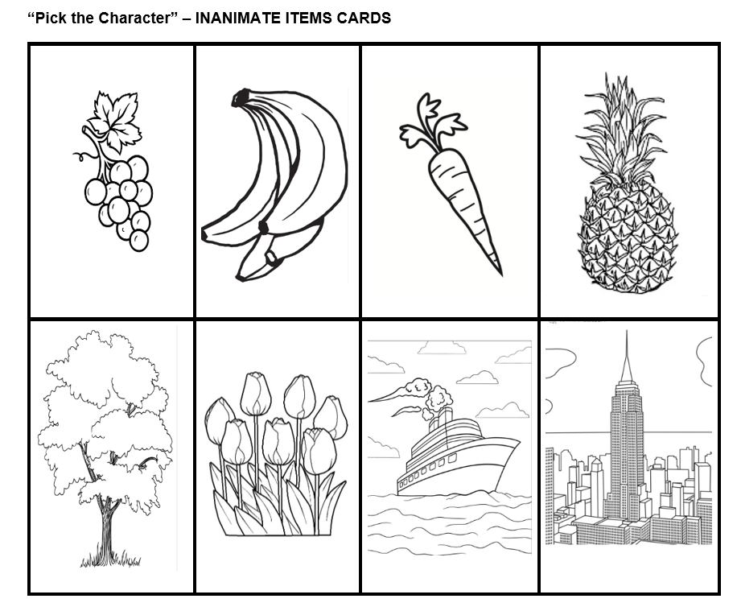

Name: _______________________________________ Date: __________________

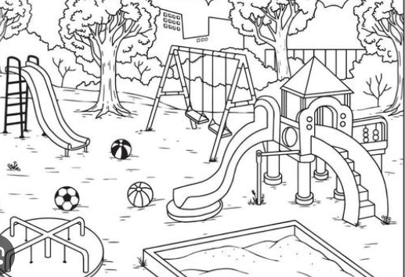
Directions: Add a picture of four characters playing on the playground.

Directions: Color four characters. Cut out the characters and glue them to the “Playground Worksheet” provided.

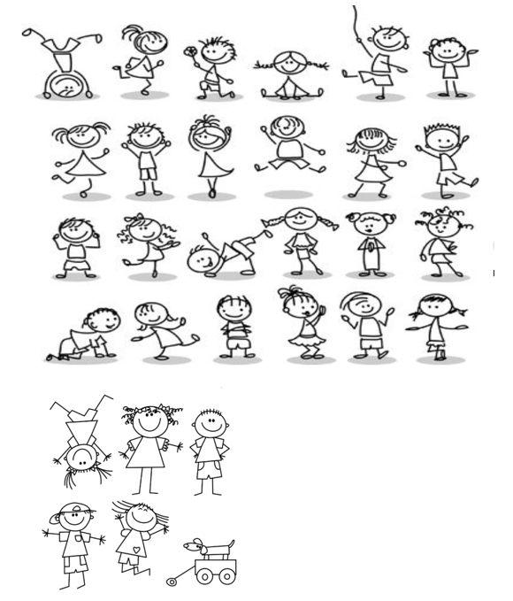

Name: ________________________________________ Date: __________________________

Directions: Circle the letter under the picture that could represent a character in a story.
1.
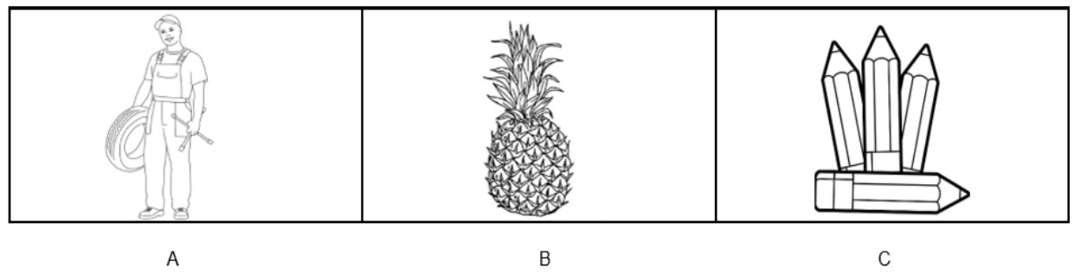

2.
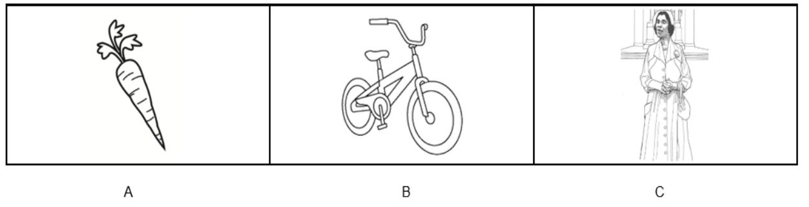

3.
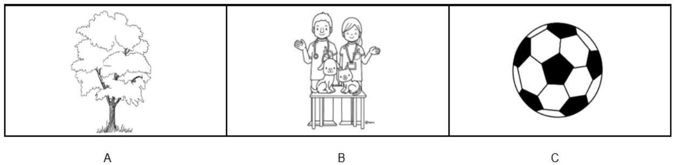

4.
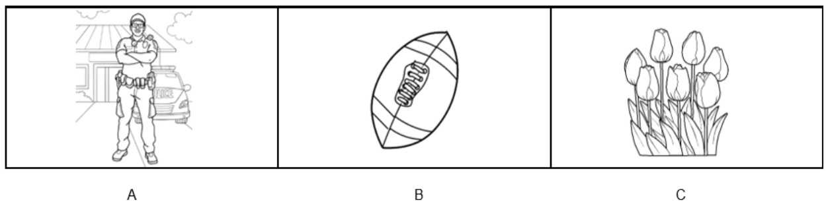

Name: ________________________________________ Date: __________________________

Directions: Circle the letter under the picture that could represent a character in a story.
5.
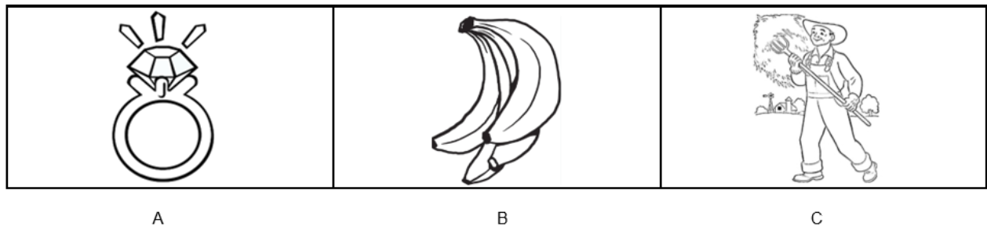

6.
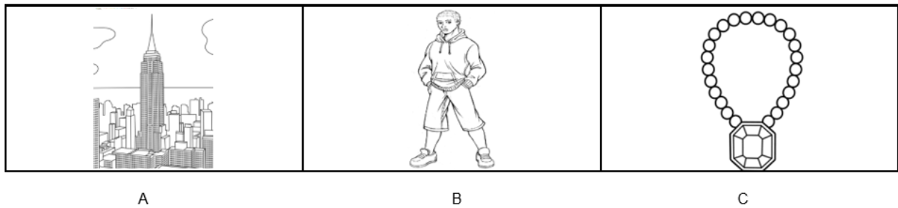

7.
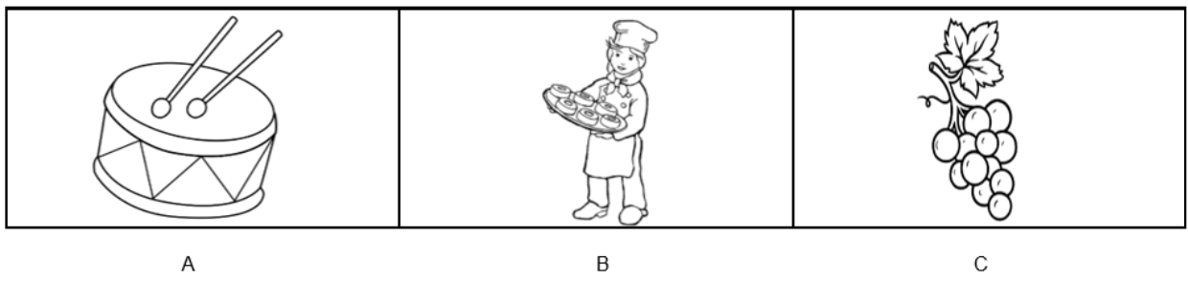

8.
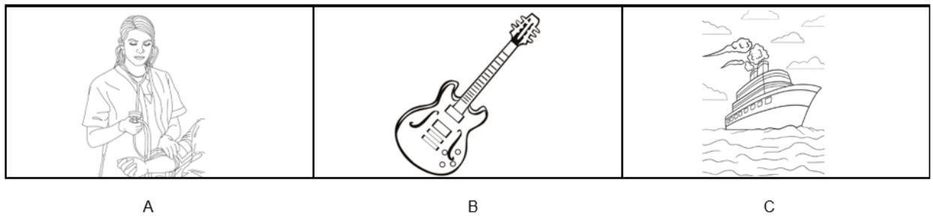

Short Stories

Directions: Read the stories below to your student and ask the student to name the characters in each story.

Football Try-Outs

Chip and Rasool tried out for the football team. They both made the team. Football practice was on Saturday mornings. The school bus will come to take the boys to practice. Chip and Rasool were happy to ride the bus.

New Best Friends

Jenny moved to a new house. She had to go to a new school. Jenny met Emma in her new class. Emma helped Jenny at the new school. Jenny asked Emma to come to her birthday party. Now they are best friends.
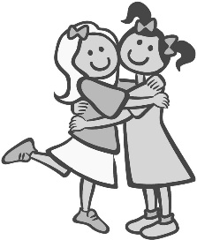

Fishing with Pop

Pop likes to take his kids fishing. Mariyah loves to go fishing with Pop. They catch lots of fish. They do not keep the fish. They always let the fish go back in the water. Mariyah thinks fishing is fun!

Mabel Wants to Swim

Mable wanted to swim. She went to the pool. She jumped in the water. She put her head under the water. She made bubbles. Mable had a great time playing in the water.
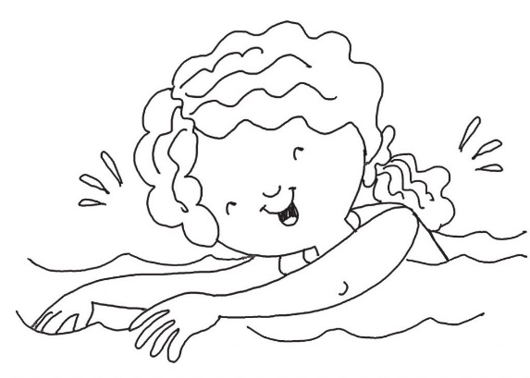

Wintertime Is Fun!

Avery and Daija can’t wait for winter to come. They want to build a snowman. They will use a hat and a scarf to dress up the snowman. They will use a carrot for the nose. They will find rocks for the eyes, mouth, and buttons. They hope it snows soon.

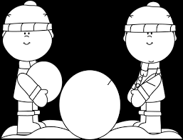

More Than one Way to Find a Cat

Thomas lives on a farm. He has a cat who likes to play hide and seek. His cat has many places to hide. Thomas put a bell on his cat’s neck. Now Thomas can always find his cat.

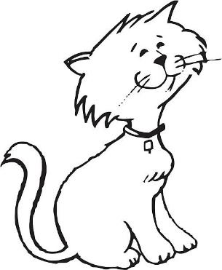

Practice Items:

