Bears for Fred
Grade Level: 4th Grade
Subject(s):
Primary: Reading
Integrated Activity: Reading, Math, Science
Reporting Category:
Demonstrate Comprehension of Fictional Texts and Use Word Analysis Strategies
Lesson Summary and Connections:
Students will answer questions about the story “Bears for Fred.”
Lesson Components Links
VESOL(s)  Complexity Continuum | Functional Skills | Assistive Technology | Materials
Vocabulary | Common Misconceptions | Student-Friendly Outcome(s) | Introductory Activity
Plan for Instruction | Differentiation | Reflection | Formative Assessment
Word Wall Cards | Supplemental Materials | Practice Items | Integrated Activity

VESOL(s):
R-4.2 Answer questions about a fiction passage that is read to the student or that the student reads.
Complexity Continuum:

The passage may range from a sentence with six or fewer words through a sentence with seven or more words or two short sentences.

Functional Skill(s):
- Students will identify the character of the story.
- Students will answer questions related to what is being read to them.
- Students will recognize that words make up stories.

Assistive Technology/AAC (Augmentative and Alternative Communication):
- Counting bears (to help students visualize the story)
- Communication device to help students count.
- Communication board related to story (include the vocabulary words)
- Tablet for virtual manipulatives

Materials:
- “Bears for Fred” book
- Counting Bears or Counters
- Vocabulary Cards (differentiated for student developmental level and disability)

Vocabulary:
Prior Knowledge
- What | - Who | - When | - Where
Current Vocabulary
- Why | - How

Common Misconceptions:
- Some students may be confused about the differences between “what” questions and “who” questions. Using picture cards can help students differentiate between the two questions and choose the correct answer.

Student-Friendly Outcome(s):
- I will answer questions about a story.

Introductory Activity:
Introduce students to the lesson by reviewing the key vocabulary.
- Go over each vocabulary word and give examples.
- Play a quick game of “What’s in the bag?” Have a bag of a familiar item or two. Describe the item using key characteristics that your students may know. You can have your students feel the item, as well. To differentiate the lesson, you may have three picture choices of what the item may be.

Plan for Instruction:
- Introduce the story, “Bears for Fred.” Tell the students that as they listen to the story they should try to remember some key information. Remind students to think about their vocabulary words.
- Give each student a counting board and ten bears of various colors. Tell the students that the bears will be used to help them follow along with the story. (For those students that you know will have a hard time with manipulatives, use picture cut-outs, felt, or the tablet or white board to help manipulate the story.)
- Read each page and model putting the bear on the page. Tell your students to do the same. On the last page, the students put the rest of the bears on the page.
- Questions are included in the story below each picture to check for understanding during reading. Ask students to point out the “question” words while checking for understanding.

Differentiation:
- The story could be broken down over two or more days, as needed. Each page of the story can serve as its own lesson.
- For students that may not be getting the concept, model by stopping after each page and asking a different question about what was read. Offer picture choices for the answer as needed.
- For students who are advanced, ask other “wh” questions about the story. Some students may be able to answer open-ended questions. Also, advanced students may not need picture choices but just the words as their answer choices.

Reflection:
- Throughout the day, you can ask students “what” and “who” questions. This could be incorporated into any subject area.
- Play games that allow students to answer questions about things that are happening at school.

Formative Assessment:
- Who has bears?
- What does Fred have?
- Who likes bears?
- Where does Fred go?
- Where does Fred put his bears at school?
- What does Fred do outside?
- Why did Fred yell?

Integrated Activity:
Reading

Bears with a Friend

Read the story to the students. Have a set of counting bears and a Bears with a Friend Graphing Sheet for each student.

Fred and his friend James were playing with bears. Fred had 10 bears and James had 10 bears. The two friends sorted the bears by color. First, they counted the red bears. They had 3 red bears. Then, they counted the green bears. They had 4 green bears. Fred and James counted the yellow bears. They had 3 yellow bears. They counted the orange bears. They had 6 orange bears. They finally counted the blue bears. They had 4 blue bears.

- Who is Fred playing with?
- James b. Chris c. Tom

- What are the friends playing with?
- drums b. cars c. bears

- What do the friends sort the bears by?
- colors b. size c. monkeys

- How many bears does James have?
- 5 b. 10 c. 3

Math (supports M-4.9 and M-4.21)

Bears with Friends Graphing Activity

Teacher Directions:
- Using the story “Bears with Friends,” students will complete the graph and answer the questions.
- Have students find the amount of bears each color has by making a tally chart and then writing the number on top of the color.
- Tell students they will use the numbers in the first column to help them color the total number of rectangles for each color bear.
- Give students time to create their graphs; then ask the following questions about the graph.
- How many bears do the friends have all together?
- Which color has the most bears?
- Which two colors have the same number of bears?
- Make a number sentence about the number of green bears and yellow bears.

Science:

- Where do bears live?

 | 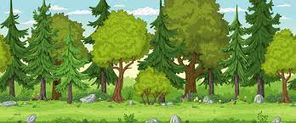
A. airplane | B. forest | C. moon

- What does a bear eat?

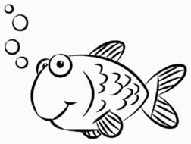 |  | 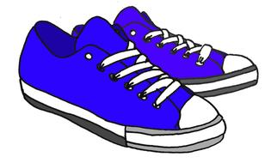
A. fish | B. paper | C. shoes

Word Wall Cards:

Who
a person or people

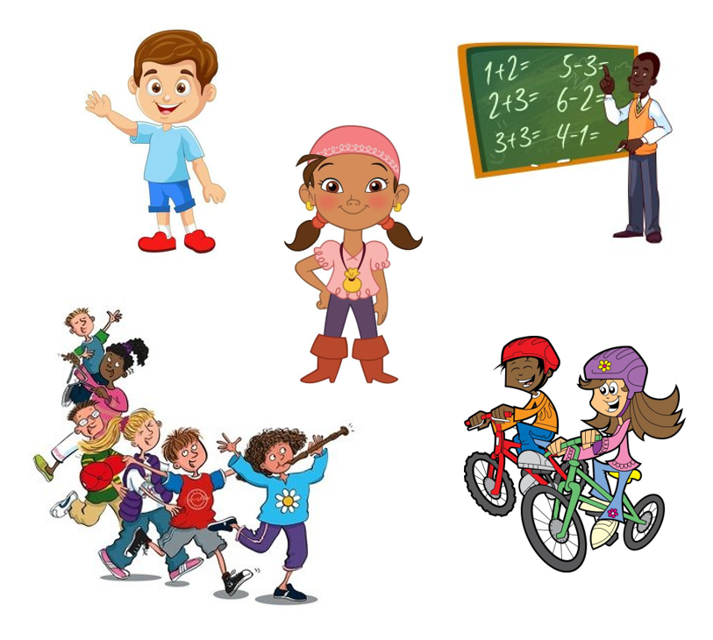

What
asking for information

When

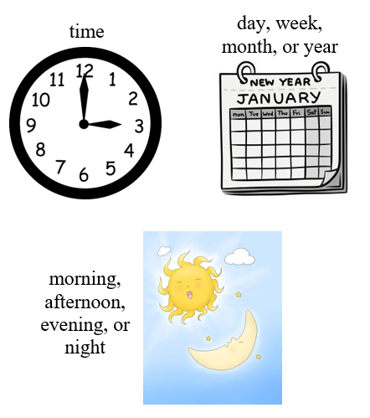
Where

location of an event

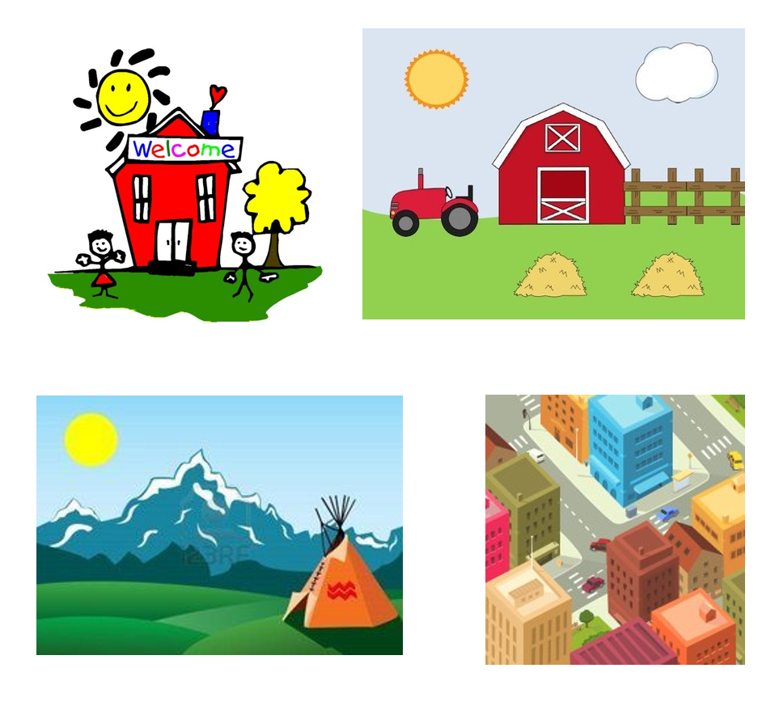

Why

for what reason

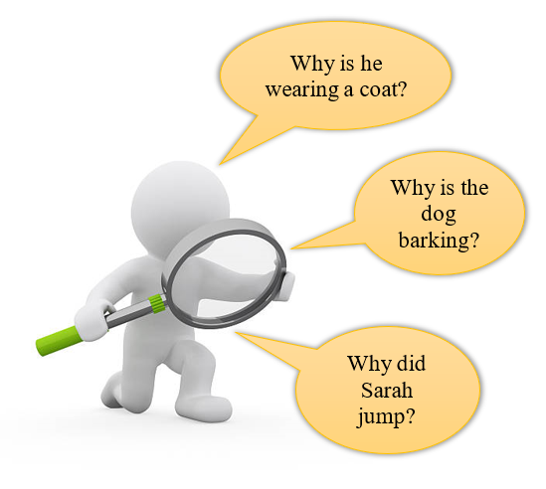

How

in what way

Supplemental Materials:

Bears for Fred

R-4.2

This is Fred. Fred likes bears.

Who likes bears? What does Fred like?

He takes them everywhere. Fred takes them in his bag.

Where does Fred take his bears? What does Fred take the bears in?

He took his bears to school today. He put them in his cubby.

Where does Fred take the bears? Where does Fred put the bears at school?

Fred went outside to play. He played on the swings.

Why does Fred go outside? What does Fred play on?

Recess was over and Fred went inside.
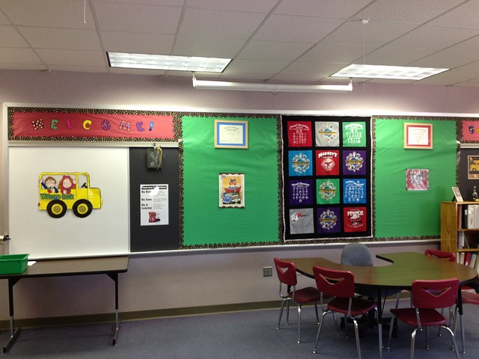

What does Fred do when recess is over?

“Where are my bears?” yelled Fred. The bears were gone.

Why did Fred yell? How do you think Fred felt? What do you think will happen next?

Practice Items:

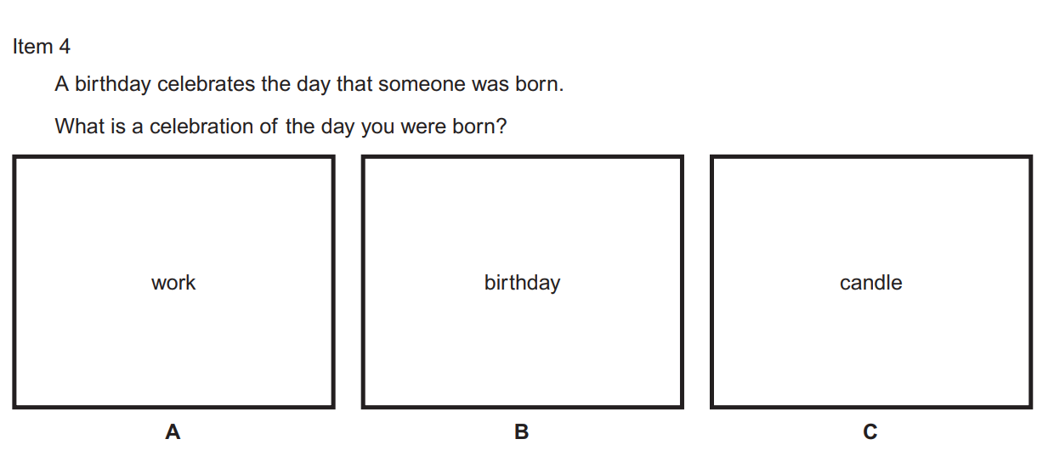

Bears With Friends Graphing Activity

Directions: color in each bar to represent the number of bears for each bear color. Use the numbers on in the to the left to help you decide how many rectangles to color.

How Many Bears?

